1.

Supervisado: clasificación.

Entrada, input y output para entrenar

Entrada, input un elemento

Salida, output la clasificación a la que pertenece ese elemento.

No supervisado: agrupamiento.

Entrada, Un vector de datos.

Salida, un conjunto de datos agrupados.

2.

Pienso que el efecto de theta en la función sigmoid es que mayor theta menor incertidumbre al momento de seleccionar para que valores de x es 0 o 1.

3. McCulloh-Pitts neurons

|  |  |  |  |
| --- | --- | --- | --- |
| x1 | x2 | x3 | (x1 and x2) or x3 |
| 1 | 1 | 1 | 1 |
| 1 | 1 | 0 | 1 |
| 1 | 0 | 1 | 1 |
| 1 | 0 | 0 | 0 |
| 0 | 1 | 1 | 1 |
| 0 | 1 | 0 | 0 |
| 0 | 0 | 1 | 1 |
| 0 | 0 | 0 | 0 |

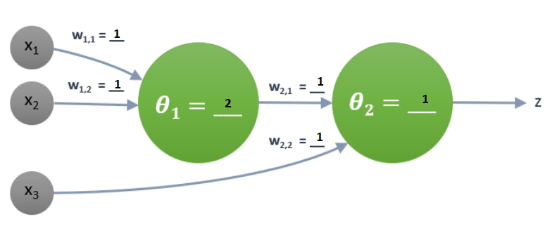

|  |  |  |  |  |  |  |
| --- | --- | --- | --- | --- | --- | --- |
| x1 | x2 | x1*w(1,1) + x2 *w(1,2) | z1 = (x1*w1 + x2 *w2 > 1) | x3 | z1*w(2,1) + x3*w(2,2) | z2 |
| 1 | 1 | 2 | 1 | 1 | 2 | 1 |
| 1 | 1 | 2 | 1 | 0 | 1 | 1 |
| 1 | 0 | 1 | 0 | 1 | 1 | 1 |
| 1 | 0 | 1 | 0 | 0 | 0 | 0 |
| 0 | 1 | 1 | 0 | 1 | 1 | 1 |
| 0 | 1 | 1 | 0 | 0 | 0 | 0 |
| 0 | 0 | 0 | 0 | 1 | 1 | 1 |
| 0 | 0 | 0 | 0 | 0 | 0 | 0 |

4. Hebb learning rule.







