SOFT HOURS WEBSITE ITERATION 3

HOME PAGE
Cookie consent: Please note, I already flagged this in the first iteration. I am copying again what I had in the last document.
- Cookies display : Please make the cookie request in the brand color and as a small banner, like the example below!

From doc II: “The cookies display is still the same as before, I had this comment in the previous notes:, can we make it a lot more subtle? Firstly, it should be in the brand color, not plain white, secondly, I like a lot the approach of Paynter below (https://paynter.co.uk) It is subtle and you can click on “learn more”, if you wanted more info.”
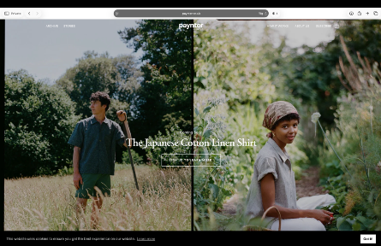

- Please make the arrows in the product carts in the cream color, it is barely visible now.
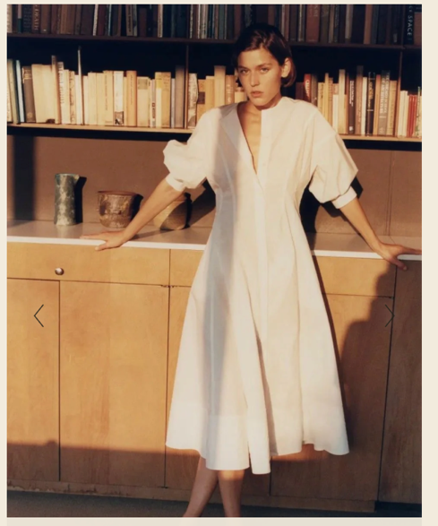

- Please change “QUICK ADD” TO “SELECT SIZE” in the product cards
- Heart / favorite feature, is great thank you – functionality-wise, there is currently nothing happening when I click on it – please explain the flow here.
- Hero Image: The Hero Image section needs to accommodate video as well

HEADER
Header
- Shop: This needs to accommodate a menu (for the future) – how is this going to be (I will need to be able to build it up further, once we have more collections / categories)?
- The country / currency selector currently only supports “United Kingdom – CHF” – is this something I need to change on my end?

PRODUCT CART
It looks a lot more refined now, thank you! One small question:
- In the quick add, I love the cream color – I was wondering how it looks if we make it a bit more transparent?

PRODUCT PAGE
- Can you please use the same heart here as we have currently on the home page of the product cards? Same comment regarding the functionality, where is the wish list hosted?
- Please remove Fit & Measurement, the Size chart is sufficient
- When scrolling down, the “complete the set” is currently bolded, can we have that in the same style as the other fonts?
- One question: Is it possible to have a zoom-in function, for example, as Jenny Kayne has it: https://www.jennikayne.com/products/rowan-turtleneck-ash-heather
- Can you please confirm functionality: The product cards are perfect as they are now – I will do them per color (meaning I won’t merge all 4 colors into one product card). This seems currently fine. Once the person clicks on the item, the product page opens and the different colors appear – this is also fine. Now, once someone clicks on a different color, the image sequence needs to switch to the correct image “batch” – please refer to Asceno to understand what I mean: https://www.asceno.com/products/georgia-shirt-light-grey-100-virgin-wool
I currently don’t understand how the right colors are mapped to the right images (when I click on a specific color, it currently jumps to the second, third, and again to the third image respectively)
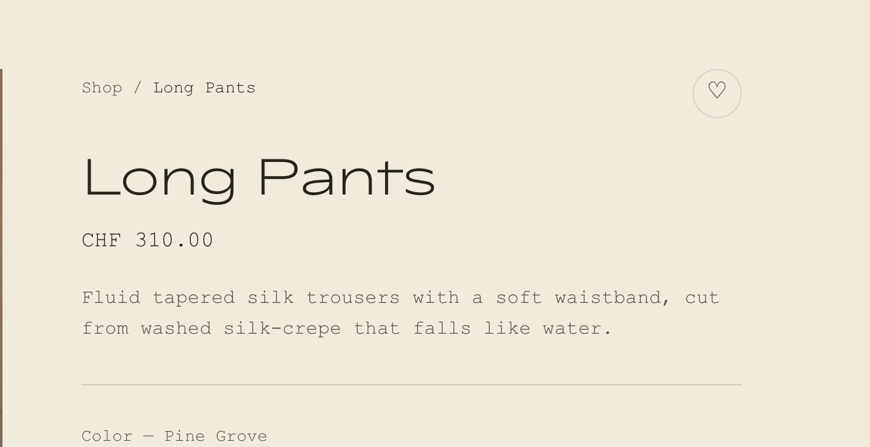
- Flexibility / Layout product page: Is it possible to allow for the layout that, if I want to, I can add also some campaign images (like below)?
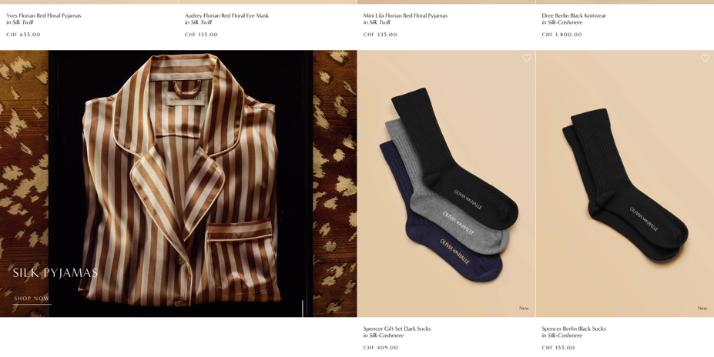

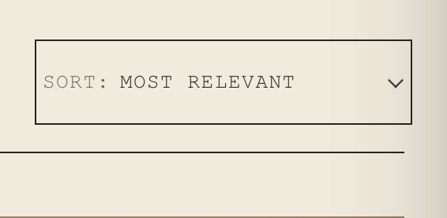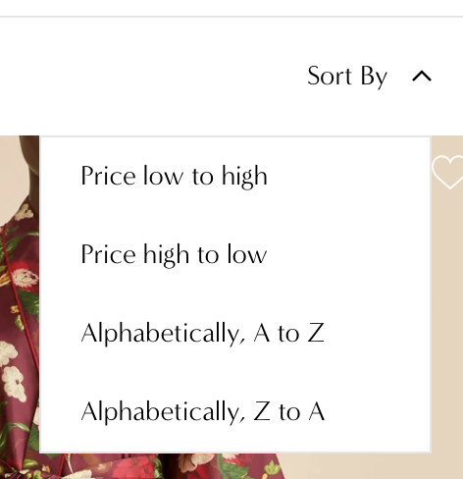
- Is there another way to do the filter? Currently, when I click on the arrow, nothing happens. One needs to click on the font I think so that it opens up. Can the drop-down be in the brand color and style?
CHECKOUT PAGE
- Can we make the checkout also look more like the site throughout (I mean having the right font as headlines and the image previous as squares?) – I have looked at other brands and it seems to be quite uncommon that anyone takes a lot of care for this site… I still find it important, if there is a way we can do it we definitely should (to improve the experience until the very end).
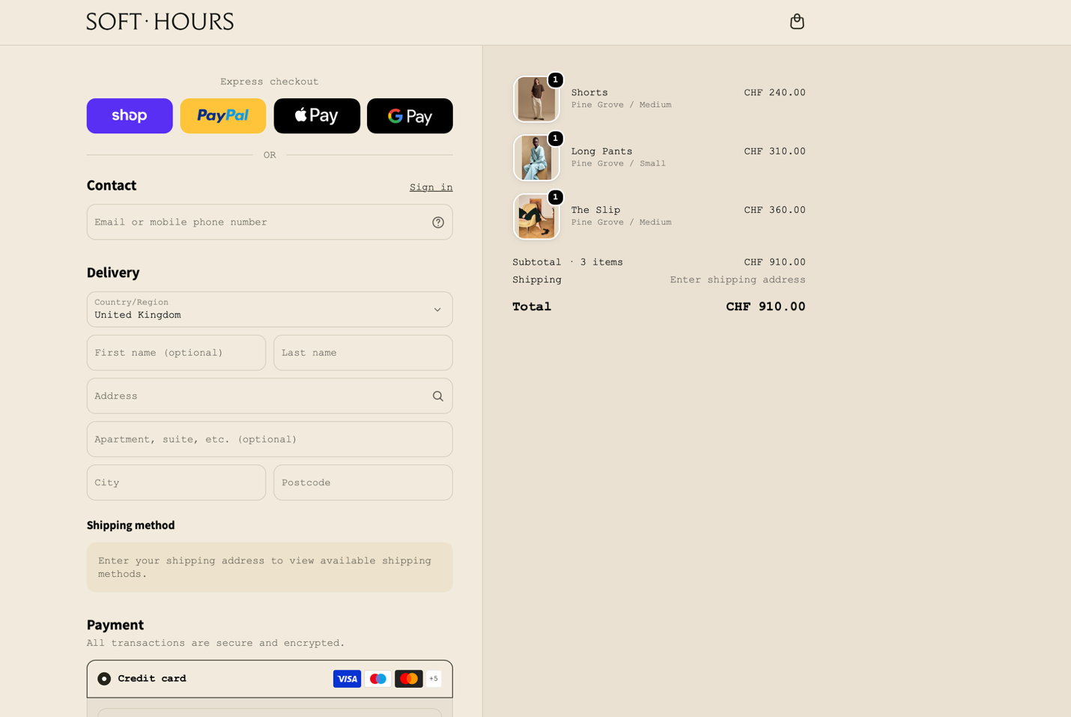
DIVERSE:
- Please let me know what you need for the pages such as FAQ, Size Guide, etc.?

