Class: CMSC203 CRN 21916
Program: Assignment 0
Instructor: Farnaz Eivazi
Assigment0_part2 Installing JDK, Compile and Run Java Program Using the command line
Part 1
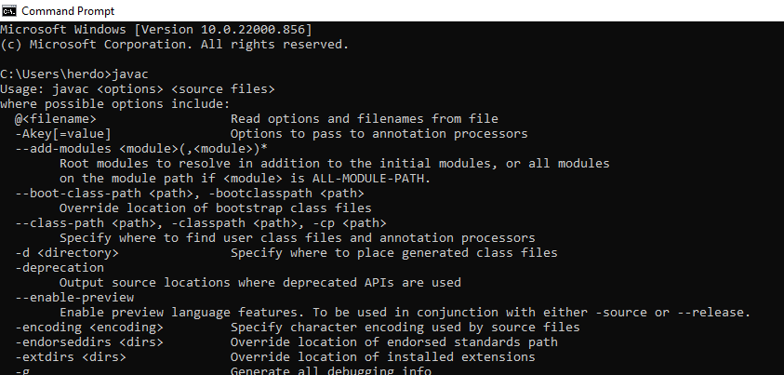
Part 2
P