Task 10.1P

not breaking the rules

# Some rules are not to be broken

## ‘Thread. Sleep’ snippet.

As far as I can tell, nothing interesting happens.

Technically the countdown works in that you wait the requisite amount of time, though the app just looks like it’s hanging – the shadow on the button remains ‘pressed’ for a while, until the text changes from the default ‘hello world’ to ‘0’.

That said, this shows up in Logcat:

5432-5432/com.example.a9726446.a10_1p I/Choreographer: Skipped 239 frames! The application may be doing too much work on its main thread.

Essentially, it’s breaking one of the rules of Android’s single thread model – it blocks the main thread.

( <https://developer.android.com/guide/components/processes-and-threads>,last accessed 1/11/18 )

This isn’t advised as it prevents all other events from being dispatched, including draw events, giving the hanging effect described above.

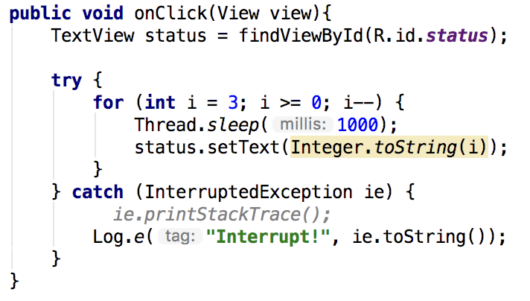

## Refactoring with Async Task

//With references from <https://android-developers.googleblog.com/2009/05/painless-threading.html> (last accessed: 1/11/18)

And the lecture slides from Module 6 (Concurrent Tasks)

### Code Snippet:

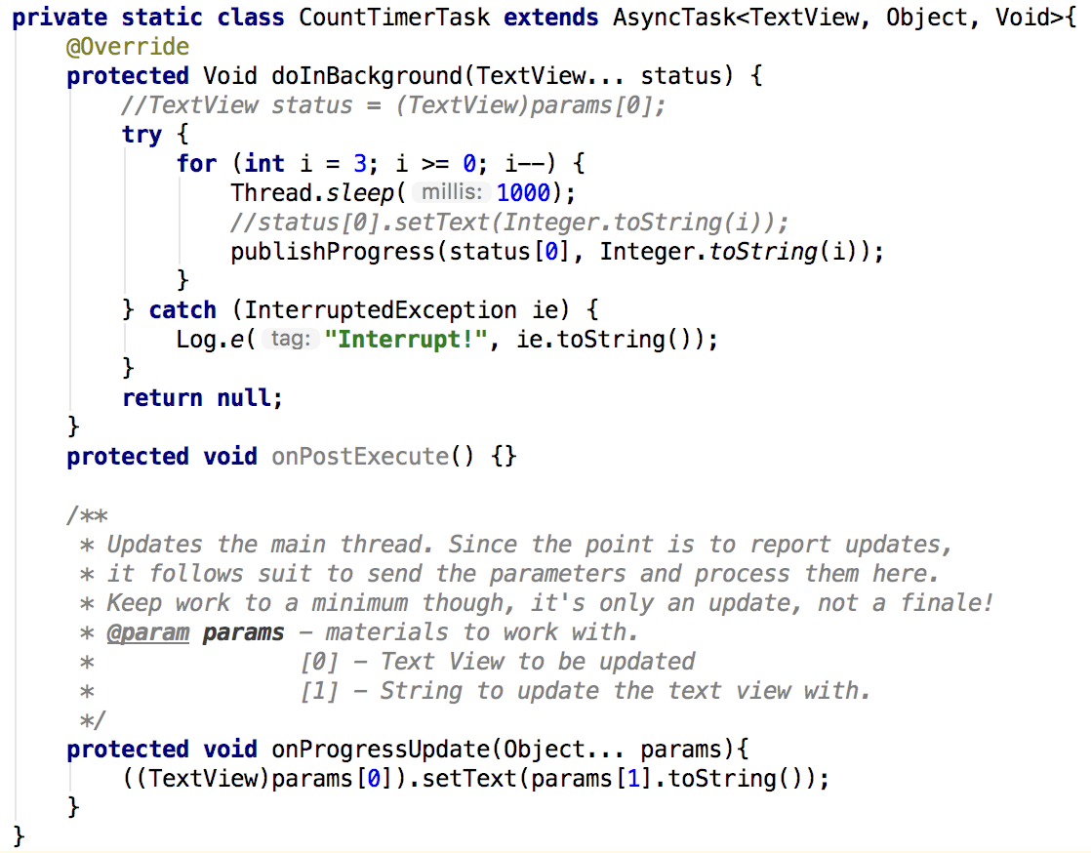

Refer Appendix for screenshots of a timer ticking down

# Appendix: Screenshots of a timer ticking down:

//Not that these illustrate that much haha…

