Task 8.1P

Working with Persistent Data

# Create a List from a file

## Code Snippet: How Data is Loaded:

As I ‘recycled’ my recycler view code from 5.1P, I already had a function to build a list of items and display them in the list. This time instead of iterating through a for loop, a buffered reader was used instead:

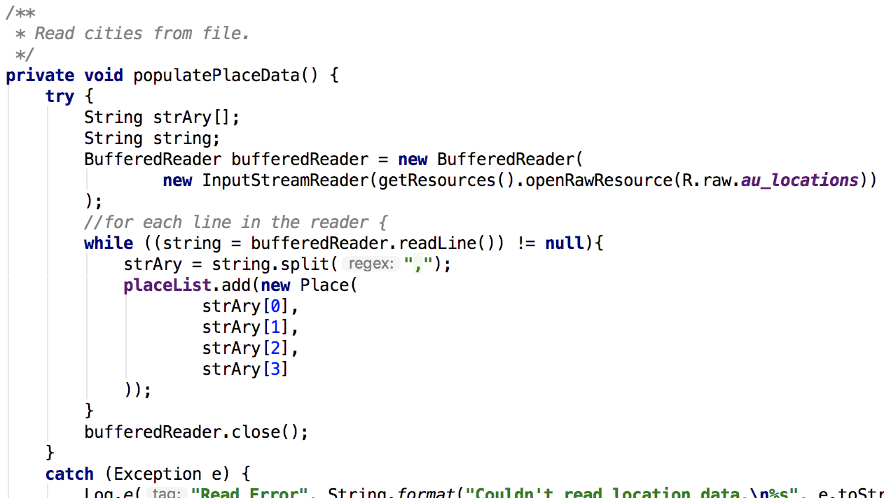

Each line was then split by their commas, plugged into an array (a more robust code would ensure the array wasn’t null) and added to the list of places.

## Code Snippet: How List Items are Selected

This was the hardest part for me. I knew I wanted to combine two techniques I’d used previously (recycler views and intents) though getting the two to marry up was tricky at first.

As the list of places could vary, I used an ‘on click’ event in the XML of the recycler view’s row:

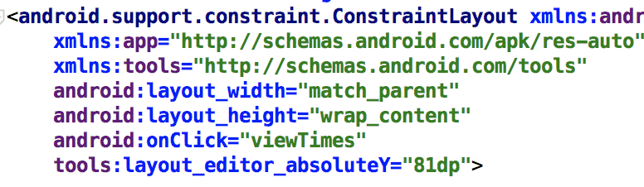

My plan was to then assign a tag to each element as it was created, though researching where this could be done took longer than expected. At least until I realised I was overthinking it and called the ‘item View’ of the view holder.

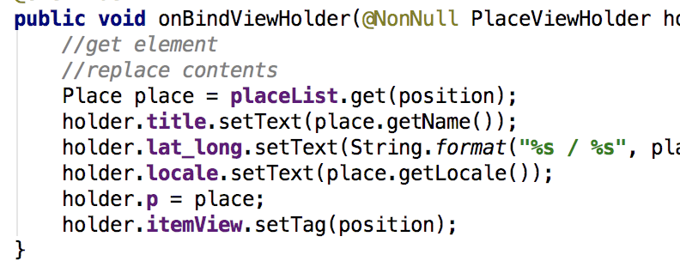

## Code Snippet: How data is shown (Sun rise/set times)

Since I knew I’d need to be passing a custom class between activities, I made a ‘Place’ implement the parcelable protocol, then recycled code from another exercise to get the following:

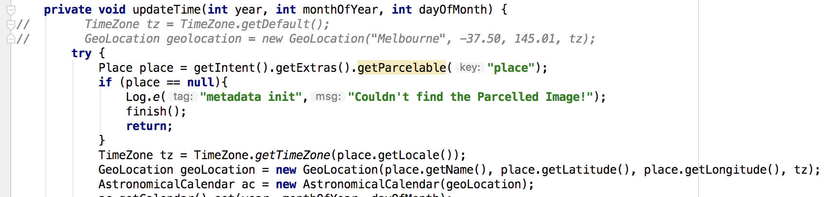

Instead of defaulting to Melbourne, the app now retrieves the name, latitude, longitude and time zone from the parcel.

## Additional locations:

Since Ferntree Gully made the list and isn’t a city, I figured I’d be okay to add Gembrook (in the hills) and Tootgarook (on the bay).

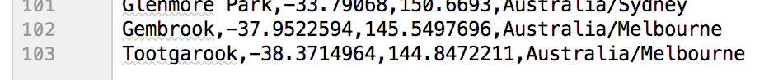

Please Refer Appendix for further Screenshots

# Appendix: Screenshots:

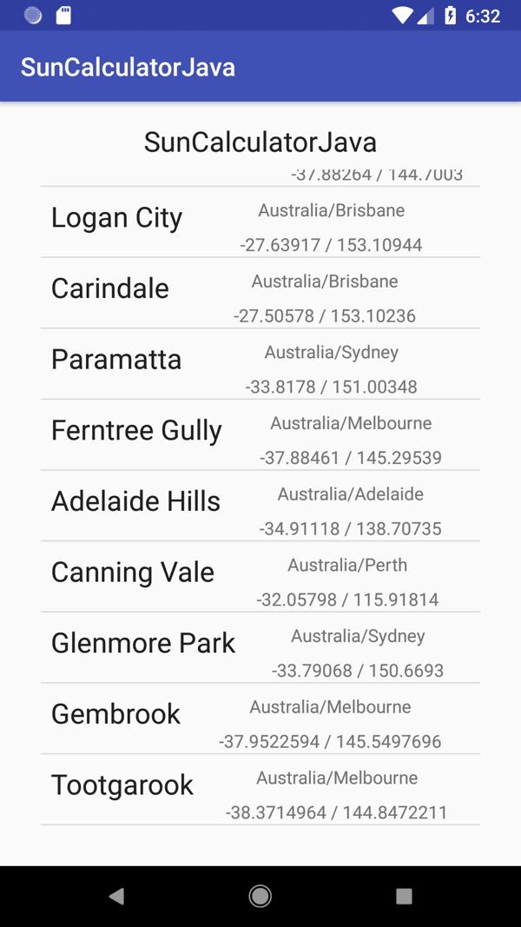 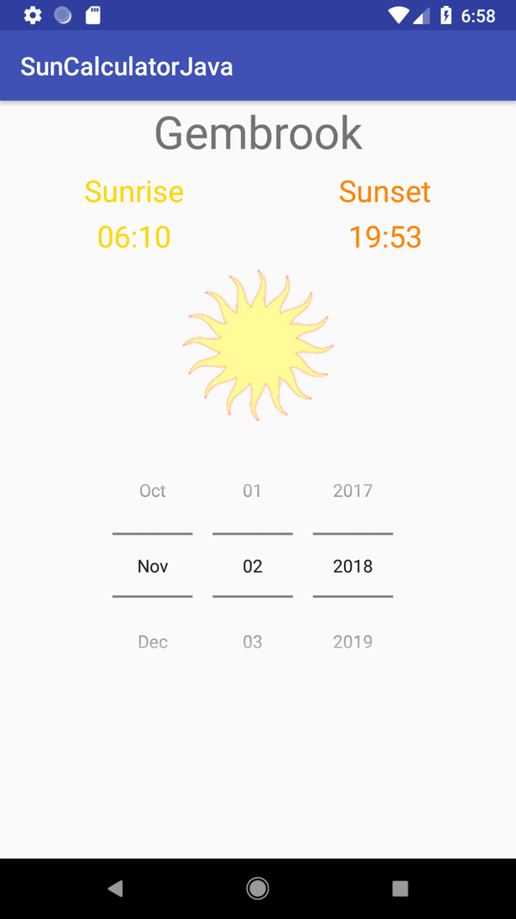

***Left:*** *Selection screen showing additional locations for Gembrook (Dandenong Ranges, Vic) and Tootgarook (Mornington Peninsula, Vic).*

***Right****: Upcoming Sunrise and Sunset times for Gembrook, on November 2nd.*