Task 9.1P

Working with Persistent Data, again

# Add a Custom Geolocation

## Code Snippet: File Load

Since you can’t write to res/raw, I figured it would be best to load the saved file separately. This lead to me combining the two loaders into a method and just passing it different buffered readers:

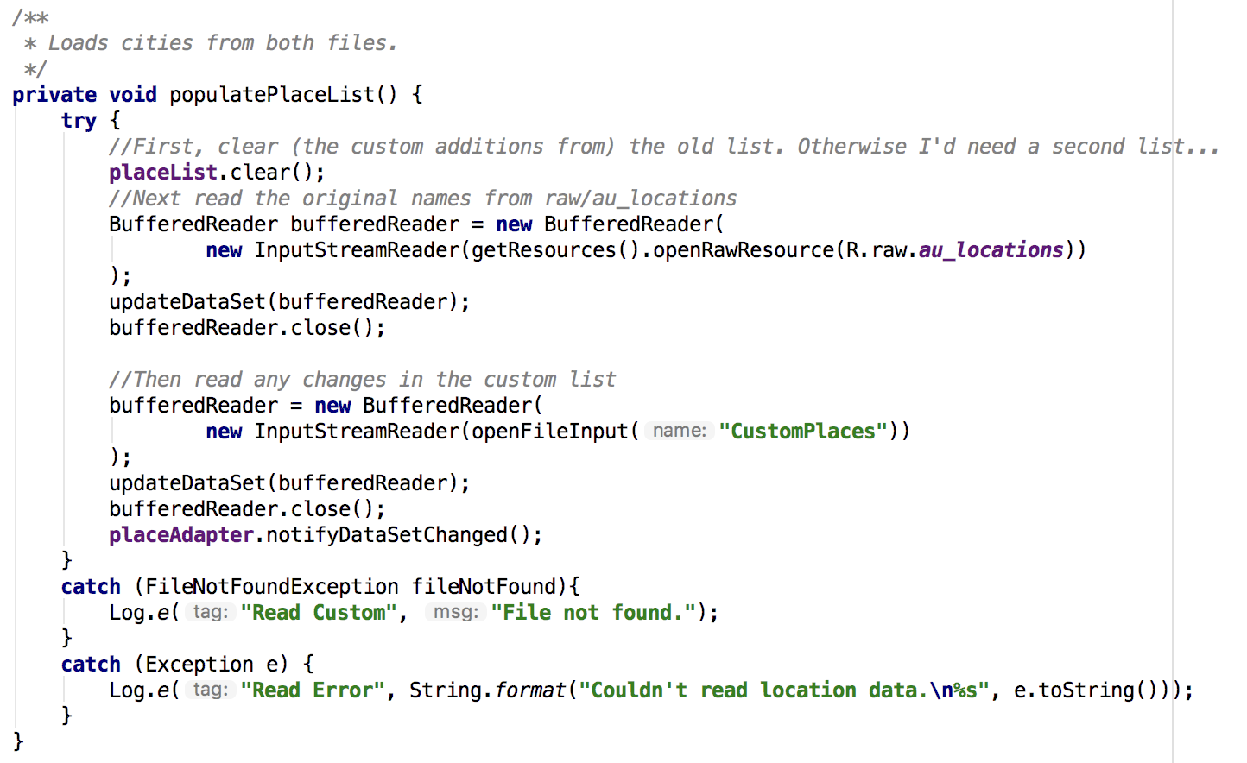

The method then proceeds as usual:

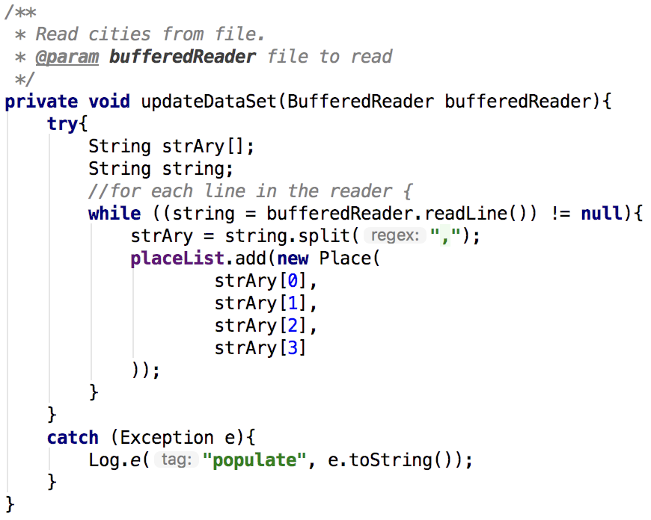

‘place Adapter’ is then told the dataset is updated afterwards.

## Code Snippet: File Write

‘Open file output’ creates a file if one matching the filename isn’t found, which saves some error handling. A ‘Place’ object (Name, Lat, Long, time zone) is then created based on the values in the fields, minor validation is applied and the location is then saved:

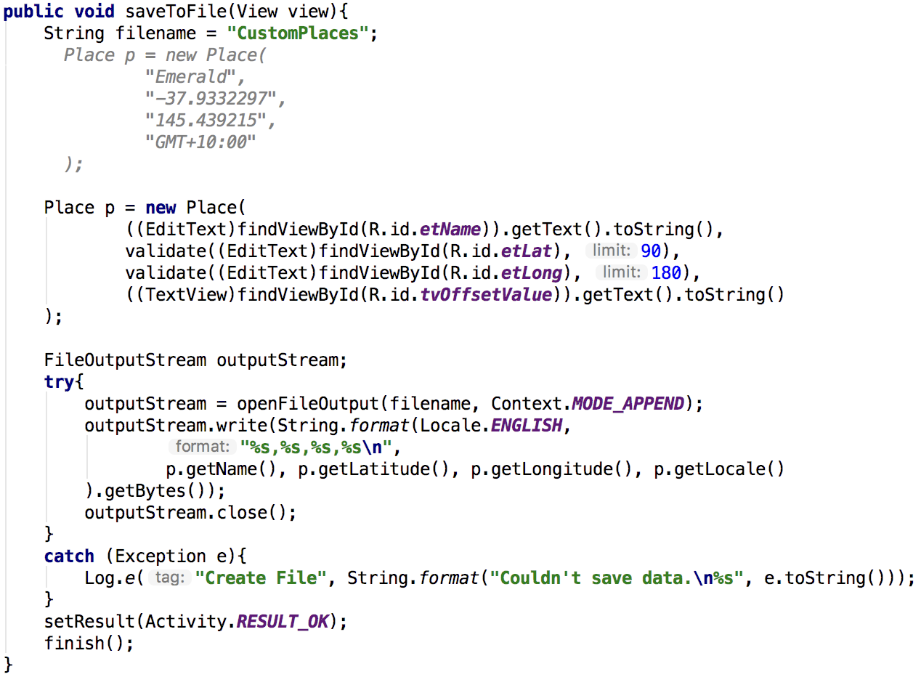

…



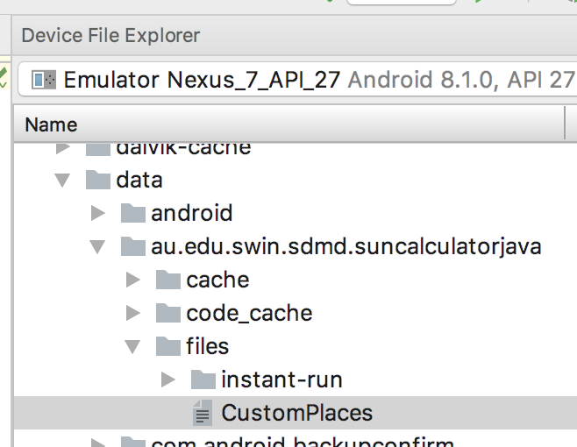

Curiously, I found an issue with the sun time calculator while testing the validation – if one inputs random coordinates that don’t match their time zone, the calculator couldn’t handle it and closes before the user gets to see any visible effect from their tap.

On the other hand, the validation at least prevents the program from stopping if the Latitude is more than +/- 90, or Longitude is more than +/-180.

# Appendix: Screenshots:

Let’s add the English city of Crewe to the calculator:

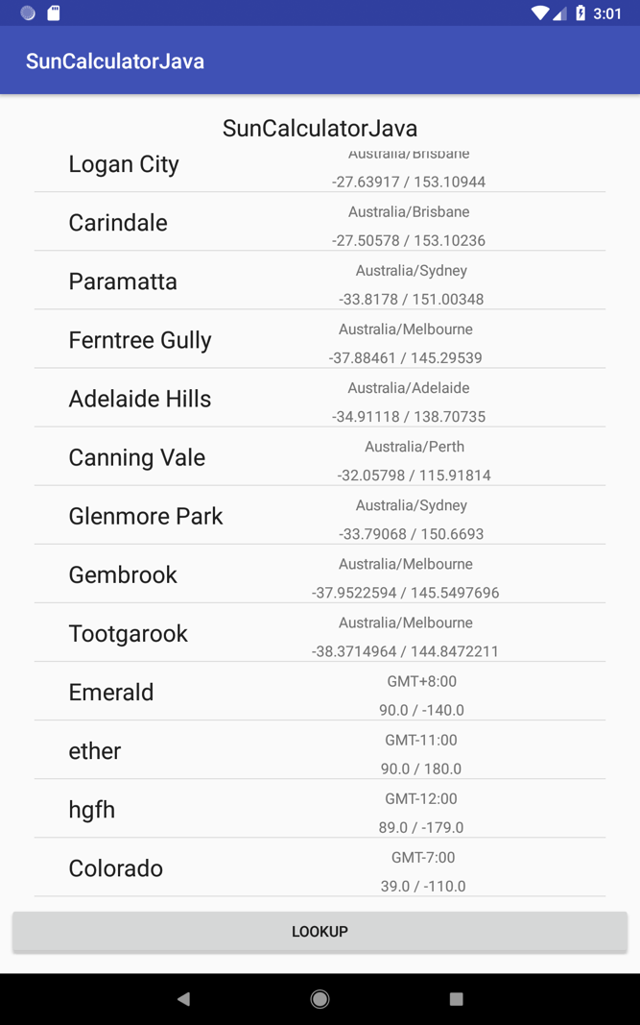 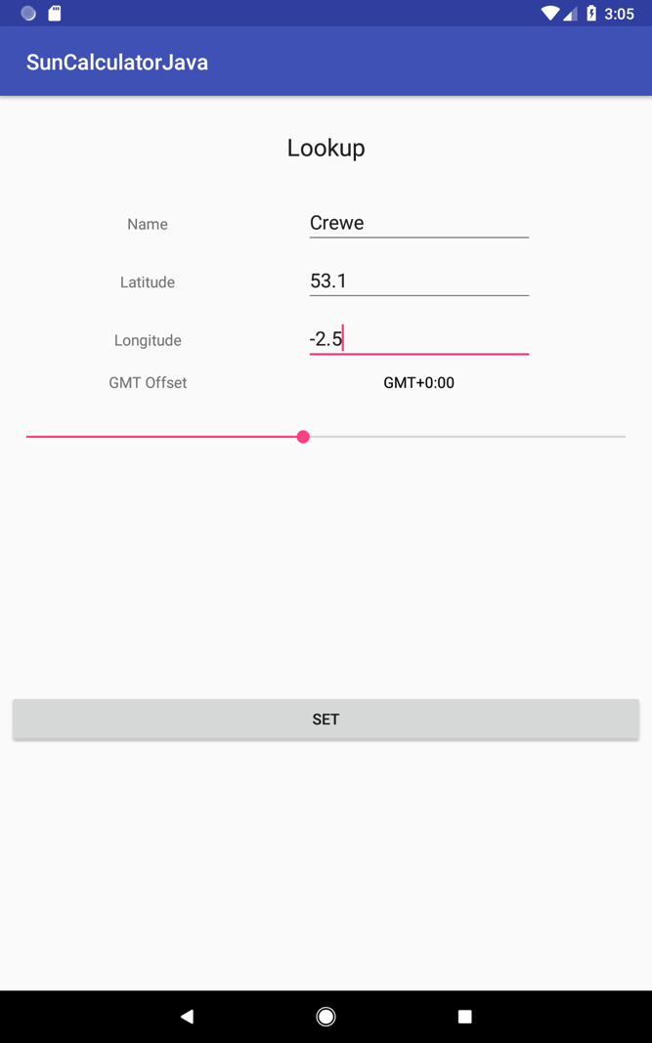

*Left: Crewe isn’t on our list. (Some test cities are, they can be ignored for now)*

*Right: Google Maps tells us it’s at about 53.1 Latitude and -2.5 Longitude. Still within GMT+0.*

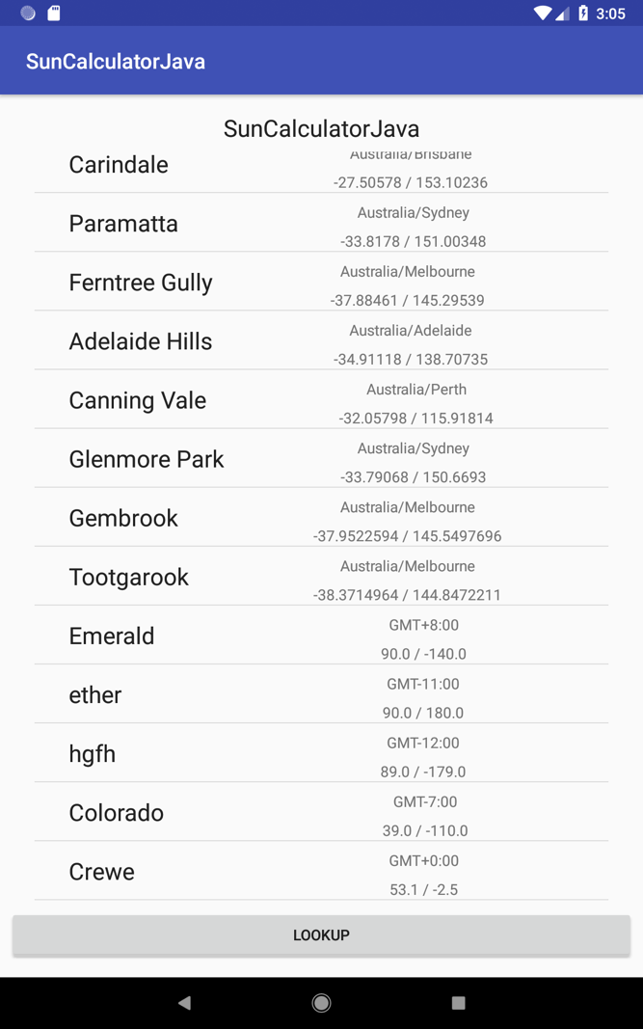 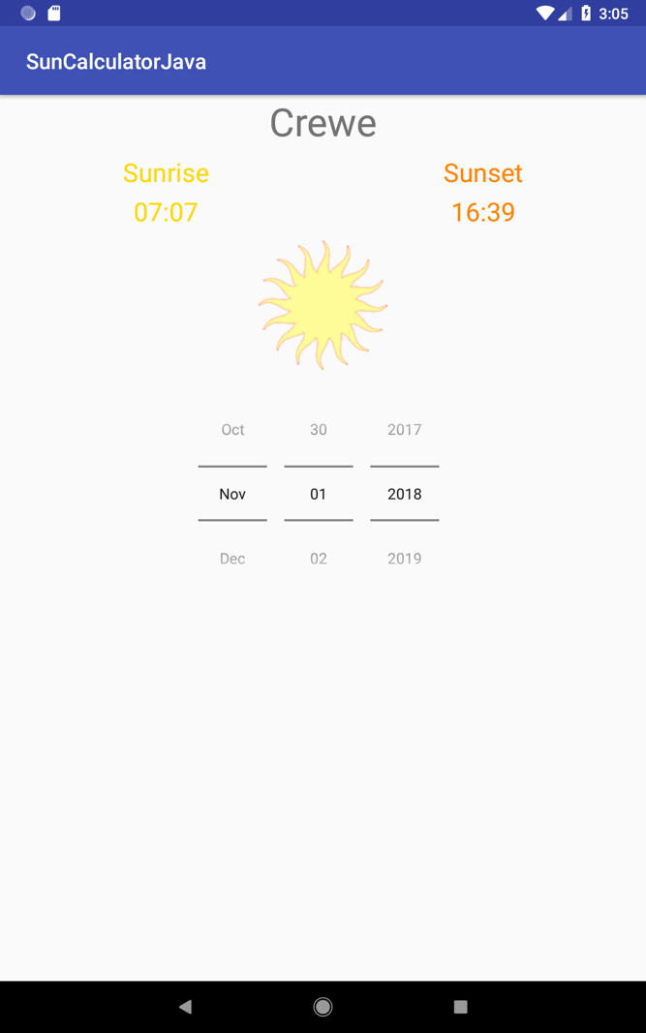

*Left: Pressing ‘Set’ takes us back to the main screen, and there’s Crewe!*

*Right: And the local sunrise/set times.*