Task 1.2P

Mid-Year Resolutions

# Font Sizes

[Submitted Separately]

# Screen Resolutions

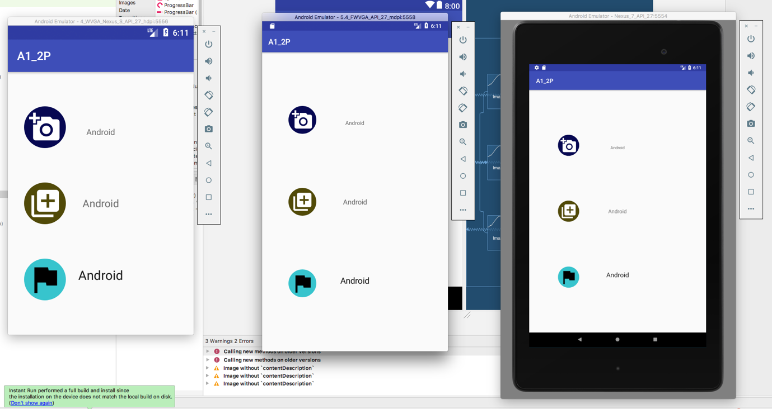

Left: HDPI, Centre: MDPI, Right: XHDPI

To force the XHDP screen to use low density images, the images in the mipmap-xhdpi folder were replaced with the ones from the mipmap-mdpi to get the following screenshot:

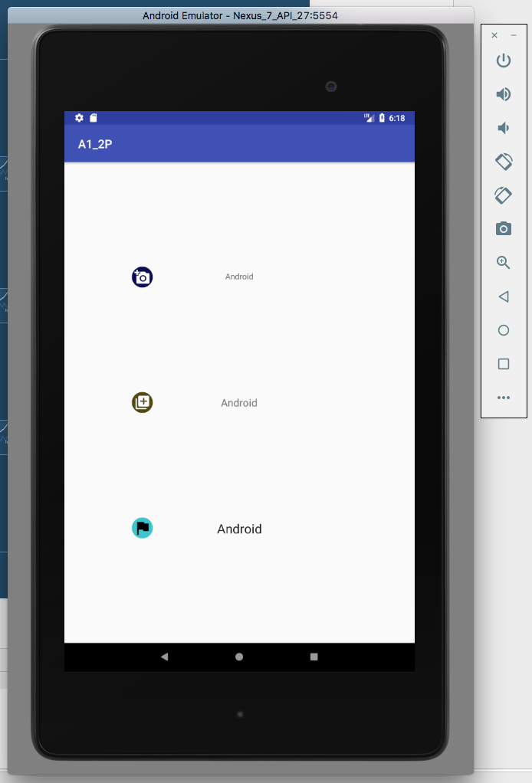

This isn’t ideal as the smaller icons are now used, which don’t take advantage of the larger pixel count that xhdpi screens are capable of.