Task 3.2P

Far away, so close!

# Conversion app

//To be demonstrated in Lab. Screenshots in Appendix 1.

# Strings and Localisation

String externalisation is the ‘outsourcing’ of string data from hard-coded values to an external resource file (eg Strings.xml in the values folder). By referencing an external file, it’s a simple matter to substitute the relevant language without having to alter a single line of code in the app itself (especially as system language etc is typically set in settings, rather than in the app itself)

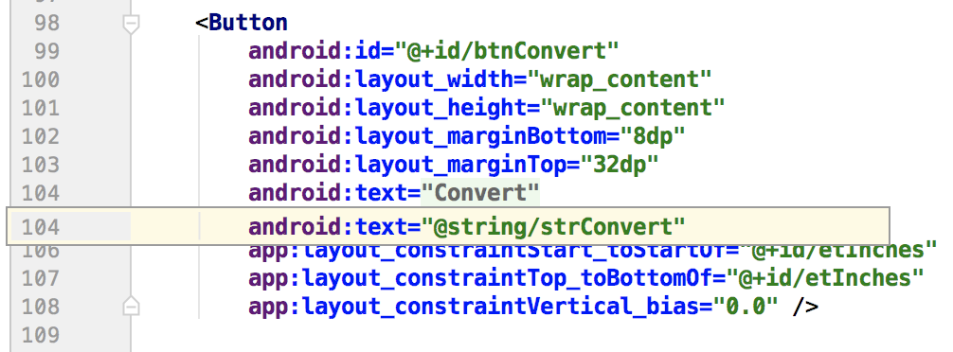

Refer Appendix 1 for screenshots illustrating this.

# Appendix 1: Screenshots

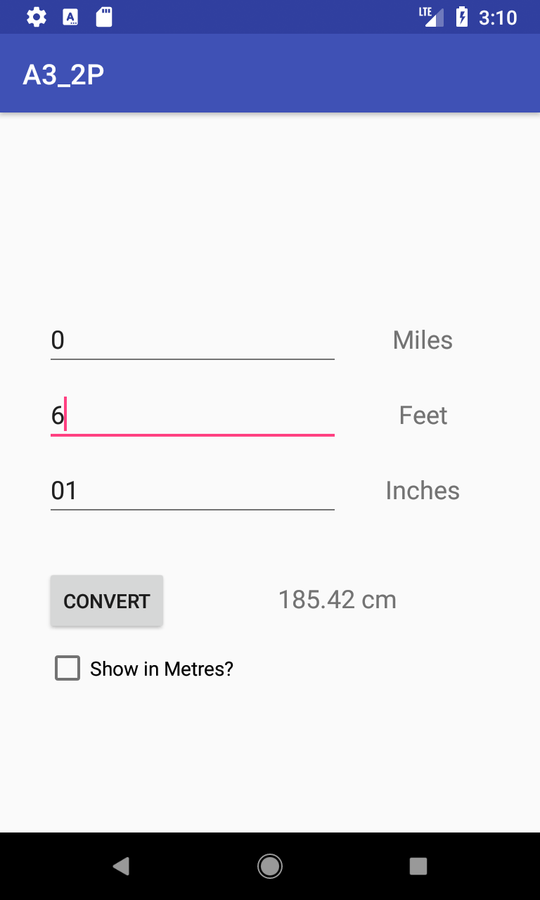 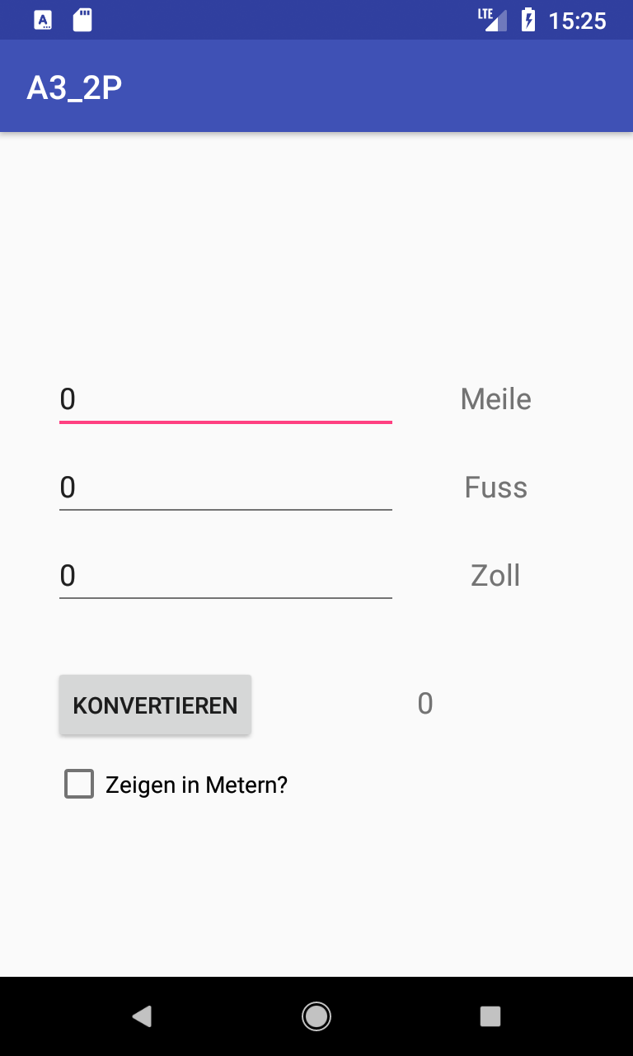

Above Left: Portrait View, English.

Above Right: Portrait View, German (Language settings changed via phone’s options menu)

Below: Landscape View, English. (Note the rearranged layout.)

