Task 4.1P

Convert ALL the things!?

# More Conversions

## Code Snippets – How Activities Are Connected

First, a pair of click listeners are set up to change the activity when triggered.

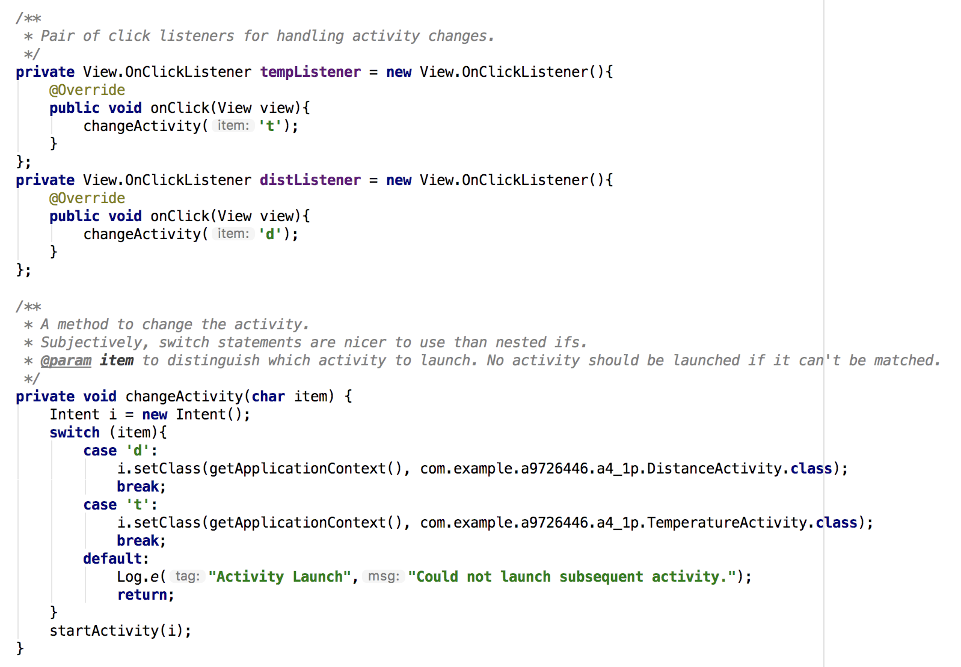

Each listener then calls another method to change the current activity. Depending on the arguments, the relevant activity is called.



## Code Snippets – How Orientation Changes Are Managed

When an activity is destroyed, onSaveInstanceState is called. As part of the process one can use a bundle to store important information…

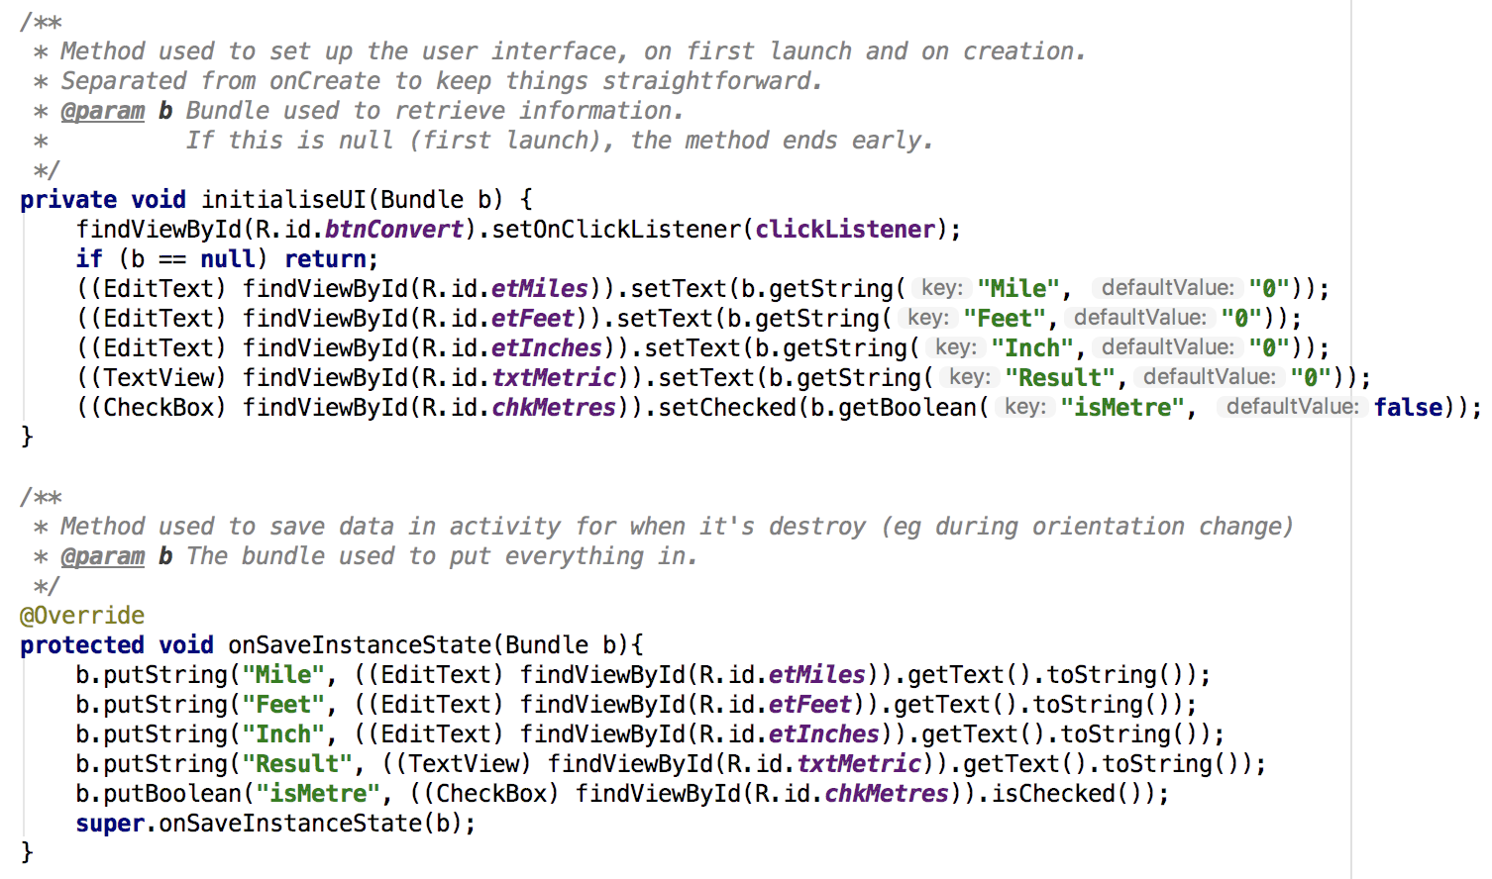

…which is then retrieved when onCreate is called, or via a method onCreate calls.

## Code Snippet – XML Layouts of the activities.

For the main activity, a constraint layout was used to position the information and buttons, which were grouped together into a Linear Layout.

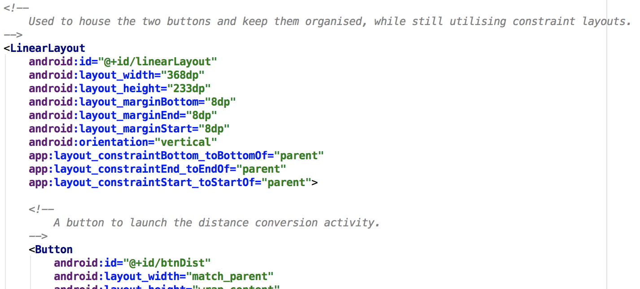

Refer Appendix 1 for Screenshots

# Appendix 1: Screenshots

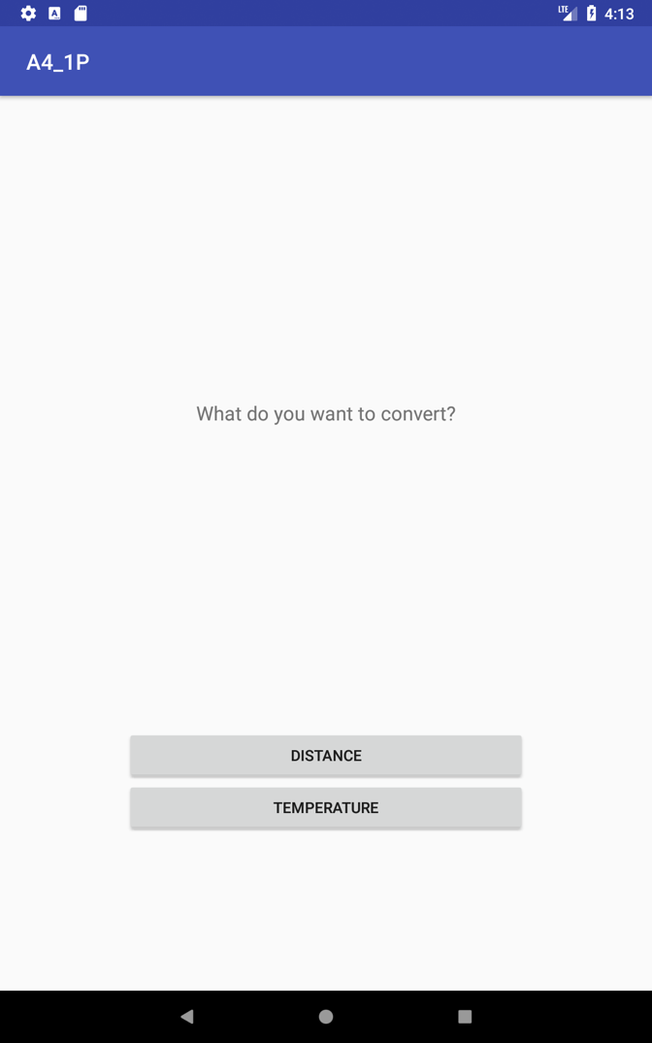 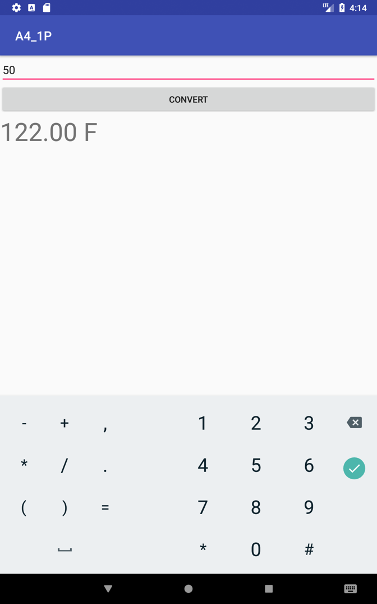

Above Left: Main Activity, Portrait View

Above Right: Temperature Converter, Portrait View (Code from Nicole’s Lecture)

Below: Distance Activity, Landscape View

