Task 5.1P

Elementary, said he.

# A simple booklist

As usual, Screenshots may be found in the Appendix.

## Code Snippet – Row Adapter

//Following the tutorial from <https://www.androidhive.info/2016/01/android-working-with-recycler-view/> (last accessed 4/10/18)

Central to the Adapter is the view holder, used to contain the information for each ‘item’ in the recycler view’s list.

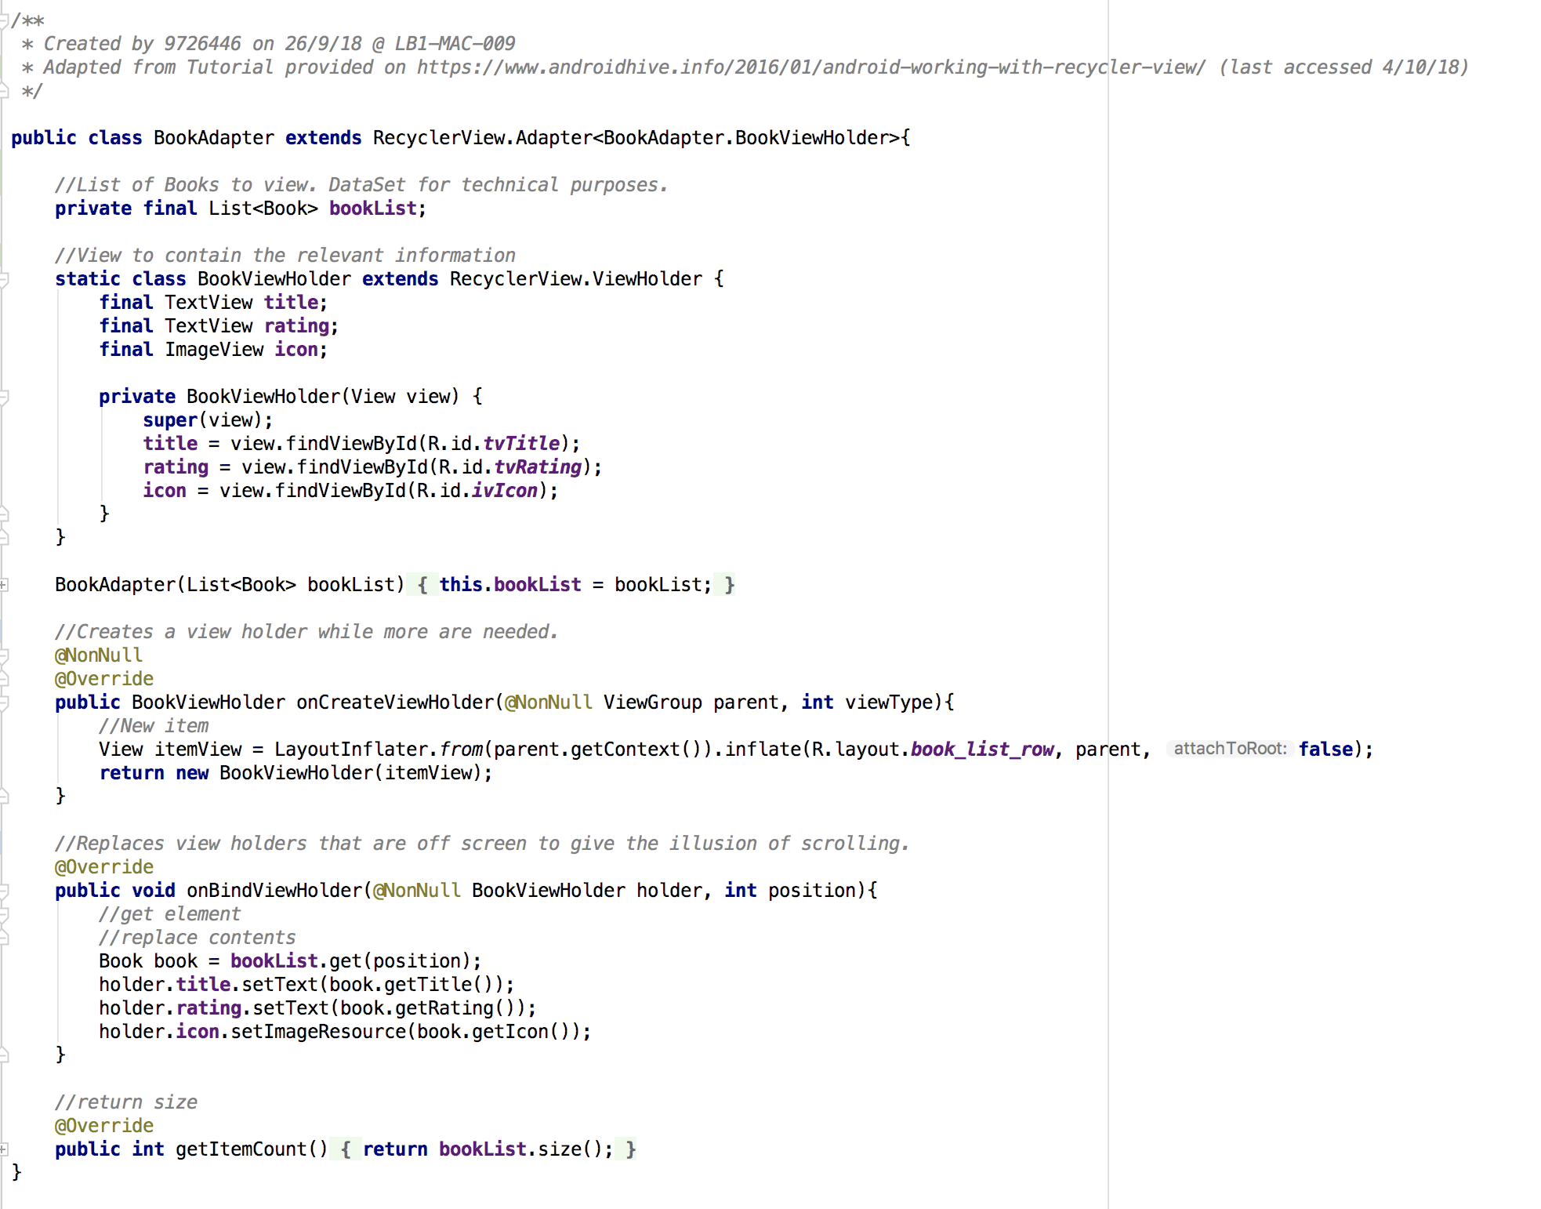

These are then created (to fill the area size) or manipulated (when scrolled offscreen) as necessary.



# Activities and Fragments

While both Activities and Fragments may display information, only Activities can be used to display views, while Fragments must be contained within an activity. Fragments, however, are modular and once placed in an activity may be swapped out as necessary depending on things like screen size or other requirements. (Refer below graphic)

‘FragmentTransaction’s are used to detach, (re-)attach, show, hide and do various other tasks with Fragments as a whole. (Data passing is still managed with Intents.) To govern this, a ‘FragmentManager’ is used by the Activity.

One particular use for Fragments is taking advantage of larger screen sizes. (eg Tablets). The perennial example is the Gmail app, where half the screen may be a fragment for selecting an item from the inbox, while the other half may be for viewing the chosen message.

# Appendix – Screenshots and Graphics

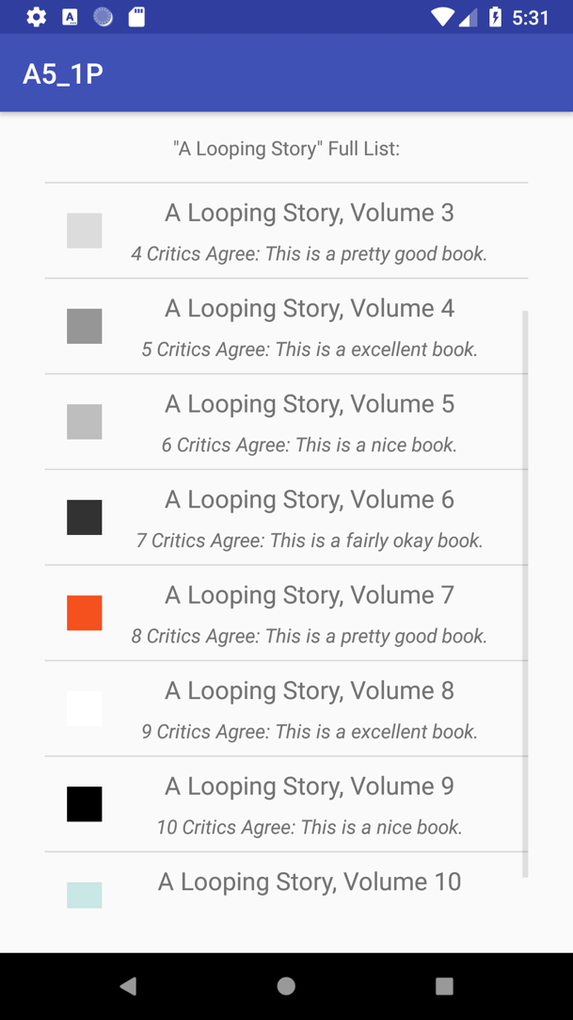

*Using the latest in publishing technology, this series is procedurally generated!*

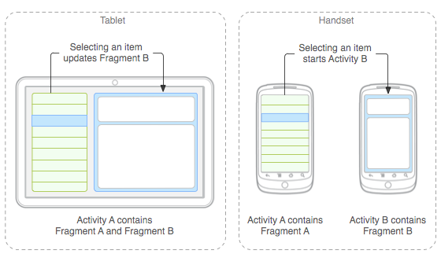

*Graphic depicting relationship between Activities and Fragments via* [*https://developer.android.com/guide/components/fragments*](https://developer.android.com/guide/components/fragments) *4/10/18*