Task 4.2P

Browsing, Not Eating

# Browsing Favourite Foods

## Code Snippet – How the Two Activities are Connected:

Click Listeners are set up for each button, each calling viewFood with a different parameter so the correct information is passed.

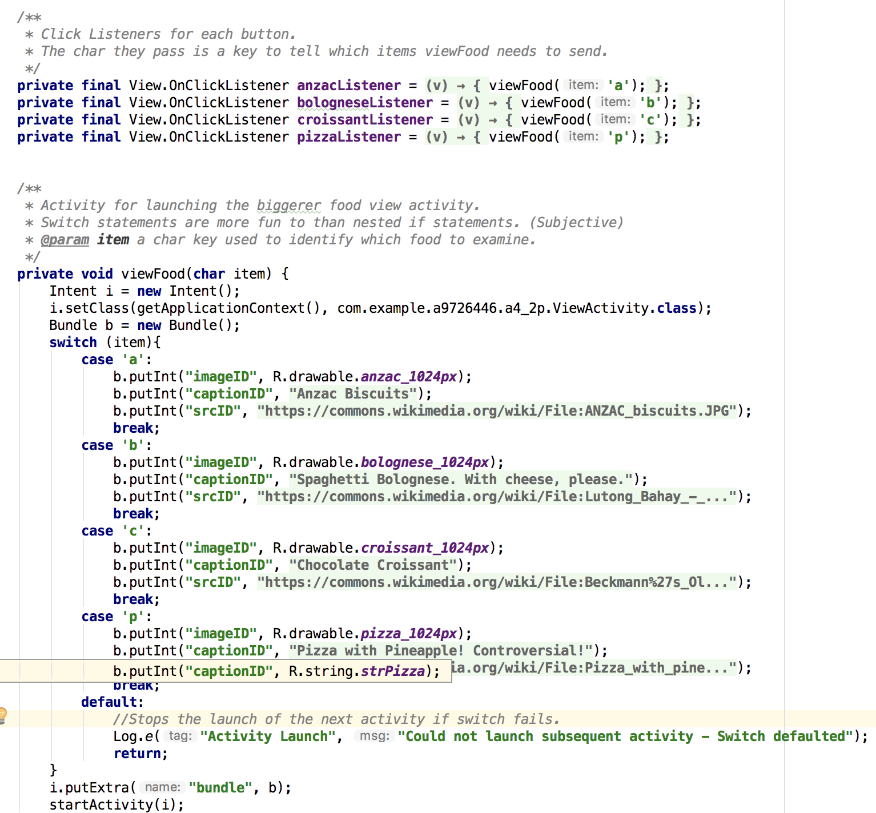

At the end of the switch, it’s put into a bundle that’s added to the intent, and the new activity is started. 

## Code Snippet – XML Layout of Activities

The layout is designed to give the image maximum space while leaving room for the header and caption.

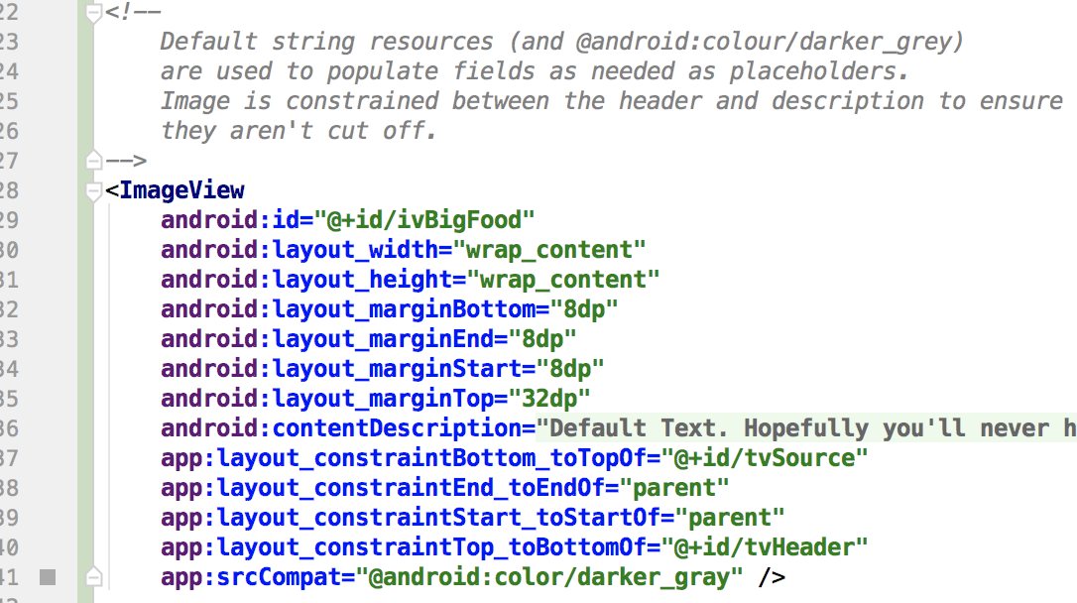

## Code Snippet – How the Image and Text are Loaded / Set

// Please refer to 2b and 2d

// Please refer to Appendix for Screenshots

# Intents

In the context of the given quote….

1. The Intent messaging is considered as a late run-time binding between two components as:
   * Intents are generated at runtime, rather than (for instance) during compilation.
   * They also serve as a ‘bridge’ between activities, allowing them to share information with each other.
2. The contents of the passive data structure (of an intent) are:
   * In a word: Elsewhere
   * In more words: Determined at runtime.

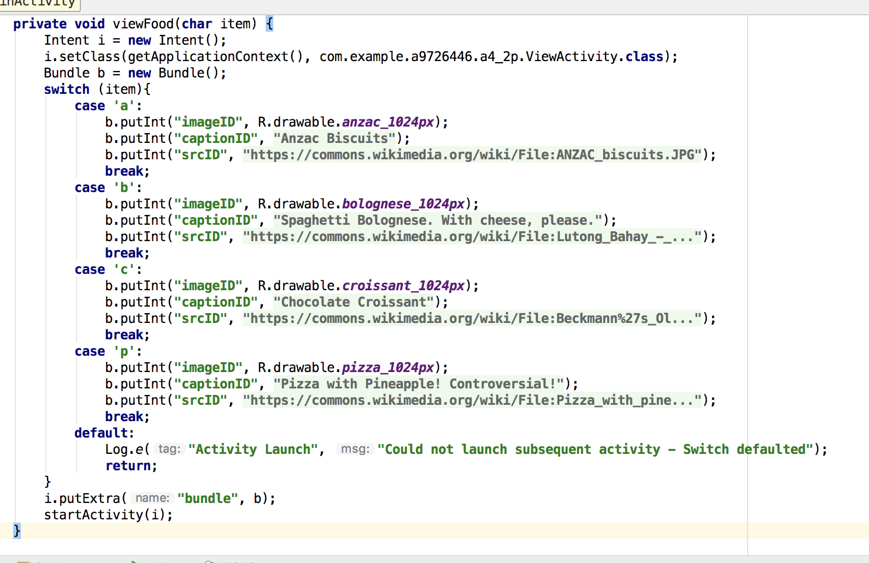

*Here an intent is created, and told what context and activity it’s going to. A bundle is also set up and loaded…*

  
*…which is then given to the intent for delivery. In that sense an Intent could be described like a Postal service for Activities.*

1. The word “passive” is used for the intent data structure as the logic for any data manipulation and integrity required is contained elsewhere.
2. “[An Intent holds an] abstract description of an operation to be performed”
   * This means that an Intent only contains a summary of a given operation, such as holding two numbers and an operator for – another – object to make use of.
   * In the above example (b) an Intent receives an item. It doesn’t know what to do with it or what it’s for – processing and validation is done by the ‘sender’.
   * Below, the receiving activity then processes the data (in this case just the bundle) and then unpacks it.

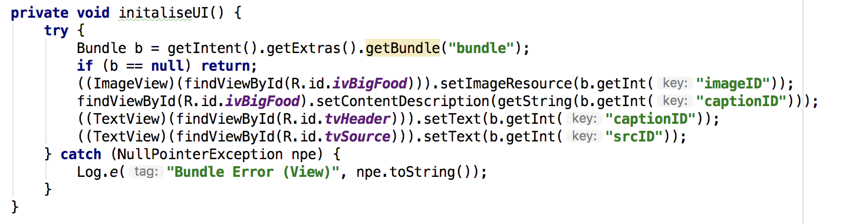

*try / catch is only used to appease some of Android Studio’s warnings…*

# Appendix – Screenshots

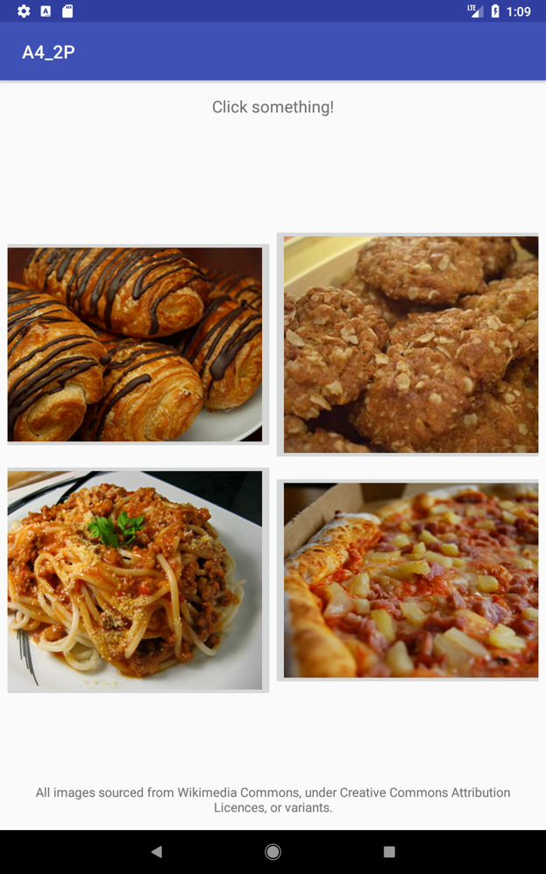 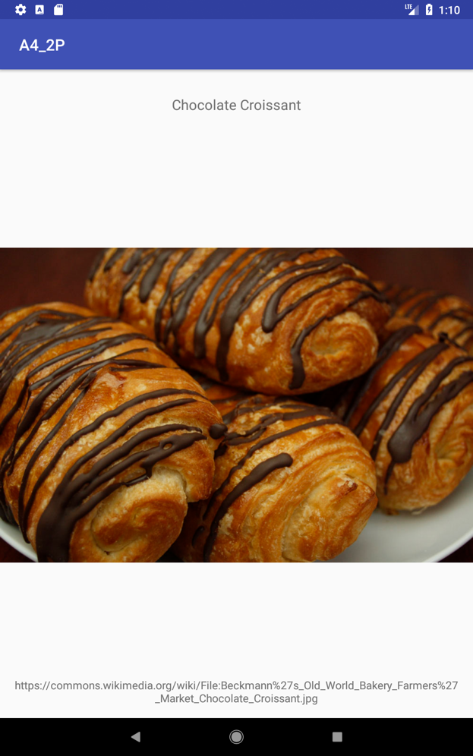  
*Clockwise from top left: Main activity, View activity featuring croissants, View activity featuring pizza!*  
