Lab 1

# C:\Users\Alex\AppData\Local\Microsoft\Windows\INetCache\Content.Word\Screenshot_20170816-234227.pngTask 1

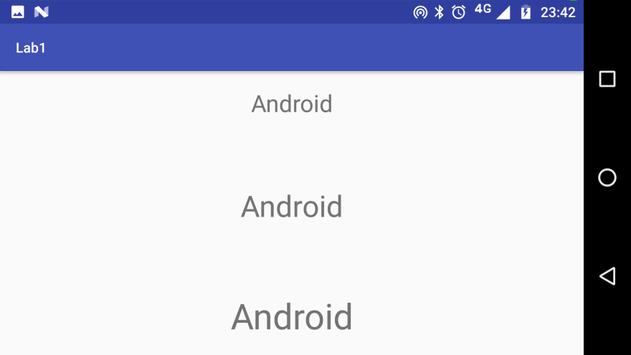

# Task 2

Three key differences between mobile OS and PC: (Why are they handled differently?)

1. Processing power is in high demand:  
   Smartphones have a very limited amount of processing power compared to the typical PC. Therefore only the most recent two or three apps can be used, and memory hogs are likely to be dealloc’d. PCs on the other hand often have power to spare, so you can have many programs running at once.
2. All hail the mighty phone call:  
   Smartphones by definition **must** be ready to accept an incoming phone call at a moment’s notice, thus their apps must be able to handle being interrupted as they’re less of a priority. This is a non-issue for PCs, which cannot take calls in the first place.
3. Power is limited  
   Smartphones are almost entirely used on battery, so preserving battery life must be considered. By contrast, this is a non-issue with Desktop computers and only a minor one with Laptops (where charging while in use is only a mild inconvenience).

# Task 3

MDPI:

HDPI:

XDHPI:

Low-Density XHDPI:

This isn’t ideal as…

I can only presume this has something to do with using low resolution graphics on a high resolution display. Functionally irrelevant though aesthetically displeasing; that or forcing high-res images into a low-res format is moot when one may just provide a lower res image and save the processing power.

# Task 4

‘Separation of Concerns’ is a design principle where a program is split into ‘distinct sections… each addressing a separate concern’ [1] or area of what the program does.  
*[1] Wikipedia,* [*https://en.wikipedia.org/wiki/Separation\_of\_concerns*](https://en.wikipedia.org/wiki/Separation_of_concerns) *Accessed: 3/8/17*

In respect to UI design, it means that for every feature or ‘concern’ a program has, there’s a separate area to do that in; one wouldn’t look for components to add to a program, and the debugger in the same place.

This then means that users have a better time finding different functions and hopefully makes the app easier to use.