Lab 2

(Please refer to Appendix I for general issues and observations)

# Task 1

1. 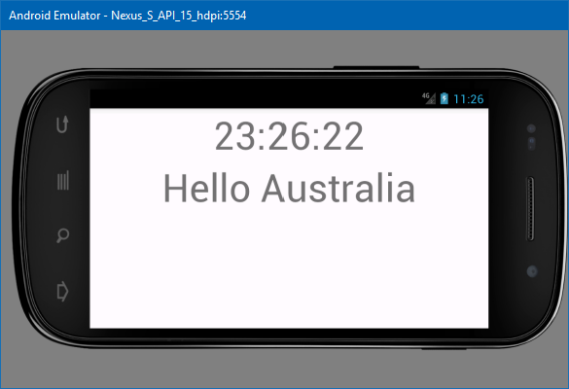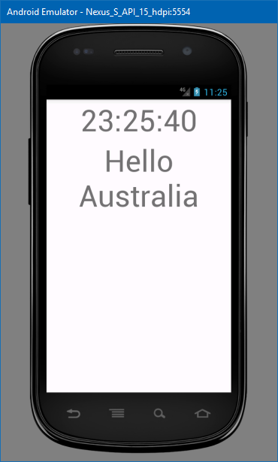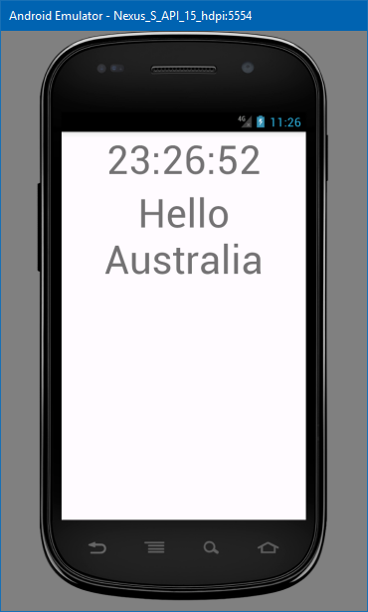The time information updates as each orientation is a newly created activity. Android destroys the current activity when it detects a change in configuration (such as screen orientation), and so the time is not ‘updated’ per se, though rather re-read each time.  
     
   In the Activity Life Cycle Diagram (Appendix II), the time ‘change’ is triggered during ‘onCreate()’.  
     
     
   *Left: Initial portrait display. Middle: Display when rotated to landscape. Right: Back to Portrait.  
   NB: The emulator was very slow. Most of it was cropped to conserve space.*
2. The differences between Resume, Pause and Stopped states are as follows:
   * Resume:  
     Called after Restart, Pause or Restore Instance State, allowing the activity begin interacting with the user.
   * Pause:  
     Counterpart of Resume; called when an activity has been moved into the background, though has not (yet) been killed.
   * Stopped:  
     Called when an activity is no longer visible to the user. Followed by Restart, Destroy or nothing depending on what happens next.

Source: <https://developer.android.com/reference/android/app/Activity.html> [last accessed 31/8/17]

# Screenshot_20170831-113117Task 2

The onRestart event was triggered by switching away from the app and then opening it again, not even moving to another app was required.  
*Right: Life Cycle States with onRestart logged (3rd last item)*

# Task 3

* *08-31 12:04:10.900 24276-24276/com.example.s9726446.testlifecycleapp I/L-C-A-CURRENT-STATE: onCreate*
* *08-31 12:04:10.901 24276-24276/com.example.s9726446.testlifecycleapp I/L-C-A-CURRENT-STATE: onStart*
* *08-31 12:04:10.909 24276-24276/com.example.s9726446.testlifecycleapp I/L-C-A-CURRENT-STATE: onResume*
* *08-31 12:04:13.459 24276-24276/com.example.s9726446.testlifecycleapp I/L-C-A-CURRENT-STATE: onPause*
* *08-31 12:04:13.507 24276-24276/com.example.s9726446.testlifecycleapp I/L-C-A-CURRENT-STATE: onStop*
* *08-31 12:04:14.477 24276-24276/com.example.s9726446.testlifecycleapp I/L-C-A-CURRENT-STATE: onRestart*
* *08-31 12:04:14.489 24276-24276/com.example.s9726446.testlifecycleapp I/L-C-A-CURRENT-STATE: onStart*
* *08-31 12:04:14.490 24276-24276/com.example.s9726446.testlifecycleapp I/L-C-A-CURRENT-STATE: onResume*
* *08-31 12:04:14.492 24276-24276/com.example.s9726446.testlifecycleapp I/L-C-A-CURRENT-STATE: onPause*
* *08-31 12:04:14.974 24276-24276/com.example.s9726446.testlifecycleapp I/L-C-A-CURRENT-STATE: onStop*
* *08-31 12:04:14.977 24276-24276/com.example.s9726446.testlifecycleapp I/L-C-A-CURRENT-STATE: onDestroy*

I figured it was easiest to alter the code to call ‘finish()’ during onRestart, if only so onDestroy would be triggered sooner.

As the system is in the process of finishing / destruction, any further messages won’t be able to be shown on the screen as the activity is being killed.

# Task 4

String Externalisation is effectively ‘outsourcing’ all of the text that appears in an app to an external file. This helps localisation in that as no values are hard coded into the program, translations may be swapped in and out with ease.

This is achieved with the following line:

android:text="@string/str\_welcome"

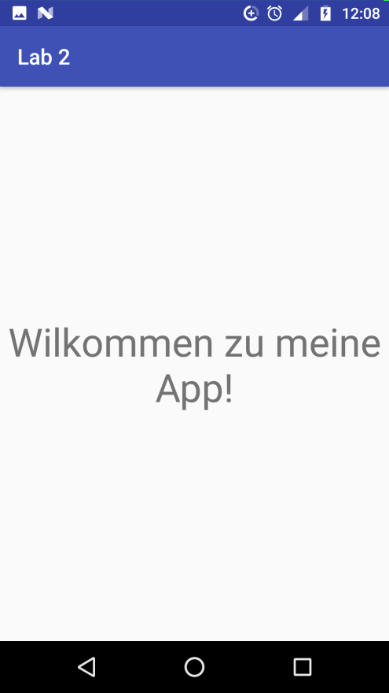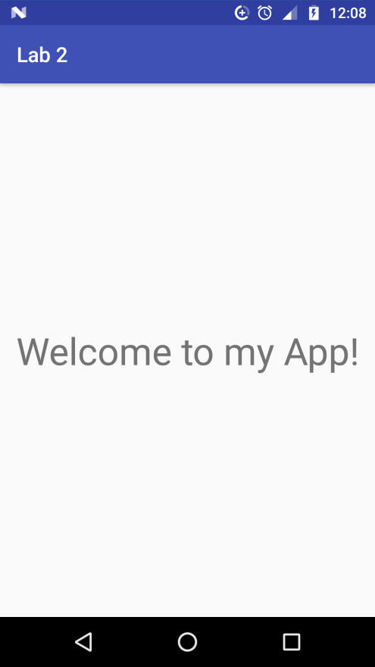

While the source file is “Strings.xml” there may exist multiple versions of it (in this case, two); one in the default “values” folder, and zero-to-many translations in a “values-xx” folder; where xx is the localised language. In this example: ‘values-de’ for Deutsch (German).

*Left: English (default) version.*

*Right: German localisation.*

# Screenshot_20170830-224020Task 5

Similar to localisations, one or many versions of each activity may exist, again in different folders. In this case there are two “activity\_main.xml” files, one in the ‘layout’ folder and the other in ‘layout-land’ (landscape)

*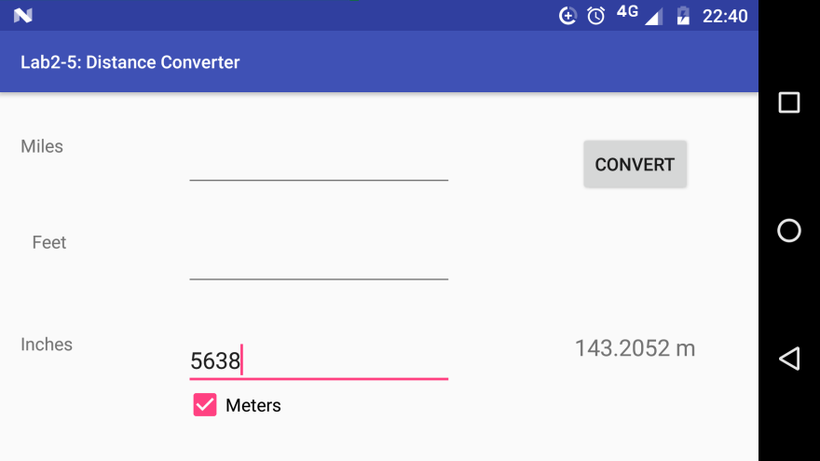Right: Distance Converter in Portrait (default)  
Below: Same, in Landscape:*

# Appendix I

Notes:

* 29/8: Couldn’t build any of the demo apps, at least not in offline mode. No mobile data to spare either, so Skipping to Task 4 (string externalisation):
* 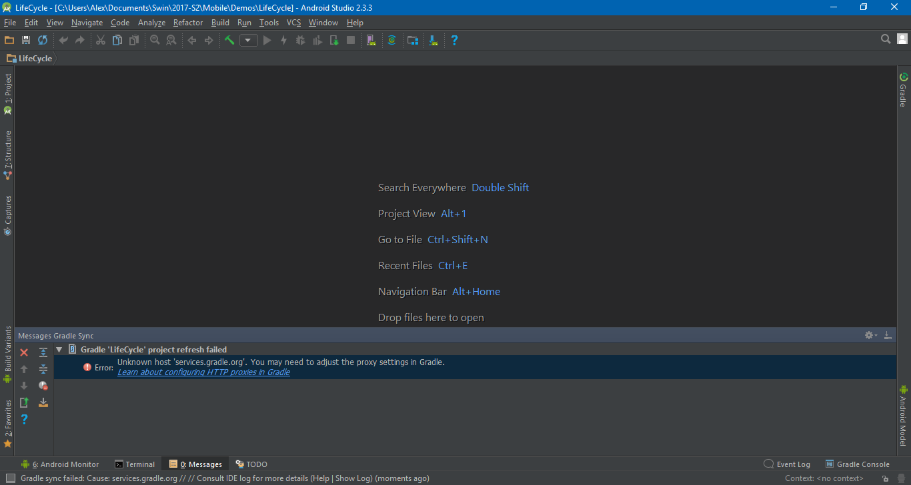30/8: Task 5’s app kept crashing in Landscape mode. Eventually just started over by copying the xml from the portrait version to find it worked fine. My guess is that somewhere along the way the landscape xml went out of step with the rest of the project.
* 30/8 - Update: Created a new project and substituted main.xml, strings.xml and ClockDisplayActivity.java. StaticClock now works normally.
* 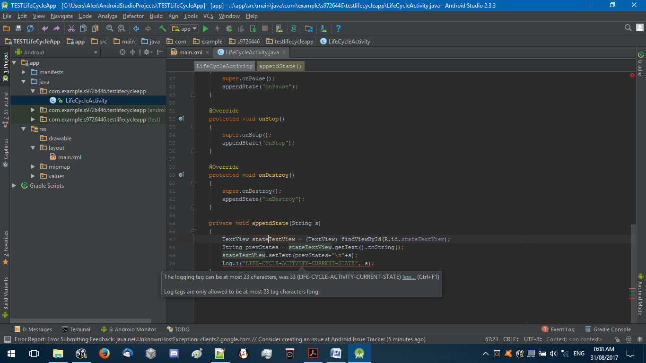31/8 [0007h] Life Cycle Activity’s logger tag changed to ‘L-C-A-CURRENT-STATE’ due to length restrictions in the IDE:
* 31/8 [0030h] Emulator crashes and so does the app when I use my Smartphone. Uninstalling and reinstalling after a clean build didn’t resolve it.  
  Will try again on uni’s Wi-Fi before tomorrow’s Lab, this isn’t worth burning the midnight oil over.
* 31/8 [1120h] Seems it was a problem with the manifest file looking for the wrong main activity. That’s been resolved now.

# Appendix II

Activity Life Cycle Diagram (As screenshot from Lecture slides)

*2 – The activity is replaced with a new version with the alternate layout.*

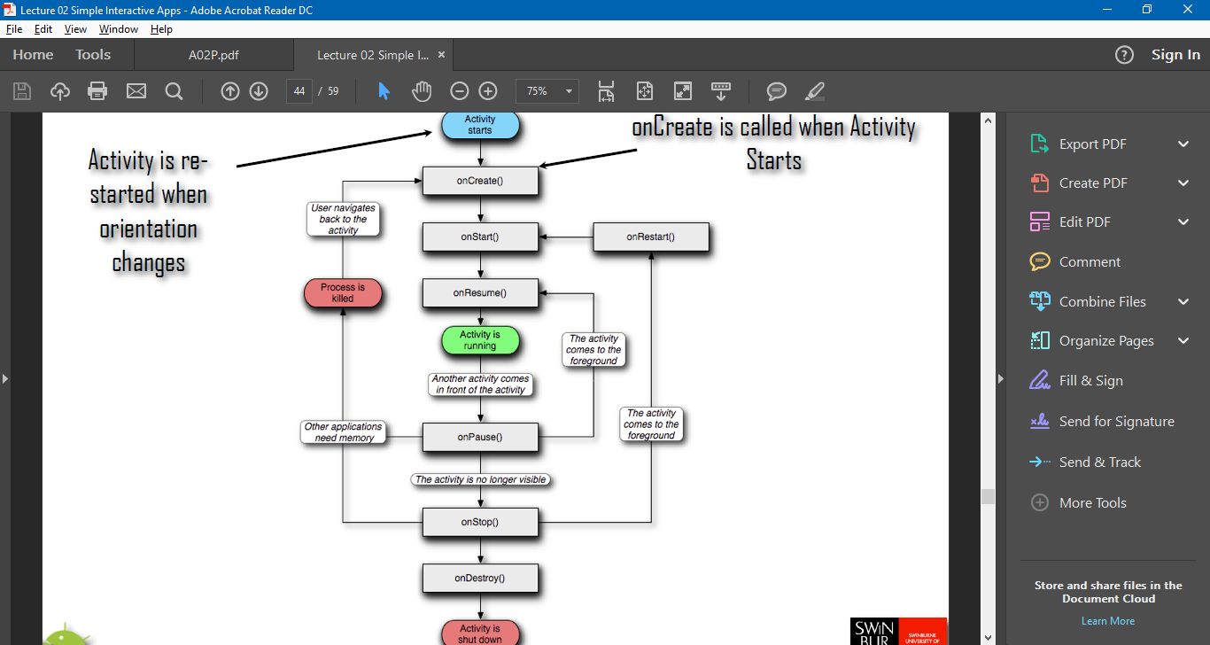

*3 – The Activity reaches onCreate() where the new time is read, appearing as an ‘update’.*

*1 – When the orientation changes, the current activity is destroyed*