Task 2.1P

Orienting Ourselves

# Separation of Concerns

“Separation of Concerns” is a design principle where a program is split into ‘distinct sections… each addressing a separate concern’ or area of what the program does.

The principle behind this is to divide larger issues into smaller, distinct areas so that not only is the result more organised, but efficient as only necessary features are nearby others.

This is facilitated in Android App Development through Android Studio, where for each feature (or ‘concern’), there’s a separate area to house it. (refer Appendix I for details.)

*Source: Wikipedia,* [*https://en.wikipedia.org/wiki/Separation_of_concerns Accessed 22/08/18*](https://en.wikipedia.org/wiki/Separation_of_concerns%20Accessed%2022/08/18)

# Orientation State

1. The time information updates when the orientation changes as the textView displaying the time is only updated when the activity is created and the UI is initialised. (onCreate() in the Activity Lifecycle, refer Appendix II)

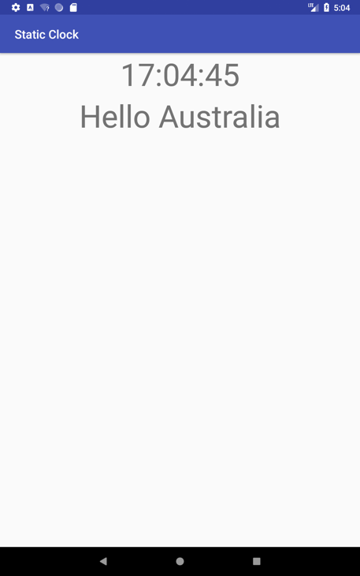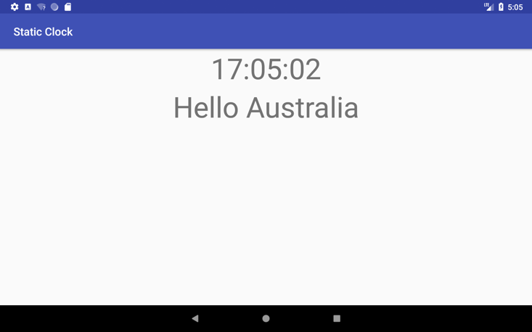

1. The differences between the Pause, Stop and Resume states are as follows:
   * Resume – Called after Restart, Pause or Restore Instance State, allowing the activity to begin interacting with the user.
   * Pause – Counterpart of Resume; called when an activity has been moved to the background, though has not (yet) been killed.
   * Stop – Called when an activity is no longer visible to the user. Followed by Restart, Destroy or nothing depending on what happens next.

*Source:* [*https://developer.android.com/reference/android/app/Activity*](https://developer.android.com/reference/android/app/Activity) *[last accessed 22/08/18]*

# Appendix I:

Android Studio Layout

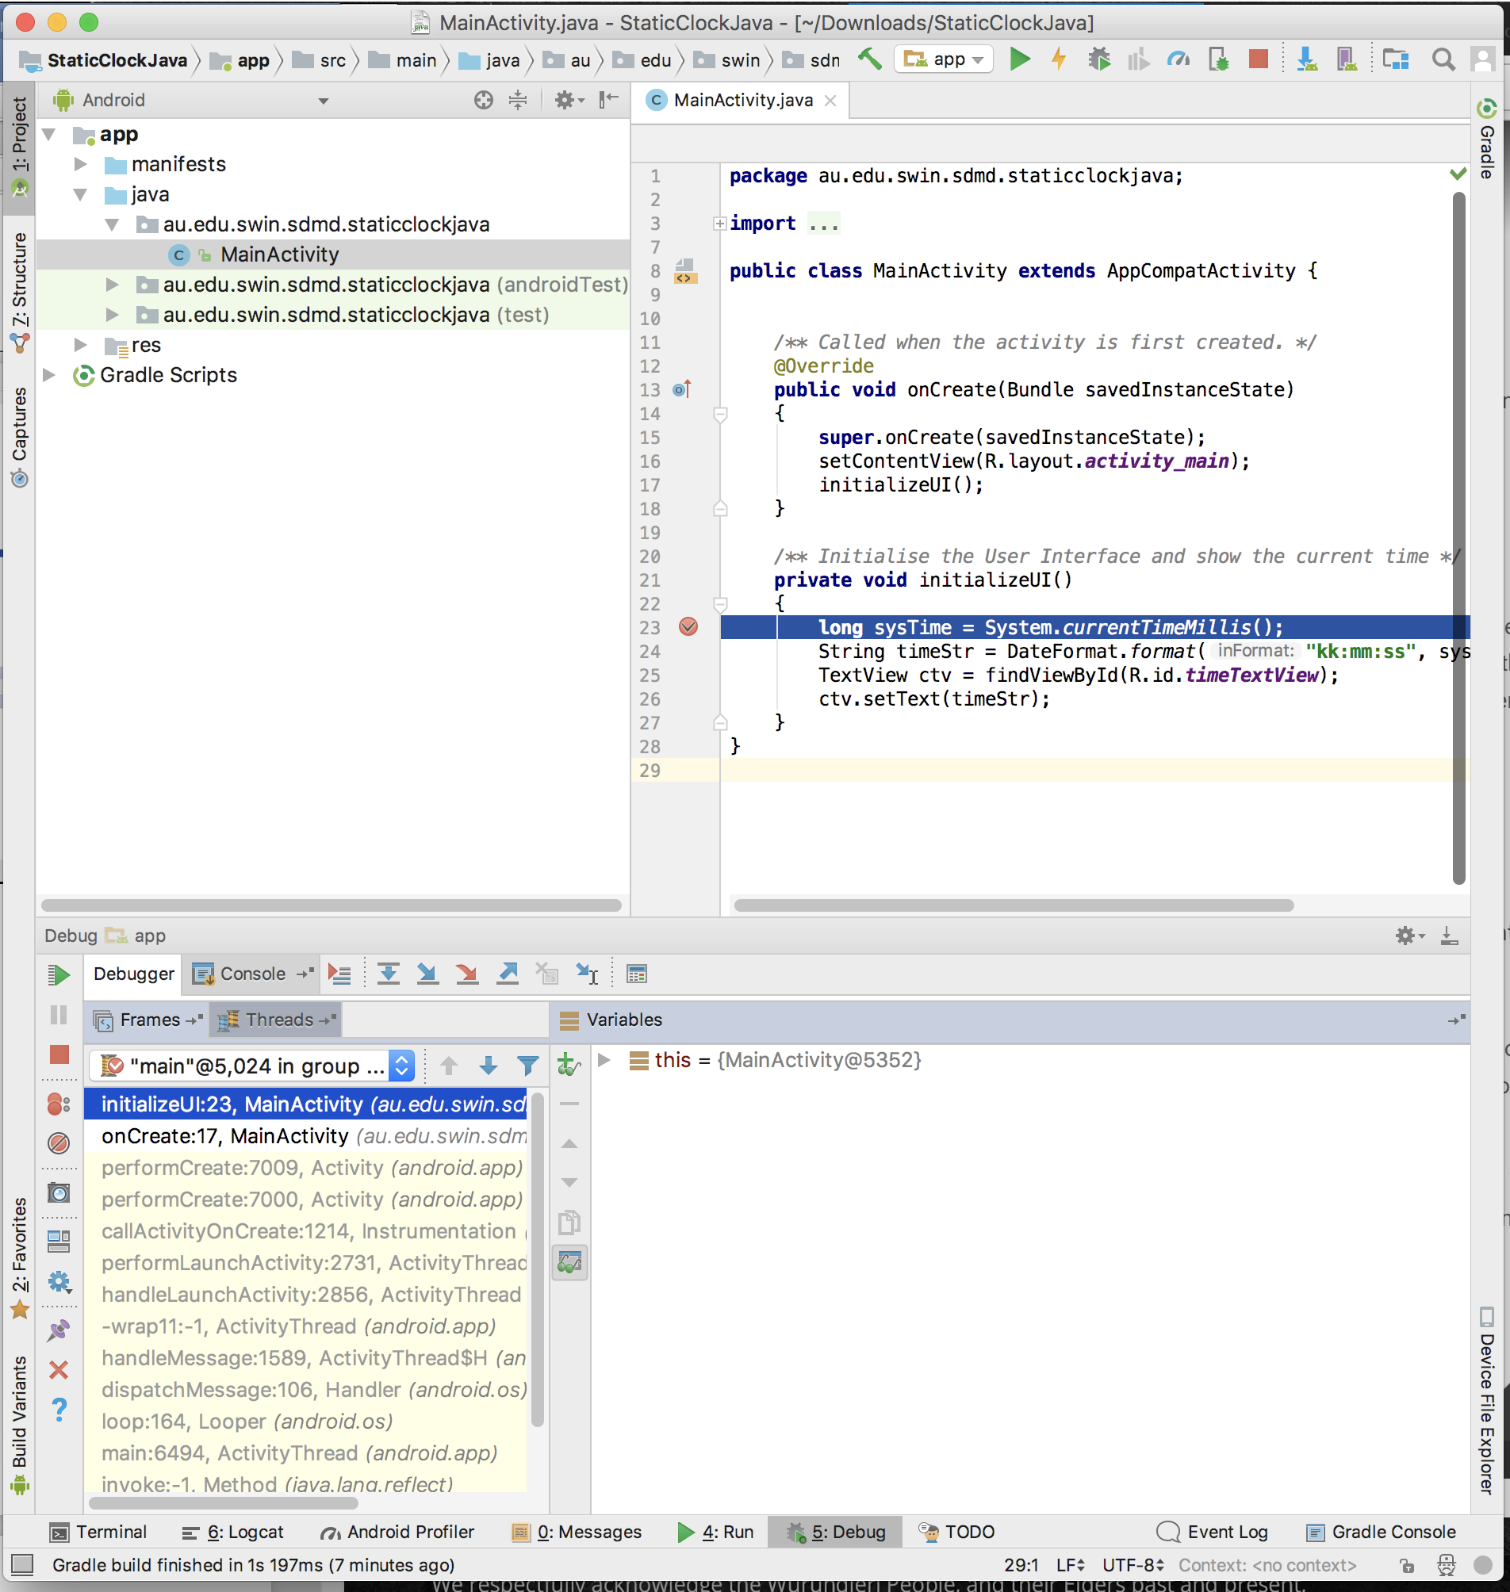

Even within the one concern, sub-actions are also clearly divided, keeping with the design principle.

Similar controls with different purposes are kept far apart. In this case buttons for stepping through code is far removed from buttons to run it (at top).

Panels are kept clear, here, there’s one for file navigation, another for code and a third for the debugger.

# Appendix II:

2 – The activity is replaced with a new activity with the alternate layout.

Activity Lifecycle Diagram

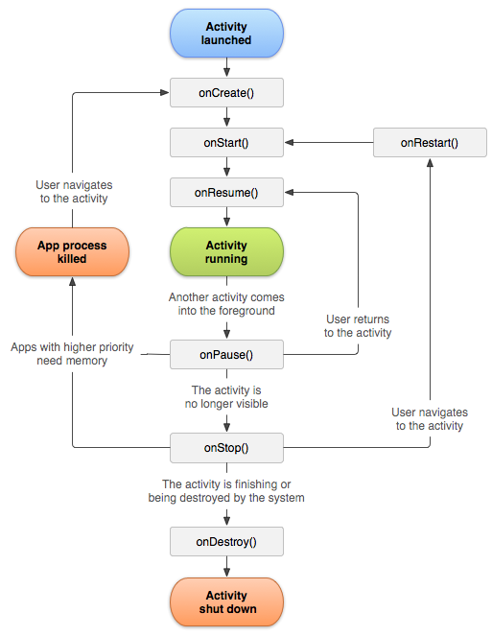

3 – The new Activity reaches onCreate() where the new time is read and placed in the TextView.

1 – When the orientation changes, the current activity is destroyed.