Task 3.1P

Understanding Android activity lifecycles

# onRestart()

OnRestart was triggered by pressing the square button and switching away from the app (Square button), then going back to it. Moving to another app wasn’t required.

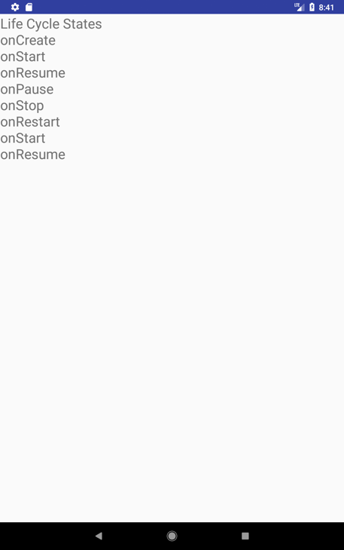

# Lifecycle events

* *LOG*

EXPLANATION

[Screenshot]