Task 7.1P

Sketching app designs

# Create a Complete hi-fidelity prototype using FluidUI (or similar)

Overall Display:

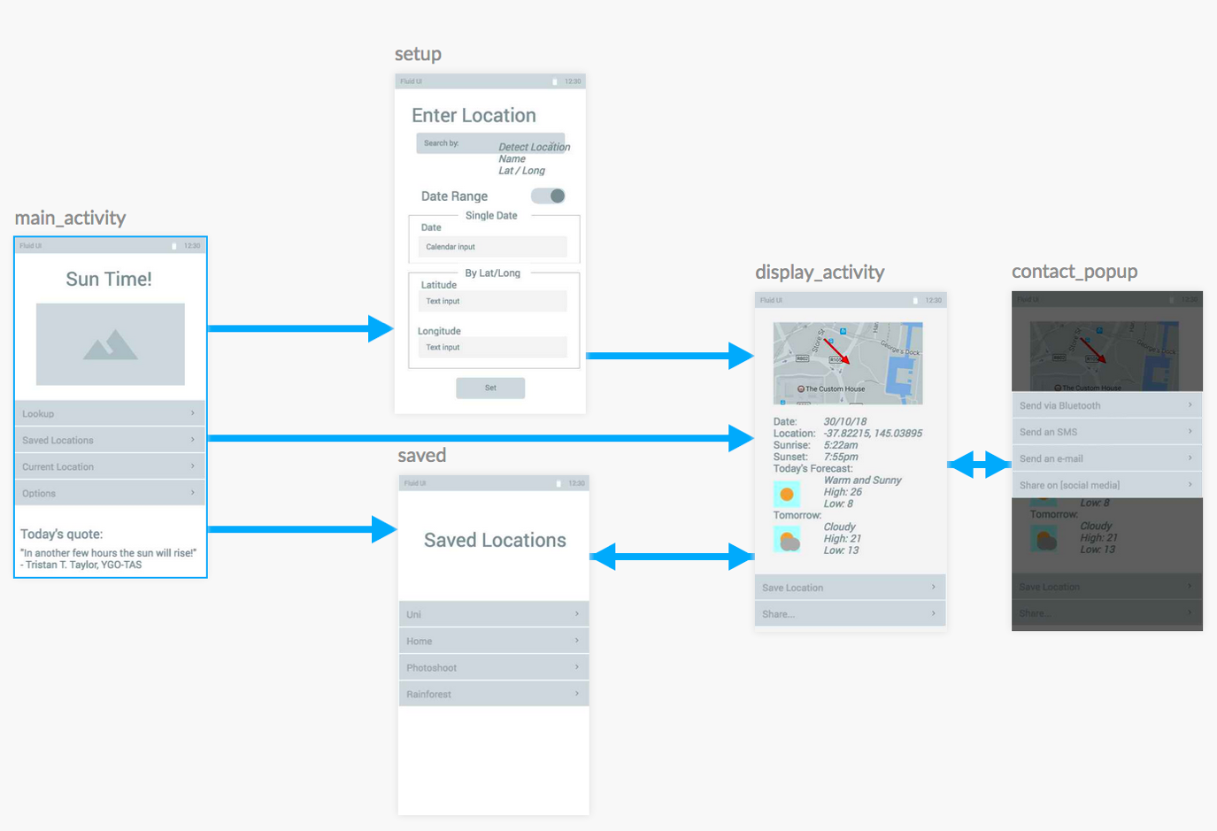

Please Refer Appendix 2 for further Screenshots

## Design Motivations:

### Main Activity

Welcomes user to the app. Directs user to where they wish to go. Keeping things simple and linear.

### Setup

Top section has controls for what the user wants to enter, bottom section has controls for the data itself, reacting to the upper controls.

### Display activity / contact popup

Shows information based on what was entered earlier (or detected automatically).

The popup launches another app, which can handle specific messages.

### Saved

A list of saved coordinates, keep it simple with a title and recycle list.

## Feature List vs. Screens

### Main

* Can detect current location

### Setup

* Generate a table of sun rise/set times for a date range

(When choosing by map)

* Integrated into Google maps
* Can detect current location (as a starting point)
* View sun rise/set times for various locations on a map

### Display

* Show sun rise/ set times for a date/location
  + A horizontal Recycler view can be loaded with multiple days’ worth of times and forecasts.
* Can add new custom locations
* Integrated into Google maps
* View sun rise/set times for various locations on a map
* View weather forecast (current, and near future).

### Saved

* Can select from pre-built set of locations

### Contact Popup

* Share information via SMS and email

## Navigation Steps per Scenarios from 6.1P

### I. Steve, Nature Photographer

1. Open App (Main Activity)
2. Menu item 1 (“Lookup”)
3. Drop-down box (Select by Map)
4. Set pointer on map.
5. Button (“Set”)
6. Review result.

### II. Macy, Tourist on Videocall

1. Open App (Main Activity)
2. Menu item 2 (“Saved Locations”)
3. Menu item n (Home location)
4. Check local times (to see when family at home would be awake)
5. Back button to Saved Locations
6. Menu item n (Uluru)
7. Compare the two sets of times to see what would be the best time to call.

### III. Bob, Builder

1. Open App (Main Activity)
2. Menu item 1 (“Lookup”)
3. Drop-down box (Select by Name)
4. Look up worksite.
5. Button (“Set”)
6. Plan journey accordingly
7. Menu item 2 (“Share”)
8. Menu item n (“Send via email”)
9. Compose message in preferred email program and inform client

### IV. Sam, Firefighter

1. Open App (Main Activity)
2. Menu item 3 (“Current Location”)
3. Compare Sunrise time to current time. (and observe forecast)

# Appendix 1: Reflections:

FluidUI was fun to use, but it was annoying that it kept losing connection while I was in the middle of rearranging elements.

# Appendix 2: Screenshots

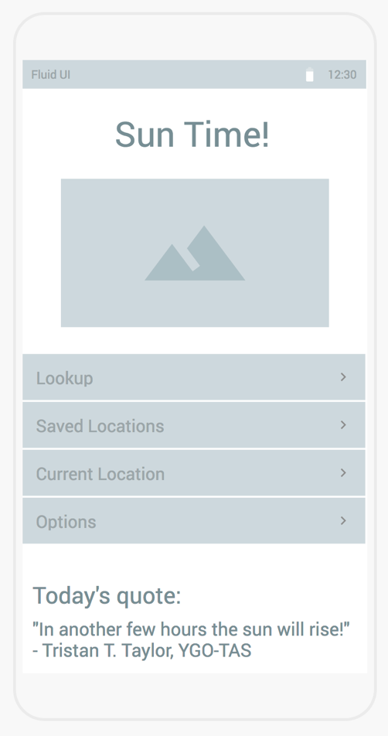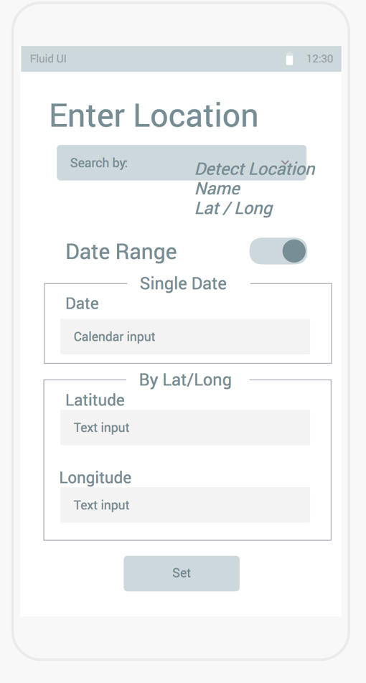

Top Row: Main Activity. Setup

Bottom Row: Saved Locations, Display, Sharing Popup

