Task 1 – UK Visa Information Task

1. Summary:

**Application under test:**

Check UK visa website; URL: [https://www.gov.uk/check-uk-visa/y](https://www.gov.uk/check-uk-visa/)

**Scenarios:**

1**.**

1. Given I provide a nationality of Japan

And I select the reason “Study”

And I state I am intending to stay for more than 6 months

When I submit the form

Then I will be informed “I need a visa to study in the UK”

2.

* 1. Given I provide a nationality of Japan

And I select the reason “Tourism”

When I submit the form

Then I will be informed “I won’t need a visa to study in the UK”

3.

a. Given I provide a nationality of Russia

And I select the reason “Tourism”

And I state I am not travelling or visiting a partner or family

When I submit the form

Then I will be informed “I need a visa to come to the UK”

2. Build and Run Information

To build and run the task, please run below command:

mvn clean verify

3. Output Reports Location

Aggregated Test reports will be output at below location:

\target\site\serenity\index.html

4. Task implementation summary

* This Task has been implemented using Serenity BDD Cucumber framework.
* It uses Junit Library for Assertion
* Maven build tool

5. Software Design

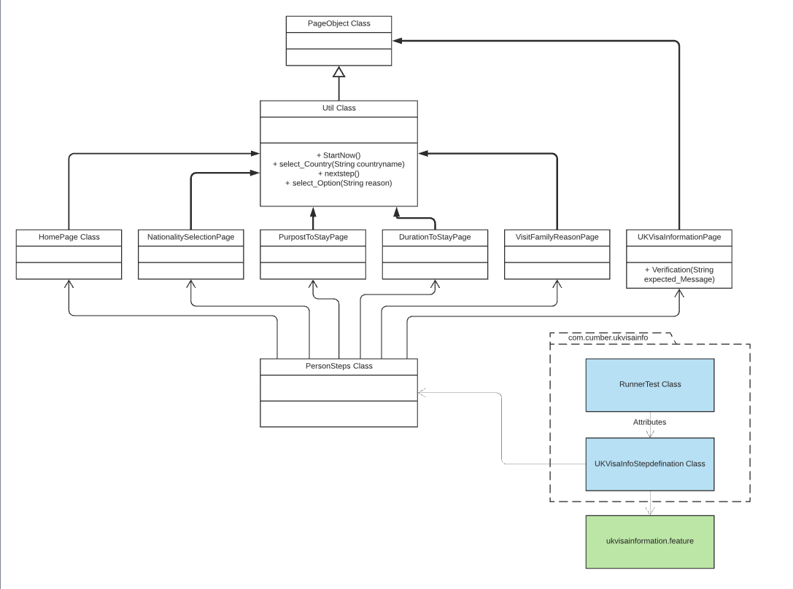

6. Dependencies

* Serenity Core,
* Serenity Junit,
* Serenity Cucumber,
* Self4j-simple,
* junit,
* assert-core,
* hamcrest-all
* Maven Surefire Plugin,
* Maven Fail Safe Plugin,
* Maven Compiler Plugin,
* Serenity Maven Plugin,
* Serenity Core,
* Serenity Reports

For version information of each dependency, please refer to pom.xml

7. File Structure:

+---src

| +---main

| \---test

| +---java

| | \---com

| | \---cucumber

| | \---ukvisainfo

| | | RunnerTest.java ------------------> Runner class

| | | UKVisaInfoStepDefinitions.java ------------------> Step Definition file

| | |

| | +---pageobject

| | | Util.java ------------------> Util class extending Page Object

| | | DurationToStayPage.java ------------------> Duration class

| | | HomePage.java ------------------> Home Page class

| | | NationalitySelectionPage.java ------------------> Country Selection class

| | | PurposeToStayPage.java ------------------> Purpose to stay class

| | | UKVisaInformationPage.java ------------------> Result class

| | | VisitFamilyResonsePage.java ------------------> Family Information class

| | |

| | \---serenity

| | PersonSteps.java ------------------> Serenity Step class

| |

| \---resources

| | serenity.conf ------------------> Environment properties

| |

| +---com

| | \---cucumber

| | \---features

| | ukvisainformation.feature

| |

| \---webdriver

| +---linux

| +---mac

| \---windows ------------------> Web browser drivers

| chromedriver.exe

| geckodriver.exe

| IEDriverServer.exe

\---target

+---site

| \---serenity

| | index.html ------------------> Output Report Summary

| serenity.properties ------------------> Serenity property file

+Pom.xml ------------------> Dependency config file