# Definition of CRM for Creative Processes Representation Version 1.5.1

Version: 1.5.1

2023/11/05

Contributors: George Bruseker, Anais Guillem, Matthew Fielding

License information: Creative Commons Licence Attribution-ShareAlike 4.0 International

Exported from OntoME: https://ontome.net/namespace/247

Definition of CRM for Creative Processes Representation Version 1.5.1 1

Introduction 3

The Basic FRBRoo Pattern 4

The Overall CRMcpr Approach 5

Oeuvre Conception and the Oeuvre 8

Formulations 10

Programme Conception 12

Design Conception 13

Realization Planning 14

Realization 15

Assessment 16

Putting it All Together 17

Examples Used 18

Compatibility and Nomenclature 19

Namespace 19

Maintenance and Archiving 19

Ontology Development 20

Issue Management and Revision Storage 20

Acknowledgements 20

Funding Support 20

Institutional Support 20

Status 21

Class Hierarchy 21

Referenced Classes 24

Property Hierarchy 25

Class Declarations 27

CC1 Model 28

CC2 Realization 29

CC3 Realization Concept 29

CC4 Realization Plan 30

CC5 Formulation 31

CC6 Programme 32

CC9 Oeuvre Conception 33

CC11 Object Trigger Template 34

CC12 Event Trigger Template 35

CC13 Design Concept 36

CC14 Programme Conception 37

CC15 Design Conception 38

CC16 Realization Planning 38

CC17 Projective Requirements 39

CC19 Assessment 40

CC20 Oeuvre 41

Property Declarations 42

CP4 projects (was projected by) 43

CP5 stipulates type of object outcome (is type of object outcome stipulated by) 44

CP6 stipulates event type (is type of event stipulated by) 44

CP7 stipulates actor type (is actor type stipulated by) 45

CP8 stipulates place (is place stipulated by) 46

CP9 stipulates time-span (is time-span stipulated by) 46

CP10 stipulates actor (is actor stipulated by) 47

CP11 stipulates equipment (is equipment stipulated by) 48

CP12 stipulates particular method (is particular method stipulated by) 48

CP13 stipulates specific budget (is budget stipulated by) 49

CP14 stipulates object outcome (is object outcome stipulated by) 50

CP15 stipulates sub-event (is sub-event stipulated by) 50

CP16 stipulates material (is material stipulated by) 51

CP17 stipulates site (is site stipulated by) 52

CP18 stipulates dimension (is dimension stipulated by) 53

CP19 stipulates function (is function stipulated by) 53

CP20 stipulates reference (is reference stipulated by) 54

CP21 stipulates part (is part stipulated by) 55

CP22 assessed (was assessed by) 55

CP24 produced revision (was revision produced by) 56

CP25 concerns extant object (is object of concern of) 57

## Introduction

CRMcpr is an ontology that builds on the bibliographic records ontological model FRBRoo (<https://cidoc-crm.org/frbroo/>) to cover the scope of creative process documentation. In creative process representation we mean to cover documentation data structures that have to do with the recording and interlinking of facts relative to the temporal progress of artistic concepts from their initial state of discussion, through drafts and reworks, practical exercises and testing all the way through to realized artistic objects, be these physical or conceptual. Analytic research in art and architectural domains has a documentation range that moves well beyond the final artistic object as a fait accompli and typically wants to understand that object within a historical progression of thought and human interaction that have contingently or deliberately brought about one or another artistic work through a series of historically determined processes.

In the domain of cultural heritage, CIDOC CRM provides a foundational, event-centred approach to representing historical data which is highly suitable as a ground ontology for representing and connecting information structures. The base ontology, however, remains at a level of generality that is at a remove from the language and thinking patterns of the art and architectural researcher. Moreover, the base ontology provides only a general tool for representing meetings in time and space but no specific theory for the representation of the evolution of ideas. FRBRoo, an official extension of CIDOC CRM, enriches the base ontology by providing a powerful model for the description of the progress of an idea from its most abstract beginnings, its development in different intermediary products and its final articulation. This brings the ontology significantly closer to the needs of the art and architectural historical researcher by providing an engine of representation for the progressive materialization of ideas. The scope of FRBRoo, however, focuses its more specific modelling constructs and patterns on the articulation of linguistic ideas in bibliographic products. While this is perfectly adequate to its defined scope, it makes the ontology less well adapted to the interests and needs of art and architectural historians more generally, who are interested in tracing the details of creative processes through time.

CRMcpr therefore extends FRBRoo with the explicit intention of reusing its basic representational strategy, but adapting this to provide a framework which represents the typical processes in a general creative process. In so doing, CRMcpr aims to provide an ontological framework which is adapted to tracing art from its abstract conception to its final realization. Its basic introduction of the concepts of the CC9 Oeuvre Conception and CC9 Oeuvre in particular provide a useful shift away from an object focussed representation of art to a processual representation of the evolutional realization of ideas from more general into more articulate forms. The shift from an object register style of documentation to one which represents ideas and their evolution provides important benefits to the expressivity of data in art and architectural research. The objects of study in this field are not just the physical holdings of museums and archives, but also the intellectual efforts they bear witness to, efforts which often remain partial or incomplete and must be catalogued in their own right due to their historical importance.

In this introduction, we will outline the basic modelling patterns introduced by CRMcpr and how they are intended to be used. This introduction will then provide the synoptic view of the classes and properties declared in the specification itself and allow the reader to gain a view of the whole.

### The Basic FRBRoo Pattern

In this figure we see the central ontological pattern that FRBRoo elaborates and which CRMcpr adopts and extends in order to provide a consistent approach to modelling creative process related data.

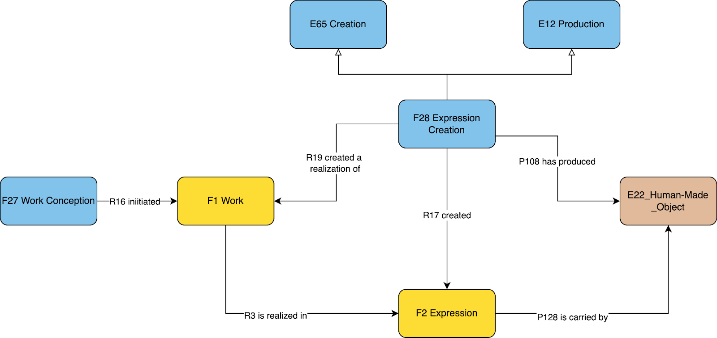*Figure 1: Basic FRBRoo Patterns*

The basic picture that FRBRoo presents is that for any artistic object, if we wish to be able to speak about it in its entire historical progress and extent and connect together the most immediate, salient historical facts for its evolution and production and potentially the most far flung derivations of it through time, we must be able to represent the idea of an object or work before any of its particular manifestations. FRBRoo thus declares a conceptual class **F1 Work** which is the anchor point for the documentation of any further facts about an artistic object. An instance of **F1 Work** is abstract and yet a distinct, conceptual individual that is characterized by a set conceptual content, recognizable by independent observers, that can potentially be materialized in many different ways. An **F1 Work** comes to be through an event of creation, **F27 Work Creation**, which links the idea back to the time, place and agency of the initiators of an idea. Instances of **F1 Work** are rendered into particular informational and physical manifestations through specific moments of creative activity which are modelled with the event class of **F28 Expression Creation**. This class is a key tool for the representation of artistic processes because it recognizes such events as those in which, at once, new physical objects (**F4 Manifestation Singleton**) and informational content (**F2 Expressions**) are brought into existence simultaneously. Crucially, acts of **F28 Expression Creation** and their informational products (**F2 Expression**) are related back to **F1 Work** and **F27 Work Creation** as generating realizations of the initial idea (**F1 Work**). This central picture allows for the representation of the iteration of abstract ideas over time into different realized forms. The representational machinery thus exists to represent sketches, drafts, plans, alternative versions, derivations, etc, and how they interrelate through time to take up and elaborate an idea into particular realized contents. This core ontological pattern provides a powerful toolset for the representation of creative processes. The motivation for extending this pattern with a subset of classes and relations arises from the scoping of the FRBRoo modelling. As stated in the introduction FRBRoo is formulated as , “a formal ontology that captures and represents the underlying semantics of bibliographic information”. (FRBR 3.0, page 11) This scoping of the ontology to bibliographic needs, means that the formulation of the classes and properties are appropriately restricted to information within the bibliographic record and thus by necessity excludes a whole range of creative activities that do not necessarily appear therein. We can see the bibliographic focus of the ontology in the elaborated subclasses of the model’s fundamental pattern which deal with questions of the progression of an idea through a scholarly process from writing through publication, recording and other bibliographic documentation. Despite this focus, however, the ontology also comes with an invitation to its interpretation and extension, “It should be kept in mind that FRBROO was developed as a high-level conceptual model. It is not meant to be implemented verbatim.” (FRBR 3.0, page 12) Thus, recognizing the power of the core pattern derived through this modelling, CRMcpr intends to do just this by creating an extension ontology scoped to a broader range of creative activities but following the well derived foundational modelling already in place. CRMcpr aims to create a broader set of sub-patterns of generalized creative process, relating to generic phases of creative process regardless of medium or artistic area.

### The Overall CRMcpr Approach

CRMcpr thus specializes FRBRoo to this purpose, attempting to adhere as closely as possible to the high level modelling principles and patterns offered in FRBRoo but using as an input for developing its specific subclasses and relations, the typical activities and processes within a general creative process. The goal is to offer a consistent set of classes which allow the representation of an idea from its inception through to its realization in a coherent fashion relative to well known stages of creative realization, recognizing how such stages can be partial, iterative and multi-track.

To accomplish this goal, CRMcpr introduces two central conceptual classes, **CC20 Oeuvre**, as a subclass of **F15 Complex Work**, and **CC5 Formulation**, as a subclass of **F2 Expression** and **E29 Design or Procedure**. These core concepts are then specialized with specific classes that represent respectively the particular type of ‘work’ under elaboration in a particular phase of creative production and its relative type of ‘expression’ as a realized intellectual and or physical product. The phases identified, and described in greater detail below are Programming, Designing and Realisation Planning the relevant classes declared are: **F15 Complex Work** (**CC17 Projective Requirements**, **CC13 Design Concept** and **CC3 Realization Concept)** and **F2 Expression / E29 Design or Procedure** (**CC6 Programme**, **CC1 Model** and **CC4 Realization Plan**).

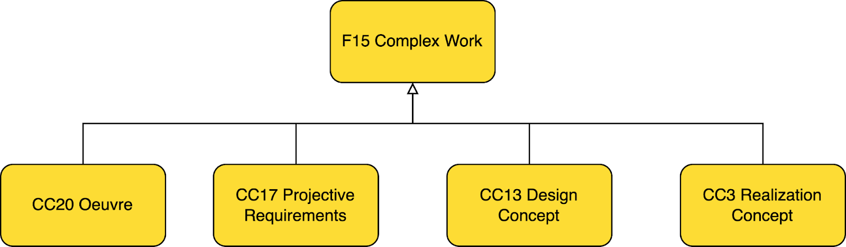*Figure 2: IsA Hierarchy between CRMcpr work classes and FRBRoo*

At the core of the proposal is the idea of **CC20 Oeuvre**, which is the abstract creative idea that is iteratively realized through a series of historical creative activities. The **CC20 Oeuvre** work class and its paired **CC9 Oeuvre Conception** event class are the anchor classes for this extension, as the starting point for the documentation of a creative idea and process. The event of **CC9 Oeuvre Conception** allows the representation of the witness of the initiation of an idea and the commitments of various parties to the realization of this idea in roles of patron / client and designer / service provider *inter alia*. This provides an important starting point for documenting and understanding an **CC20 Oeuvre** in a socio-historical context.

The three related core work classes, **CC17 Projective Requirements**, **CC13 Design Concept** and **CC13 Realization Concept** and the respective events that create them, **CC14 Programme Conception**, **CC13 Design Conception**, and **CC16 Realization Conception**, give appropriate representation to well recognized phases of the creative process. They pick out the fact that there are distinct temporal processes related to elaborating an aesthetic creation into a realized, semi-realized or, even finally, unrealized concrete physical or informational object.

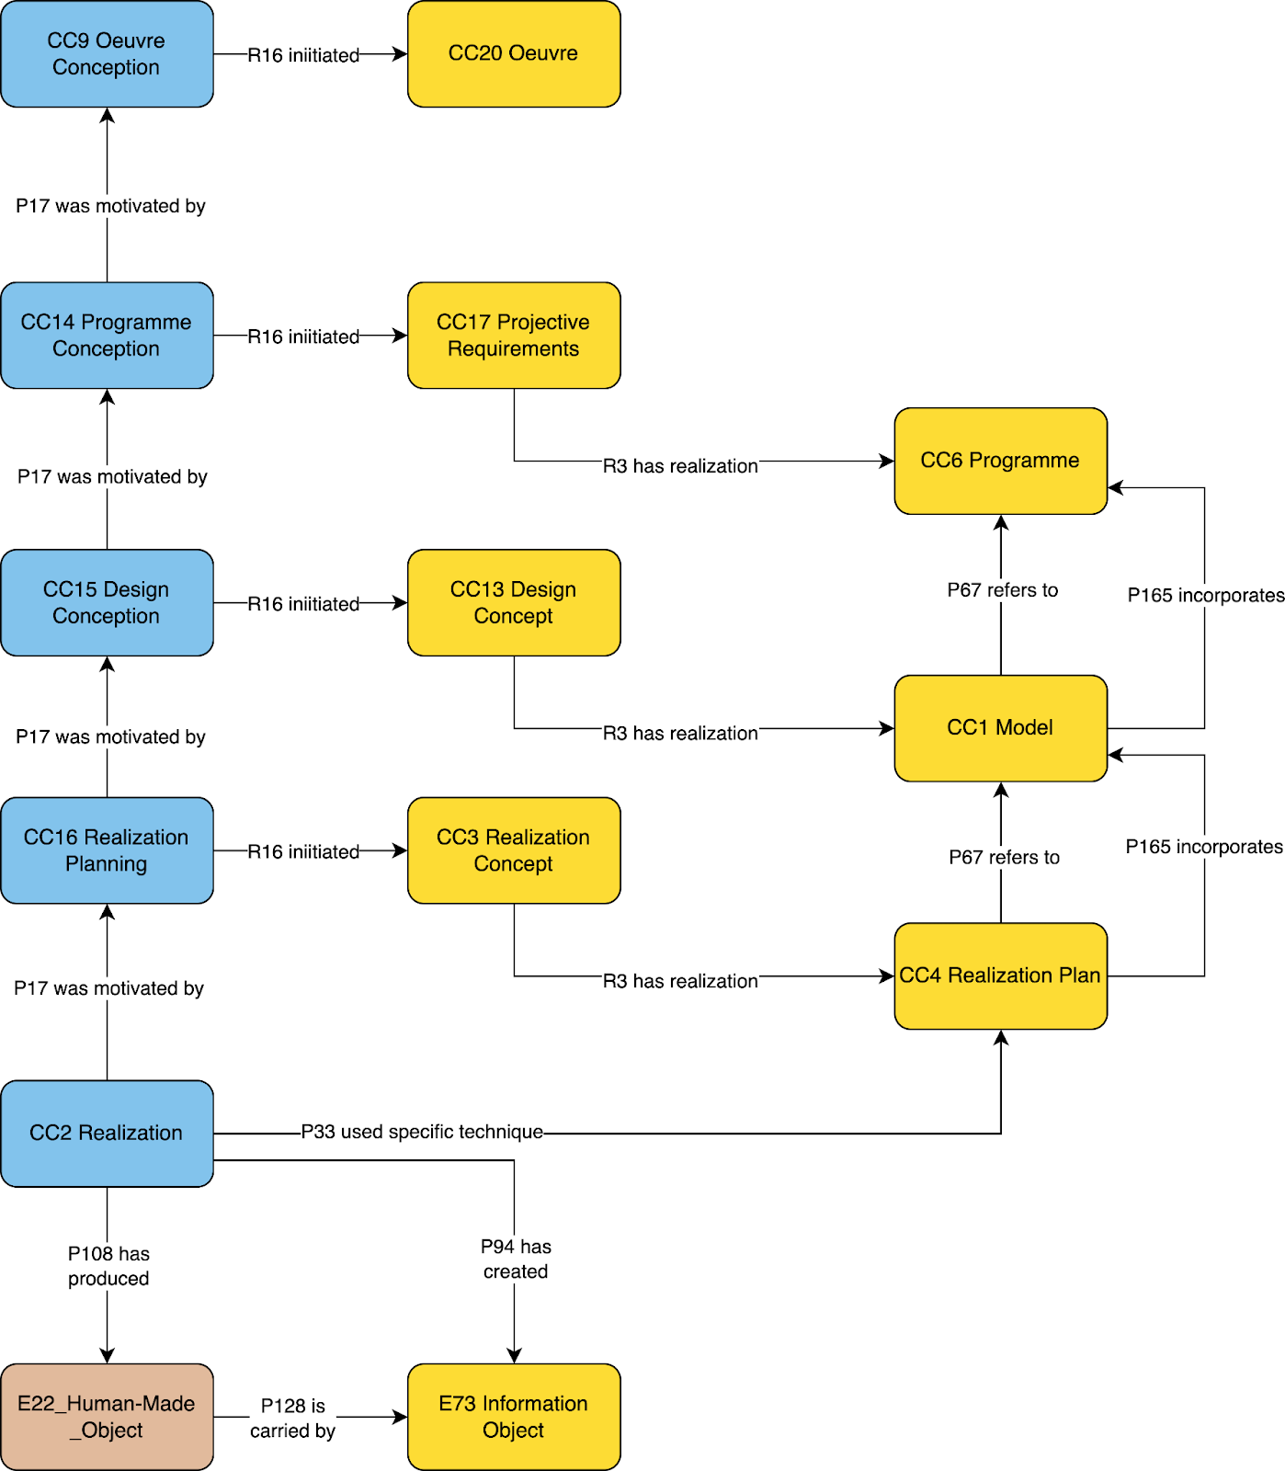*Figure 3: Creation Process Events, Works, Formulations and potential interrelations*

In particular, there is a process of programming, in which the desired outcome of an oeuvre is elaborated. There is a design phase in which different concepts for achieving the project requirements are tested and elaborated. There is then a phase of realization planning in which an accepted design must be understood and adapted in order to be objectively realized as an end product. Each of these phases can thus be factually represented in a semantic graph with its distinct elements relative to their distinct modes elaboration. Of course in actual historical evolution each of these phases may have many iterations and may be left out entirely, or be unknown. Following the pattern of FRBRoo, it is possible to document the individual informational products typically found in archives according to their function within this process. Thus each of these phases has a distinct form of expression defined in the classes of **CC6 Programme**, **CC1 Model** and **CC4 Realization Plan**.

These intermediary processes all potentially lead up to an act of production which is modelled with the event class **CC2 Realization** of the aimed for idea, or **CC20 Oeuvre**. The products of the processes leading to this event, as described above, canonically culminating with a **CC4 Realization Plan**, are the expected input to this final realization act.

In creating such a chain of provenance between the original idea and its articulation and elaboration in various creative phases down to the attempted execution of the finally elaborated artistic object it is possible to support sophisticated art historical documentation of the provenance of art and architectural objects not just as things, but as manifestations of creative processes and ideas in interaction through time.

In what follows we focus the overall structure of oeuvre and then the various phases modelled and how these are put together to enable particular historical progressions of an idea from concept to realized thing.

### Oeuvre Conception and the Oeuvre

At its heart, CRMcpr provides a central documentation point in the notion of the **CC20 Oeuvre** and its related event, the **CC9 Oeuvre Conception**. The notion of **CC20 Oeuvre** allows a highest collection point to relate all further creative products generated in a creative process back to one overall work. This can be realized through multiple semantic paths according to one's needs, but the most direct is to link the other works generated within a creative process to the overall oeuvre through a relationship of membership (**R10 has member**). The **CC9 Oeuvre Conception** event allows the tracing of the temporal, agential and locative properties of an event of creation following standard CIDOC CRM patterns. It also allows for creating a relationship of parthood (**P9 consists of**) or motivation (**P17 motivated by**) between the overall oeuvre conception activity and the sub-processes in the overall creative process.

Instead of being limited to the documentation of physical documents, artworks, or architectural works alone, the **CC20 Oeuvre** class allows a researcher to create a documentation point for the overall idea of a work and to document the various events and outcomes that led to the realization of this or that final creative work(s) or their non-realization along the way.

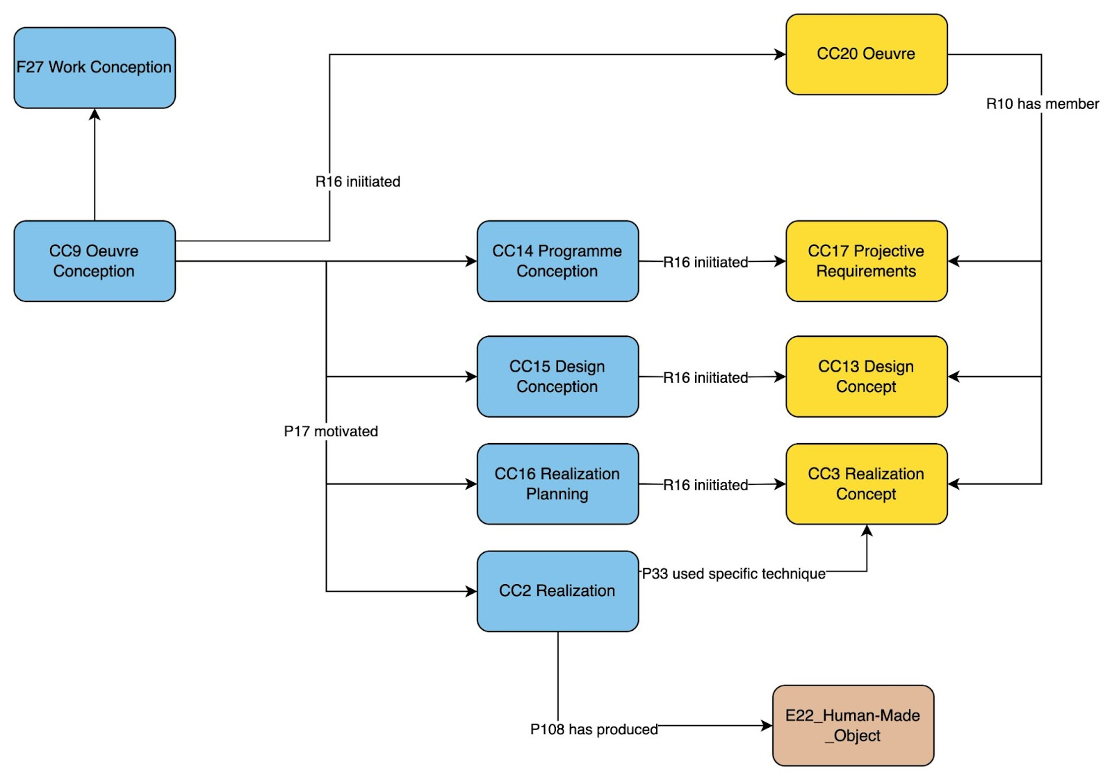

*Figure 4: Oeuvre and Oeuvre Conception as Contexts for complex creative process histories*

The topic of agency with regards to the **CC20 Oeuvre** is of particular interest. It is typical in a creative process to have multiple actors or stakeholders engaged or otherwise invested in an eventual outcome. It is highly salient to be able to track these stakeholders and how they are engaged with the creative process through time and in what role. Two very basic roles that are typically seen are that of a patron or client and a designer or service provider. In the diagram below, we see the modelling recommended to represent this relation. Adopting the patterns of CRMaaa, this model connects the **CC9 Oeuvre Conception** to individual actors through a specified role. The cause and duration of these roles can be documented separately via the mechanisms of **ZE13 Speech Act** described in that standard.

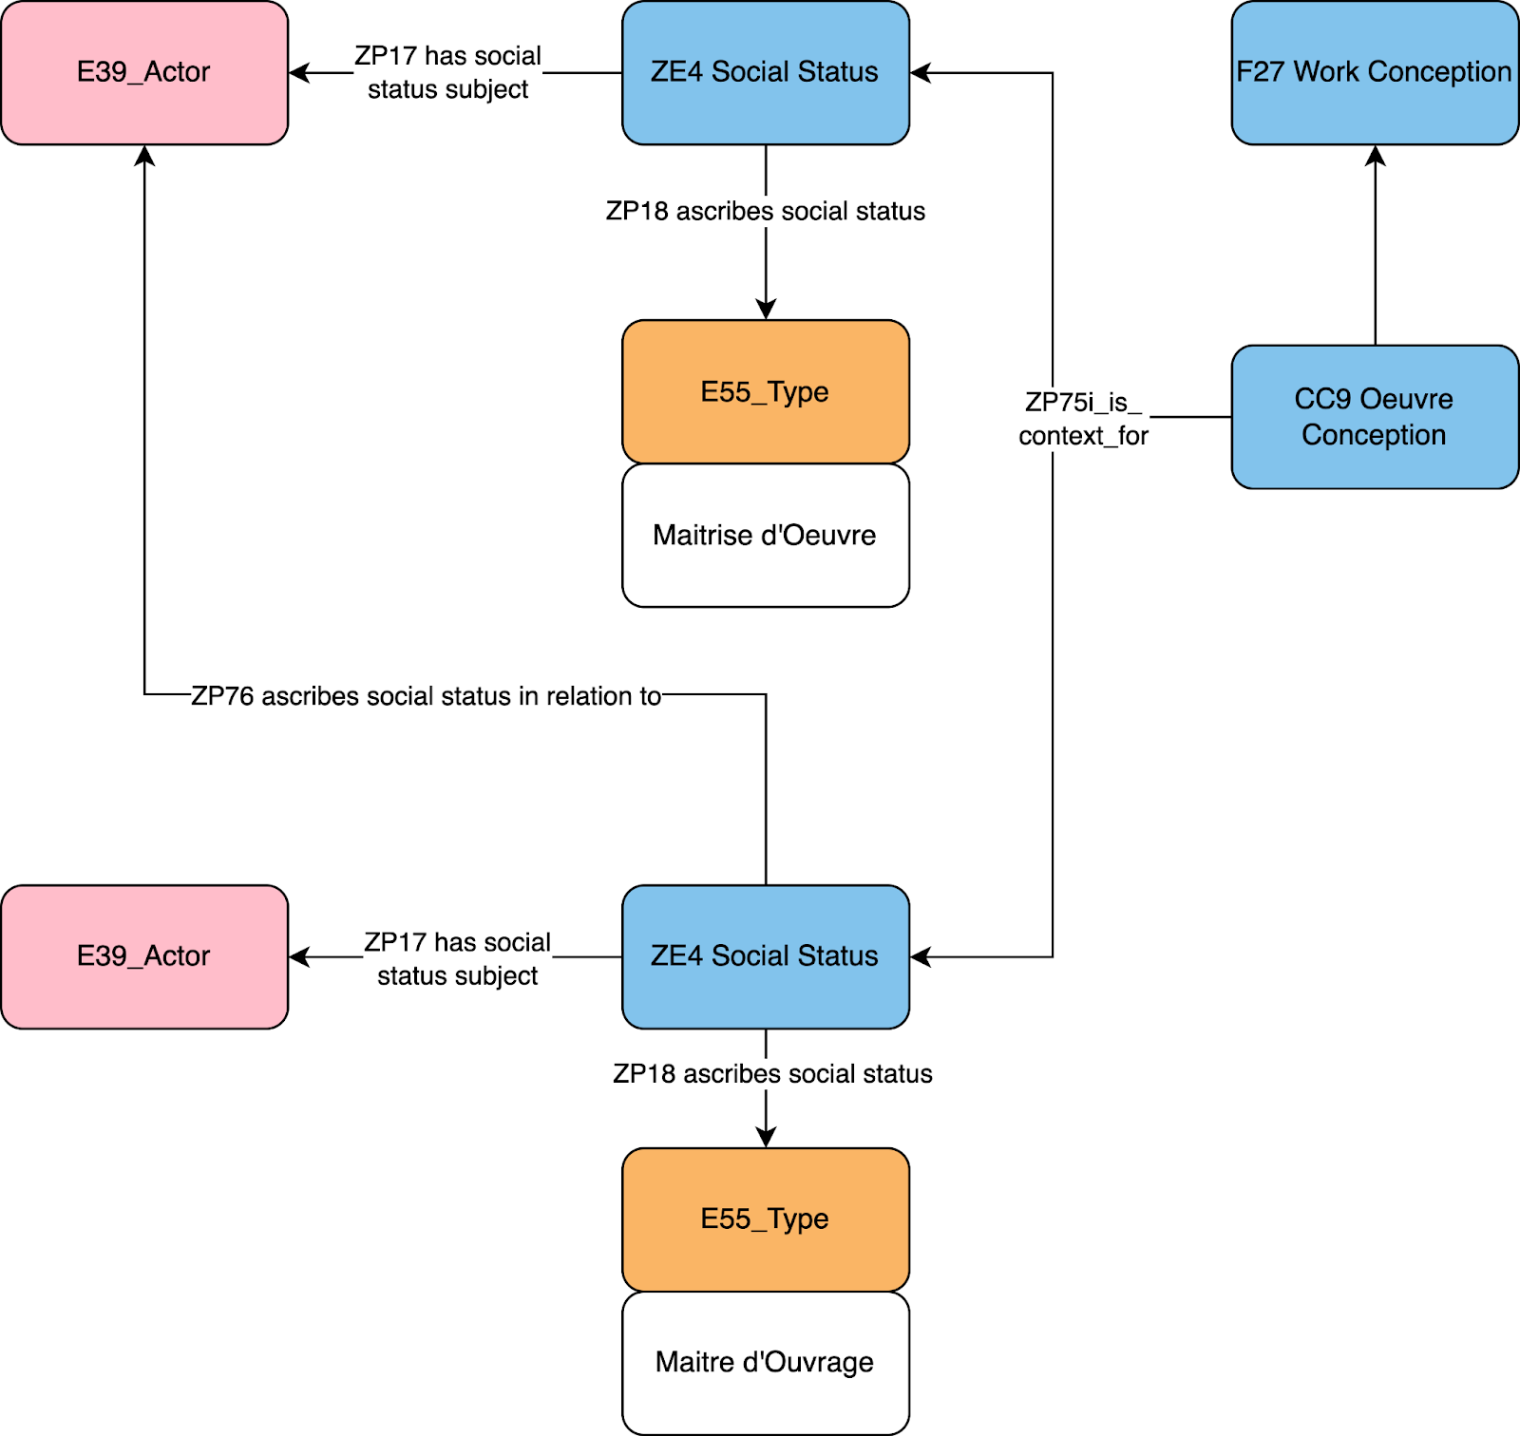*Figure 5: Representing social agency in creative processes, designated roles*

Because of the frequency of this patron / provider relationship, we have generated two basic vocabulary terms, borrowing from the French architectural tradition, which are recommended as potential control terms where applicable in order to specify the particular role that each party plays in the overall reailization of instance of **CC20 Oeuvre**. These are ‘Maitrise d’Oeuvre’ and ‘Maitrise d'Ouvrage’.

### Formulations

CRMcpr aims to allow for the accurate representation of the key kinds of information objects that are generated in creative processes and their association into a representative network of relations between processes. The key class proposed in this regard is the **CC5 Formulation** concept class. This class is declared as subclass of **F2 Expression** and **E29 Design or Procedure** and stands as the superclass to the other new classes of this type: **CC6 Programme**, **CC1 Model** and **CC4 Realization Plan**, that model, respectively, the formal intellectual output of different development phases. The idea introduced by the class of **CC5 Formulation** is that within a creative process the resulting information objects generated to try to realize an overall idea in practice, are not only new and unique information objects in themselves (**F2 Expressions**) but also serve as indications to be used in other parts of the creative process, i.e. plans that indicate a desired outcome of one sort or the other. Each phase of the creative process does or may create such plans. The general notion of formulation is further specified into the specific products of each different major potential phases of the creative process flow. These distinctions are made because of the distinct functions these kinds of documents tend to play within a creative process, whether externalizing a particular creative aim, designing objects to meet an aim and creating plans for realizing designs into actuality.

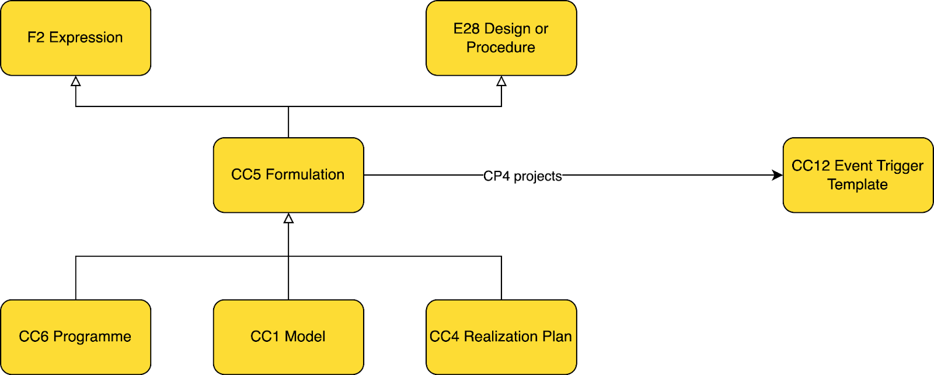*Figure 6: Formulation Class, Expressions with a Plan*

Another important feature introduced by the **CC5 Formulation** class is the notion of projecting a certain outcome either as a futural event or as a desired object. In many cases, an instance of a formulation contains within it stipulations regarding future desired states of affairs. A programme document can, for example, specify the budget, actor, location of a future projected action or the material, size, type of a future projected object. Ontologically project events and objects are only ideas and yet it can be interesting to capture some of these specifications in the semantic network in order to compare specified outcomes to realized outcomes in a creative process.

To this end, we have borrowed from the work done on CRMact (<https://cidoc-crm.org/crmact/>) which begins to provide a modelling foundation for talking about futural objects, representing them as propositional objects. In the following diagram we see the potential representations around a specified future event.

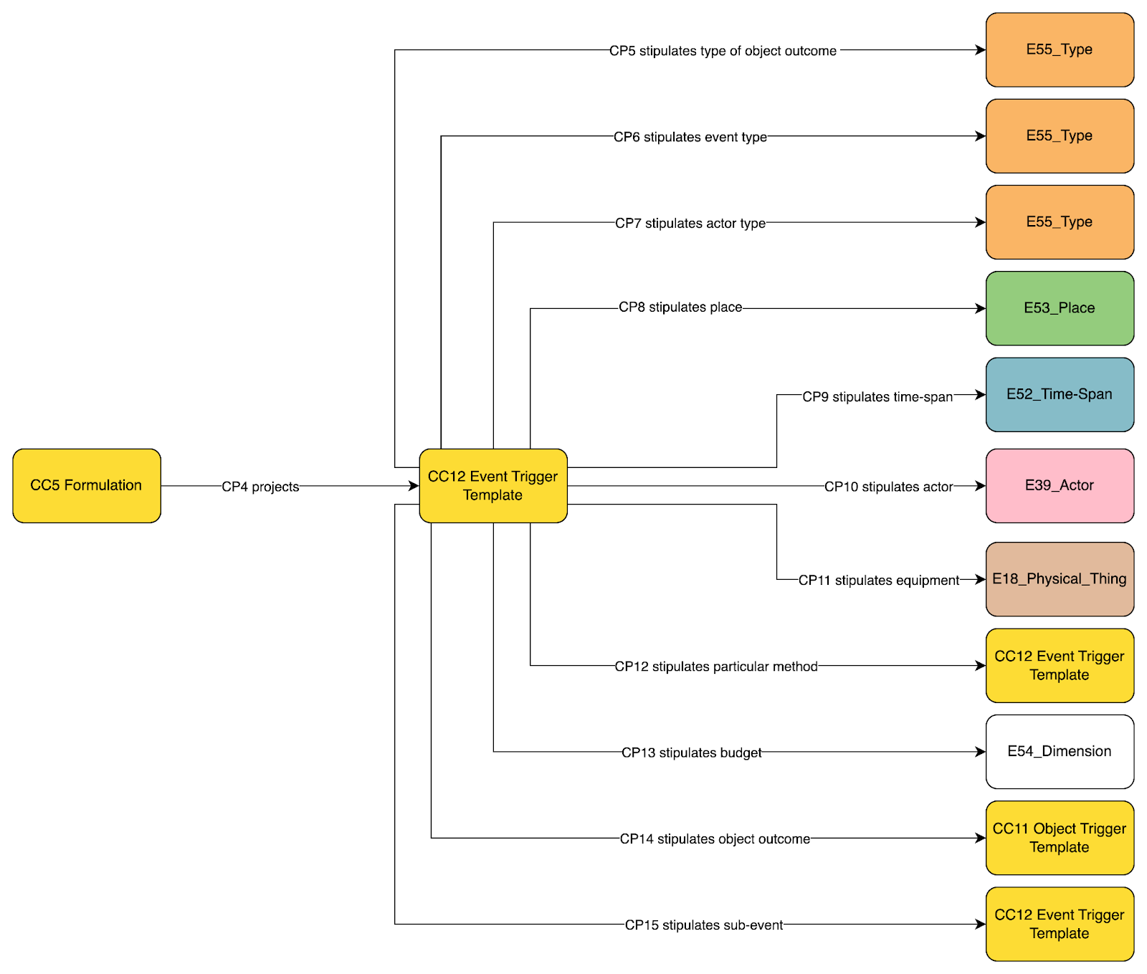*Figure 7: Project Features of Futural Events, CC12 Event Trigger Template*

In practice, this modelling innovation allows the researcher to document the contents of CC5 Formulations regarding the proposed future events / objects and then to compare the values of those properties to the eventually realized artistic object.

### Programme Conception

A major phase of the creative process identified by this model is that of programming or programmation. The idea here is that an oeuvre, once willed to exist, still requires some definition as to its more or less exact specifications. One wants a house, an artwork, a computer programme, and the question is to elicit the correct requirements appropriate to this as of yet underdetermined futural thing, in order to produce a specification against which an artist or a designer can attempt to deliver an adequate design.

In this phase then, the main complex of classes called upon are **CC14 Programme Conception**, **CC17 Projective Requirements** and **CC6 Programme**. In this phase an oeuvre gains an important member work and greater level of realization with **CC17 Project Requirements** and eventually a determined **CC6 Programme**, the content of which can be used by later stages of the process to base their efforts on.

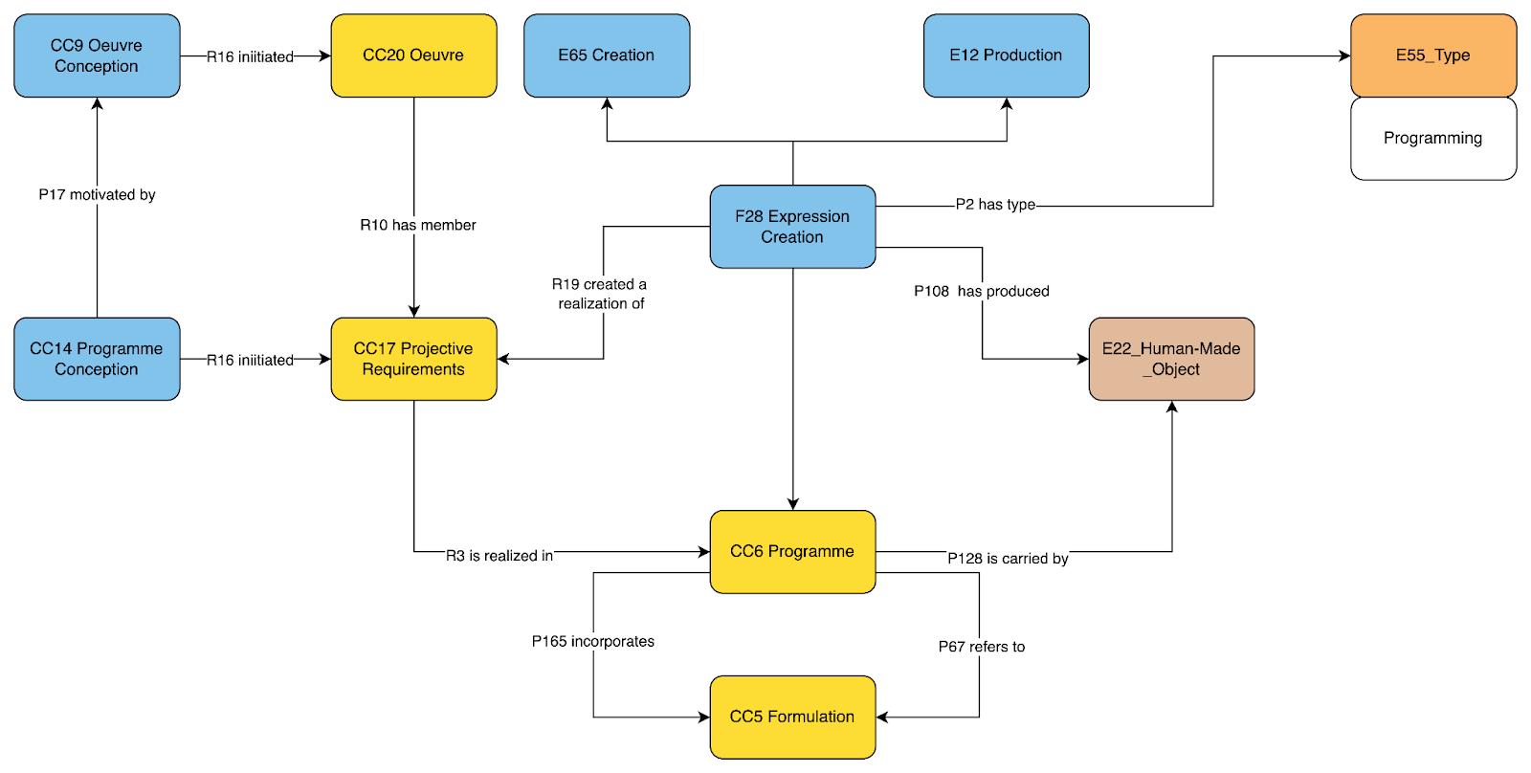 *Figure 8: Programme Conception Modelling Pattern: eliciting requirements, refining projective outcomes*

### Design Conception

A second typical creative phase identified in the CRMcpr ontology is that of design. What is meant here is the creative process of generating conceptual models which project all or part of a potential realization of an oeuvre. This is the stage of development related to sketches, drafts and proposals which attempt to consolidate the notion of a particular oeuvre and move it in a particular direction. If the design process has been preceded by a programming phase, then it typically takes into account the **CC6 Programme** that was identified as realizing the **CC17 Project Requirements** articulated in relation to the **CC20 Oeuvre** at the outset, whether by the artist herself or a third party, such as an appointed Maitrise d”Oeuvrage . Here we see the same interplay of an overall creative activity working out different informational objects in order to come to a definite model for the previously abstract oeuvre. The triad of classes of import here are **CC15 Design Conception**, **CC13 Design Concept** and **CC1 Model**.

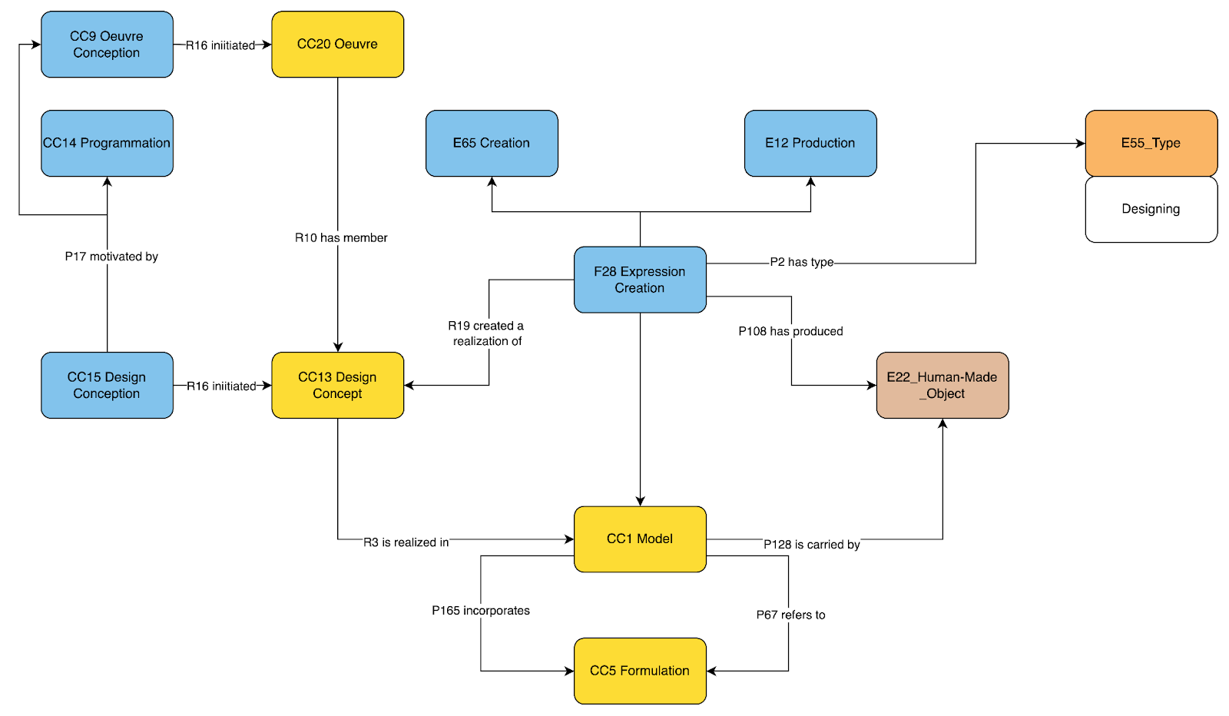*Figure 9: Design Conception Modelling Pattern: creating, testing and refining models*

The end of this process, if completed, is a particular instance of **CC1 Model** which is chosen as an acceptable representation of a particular **CC13 Design Concept** and which is decided to be a specific conceptual model for guiding the further realization of the oeuvre.

### Realization Planning

The final potential phase of a creative process identified in the CRMcpr ontology is that of realization planning. Here the creative process has decided on a programme and accepted a model that satisfies this programme and now moves into a phase of creating the specific plans for materializing the final design, whether that be in physical or some other form. Here, in the case of architecture for example, we are in the phase of creating construction plans, in the case of some art practices we may be looking at the creation of moulds or projections, in cooking the writing of recipes etc. This phase typically has the input of a design phase and attempts to create a practical plan for achieving the outcome described in the model which can be used for an activity of creation of the final product (**CC2 Realization**). The triad of classes deployed in this phase are CC16 Realization Planning, CC3 Realization Concept and CC4 Realization Plan. Again, here it has to do with a process that starts from a general will to have a plan to the creation of one or more specific information objects which define a plan that can be used in practice to generate a creative object that is an accepted realization of the **CC4 Realization Plan** and, indeed, of the overall **CC20 Oeuvre**. We are not yet here at the stage of realizing the project concrete object of the overall **CC20 Oeuvre** itself, but in the final preparatory stage which supports the actual event of **CC2 Realization**.

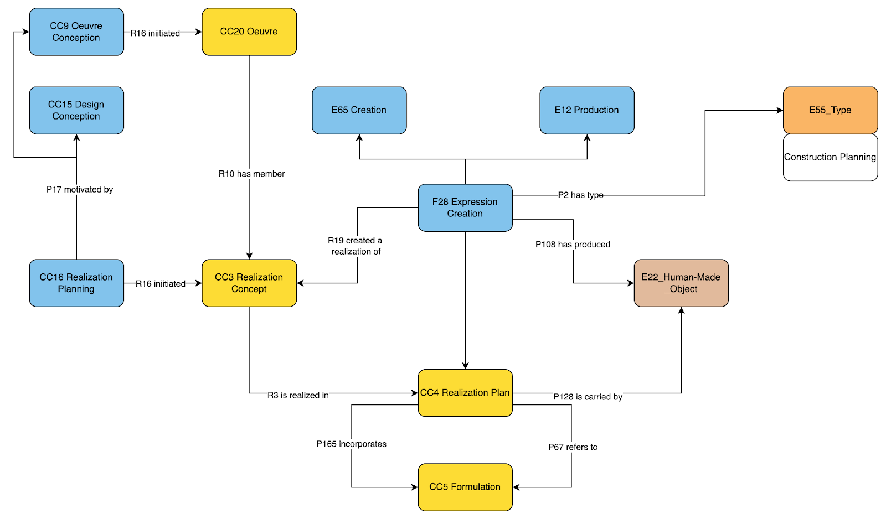*Figure 10: Realization Planning Modelling Pattern: translating models into plans*

### Realization

The final phase of the creative process, if it is arrived at, is the actual generation of a particular overall object which is the planned for outcome. This is represented in CRMcpr through the event class **CC2 Realization**. This class is declared as a subclass of both **E12 Production** and **E65 Creation**. It is an event that aims to bring into existence the object projected through the different **CC5 Formulation** instances derived in the course of elaborating the idea of an oeuvre into a progressively more concrete outcome. The enactment of an event of **CC2 Realization** is the event which brings the oeuvre into actuality as a distinct object. This object may be a physical object, an information object or both. It is crucial for an instance of **CC2 Realization** as the act which achieves an oeuvre that it use one or more instances of **CC5 Formulation** from that oeuvre’s overall elaboration in order to carry out its activities.

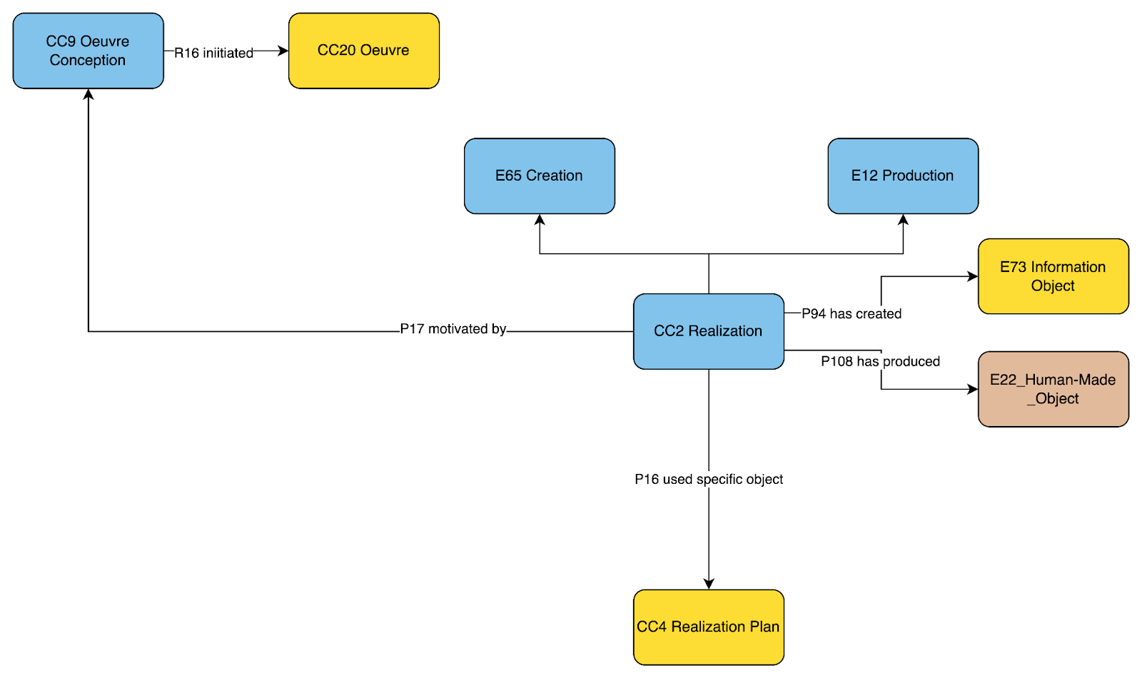*Figure 11: Realization Modelling Pattern: from plan to act*

Here particularly we see the novel approach of CRMcpr towards a more complete documentation of art and architectural history. The actual ‘art object’ is an end node on a rich set of events, objects and actors, connected in time and space, which provide a contextual provenance of understanding for the eventual art object itself. Rather than clustering limited material facts around the object alone, we are given a processual way of understanding the elaboration of an oeuvre as the iterative, partial, and looping generation of different creative formulations in order to eventually arrive or not arrive at a final creative object.

### Assessment

Not a distinct phase in itself, the notion of assessment is introduced into CRMcpr to take into account the iterative and collaborative nature of creative processes. The informational objects generated by different creative processes are constantly subjected to evaluation in order to determine their suitability, correctness and utility according to various standards, whether they be explicitly documented or not. The process of assessment and evaluation can be very important with creative projects presenting multiple potential programmes, models and realization plans before landing on a particular object that is deemed useful to go forward. For this reason, CRMcpr proposes a new event class **CC19 Assessment** which allows for the documentation of this process of adjudicating and even adjusting information objects in a historical process. The general pattern for this is presented below.

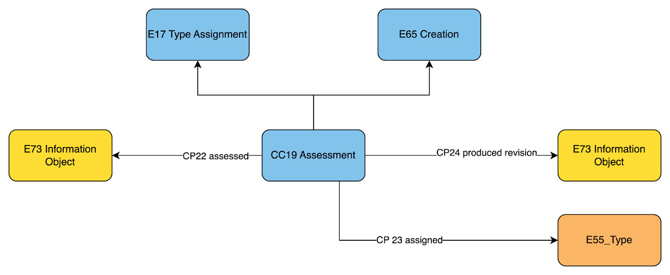*Figure 12: Assessment Modelling Pattern: testing, refining and progressing formulations*

### Putting it All Together

As demonstrated above, CRMcpr proposes an overall extension to FRBRoo which uses the expressive power of that model to create an ontology for the documentation of creative processes and their outcomes. The resultant model largely follows the ontological positions of FRBRoo at the top-level but creates a more particular set of classes and properties adapted to the context of creative processes in general rather than bibliographic processes. The various sub-phases of the realization of an oeuvre proposed in CRMcpr reflect common patterns in creative production and can be found in both large scale creative processes like architecture but also more small scale artistic production like painting or photography. That said, the ontology is not meant to be proscriptive but simply to cover common areas of activity with typical relations. It is not necessarily the case that each and every possible node in all of the phases modelled here are either included or are of equal import in different areas of creative production. Nonetheless, in such a case where it holds, the final potential picture of a complete oeuvre workflow is achieved as per figure 3 above.

Such a model illustrates the potentially dense complexity of the documentation of an oeuvre in all of its historical development. Here we have the potential to document not just an object or an idea but a complex of activities and documents which in their historical interaction lead to an artistic outcome. Such processes may be partial, full, incomplete, revised, deviated from etc. And it is in this complex that the oeuvre as starting point of documentation allows that the interest of the art historical data in a semantic network can begin to take shape by showing the interconnections and lacuna between processes and ideas that lead ultimately to different outcomes.

## Examples Used

In order to illustrate the ontology's use, the specification provides a related set of examples from architecture, the rebuild project on the site of the World Trade Centre, NY, and art the "Gates of Hell" by Rodin. Future editions aim to carry examples from additional fields.

## Compatibility and Nomenclature

This unofficial extension of the CIDOC CRM is formulated in relation to:

* [CIDOC CRM v.7.1.2](https://www.cidoc-crm.org/Version/version-7.1.2)
* [FRBRoo v.2.4](https://cidoc-crm.org/frbroo/ModelVersion/frbroo-v.-2.4)

The specification consists of a set of declarations for formalized classes and properties that extend the CIDOC CRM and the above official extensions.

Please note that FRBRoo 2.4 was formulated originally in relation to CIDOC CRM 6.2. In order to harmonize to the latest CIDOC CRM while using the FRBRoo modelling strategy we have ensured to use only classes and properties that are compatible across these two models. We choose to retain the modelling patterns of FRBRoo rather than the new model LRMoo which further restricts its scope to only library practice and loses many of the features that interest us in the modelling of creative process.

Adopting the conventions of the CIDOC CRM each class and property have been given an identifier in addition to their names. The naming convention adopted for this extension is:

CC = class

CP = property

The choice of these names was arbitrary, making a conceptual connection with the official CRM representation while clearly distinguishing the new classes and properties from those of either CRM base or its official extensions.

## Namespace

<https://takin.solutions/ontologies/crmcpr>

## Maintenance and Archiving

CRMcpr is an actively maintained ontology. It is our aim to develop publicaly and participatively, learning from and engaging with the scholarly community that adopts it. Towards this end we maintain the ontology with the following processes and relative tools.

### Ontology Development

We adopt the OntoMe tool developed by [LARHRA](http://larhra.ish-lyon.cnrs.fr/) to manage the ontology and produce editions. This ensures a consistent management of the ontology and provides a public space to engage in revisions.

The maintenace space for the ontology can be found here: <https://ontome.net/project/30>

### Issue Management and Revision Storage

We adopt github as a platform for inviting and managing issues related to the ontology as well as providing an active place to be able to access the latest edition of the ontology, its specification and relevant documentation.

The address for the github repository is: <https://github.com/takinsolutions/crmcpr>

## Acknowledgements

The initiative for creating, developing and maintaining this ontology is made possible by important on-going funding and institutional commitment, which is gratefully acknowledged here.

### Funding Support

* The development/creation of the initial version (v1.0) of CRMcpr has been jointly funded by Swiss Art Research Infrastructure ([SARI](https://www.sari.uzh.ch/)) and the University of Zurich’s Digital Society Initiative ([DSI](https://www.dsi.uzh.ch/))
* The continued development and enrichment of the latest version (v1.5) has been funded as part of the Open Research Data ([ORD](https://www.swissuniversities.ch/fileadmin/swissuniversities/Dokumente/Hochschulpolitik/ORD/Swiss_National_ORD_Strategy_en.pdf)) initiative by [swissuniversities](https://www.swissuniversities.ch/).

### Institutional Support

The continuous maintenance and promotion of CRMcpr is made possible by the initial and on-going commitment of its institutional partners to this task.

* [Takin.solutions](https://takin.solutions/)
* [Swiss Art Research Infrastructure - University of Zurich](https://www.sari.uzh.ch/en.html)
* [UMR 3495 CNRS/MC MAP](http://www.map.cnrs.fr/?page_id=64215)

## Status

Published version

## Class Hierarchy

This class hierarchy lists:

* all classes declared in CRM for Creative Processes Representation Version 1.5.1
* all classes declared in CIDOC CRM version 7.1.2 that are declared as superclasses of classes declared in the CRM for Creative Processes Representation Version 1.5.1
* all classes declared in FRBRoo version 2.4 version 2.4 that are declared as superclasses of classes declared in the CRM for Creative Processes Representation Version 1.5.1
* all classes declared in CRM Activity Plans that are declared as superclasses of classes declared in the CRM for Creative Processes Representation Version 1.5.1
* all classes declared in CIDOC CRM version 6.2 that are either domain or range for a property declared in the CRM for Creative Processes Representation Version 1.5.1
* all classes declared in FRBRoo version 2.4 version 2.4 that are either domain or range for a property declared in the CRM for Creative Processes Representation Version 1.5.1
* all classes declared in CRM Activity Plans that are either domain or range for a property declared in the CRM for Creative Processes Representation Version 1.5.1

Table 1: Class Hierarchy

E1 CRM Entity

E2 - Temporary Entity

E4 - - Period

E5 - - - Event

E7 - - - - Activity

E12 - - - - - Production

CC2 - - - - - - Realization

E65 - - - - - Creation

F27 - - - - - - Work Conception

CC9 - - - - - - - Oeuvre Conception

CC14 - - - - - - - Programme Conception

CC15 - - - - - - - Design Conception

CC16 - - - - - - - Realization Planning

CC2 - - - - - - Realization

CC19 - - - - - - Assessment

E13 - - - - - Attribute Assignment

E17 - - - - - - Type Assignment

CC19 - - - - - - - Assessment

E63 - - - - Beginning of Existence

E12 - - - - - Production

CC2 - - - - - - Realization

E65 - - - - - Creation

F27 - - - - - - Work Conception

CC2 - - - - - - Realization

CC19 - - - - - - Assessment

E77 - Persistent Item

E70 - - Thing

E71 - - - Human-Made Thing

E28 - - - - Conceptual Object

E89 - - - - - Propositional Object

F1 - - - - - - Work

F15 - - - - - - - Complex Work

CC20 - - - - - - - - Oeuvre

CC17 - - - - - - - - Project Requirements

CC13 - - - - - - - - Design Concept

CC3 - - - - - - - - Realization Concept

CC12 - - - - - - Event Trigger Template

CC11 - - - - - - Object Trigger Template

E73 - - - - - - Information Object

E29 - - - - - - - Design or Procedure

CC5 - - - - - - - - Formulation

CC6 - - - - - - - - - Programme

CC1 - - - - - - - - - Model

CC4 - - - - - - - - - Realization Plan

F2 - - - - - - - Expression

CC5 - - - - - - - - Formulation

CC6 - - - - - - - - - Programme

CC1 - - - - - - - - - Model

CC4 - - - - - - - - - Realization Plan

|  |  |  |  |
| --- | --- | --- | --- |
|  |  |  |  |

### Referenced Classes

Table 2: List of external classes grouped by model and ordered by model (exception: CRMbase always goes first) and then by class identifier.

|  |  |  |  |
| --- | --- | --- | --- |
| **Class identifier** | **Class name** | **Model** | **Version** |
| E12 | Production | CIDOC CRM | 7.1.2 |
| E17 | Type Assignment | CIDOC CRM | 7.1.2 |
| E18 | Physical Thing | CIDOC CRM | 7.1.2 |
| E27 | Site | CIDOC CRM | 7.1.2 |
| E29 | Design or Procedure | CIDOC CRM | 7.1.2 |
| E39 | Actor | CIDOC CRM | 7.1.2 |
| E52 | Time-Span | CIDOC CRM | 7.1.2 |
| E53 | Place | CIDOC CRM | 7.1.2 |
| E54 | Dimension | CIDOC CRM | 7.1.2 |
| E55 | Type | CIDOC CRM | 7.1.2 |
| E57 | Material | CIDOC CRM | 7.1.2 |
| E65 | Creation | CIDOC CRM | 7.1.2 |
| E73 | Information Object | CIDOC CRM | 7.1.2 |
| E89 | Propositional Object | CIDOC CRM | 7.1.2 |
| F2 | Expression | FRBRoo: Functional Requirements for Bibliographic Records | 2.4 |
| F15 | Complex Work | FRBRoo: Functional Requirements for Bibliographic Records | 2.4 |
| F27 | Work Conception | FRBRoo: Functional Requirements for Bibliographic Records | 2.4 |

## Property Hierarchy

This property hierarchy lists:

* all properties declared in CRM for Creative Processes Representation Version 1.5.1
* all properties declared in CIDOC CRM version 7.1.2 that are declared as superproperties of properties declared in the CRM for Creative Processes Representation Version 1.5.1
* all properties declared in FRBRoo version 2.4 version 2.4 that are declared as superproperties of properties declared in the CRM for Creative Processes Representation Version 1.5.1
* all properties declared in CRM Activity Plans that are declared as superproperties of properties declared in the CRM for Creative Processes Representation Version 1.5.1

Table 3: Property Hierarchy

|  |  |  |  |
| --- | --- | --- | --- |
| **ID** | **Property Name** | **Entity – Domain** | **Entity - Range** |
| CP4 | projects (was projected by) | CC5 Formulation | CC12 Event Trigger Template |
| CP5 | stipulates type of object outcome (is type of object outcome stipulated by) | CC12 Event Trigger Template | E55 Type |
| CP6 | stipulates event type (is type of event stipulated by) | CC12 Event Trigger Template | E55 Type |
| CP7 | stipulates actor type (is actor type stipulated by) | CC12 Event Trigger Template | E55 Type |
| CP8` | stipulates place (is place stipulated by) | CC12 Event Trigger Template | E53 Place |
| CP9 | stipulates time-span (is time-span stipulated by) | CC12 Event Trigger Template | E52 Time-Span |
| CP10 | stipulates actor (is actor stipulated by) | CC12 Event Trigger Template | E39 Actor |
| CP11 | stipulates equipment (is equipment stipulated by) | CC12 Event Trigger Template | E18 Physical Thing |
| CP12 | stipulates particular method (is particular method stipulated by) | CC12 Event Trigger Template | E29 Design or Procedure |
| CP13 | stipulates specific budget (is budget stipulated by) | CC12 Event Trigger Template | E54 Dimension |
| CP14 | stipulates object outcome (is object outcome stipulated by) | CC12 Event Trigger Template | CC11 Object Trigger Template |
| CP15 | stipulates sub-event (is sub-event stipulated by) | CC12 Event Trigger Template | CC12 Event Trigger Template |
| CP16 | stipulates material (is material stipulated by) | CC11 Object Trigger Template | E57 Material |
| CP17 | stipulates site (is site stipulated by) | CC11 Object Trigger Template | E27 Site |
| CP18 | stipulates dimension (is dimension stipulated by) | CC11 Object Trigger Template | E54 Dimension |
| CP19 | stipulates function (is function stipulated by) | CC11 Object Trigger Template | E55 Type |
| CP20 | stipulates reference (is reference stipulated by) | CC11 Object Trigger Template | E73 Information Object |
| CP21 | stipulates part (is part stipulated by) | CC11 Object Trigger Template | CC11 Object Trigger Template |
| CP22 | assessed (was assessed by) | CC11 Object Trigger Template | E73 Information Object |
| CP24 | produced revision (was revision produced by) | CC11 Object Trigger Template | E73 Information Object |
| CP25 | concerns extant object (is object of concern of) | CC11 Object Trigger Template | E18 Physical Thing |

## Class Declarations

The classes are comprehensively declared in this section using the following format:

* Class names are presented as headings in bold face, preceded by the class’ unique identifier;
* The line “Subclass of:” declares the superclass of the class from which it inherits properties;
* The line “Superclass of:” is a cross-reference to the subclasses of this class;
* The line “Scope note:” contains the textual definition of the concept the class represents;
* The line “Examples:” contains a bulleted list of examples of instances of this class.
* The line “Properties:” declares the list of the class’s properties;
* Each property is represented by its unique identifier, its forward name and the range class that it links to, separated by colons;
* Inherited properties are not represented;

### CC1 Model

Subclass of:

CC5 Formulation

Scope note:

This class comprises the particularly expressed, immaterial, intellectual content of objects created during the creative design phase in order to represent aesthetic concepts. The propositional content contained in a model provides information regarding an overall CC13 Design Concept and can be used to understand some aspect of the creator’s intent. Instances of this class are information objects produced as  a result of design processes (instances of F28 Expression Creation) undertaken in relation to the goals of an instance of an overall CC15 Design Conception activity which, in turn, typically intends to comply with the specifications of an instance of CC6 Programme. As a subclass of F22 Self-Contained Expression, an instance of CC1 Model realizes, in whole or in part, the propositional content of the instance of CC13 Design Concept. As a subclass of CC5 Formulation, an instance of CC1 Model may function to project representations of the relations of space and materiality of the CC13 Design Concept, via CC12 Event Trigger Template, such that these representations can be used as guides for their eventual realization in some manufactured object.

Examples:

* The specific informational content of Rodin’s third architectural model for “The Gates of Hell”, known as “the third maquette”. (<https://frenchsculpture.org/index.php/Detail/objects/30120>)
* The specific intellectual content of Studio Libeskind’s One World Trade Center Master Plan. (<https://libeskind.com/work/ground-zero-master-plan/>).

In First Order Logic:

CC1(x) ⇒ CC5(x)

### CC2 Realization

Subclass of:

E12 Production

E65 Creation

Scope note:

This class comprises the event of the instantiated realization of a planned artistic concept (CC20 Oeuvre), into an objective, concretized form (material and / or informational). This activity follows plans and projections delivered from one of more creative processes, such as CC14 Programme Conception, CC15 Design Conception and CC16 Realization Planning. Each of these is capable of delivering one or more outputs in the form of instances of CC5 Formulations which can be used by an instance of CC2 Realization to attempt to bring into existence the aimed for artistic object (E22 Human-made Object and/or E73 Information Object).

Examples:

* The casting of Rodin’s sculpture “The Gates of Hell” in 1926 (<https://en.wikipedia.org/wiki/The_Gates_of_Hell>)
* The construction of the One World Trade Center, 27 April 2006 - 10 May 2013. (<https://www.architectmagazine.com/design/one-world-trade-center>)

In First Order Logic:

CC2(x) ⇒ E12(x)

CC2(x) ⇒ E65(x)

### CC3 Realization Concept

Subclass of:

F15 Complex Work

Scope note:

This class comprises combinations of concepts such as are found in planning documents, including BIM, details, drawings, sketches, diagrams, blueprints, descriptions, 3D representations etc. which altogether aim to describe an approach for realizing an artistic concept. The instance of CC3 Realization Concept is a complex set of ideas that is proposed as the intellectual response to a certain projected CC13 Design Concept, which has itself typically been expressed in a number of instances of CC1 Model. An instance of CC3 Realization Concept is the overall approach for how to interpret the latter into a plan for the design’s physical realization or materialization (CC2 Realization). An instance of CC3 Realization Concept is typically elaborated by an actor acting as the “Maitrise d’Oeuvre” through different planning documents (instances of CC4 Realization Plan) that represent particular aspects of the overall plan. In the normal case, one of these proposals will be selected (CC19 Assessment)  as satisfying the CC13 Design Concept expressed in some particular set of instances of CC1 Model and will serve as the instance of CC4 Realization Plan that expresses the proposed CC3 Realization Concept.   The substance of CC3 Realization Concept is ideas; with regards to realizing objects into reality, the ideas proposed typically deal with the planning of the execution of a CC1 Model into a physical object, while taking into account various real-world constraints regarding the organization of the events necessary to bring this end about (CC12 Event Trigger Template). An instance of CC3 Realization Concept is complex by nature as it interacts with the set of constraints expressed in one or more instances of CC1 Model that detail the conceptual and physical aspects of the spatial projection selected as expressing the CC13 Design Concept.

The specific functionality of this class is to indicate the sets of concepts generated in order to plan the execution of an act of artistic realization of some object.

Examples:

* The realization concept proposed by Skidmore, Owings & Merrill (E74) based on the architectural model (CC1) of Studio Libeskind for the One World Freedom Tower. (<https://en.wikiarquitectura.com/building/one-world-trade-center-freedom-tower/>)
* The realization concept proposed in 1917 by Léonce Bénédite (E21), based on Rodin’s original 1889 door, for the casting (CC2) of Rodin’s sculpture “The Gates of Hell”. (<https://www.musee-rodin.fr/en/musee/collections/oeuvres/gates-hell>)

In First Order Logic:

CC3(x) ⇒ F15(x)

### CC4 Realization Plan

Subclass of:

CC5 Formulation

Scope note:

This class comprises the particularly expressed, immaterial, intellectual content of objects created during CC16 Realization Planning activities, in order to express and represent aspects of a projected CC2 Realization to be undertaken and its outcome. The propositional content contained in an instance of CC4 Realization Plan provides information regarding some aspect of an overall concept for a CC3 Realization Concept and can be used to understand the intent of the one who drafted the plan. Instances of this class are information objects produced as the result of realization planning processes (instances of F28 Expression Creation) undertaken in relation to the goals of an instance of an overall CC16 Realization Planning activity which, in turn, aims to comply with the specifications of an instance of CC1 Model. An instance of CC4 Realization Plan represents, in whole or in part, the propositional content of the instance of CC3 Realization Concept.

Examples:

* The conceptual content of Rodin’s 1989 plaster, capturing the final arrangement of the figures which had been previously modelled independently (CC20), to be employed in the casting of the sculpture entitled “The Gates of Hell” (CC2) (<https://en.wikipedia.org/wiki/The_Gates_of_Hell>).
* The conceptual content of the blueprints for the One World Trade Center, to be employed in its construction (CC2). (<https://en.wikiarquitectura.com/building/one-world-trade-center-freedom-tower/>)

In First Order Logic:

CC4(x) ⇒ CC5(x)

### CC5 Formulation

Subclass of:

E29 Design or Procedure

F2 Expression

Superclass of:

CC1 Model

CC4 Realization Plan

CC6 Programme

Scope note:

This class comprises the particularly expressed, immaterial, intellectual content of objects generated during creative conception activities which project certain potential events and objects into the world. The propositional content contained in a formulation provides information which represents particular creative concepts proposed for a certain project and which may provide information pertaining to a projected generated object and the manner of its CC2 Realization. Instances of this class are information objects arising through an activity of F28 Expression Creation, undertaken in relation to the goals of an instance of CC9 Oeuvre Conception, aiming towards realizing a creative idea. An instance of CC5 Formulation represents, in whole or in part, the propositional content of the instance of CC20 Oeuvre.

Examples:

* The specific informational content of Rodin’s third architectural model for “The Gates of Hell”, known as “the third maquette” (CC1). (<https://frenchsculpture.org/index.php/Detail/objects/30120>)
* The conceptual content of the blueprints for the One World Trade Center (CC4). (<https://en.wikiarquitectura.com/building/one-world-trade-center-freedom-tower/>)

In First Order Logic:

CC5(x) ⇒ E29(x)

CC5(x) ⇒ F2(x)

Properties:

CP4 projects (was projected by): CC12 Event Trigger Template

### CC6 Programme

Subclass of:

CC5 Formulation

Scope note:

This class comprises the particularly expressed, immaterial, intellectual content of objects created during the creative programmation phase in order to express and represent CC17 Projective Requirements for a particular overall artistic project. This class comprises instances of information objects expressing projective requirements, wishes and needs for some CC20 Oeuvre in a formalized manner. A finalized, accepted CC6 Programme provides an expression of the requirements that will be employed to guide and constrain an eventual CC13 Design Concept. An instance of CC6 Programme comes into existence from an activity of expression creation (instance of F28 Expression Creation) and aims to represent, in whole or in part, the propositional content of the instance of CC17 Projective Requirements.

Examples:

* The specific informational content of the Principles and Preliminary Blueprint for the Future of Lower Manhattan (CC6), generated by LMDC (E74), April 2002. (<http://www.renewnyc.com/attachments/content/Pdfs/PrinciplesBlueprint071102.pdf>)
* The specific informational content of the 6 August 1880 agreement between Rodin (E21) and the French Directorate of Fine Arts (E74) for a bronze portal, to be installed in the new Museum of Decorative Arts for the 1900 Universal Exhibition. (<https://rodinmuseum.org/collection/about-auguste-rodin>)

In First Order Logic:

CC6(x) ⇒ CC5(x)

### CC9 Oeuvre Conception

Subclass of:

F27 Work Conception

Scope note:

This class comprises the evolution of a set of activities that aim towards the common intent of realizing a creative work in a broad sense. The coming into existence of an instance of CC9 Oeuvre Conception marks the initiation of an instance of CC20 Oeuvre. The latter intellectually gathers together the ideas and formulations contained in the various subworks (CC17 Projective Requirements, CC13 Design Concept, CC3 Realization Concept) and their formal expressions (CC6 Programme, CC1 Model, CC4 Realization Plan) that serve the common goal of the work’s final realization (CC2 Realization). In a commercial sphere, this is frequently undertaken with the participation of a client team acting as a client or patron and an executing team acting as a designer or service provider. An instance of this class often comes into being alongside the assignment of two groups as holding the roles of client and realizer who are formally attributed statuses as such. An associated ‘witness’ of such a will motivates the documentation of an instance of this event. Where possible, then, instances of CC9 Oeuvre Conception should be associated to instances of ZE6 Social Status through the property *ZP75i is context for* which document the actors causally implicated in willing the existence of the oeuvre and the roles that they play respectively, especially via their playing the role of client or patron / design or service provider. The instance of CC9 Oeuvre Conception is considered to be on-going and to encompass the sub-activities undertaken towards the realization of the main goal as long as the two parties continue to pursue this aim.

Examples:

* The activities initiated by the establishment of the Lower Manhattan Development Corporation (E74), with the aim of the redevelopment of the World Trade Centre Site (E27), 30 November 2001. (<https://untappedcities.com/2014/11/04/the-nyc-that-never-was-1-wtc-and-the-competition-for-the-world-trade-center-site/>)
* The activities initiated by the commission granted to Rodin (E21) by the Directorate of Fine Arts (E79), for a portal designed for the eventual Museum of Decorative Arts, 6 August 1880. (<http://rodin-web.org/works/1880_gates.htm>)

In First Order Logic:

CC9(x) ⇒ F27(x)

### CC11 Object Trigger Template

Subclass of:

E89 Propositional Object

Scope note:

This class comprises specifications of projected artistic and architectural objects that detail constraints, specified as desired or necessary, that the projected object should comply with, according to a documented instance of CC5 Formulation. The function of CC11 Object Trigger Template is to allow the specification of qualities which the realized object should have such as dimension, material, function etc. The qualities specified here should be considered to stand as valid constraints to downstream and potentially upstream creative activities (CC14 Programme Conception, CC15 Design Conception, CC16 Realization Planning) within the context of an ongoing CC9 Oeuvre Conception, which can be used as to check conformity between desired and delivered outcomes ranging across realized plans (CC6 Programme, CC1 Model and CC4 Realization Plan) as well as the artistic object (E22 Human-made Object and/or E73 Information Object) finally generated through an act of CC2 Realization.

For the documentation of the details of the constraints on the projected creation activity of a physical object (E22 Human-made Object), an associated instance of CC12 Event Trigger Template should be instantiated and connected through the property cp14i is stipulated object outcome.

Examples:

* The analytic description of the material stipulations contained in the realization plan (CC4) carried by the plaster (E24) intended to produce the mould for casting Rodin’s “Gates of Hell” (CC2), namely, that it be made of bronze (E57), that it have a dimension of 7.5 x 4 metres (E54), that it have figurative parts such as “The Thinker” (CC20), “Ugolino and his Children” (CC20), etc., in such and such an arrangement, and so forth. (<https://en.wikipedia.org/wiki/The_Gates_of_Hell>)
* The analytic description of the material stipulations in the blueprints for the One World Trade Center (CC4), intended to be used in its construction (CC2), namely, that its parts be made of such and such material (E57), that they be of such and such dimensions (E54), etc., and so forth. (<https://en.wikiarquitectura.com/building/one-world-trade-center-freedom-tower/>)

In First Order Logic:

CC11(x) ⇒ E89(x)

Properties:

CP16 stipulates material (is material stipulated by): E57 Material

CP17 stipulates site (is site stipulated by): E27 Site

CP18 stipulates dimension (is dimension stipulated by): E54 Dimension

CP19 stipulates function (is function stipulated by): E55 Type

CP20 stipulates reference (is reference stipulated by): E73 Information Object

CP21 stipulates part (is part stipulated by): CC11 Object Trigger Template

CP25 concerns extant object (is object of concern of): E18 Physical Thing

### CC12 Event Trigger Template

Subclass of:

E89 Propositional Object

Scope note:

This class comprises specifications of projected creative activities towards the CC2 Realization of a creative work. It details guidelines and constraints that downstream and upstream creative activities should comply with, according to a documented instance of CC5 Formulation. The specified constraints can be instantiated on the level of kinds of processes, items or qualities and quantities involved in the action. The qualities specified here should be considered to stand as valid constraints on downstream and potentially upstream creative activities (CC14 Programme Conception, CC15 Design Conception, CC16 Realization Planning) within the context of an ongoing CC9 Oeuvre, which can be used as a check of conformity between desired and delivered outcomes ranging across instances of CC5 Formulation subtypes (i.e., CC6 Programme, CC1 Model and CC4 Realization Plan) as well as the act of CC2 Realization itself, unless a newer instance of CC5 Formulation is created to supersede.

An instance of an expected kind of outcome in terms of object, e.g. design or building, is typically implied in most instances of CC12 Event Trigger Template and should be documented via an instance of CC11 Object Trigger Template.

Examples:

* The analytic description of the evental stipulations contained in the programme (CC9) corresponding to the projective requirements (CC17) determined by the commission awarded to Rodin (E21) by the French Directorate of Fine Arts (E74), 6 August 1880, for a portal to be installed in the new Museum of Decorative Arts for the 1900 Paris World Fair (i.e., that it be completed by 1885 (E52), within a budget of 8000 French francs (E54), and so forth). (<https://rodinmuseum.org/collection/about-auguste-rodin>)
* The analytic description of the evental stipulations contained in the design concept (CC13) proposed by Daniel Libeskind, expressed in the winning proposal (CC1) for the competition to design the One World Trade Center (i.e., that it be completed within a given timeframe (E52) and budget (E54), that it be built in such and such a place (E53), and so forth. (<https://untappedcities.com/2014/11/04/the-nyc-that-never-was-1-wtc-and-the-competition-for-the-world-trade-center-site/>)

In First Order Logic:

CC12(x) ⇒ E89(x)

Properties:

CP5 stipulates type of object outcome (is type of object outcome stipulated by): E55 Type

CP6 stipulates event type (is type of event stipulated by): E55 Type

CP7 stipulates actor type (is actor type stipulated by): E55 Type

CP8 stipulates place (is place stipulated by): E53 Place

CP9 stipulates time-span (is time-span stipulated by): E52 Time-Span

CP10 stipulates actor (is actor stipulated by): E39 Actor

CP11 stipulates equipment (is equipment stipulated by): E18 Physical Thing

CP12 stipulates particular method (is particular method stipulated by): E29 Design or Procedure

CP13 stipulates specific budget (is budget stipulated by): E54 Dimension

CP14 stipulates object outcome (is object outcome stipulated by): CC11 Object Trigger Template

CP15 stipulates sub-event (is sub-event stipulated by): CC12 Event Trigger Template

### CC13 Design Concept

Subclass of:

F15 Complex Work

Scope note:

This class comprises combinations of concepts found in creative expressions, such as drawings, sketches, diagrams, plans, descriptions, 3D representations etc, which together form an overall concept for a design. An instance of CC13 Design Concept is a complex set of ideas that is proposed as the intellectual response to a certain, projected creative aim, that may be documented as an instance of CC6 Programme, expressing the latter as particular creative design proposals. The CC13 Design Concept is typically elaborated by an actor in the role of ‘Maitrise d’Oeuvre’ through different design documents (instances of CC1 Model) that represent various aspects of the overall idea. The substance of CC13 Design Concept is ideas.

An instance of CC13 Design Concept is complex by nature as it interacts with the set of requirements typically expressed in an instance of CC6 Programme, which concretizes the requirements set out by an instance of CC17 Projective Requirements. It is articulated through various documents expressing different collective proposals that will go through processes of selection and filtering. In the normal case, one of these proposals will be selected as satisfying the CC17 Projective Requirements expressed in a CC6 Programme and serve as the accepted instance(s) of CC1 Model that expresses the final CC13 Design Concept.

Examples:

* The design concept proposed by Daniel Libeskind expressed in the winning proposal (CC1) for the competition to design the One World Trade Centre, based on the program (CC6) articulated by the Lower Manhattan Development Corporation (E74). (<https://untappedcities.com/2014/11/04/the-nyc-that-never-was-1-wtc-and-the-competition-for-the-world-trade-center-site/>)
* The design concept created by Rodin (E21) for the sculpture entitled “The Gates of Hell” (CC20), in which straight lines are intersected asymmetrically by human figures, realised by the model (CC1) known as “the third maquette”, currently held by the Rodin Museum, Philadelphia (E74) (<https://frenchsculpture.org/index.php/Detail/objects/30120>)

In First Order Logic:

CC13(x) ⇒ F15(x)

### CC14 Programme Conception

Subclass of:

F27 Work Conception

Scope note:

This class comprises the beginning of the evolution of a set of activities that aim towards the formulation of user or client’s (e.g.: a designated “Maîtrise d'Ouvrage”) needs, wishes and requirements for a projected CC20 Oeuvre. The substance of programming is intentional activity towards generated CC17 Projective Requirements that will typically be formally specified and approved in a requirements document, an instance of CC6 Programme. The instance of CC14 Programme Conception begins when the client starts to formulate their needs, with or without external party participation of the eventually designated realizing party (e.g., a designated ‘Maîtrise d'Oeuvre’).

Examples:

* The programming activities undertaken by the Lower Manhattan Development Corporation (E74) in order to specify the projective requirements (CC17) for the future design of the One World Trade Centre (E22) in New York, as realized in the “Principles and Revised Preliminary Blueprint for the Future of Lower Manhattan” (CC6). (<http://www.renewnyc.com/attachments/content/Pdfs/PrinciplesBlueprint071102.pdf>)
* The programming activities undertaken by the French Directorate of Fine Arts (E74) in order to specify the projective requirements (CC17) for the design of a portal (E22) to be installed in the Museum of Decorative Arts for the 1900 Paris World Fair. ( <https://en.wikipedia.org/wiki/The_Gates_of_Hell>)

In First Order Logic:

CC14(x) ⇒ F27(x)

### CC15 Design Conception

Subclass of:

F27 Work Conception

Scope note:

This class comprises the beginning of the evolution of a set of activities that aim towards the formulation of a creative design concept (CC13), realized in one or more instances of CC1 Model, that usually respond to an instance of CC17 Projective Requirements formulated for a projected creative work (CC20). The substance of design conception is intentional activity towards the formalization of a proposal detailing a (series of) model(s) (CC1) aiming to satisfy the initiating client’s requirements expressed in a formal programme (CC6). The instance of design conception begins when the actor charged with realizing the creative work (e.g.: the designated ‘Maîtrise d'Oeuvre’) starts the activities to formulate a design proposal, with or without an external party participating, which may or may not include the designated ‘Maîtrise d'Ouvrage’.

Examples:

* The design activities undertaken by the architect Daniel Libeskind (E21) in relation to the specified projective requirements of the Lower Manhattan Development Company (E74) for the design of the One World Trade Centre (E22) in New York. (<https://libeskind.com/work/ground-zero-master-plan/>)
* The design activities undertaken by Rodin (E21), c. 1880 - 1881, which lead towards the formulation of the design concept (CC13) realised by the model (CC1) known as “the third maquette”, currently held by the Rodin Museum, Philadelphia (E74). (<https://frenchsculpture.org/index.php/Detail/objects/30120>)

In First Order Logic:

CC15(x) ⇒ F27(x)

### CC16 Realization Planning

Subclass of:

F27 Work Conception

Scope note:

This class comprises the beginning of the evolution of a set of activities that aim towards the articulation of a CC3 Realization Concept, concretized in one or more CC4 Realization Plans, which aim to accurately incorporate a specific set of design documents (instances of CC1 Model) into a plan to realize a creative idea, typically as a physical work (E22 Human-made Object). The instance of this event begins when an actor, such as that designated ‘Maîtrise d'Oeuvre’, starts the activities of formulating the plan towards realization, with or without an external party participating, which may or may not include the ‘Maîtrise d'Ouvrage’.

Examples:

* The construction planning for the realization of the One World Trade Centre (E22) in New York, undertaken by Tishman Construction (E74) based on the final designs (CC1) of the architect Daniel Libeskind (E21). (<https://www.architectmagazine.com/design/one-world-trade-center>)
* The planning activities for the casting of Rodin’s “Gates of Hell” (E22), undertaken by Léonce Bénédite (E21), 1917 - 1926, based on the composition proposed by Rodin (E21) in the plaster of 1889 (CC1). (<http://rodin-web.org/works/1880_gates.htm>)

In First Order Logic:

CC16(x) ⇒ F27(x)

### CC17 Projective Requirements

Subclass of:

F15 Complex Work

Scope note:

This class comprises distinct concepts or combinations of concepts embodying the aim, will and/or desire of an actor with regards to a particular projected CC20 Oeuvre. The instance of CC17 Projective Requirements is elicited from an actor either by him/herself or, more usually, with others, in order to express it in some concrete, documented form which will be used to guide the activities of a CC15 Design Conception. The substance of an instance of CC17 Projective Requirements is ideas in the sense of an articulated will, aim and desire with regards to a projected outcome, which is usually elaborated and reformulated over time in different iterations and derivations of the initial will, and finally realized in one or more CC6 Programmes, to be adopted as a guide in the design phase.

Examples:

* The collective projective requirements realized in the Principles and Preliminary Blueprint for the Future of Lower Manhattan (CC6), generated by LMDC (E74) for the redevelopment of the former site of the World Trade Centre (E27), April 2002 (<http://www.renewnyc.com/attachments/content/Pdfs/PrinciplesBlueprint071102.pdf>)
* The collective projective requirements generated in the commission awarded by the French Directorate of Fine Arts (E74) to Rodin (E21), 6 August 1880, for the creation of “The Gates of Hell” (E22). (<https://rodinmuseum.org/collection/about-auguste-rodin>)

In First Order Logic:

CC17(x) ⇒ F15(x)

### CC19 Assessment

Subclass of:

E17 Type Assignment

E65 Creation

Scope note:

This class comprises acts of evaluation of an instance of E73 Information Object against an implicit or explicit standard by some actor. An instance of CC19 Assessment is undertaken in order to provide some form of feedback and evaluation on the assessed instance of E73 Information Object in the form of a categorical assessment, a reviewed information object or both. An act of assessment may result in the assignment of an evaluative categorical rank to the assessed conceptual pattern. An act of assessment may also result in a revised version of the assessed instance of E73 Information Object being produced by the assessor. The newly resultant assessed instance of E73 Information Object may include additions, deletions, modifications and commentaries relative to the original target of assessment. The resultant instance information object is, then, considered to incorporate elements of the original E73 Information Object. The edge cases of an act of assessment are the rejection or acceptance of the assessed E73 Information Object. In the case of rejection, the assessed information object has been categorized as a failure by the assessing actor, potentially terminating a direction of creation. In the case of approval, the assessed information object is considered to have been categorized as accepted in toto qua information object by the assessor, relative to the standard of evaluation. Acts of assessment are considered to generate and be generated by instances of F28 Expression Creation in a cycle that typically aims towards achieving an acceptance evaluation. Within the context of a cycle of creative processes, an act of assessment resulting in an assignment of approval typically indicates that the assessor considers the main idea and all relevant additional parameters of judgement with regards to the formulation of the object to be satisfactory and to express the instance of F15 Complex Work which it was formulated to materialize.

Examples:

* Joint public hearing on the Lower Manhattan Development Corporation’s “Principles and Preliminary Blueprint for the Future of Lower Manhattan'' proposal (CC6), 23 May 2002. (<http://renewnyc.com/attachments/content/pdfs/rod/01_Rec_of_Decision.pdf>)
* Rodin’s decision to replace the figurative work known as “The Kiss” (CC20) by that known as “Fugit Amor” (CC20) in the final composition of figures expressed in the realization plan (CC4) carried by the plaster (E24) intended to produce the mould for casting Rodin’s “Gates of Hell” (CC2), ca. September 1887 (<http://rodin-web.org/works/1887_fugit_amor.htm>)

In First Order Logic:

CC19(x) ⇒ E17(x)

CC19(x) ⇒ E65(x)

Properties:

CP22 assessed (was assessed by): E73 Information Object

CP24 produced revision (was revision produced by): E73 Information Object

### CC20 Oeuvre

Subclass of:

F15 Complex Work

Scope note:

This class comprises combinations of concepts that together represent a recognizable novel intellectual content that is intended to be realized into a particular physical or conceptual form. The substance of an instance of this class is its unique set of ideas. An instance of this class is complex in that it is typically composed of a set of other ideas which together form its content. An instance of CC20 Oeuvre is typically formed of member works consisting of a CC17 Project Requirement, CC13 Design Concept and a CC4 Realization Plan. Together these works are progressively realized in order to be able to bring into existence a particular creation, physical or intellectual, through a CC2 Realization act. An instance of this class comes to be through its initiation by an activity of creation (CC9 Oeuvre Conception) which, in turn, entails the willing of the realization of this idea by one or more parties acting as patrons and service providers in turn. The substance of CC20 Oeuvre is ideas.

An instance of CC20 Oeuvre represents the most abstract level of a creative intellectual project, and gathers together all the particular ideas created towards its expression into a larger whole. CC20 Oeuvre stands apart from any individual physical or intellectual creation undertaken in the elaboration of a creative idea and stands for the idea itself. The documentation of an instance of CC20 Oeuvre thus allows both for the richer elaboration of the elements that lead to an eventual physical or intellectual instantiation of the idea through tracing the individual processes and components leading to a final as well as supporting the possibility to document partially realized or mostly unrealized creative projects.

Examples:

* The specific informational content of the work intended for the redevelopment of the former World Trade Center site, known as the “One World Trade Center”. (<https://untappedcities.com/2014/11/04/the-nyc-that-never-was-1-wtc-and-the-competition-for-the-world-trade-center-site/>)
* The specific informational content of the sculpture, designed by Auguste Rodin, known as “The Gates of Hell”. (<https://en.wikipedia.org/wiki/The_Gates_of_Hell>)

In First Order Logic:

CC20(x) ⇒ F15(x)

## Property Declarations

The properties are comprehensively declared in this section using the following format:

* Property names are presented as headings in bold face, preceded by unique property identifiers;
* The line “Domain:” declares the class for which the property is defined;
* The line “Range:” declares the class to which the property points, or that provides the values for the property;
* The line “Superproperty of:” is a cross-reference to any subproperties the property may have;
* The line “Quantification:” declares the possible number of occurrences for domain and range class instances for the property. Possible values are: one to many, many to many, many to one. Quantifications are presented in UML format and in ER format (used by the CIDOC CRM);
* The line “Scope note:” contains the textual definition of the concept the property represents;
* The line “Examples:” contains a bulleted list of examples of instances of this property.

### CP4 projects (was projected by)

Domain:

CC5 Formulation

Range:

CC12 Event Trigger Template

Scope note:

This property describes the relation between a CC5 Formulation and a projected event it plans for. Instances of CC5 Formulation may contain detailed, analytic information regarding how the plan formulates an intended event, or set of events, to occur, documenting also how and under what conditions a specific event can be said to have taken place and achieved according to a set of agreed terms. By instantiating this property, an activity plan can be connected to the analytic information it details for the projected manner of execution of the event that it foresees.

Examples:

* The specific informational content of Studio Libeskind’s World Trade Center Master Plan (CC1) projects the eventual outcome (CC12), namely, that a building be erected at a given a site, within a given budget, and so forth. (<https://libeskind.com/work/ground-zero-master-plan/>)
* The specific informational content of the 6 August 1880 agreement between Rodin and the French Directorate of Fine Arts (CC6) projects the eventual outcome (CC12), namely, that a functional portal be constructed within a given timeframe and budget, and so forth. (<https://rodinmuseum.org/collection/about-auguste-rodin>)

In First Order Logic:

CP4(x,y) ⇒ CC5(x)

CP4(x,y) ⇒ CC12(y)

### CP5 stipulates type of object outcome (is type of object outcome stipulated by)

Domain:

CC12 Event Trigger Template

Range:

E55 Type

Scope note:

This property describes what type of object has been stipulated in a CC12 Event Trigger Template, as expected to be brought into existence through the event it projects. The form of stipulation is categorical, specifying a kind of object to be produced but not its particular features.

Examples:

* The projected outcome (CC12) of the Principles and Preliminary Blueprint for the Future of Lower Manhattan (CC6), generated by LMDC (E74) April 2002, stipulates type of object outcome ‘building’ (E55). (<http://www.renewnyc.com/attachments/content/Pdfs/PrinciplesBlueprint071102.pdf>)
* The projected outcome (CC12) of the 6 August 1880 agreement (CC6) between Rodin (E21) and the French Directorate of Fine Arts (E74) stipulate type of object outcome 'portal' (E55). (<https://rodinmuseum.org/collection/about-auguste-rodin>)

In First Order Logic:

CP5(x,y) ⇒ CC12(x)

CP5(x,y) ⇒ E55(y)

### CP6 stipulates event type (is type of event stipulated by)

Domain:

CC12 Event Trigger Template

Range:

E55 Type

Scope note:

This property describes what form of activity the projected event is expected to consist in, stipulating its basic nature such as: production, communication, design.

Examples:

* The One World Freedom Tower Construction Plan (CC4) stipulates event type ‘construction’ (E55) as it is there projected (CC12). (<https://en.wikiarquitectura.com/building/one-world-trade-center-freedom-tower/>)
* The 1989 plaster of Rodin’s “The Gates of Hell” (CC4), restored by Léonce Bénédite (E21), stipulates event type ‘casting’ (E55) as it is there projected (CC12). (<https://en.wikipedia.org/wiki/The_Gates_of_Hell>)

In First Order Logic:

CP6(x,y) ⇒ CC12(x)

CP6(x,y) ⇒ E55(y)

### CP7 stipulates actor type (is actor type stipulated by)

Domain:

CC12 Event Trigger Template

Range:

E55 Type

Scope note:

This property describes the kind(s) of actor that a projected activity is foreseen to involve. It thus allows the description of kinds of participants in the foreseen event at the categorical level. A plan may, thus, call for a certain type of professional to be involved, a certain category of individual etc.

Examples:

* The projected outcome (CC12) of the blueprints for the One World Trade Center (CC4), to be employed in its construction (CC2), stipulates actor type ‘developer’ (E55).(<https://en.wikiarquitectura.com/building/one-world-trade-center-freedom-tower/>)
* The projected outcome (CC12) of the third architectural model for “The Gates of Hell”, known as “the third maquette” (CC1), stipulates actor type ‘model’ (E55). (<https://en.wikipedia.org/wiki/The_Thinker>)

In First Order Logic:

CP7(x,y) ⇒ CC12(x)

CP7(x,y) ⇒ E55(y)

### CP8 stipulates place (is place stipulated by)

Domain:

CC12 Event Trigger Template

Range:

E53 Place

Scope note:

This property describes the expected, real-world place where the projected event is supposed to occur.

Examples:

* The projected outcome (CC12) of the Principles and Revised Preliminary Blueprint for the Future of Lower Manhattan, generated by LMDC, April 2002 (CC6), stipulates place 285 Fulton Street, Manhattan, NY (E53) for the construction of the One World Trade Center. (<https://en.wikiarquitectura.com/building/one-world-trade-center-freedom-tower/>)
* The projected outcome (CC12) of Rodin’s effacement of the 1889 plaster to create the 1900 plaster (CC1) stipulates place Place d’Alma, Paris (E53) for the latter's exhibition. (<http://rodin-web.org/works/1880_gates.htm>)

In First Order Logic:

CP8(x,y) ⇒ CC12(x)

CP8(x,y) ⇒ E53(y)

### CP9 stipulates time-span (is time-span stipulated by)

Domain:

CC12 Event Trigger Template

Range:

E52 Time-Span

Scope note:

This property describes the expected time-span within which the projected event is supposed to occur.

Examples:

* The projected outcome (CC12) of the 6 August 1880 agreement (CC6) between Rodin (E21) and the French Directorate of Fine Arts (E74) for a portal, to be installed in the new Museum of Decorative Arts for the 1900 Universal Exhibition, stipulates time-span 1885 (E52) for its completion. (<https://rodinmuseum.org/collection/about-auguste-rodin>)
* The projected outcome (CC12) of the permission to build (CC4) granted by the Port Authority of New York and New Jersey (E74) to the developer Tishman Realty & Construction (E74) stipulates time-span 27 April 2006 (E52) for start of construction. (<https://en.wikipedia.org/wiki/Construction_of_One_World_Trade_Center>)

In First Order Logic:

CP9(x,y) ⇒ CC12(x)

CP9(x,y) ⇒ E52(y)

### CP10 stipulates actor (is actor stipulated by)

Domain:

CC12 Event Trigger Template

Range:

E39 Actor

Scope note:

This property describes instances of particular individuals persons or groups that are expected to participate within the projected event.

Examples:

* The projected outcome (CC12) of the Port Authority of New York and New Jersey permission to build the One World Trade Center (CC4) stipulates actor Tishman Realty & Construction (E74) be the developer. (<https://en.wikipedia.org/wiki/Construction_of_One_World_Trade_Center>)
* The projected outcome (CC12) of Rodin's 1917 agreement to restore the plaster to its 1989 condition (CC6) stipulates actor Léonce Bénédite (E21) take on the role of Maitre d'Ouvrage.(<https://en.wikipedia.org/wiki/The_Gates_of_Hell>).

In First Order Logic:

CP10(x,y) ⇒ CC12(x)

CP10(x,y) ⇒ E39(y)

### CP11 stipulates equipment (is equipment stipulated by)

Domain:

CC12 Event Trigger Template

Range:

E18 Physical Thing

Scope note:

This property describes instances of equipment (E18) that are stipulated as expected to be used in the carrying out of the projected event.

Examples:

* The projected outcome (CC12) of Rodin’s 1989 plaster (CC4) stipulates equipment mould (E24) to be used in casting the sculpture. (<https://en.wikipedia.org/wiki/The_Gates_of_Hell>)
* The projected outcome (CC12) of the plans to have a cornerstone laying ceremony (CC6) stipulates equipment symbolic corner stone (E18). (<https://en.wikipedia.org/wiki/One_World_Trade_Center>)

In First Order Logic:

CP11(x,y) ⇒ CC12(x)

CP11(x,y) ⇒ E18(y)

### CP12 stipulates particular method (is particular method stipulated by)

Domain:

CC12 Event Trigger Template

Range:

E29 Design or Procedure

Scope note:

This property describes instances of design or procedures that are stipulated to be followed in the carrying out of the projected event.

Examples:

* The projected outcome (CC12) of the plans to lay the cornerstone of the One World Trade Center on 4 July 2004 (CC6) stipulates particular method cornerstone ceremony (E29). (<https://en.wikipedia.org/wiki/Cornerstone>)
* The projected outcome (CC12) of the 1982 decision to restore the arrangement of the figures of Rodin's The Gates of Hell (CC6) stipulates particular method mounting (E29).(<http://rodin-web.org/works/1880_gates.htm>)

In First Order Logic:

CP12(x,y) ⇒ CC12(x)

CP12(x,y) ⇒ E29(y)

### CP13 stipulates specific budget (is budget stipulated by)

Domain:

CC12 Event Trigger Template

Range:

E54 Dimension

Scope note:

This property describes the budget that is stipulated as a constraint to the carrying out of the projected event.

Examples:

* The projected outcome (CC12) of the April 2012 budgetary assessment of the final stages of construction of the One World Trade Center (CC6) stipulates budget 3.9 billion USD (E54). (<https://en.wikipedia.org/wiki/One_World_Trade_Center>)
* The projected outcome (CC12) of The 20 August 1885 plan to execute the bronze casting of Rodin's sculpture "The Gates of Hell" (CC4) stipulates budget 35,000 French francs (E54), as it is there projected (CC12). (<http://rodin-web.org/works/1880_gates.htm>)

In First Order Logic:

CP13(x,y) ⇒ CC12(x)

CP13(x,y) ⇒ E54(y)

### CP14 stipulates object outcome (is object outcome stipulated by)

Domain:

CC12 Event Trigger Template

Range:

CC11 Object Trigger Template

Scope note:

This property relates an instance of Event Trigger Template to an instance of Objecter Trigger Template that is specified to be an outcome of the projected event.

Examples:

* The projected outcome (CC12) of Rodin's 1989 plaster cast of the "Gates of Hell" (CC4) stipulates object outcome constraints for Gates of Hell (CC11) i.e., that the eventual sculpture (E22) be of such-and-such a dimension (E54), made of such a material (E57), and so forth. (<https://en.wikipedia.org/wiki/The_Gates_of_Hell>)
* The projected outcome (CC12) of the blueprints for the One World Trade Center (CC4) stipulates object outcome constraints for One World Trade Centre (CC11) i.e., that the eventual building (E22) be located at such a site (E27), perform such a function (E55), and so forth. (<https://en.wikiarquitectura.com/building/one-world-trade-center-freedom-tower/>)

In First Order Logic:

CP14(x,y) ⇒ CC12(x)

CP14(x,y) ⇒ CC11(y)

### CP15 stipulates sub-event (is sub-event stipulated by)

Domain:

CC12 Event Trigger Template

Range:

CC12 Event Trigger Template

Scope note:

This property enables the documentation of planned sub-events stipulated as part of an overall projected event. It is used to link an instance of Event Trigger Template to another instance of this class which would be an element of its own execution. The intention of this property is to enable the modelling of the projection of a complex event with sub-elements.

Examples:

* The projected outcome (CC12) of Rodin and Léonce Bénédite's 1916 agreement to complete "The Gates of Hell" according to the figuration of the 1889 plaster cast (CC4), disfigured by Rodin (E21) in 1900, stipulates sub-event the restoration of the 1889 plaster (CC12). (<http://rodin-web.org/works/1880_gates.htm>)
* The projected outcome (CC12) of Beyer Blinder Belle's Memorial Plaza concept for the redevelopment of the World Trade Centre site (CC1) stipulates sub-event site environmental impact assessment (CC12). (<http://renewnyc.com/attachments/content/pdfs/rod/01_Rec_of_Decision.pdf>)

In First Order Logic:

CP15(x,y) ⇒ CC12(x)

CP15(x,y) ⇒ CC12(y)

### CP16 stipulates material (is material stipulated by)

Domain:

CC11 Object Trigger Template

Range:

E57 Material

Scope note:

This property describes the material of which the projected object is expected to be comprised.

Examples:

* The projected object outcome of a portal to be installed in the new Museum of Decorative Arts for the 1900 Universal Exhibition (CC11) specified by the projected outcome (CC12) of the 16 August 1880 agreement (CC6) between Rodin (E21) and the French Directorate of Fine Arts (E74)  stipulates material 'bronze' (E57). (<https://rodinmuseum.org/collection/about-auguste-rodin>)
* The projected object outcome of a building called the One World Trade Centre (CC11) specified by the projected outcome (CC12) of the design concept proposed by Libeskind in the winning proposal for the competition to design the One World Trade Centre (CC1) stipulates material 'prismatic crystals' (E57). (<https://en.wikiarquitectura.com/building/one-world-trade-center-freedom-tower/>)

In First Order Logic:

CP16(x,y) ⇒ CC11(x)

CP16(x,y) ⇒ E57(y)

### CP17 stipulates site (is site stipulated by)

Domain:

CC11 Object Trigger Template

Range:

E27 Site

Scope note:

This property describes a particular real world site at which the projected object is expected to be installed or placed.

Examples:

* The projected object outcome of a World Trade Center Site Memorial (CC1) specified by the projected outcome (CC12) of the winning design concept of the World Trade Center Site Memorial Competition (CC6) stipulates site the site of the former World Trade Center towers (E27). ([https://en.wikipedia.org/wiki/National_September_11_Memorial_%26_Museum)](https://en.wikipedia.org/wiki/National_September_11_Memorial_%26_Museum)
* The projected object outcome of a bronze portal (CC1) specified by the projected outcome (CC12) of the 16 August 1880 agreement (CC6) between Rodin (E21) and the French Directorate of Fine Arts (E74) stipulates site the Museum of Decorative Arts (E27). (<https://rodinmuseum.org/collection/about-auguste-rodin>)

In First Order Logic:

CP17(x,y) ⇒ CC11(x)

CP17(x,y) ⇒ E27(y)

### CP18 stipulates dimension (is dimension stipulated by)

Domain:

CC11 Object Trigger Template

Range:

E54 Dimension

Scope note:

This property describes the expected dimensions of the projected object.

Examples:

* The projected object outcome of a sculpture (CC11) specified by the projected outcome (CC12) of the 1989 plaster cast of Rodin's "Gates of Hell" (CC4) stipulates dimension 18 x 12 feet (E54). (<https://www.artchive.com/artwork/the-gates-of-hell-auguste-rodin-1880-1917/>)
* The projected object outcome of a building called One World Trade Center (CC1) as specified by the projected outcome (CC12) of the the blueprints for the One World Trade Center (CC4) stipulates dimension 124m (E54). ([https://en.wikiarquitectura.com/building/one-world-trade-center-freedom-tower/)](https://en.wikiarquitectura.com/building/one-world-trade-center-freedom-tower/)

In First Order Logic:

CP18(x,y) ⇒ CC11(x)

CP18(x,y) ⇒ E54(y)

### CP19 stipulates function (is function stipulated by)

Domain:

CC11 Object Trigger Template

Range:

E55 Type

Scope note:

This property describes the expected function of the projected object.

Examples:

* The projected object outcome of a portal (CC1) as stipulated by the projected outcome (CC120 of the 6 August 1880 agreement (CC6) between Rodin (E21) and the French Directorate of Fine Arts (E74) stipulate function 'portal'. (<https://rodinmuseum.org/collection/about-auguste-rodin>)
* The projected object outcome of a World Trade Center Site Memorial (CC1) specified by the projected outcome (CC12) of Beyer Blinder Belle's Memorial Plaza concept of 16 July 2002 for the redevelopment of the World Trade Centre site (CC11) stipulates function 'cultural center' (E55), 'memorial' (E55), 'commercial space' (E55), and 'transit hub' (E55). (<https://untappedcities.com/2014/11/04/the-nyc-that-never-was-1-wtc-and-the-competition-for-the-world-trade-center-site/>)

In First Order Logic:

CP19(x,y) ⇒ CC11(x)

CP19(x,y) ⇒ E55(y)

### CP20 stipulates reference (is reference stipulated by)

Domain:

CC11 Object Trigger Template

Range:

E73 Information Object

Scope note:

This property associates an instance of Object Trigger Template with an Information Object which is to be used as a reference in the making of the projected object. The end result should show similarity to the referenced object

Examples:

* The projected object outcome of a portal (CC11) as stipulated by the projected outcome (CC12) of Rodin's first architectural drafts for the "Gates of Hell" (CC1) stipulates reference Dante Alighieri "Divine Comedy" (E33). ([http://rodin-web.org/works/1880_gates.htm)](http://rodin-web.org/works/1880_gates.htm)
* The projected object outcome of a building (CC11) as stipulated by the projected outcome (CC12) of the plans for laying the cornerstone for the World Trade Center (CC6) stipulates reference a quote from GOP party member Arthur J. Finkelstein (E33). ([https://www.nbcnews.com/id/wbna13530159)](https://www.nbcnews.com/id/wbna13530159)

In First Order Logic:

CP20(x,y) ⇒ CC11(x)

CP20(x,y) ⇒ E73(y)

### CP21 stipulates part (is part stipulated by)

Domain:

CC11 Object Trigger Template

Range:

CC11 Object Trigger Template

Scope note:

This property enables the documentation of expected parts of a planned object and the particular features of those parts.

Examples:

* The projected object outcome of a portal (CC11) as stipulated by the projected outcome (CC12) of Rodin's late-1880 third macquette for the "Gates of Hell" (CC1) stipulates part the projected object ourcome of the figure of 'The Thinker' (CC11). ([https://frenchsculpture.org/index.php/Detail/objects/30120)](https://frenchsculpture.org/index.php/Detail/objects/30120)
* The projected object outcome of a building (CC11) as stipulated by the projected outcome (CC12) of David Child's final design for the “Freedom Tower” of 28 June 2005 (CC1) stipulates part the project object outcome of a transmitting antenna (CC11). ([https://en.wikiarquitectura.com/building/one-world-trade-center-freedom-tower/)](https://en.wikiarquitectura.com/building/one-world-trade-center-freedom-tower/)

In First Order Logic:

CP21(x,y) ⇒ CC11(x)

CP21(x,y) ⇒ CC11(y)

### CP22 assessed (was assessed by)

Domain:

CC19 Assessment

Range:

E73 Information Object

Scope note:

This property indicates that an assessment activity was carried out on an instance of information object.

Examples:

* The "Listening to the City" event held at the Jacob Javits Center on July 20th, 2002 (CC19) assessed the Beyer Blinder Bell plans for the reconstruction of the World Trade Center towers (CC1). ([https://untappedcities.com/2014/11/04/the-nyc-that-never-was-1-wtc-and-the-competition-for-the-world-trade-center-site/)](https://untappedcities.com/2014/11/04/the-nyc-that-never-was-1-wtc-and-the-competition-for-the-world-trade-center-site/)
* Rodin's assessment of the plaster cast for "The Gates of Hell" in 1989 (CC19) assessed the plaster (CC1) critically. (<http://rodin-web.org/works/1880_gates.htm>)

In First Order Logic:

CP22(x,y) ⇒ CC19(x)

CP22(x,y) ⇒ E73(y)

### CP24 produced revision (was revision produced by)

Domain:

CC19 Assessment

Range:

E73 Information Object

Scope note:

This property indicates that a new information object was created out of an assessment activity. The generated instance of information object will incorporate the assessed information object but may have added, removed, or modified its content as part of the assessment activity.

Examples:

* Rodin's negative assessment of the plaster cast for "The Gates of Hell" in 1989 (CC19) produced revision the so-called "1900 door" (CC1), stripped of figuration. (<http://rodin-web.org/works/1880_gates.htm>)
* The "Listening to the City" event held at the Jacob Javits Center on 20 July 2002 (CC19) produced revision "A Vision for Lower Manhattan: Context and Program for the Innovative Design Study" (CC6). (<https://untappedcities.com/2014/11/04/the-nyc-that-never-was-1-wtc-and-the-competition-for-the-world-trade-center-site/>)

In First Order Logic:

CP24(x,y) ⇒ CC19(x)

CP24(x,y) ⇒ E73(y)

### CP25 concerns extant object (is object of concern of)

Domain:

CC11 Object Trigger Template

Range:

E18 Physical Thing

Scope note:

This property describes instances of things that are the main object concerned in the realization of the projected new configuration of an extant object. The execution of the object template may result in modification or transformation of the object indicated by this property.

Examples:

* The projected object outcome of a portal (CC11) as specified by the projected outcome (CC12) of the Rodin (E21) and Léonce Bénédite's (E21) 1916 agreement to complete "The Gates of Hell" according to the figuration of the 1889 plaster cast (CC4) concerns extant object the so-called "1900 door" (E22). (<http://rodin-web.org/works/1880_gates.htm>)
* The projected object outcome of a World Trade Center Site Memorial (CC11) as specified by the projected outcome (CC12) of the winning design concept of the World Trade Center Site Memorial Competition (CC1) concerns extant object the foundations of the former World Trade Center towers 1 and 2 (E22). (<https://en.wikipedia.org/wiki/National_September_11_Memorial_%26_Museum>)

In First Order Logic:

CP25(x,y) ⇒ CC11(x)

CP25(x,y) ⇒ E18(y)