**Disclaimer:** This document is an evolving draft and part of the guidelines and tools designed to support the Federal Administration in publishing open source code. For more information, see the main [README](https://github.com/swiss/opensource-guidelines/tree/main).

# Purpose

These instructions describe the procedure for disclosing source code of software that federal authorities develop or commission for the fulfilment of their duties in accordance with Art. 9 EMOTA. Exceptions are made if third-party rights or security-relevant grounds preclude or restrict such disclosure. Publication means that anyone may use, further develop and distribute the software. No licence fees are charged.

These instructions are intended for individuals responsible for and implementing the publication of source code.

The subject matter is divided into three main parts:

* The first part (Section 3) covers **preliminary clarifications** and exceptions according to EMOTA.
* The second part (Section 4), **Analysis and preparation**, examines existing source code and prepares it as needed.  
  Furthermore, the choice of licence is made.
* The third part (Section 5), **Publication and announcement**, describes the actual publication and further measures such as communication and building a suitable community.

**Three checklists** accompany and document the process.

Technical additions are listed in the annex.

# Overview

When releasing open source software, a distinction must be made between **contributing source code and documentation to existing open source software** and **publishing it as an independent open source project**.

The former typically involves bug fixes and feature enhancements. Depending on the licence type and software deployment, the source code must or can be released under the existing licence of the open source project. A release agreement may have to be followed.

In the second case, starting a new open source project, governance and licence can generally be freely chosen. The only consideration is the licence under which any software elements integrated into the new project are published. Further details on licence selection can be found in the document [*Em002-3 OSS Licensing Guidelines*](em002-3.md). If value can be generated for the Federal Administration from a community or if the Federal Administration wants to create an ecosystem, *Em002-4.1 OSS Community Checklist* should also be completed according to *Em002-4 OSS Community Guidelines*.

The following diagram describes the instructions and different characteristics.

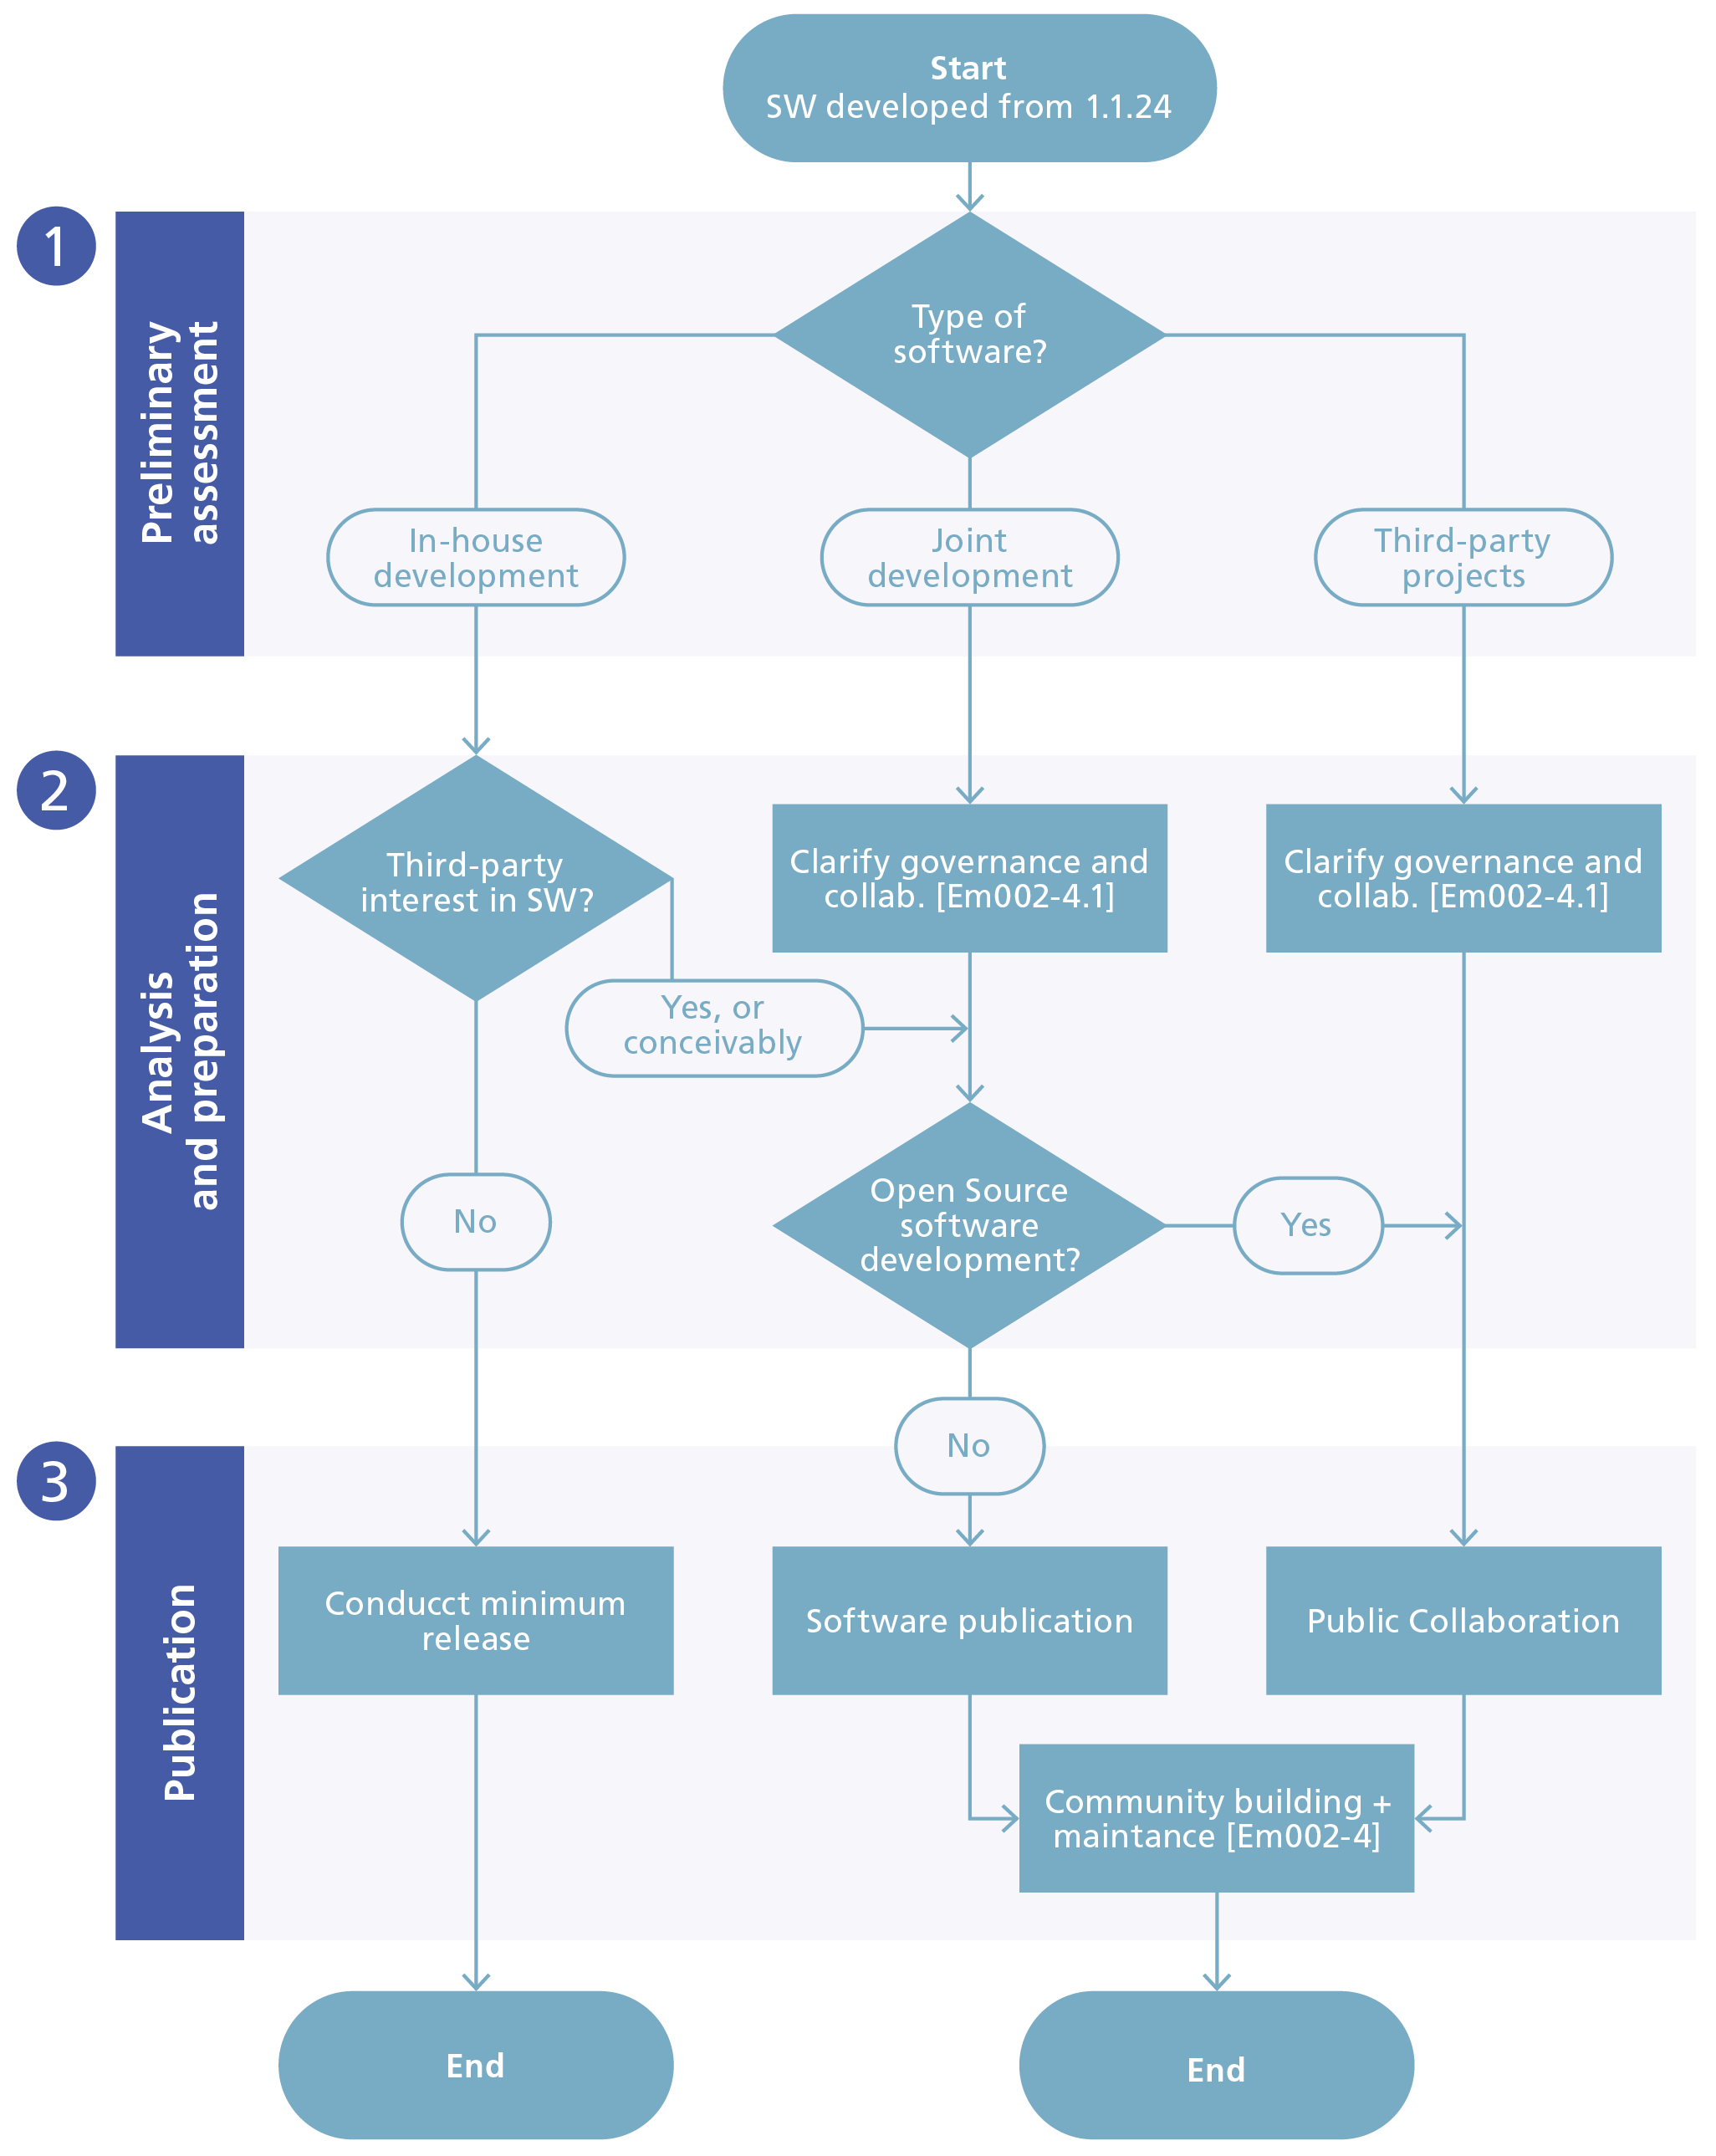

Figure 1 - Decision tree for software release.

# Preliminary clarification process

**Objective:** Understand the advantages and possible consequences of publishing the software. Decide whether the software can be published and if so, whether building an active community is worthwhile. NB: [*Em002-2.1 Preliminary Assessment Checklist*](em002-2.1.md) *[Em002-2.1]* should be completed as early as possible in the project, as this can influence the way the software is developed.

## Release under EMOTA

According to Art. 9 of the Federal Act of 17 March 2023 *[EMOTA2023]* on the Use of Electronic Means to Carry Out Official Tasks (EMOTA), the Federal Administration (specifically Art. 2 para. 1) must disclose the source code of software that it develops or commissions for the fulfilment of its duties. Exceptions apply when third-party rights or security-relevant grounds preclude or restrict this.

For custom software created on behalf of the Confederation, the General Terms and Conditions of the Confederation *[FOBL-GTC]* generally apply. Under clause 25.1, these stipulate that ownership of source code and documentation transfers to the service recipient (the Confederation). If the software was jointly procured by multiple organisations or other institutions, ownership usually lies with an association established for this purpose.

The mere use of standard software is not covered by Art. 9 EMOTA, and release would generally not be possible anyway, as the rights to standard software often remain with the vendor (GTC Confederation for Standard Software Procurement). (Art. 332 CO in conjunction with. Art. 6 para. 2 FPA) However, custom extensions to standard software are certainly suitable for publication. Normally, these are owned by the Confederation. Mere configuration adjustments are less suitable for publication.

### Software in relation to EMOTA

The current ISO/IEC Standard 24765 contains three definitions for software:

1. a program or set of programs used to operate computers
2. programs and their associated documentation
3. programs and, where applicable, associated documentation and other data necessary for computer operation.

Based on this definition, smaller scripts, macros or Infrastructure as Code (IaC) are also classified as software. EMOTA refers to source code in Article 9 paragraph 1. Under this interpretation, publication according to definition 1 would suffice.  
However, publishing without associated documentation is of little value, as the software cannot be used according to definition 2.

To achieve synergies with third parties, definition 3 must be taken as a basis. Regarding data, this specifically means master data and basic configurations (for example, enumeration values and basic data that should also be made available as open source).

Smaller projects, scripts or code examples may also be published together in one repository if deemed appropriate by the federal authority. In this case, these instructions and the corresponding checklists can be completed once.

Proportionality and effort should be considered when deciding what to publish and how.

### Type of software

As shown in Figure 1, a distinction is made between in-house development, joint development and third-party projects. Each constellation has different implications. Regardless of how the software is developed, it falls under Art. 9 EMOTA.

With in-house development, the Confederation creates the software itself or commissions it accordingly. It chooses the governance and retains the rights to the source code.

In joint development, the Confederation creates the software with other organisations. The governance and rights to the software must be regulated through the chosen form of organisation.

If the Confederation contributes directly to third-party software, this source code also falls under Art. 9 EMOTA. It must be ensured that this is done in accordance with federal authorities’ interests, that participation meets the project requirements, and that the Federal Administration adheres to the governance.

This is done using [*Em002-2.1 Preliminary Assessment Checklist*](em002-2.1.md) and [*Em002-4.1 OSS Community Checklist*](em002-4.1.md)*.*

### Legacy code

For old software (**legacy software**), the retrospective effort for publication is higher than if release was planned from the beginning. For legacy software, it only makes sense to make this effort if a potential user wants to use the software. Regardless, *Em002-2.1 Preliminary Assessment Checklist* should be completed to document relevant decisions.

Applications which federal authorities began to develop on or after 1 January 2024 or which are being developed on behalf of the Confederation based on a contract concluded after 1 January 2024 are not considered legacy and in, any case, fall under the publication requirement according to Art. 9 para. 1 EMOTA.

The publication requirement under EMOTA is not dependent on the benefit to third parties.

### Libraries, plug-ins and add-ons

In some cases, the software may not be a standalone application but only parts thereof. EMOTA and the ordinance do not further define source code. The instructions also apply to decoupled libraries, plug-ins and add-ons, and these fall under EMOTA.

**Tasks:**

* Gather information from [*Em002-5 EMOTA and OSS Factsheet*](em002-5.md). This describes both general information about open source software and specific information about applying EMOTA.
* Check whether the requirements under EMOTA are met.
* Complete [*Em002-2.1 Preliminary Assessment Checklist*](em002-2.1.md)*.* As a rule, it makes sense to directly involve the contact persons from the software supplier/developer.
* If needed, complete [*Em002-4.1 OSS Community Checklist*](em002-4.1.md).

**Decision:** Does the software have to be published and how should this be done?

## Exception: Third-party rights

Publication must be avoided if doing so would violate third-party rights. If the software was developed by federal employees, the rights belong to the employer. [General Terms and Conditions of the Swiss Confederation, in particular Section 25.1](https://www.bkb.admin.ch/bkb/de/home/themen/agb.html#accordion_21321111141713247349255) In contracts for staff leasing and IT services, the rights are usually transferred to the Confederation and should be claimed.

If the software was or is being developed on the basis of the General Terms and Conditions of the Swiss Confederation (as of 2024), [Information Security Act, ISA. Art 6 Information security](https://www.fedlex.admin.ch/eli/cc/2022/232/en#art_6), the intellectual property rights belong to the client, unless contractually agreed otherwise.

An application typically consists of numerous individual components and parts. With some types, it becomes problematic if they themselves are not open source or cannot be published under an open source licence as part of the application.

**Libraries**

Depending on the programming language, libraries are either directly compiled with the application, linked, or delivered as packages. They form an integral part of the application.

If the application contains proprietary or licence-requiring libraries, then open sourcing becomes more difficult. In principle, the source code of the rest of the application can be published, but potential users or developers would need to purchase the relevant library before the application becomes usable or extensible.

If ownership of the problematic library lies with the application supplier, it is worth seeking legal clarification as to whether the Confederation has transferable rights to these libraries.

Where possible, proprietary and licence-requiring libraries should be avoided with in-house developments or replaced if possible before release. Considering the objective of Article 9 EMOTA, as much functionality as possible used by public administrations should be published. Therefore, individual libraries that prevent code publication represent a technical debt that should be documented and, where appropriate, eliminated when the opportunity arises.

**Databases and other data storage**

If the application uses proprietary, licence-requiring data storage such as Microsoft SQL Server, this is not an obstacle to open source publication.

However, it should be examined whether additional open databases such as PostgreSQL can be supported. This can save operating costs and lower the entry barriers for potential users.

**Application servers and operating systems**

If the application requires licensed operating systems or application servers (e.g. Microsoft Windows Server or RedHat JBoss), this is not an obstacle to open source publication.

We recommend asking the software vendor whether licensed third-party libraries are used as components of the application and, if so, which ones.

If the software was jointly procured by multiple organisations or other institutions, ownership usually lies with an association or other legal entity established for this purpose.

**Other intellectual property**

Third-party rights include not only copyrights but also other intellectual property (trademarks, patents). Patents do not fundamentally prevent software from being published as open source, but they may prevent it from being used or enhanced. While patents are rather uncommon in Switzerland, it is usually worth making a brief enquiry to the software vendor about whether an examination has already taken place.

**Acquisition of necessary rights**

To fulfil the legal requirements of EMOTA, the federal authority has the option as the contracting authority to secure the rights to the work results. This prerequisite for publication can be defined as an award criterion during procurement. Acquiring necessary rights to the software afterwards can become more complex.

If the federal authority does not want to publish the software itself, it can delegate this task to the contractor, for example, or transfer the publication rights accordingly. In this case, it will transfer the necessary rights (and obligations) to the supplier and/or third parties and commission them with publication. This means that the right is effectively transferred to a third party under the condition of release/support of the corresponding software.

**Procedure**

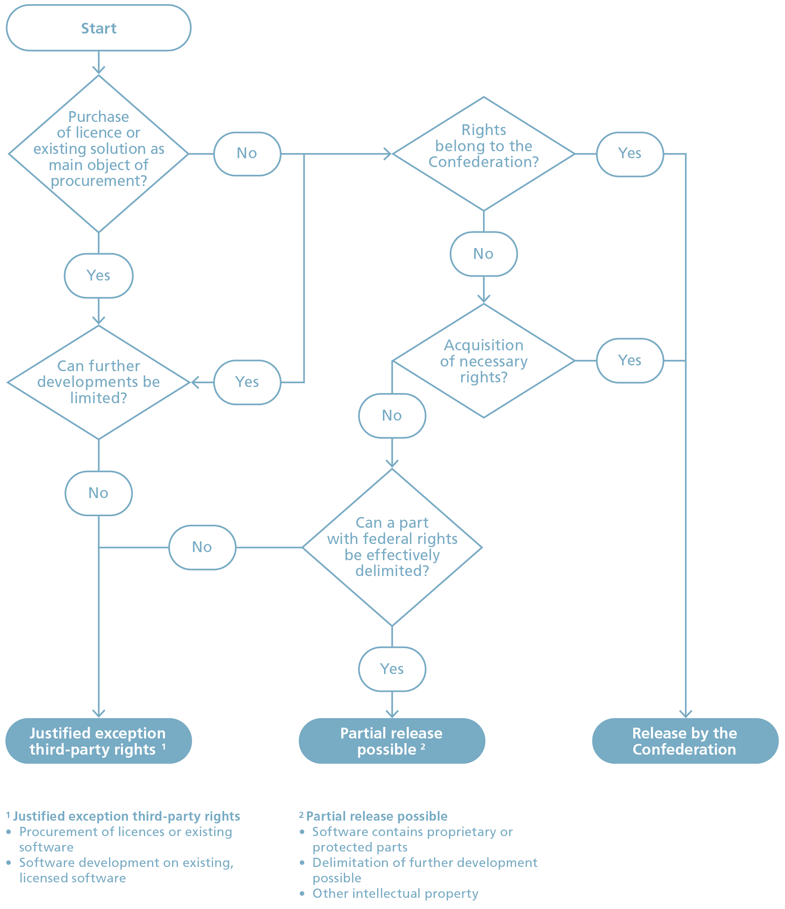

Figure 2 - Exception: Third-party rights

**Tasks:**

* Check whether the organisation owns the relevant protective rights to the software.
* Check whether the rights can be acquired.
* If necessary, obtain written permission from the rights holders.
* Verify that the application contains no proprietary or protected parts.
* Check that there are no obstacles due to patent protection (as far as possible and reasonable).
* Check whether release should be done by third parties (in anticipation of Section 0).
* Check whether development should follow open source software development (using [*Em002-4 OSS Community Guidelines*](em002-4.md), see also Section 0 ).

**Decision:** Can the software be published without violating third-party rights?

## Exception: Security-relevant reasons

Software that cannot be published on security-relevant grounds is exempt from publication.

The actual data of software is not affected by source code publication. This data is usually sensitive and is not published. However, it may be that besides the content data, certain algorithms and procedures visible in the source code should not become public (e.g. offensive cyber capabilities, details of fraud detection). Security can relate to confidentiality, integrity, availability or traceability.

**Recommendation:**

Software should be deliberately developed so that no additional risk arises even when the source code is published. The assumption that non-publication protects against successful attacks is deceptive (‘security through obscurity’).

**Procedure:**

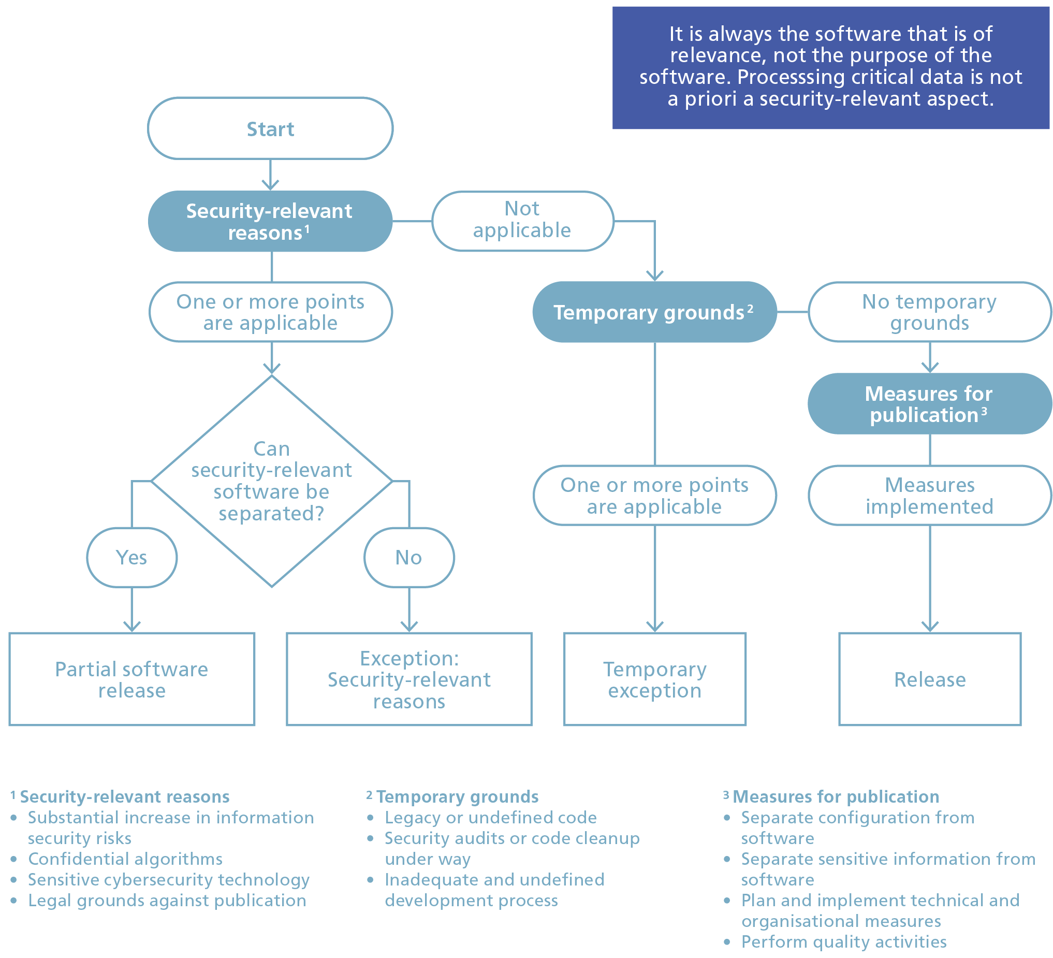

Figure 3 - Exception: Security-relevant reasons

The following grounds can be considered security-relevant for each project:

* Publication of the software would substantially increase an [information security risk](https://www.fedlex.admin.ch/eli/cc/1999/404/en#art_70).
* For fraud prevention algorithms and similar algorithms, publication may be waived where appropriate.
* Particularly sensitive cybersecurity technologies.
* Core software for operating critical infrastructure.
* When publication would violate other legal foundations.

The following temporary grounds may still prevent publication. However, publication will be enabled later through appropriate measures.

* Legacy code could not yet be cleaned up and may contain security-relevant issues.
* Security audits of the code have not yet been conducted.
* The development process is not mature enough to enable secure publication. If the development process is not sufficiently established, it is possible that parts intended not for third parties might be published. For example, code commenting guidelines and test data generation must be adapted to the new publication scenario and function reliably.

Through the following measures, software can be published despite security-relevant grounds:

* Separate configurations (e.g. type of encryption used) from the software.
* Outsource technically sensitive information (e.g. processes, calculations) that is not public into configurations or settings.
* Plan, implement and regularly practise suitable organisational, personnel and technical measures.
* Plan and carry out appropriate quality activities during publication. See the following section ‘Analysis and preparation’.

**Tasks:**

* Check the software for security-relevant grounds that would prevent publication.
* Estimate effort required to resolve temporary grounds.
* Plan measures to separate security-relevant information from the software’s source code.
* Ensure that the application contains no procedures that must not become public.

**Decision:**

Are there compelling security-relevant grounds that make publication impossible?

## Clarification of publication

This step clarifies who will publish the software. If the software was created by an external vendor, the publication can also be commissioned to that vendor. In this step, it is important to determine where the source code will be published and to establish appropriate governance accordingly.

If the software was developed internally at the Confederation and the Confederation cannot or does not wish to publish it itself, a publication order can be placed with a supplier or the rights can be assigned (transfer of obligations to a third party).

**Minimum release and support**

EMOTA does not specify any requirements regarding publication. A minimum release of the source code fulfils the legal requirement. No further activities are required. The question of whether and to what extent support is offered and how actively the project is maintained can be answered using [*Em002-4 OSS Community Guidelines*](em002-4.md)*.*

**Open source software development (OSSD)**

With open source software development (OSSD), in addition to publishing the source code, the entire development process is conducted publicly. Everything from requirements (issues) to source code is transparent. OSSD is supported by public communication tools (mailing lists, forums, etc.), a version control system (git), bug and feature lists, roadmap and developer tools. Through this transparent working method, the entire community benefits and enables collaboration across organisational boundaries. With this approach, no further publication activity is necessary upon project completion, as this was already considered at the project’s start.

**Tasks**

* Create a rough effort estimation for the analysis phase. Depending on the size and complexity of the application, the effort ranges between three days and two weeks.
* Release resources for further steps, particularly for analysis.
* Agree in principle to publish the application as open source.

**Decision:**

Basic agreement and feasibility for publishing the application as open source is given.

## Minimising effort

The checklists and instructions are structured to minimise the effort required for releases. Consistent advance planning of the release at project start and development designed for release minimises effort. Some administrative effort and costs will inevitably arise [Le2023]. These can potentially be recovered through communities with shared development costs (see [*Em002-4 OSS Community Guidelines*](em002-4.md)*)*.

## Choice of publication language

The choice of language must consider both the potential target audience and the team’s working methods. Fortunately, translations are much easier with new tools. The official languages of the Confederation[10] and English are possible options. If the project is internationally relevant, English should be the target language. For subsequent publication, it naturally makes little sense to change the language.

At minimum, the README.md should be available in multiple languages so that interested parties can immediately see if the project is relevant to them.

Public communication should primarily consider the target audience. It should also be considered that this is public communication from the Confederation.

**Note**: With publication, the Federal Administration enters a new channel of public communication. If this is not done carefully and professionally, the public image of the Confederation can quickly suffer.

# Analysis and preparation

**Objective:** The work required for open source publication is completed.  
Decisions regarding licence and type of community have been made. This is done using [*Em002-2.2 Analysis and Preparation Checklist*](em002-2.2.md).

## Source code analysis

The source code to be published and other related documents are analysed prior to publication. This analysis ensures that no confidential information is published.

If extensive source code is planned for publication, it is recommended to use appropriate automated tools for the following activities. The details are defined in Section E.

**Tasks**

* Check how existing code quality and guidelines have been implemented  
  (e.g. [ISO/IEC 25010:2023](https://www.iso.org/standard/78176.html)).
* Ensure that no sensitive (test) data is included, e.g. data based on real people or cases.
* Update software documentation (see annex).
* Delete unnecessary files or outdated documents and data.
* Check source code for [secrets/credentials](https://www.ncsc.admin.ch/ncsc/en/home/aktuell/im-fokus/2022/git.html).
* Conduct targeted security testing and subsequently establish a (public) [bug bounty programme](https://www.ncsc.admin.ch/ncsc/en/home/infos-fuer/infos-it-spezialisten/themen/bug-bounty-programme.html).
* Check all used libraries regarding licences and create corresponding lists (attributions).
* Describe deployment (CI/CD pipeline) and possibly set up a demo instance.

These activities are independent of publication but are prerequisites for good software quality and ensuring compliance. Observing these measures simplifies collaboration, increases the quality of external contributions, and enhances the image of the software or the authority.

## Licence selection

**Refer to** [***Em002-3 OSS Licensing Guidelines***](em002-3.md)**.**

Internationally established licence texts should be used where possible and appropriate. Liability claims by licensees should be excluded to the extent legally possible.

**Tasks**

* Check any dependencies on existing licences.
* For third-party code, check terms of use for compatibility with intended licence and replace code if necessary.
* Select appropriate licence.

Tools such as [Black Duck](https://www.blackducksoftware.com/), [FOSSA](https://www.fossa.com/) or [FOSSology](https://www.fossology.org/) can be used to check licence compatibilities. The [ToDO Group](https://landscape.todogroup.org/) provides an up-to-date overview of tools.

**Decision:**

* Determine and document under which the licence the software will be published.

## Open source documentation

A minimum set of documentation is expected with publication. Several documents have become established in the open-source ecosystem. This gives visitors a quick insight into the software including licensing.

The following documents are expected:

|  |  |
| --- | --- |
| Document | Description / Content: |
| README(.md) | Serves as an entry document and provides a quick overview of the project’s purpose, scope, status, licence and target groups. |
| LICENSE | Description of the chosen licence in the project |
| CONTRIBUTING(.md) | Describes the process of how to contribute to the project. |
| CODE_OF_CONDUCT(.md) | The Code of Conduct establishes expected social norms within the project. |
| CHANGELOG(.md) | Maintains a list of changes in software versions. |
| THIRD-PARTY-LICENSES(.md) | Description of third-party licences or used components. |
| Getting started | Brief guide on how to install and use the software. |
| Create Gitignore | Describes documents that will not be published, e.g. configurations, test data or generated content. Protected and sensitive information should be managed outside the project in appropriate designated tools and storage. |

Table 1 - Open source documents

Further technical details of these documents are described in the annex.

**Tasks**

* Create standard documentation.
* Include copyright, licence notices, and disclaimer in all files.
* Depending on the publication platform, additional descriptions can be made.

**Decision:**

* Final decision to publish the application as open source.

# Publication and announcement

**Objective:** The application is published as open source and easily findable by third parties. All components are ready for publication and the community is built or established. This is done using *Em002-2.3 Release and Publication Checklist*.  
To a certain extent, it involves recapitulating decisions already made.

## Choice of platform

There are several ways to publish source code. The following table provides an overview of possible source code management (SCM) systems and platforms.

The suitable platform must be selected prior to actual publication. Some federal authorities are already represented on GitHub. The website https://ossbenchmark.com gives an overview of organisations and authorities that are active on GitHub. In this case, it makes sense to use platforms already established.

**Recommendation:**

We currently recommend setting up an organisation on GitHub per federal authority for publishing source code. Within this organisation, corresponding projects (repositories) can be created and users with appropriate permissions managed. In the future, a central federal platform should be established. To maintain optimal user management and preserve the reputation of the Swiss Confederation, it is important to use fewer, but better-managed repositories.

|  |  |
| --- | --- |
| Platform | Properties |
| [GitHub](https://github.com/about/) | Microsoft’s online platform with wide distribution. A large amount of open source software is hosted on GitHub. Offers many additional tools besides SCM.Available in both Free and Enterprise versions (subscription). |
| [GitLab](https://about.gitlab.com/) | Online platform from the company of the same name GitLab, which is itself published under an open source licence. Offers many additional tools besides SCM. Can also be operated locally, thus providing a degree of sovereignty.Available in both Free and Enterprise versions (subscription). |
| [Bitbucket](https://bitbucket.org/product/en) | Atlassian’s online platform, specifically integrated into its ecosystem.Available in both Free and Enterprise versions (subscription). |
| Internal SCM system | If own SCM platform is provided, it can also publish and make certain repo/projects available. Operation must be ensured. |
| Federal platform | There is currently no central federal platform for publishing software. A measure to this effect is proposed in [Em002 Strategic Guidelines for Open Source Software in the Federal Administration](em002.md). |
| Website, public FTP server, etc. | EMOTA does not define how software should be published. A minimum release according to Section 0 can also be done on a website or other publicly accessible resources. However, this is not suitable for sustainable collaboration in the sense of open source. |

Table 2 - Platforms for publishing open source software

If the software is published jointly with an external partner or organisation, care must be taken to ensure that appropriate permissions and access to the source code are available.

**Tasks**

* Evaluate suitable platform, including corresponding organisation/project.
* If not yet clarified, determine project/repository naming.
* Define and check permissions on the repo.
* Ensure appropriate governance and any replication of source code.

**Decision:**

* Platform for publication has been appropriately chosen.

## Software publication

When the prerequisites are clarified, the software can be published.

**Tasks**

* Check prerequisites against the *Release and Publication Checklist*.
* Access to platform is available and governance clarified.
* Publication of source code and documentation by the developer.

## Communication

After actual publication, further communication activities can be initiated by and within the federal authority concerned. These help with distribution and bring the desired added value from publication.

**Tasks**

* Description in repo hosting, security settings, etc.
* Internal and, if applicable, external communication
* Write a message to the community.
* Make the application known within the organisation and in specialist committees, promote its use and contributions.

## Community building and maintenance

When publishing software, a community can develop that can contribute to the software through contributions (pull requests), questions, documentation suggestions, etc. To have an active community, considerable effort is required for both building and continuous maintenance. A well-functioning community minimises unwanted forks of the software. The goal here is to activate the added value of the community through targeted activities. Even with minimum publication, handling feedback and questions about the software should be defined.

**Tasks**

* Clarify who potential users or interested parties are.
* Determine the appropriate form for the specific application using the *OSS Community Guidelines*.
* Build the community.
* Community building activities.

# Annex

## Changes from previous version

New document

## References

See [*Em002 Strategic Guidelines for Open Source Software in the Federal Administration*](em002.md).

## Abbreviations

See *Em002 Strategic Guidelines for Open Source Software in the Federal Administration* and [*Em002-6 FAQ on OSS and Art. 9 EMOTA*](em002-6.md)*.*

## Accompanying documentation for the *Analysis and Preparation Checklist* - Documentation

### Source code documentation

The documentation should be part of the project’s source code to ensure that changes to the documentation are stored in a revision-secure manner and the documentation is versioned alongside the project. This automatically ensures that the documentation, if properly maintained, does not diverge from the project’s development status, and documentation for older versions of the project can be retrieved at any time.

Furthermore, this gives third parties the opportunity to easily contribute changes to the documentation.

Markdown should be used as the markup language for the text formatting as it is easy to write, widely used, and machine-readable. Additionally, markdown documents are displayed in a well-readable target format by all common platforms. Markdown documents can be rendered into any target format independent of the platform used, using static site generators such as Jekyll, MkDocs, Gatsby, or Sphinx, for example, with the corporate identity specifications of an administration.

### Documentation recipients and structure

The project documentation should address both end users and technical professionals, thus not focusing solely on technology. For language selection, see Section 3.6. This supports the software’s distribution.

A README.md file serves as the entry document. Files with this name are recognised and displayed as the entry point to the documentation by all common platforms. For more information on creating a readme file: <https://www.makeareadme.com/>

README.md should provide a quick overview of the project’s purpose, scope, status, licence and target groups. Specifically, README.md should include the following points:

* Software name
* Brief description of the software’s purpose and function. Scope and possible limitations
* Installation guidelines
* How to use the software
* Reference to any demo instance
* Support and contact details
* How to contribute to open source software (Contributing)
* Licence used (Licence)
* Project status / development status

### Emphasising open source and licence storage

Directly after the mission statement, it should be clearly and unambiguously stated that the project is open source software. The licence used by the project should be specified with the corresponding [SPDX identifier](https://spdx.org/about) and linked to the specific licence text in the LICENSE file. Licence templates typically include a variable part (e.g. project name, copyright year, author’s name) that must be adapted in the LICENSE file.

Most platforms recognise licences in a LICENSE file and offer clear information about the licence, e.g. a brief summary of the licence terms.

It is recommended to add a minimum licence and copyright header to each source file that is created. Existing headers in existing files should not be changed. If contributing to a project that has clear standards for headers, these should be followed.

For more details see: Producing Open Source Software: [State That the Project is Free](https://producingoss.com/en/getting-started.html#state-freedom).

### Current development status

To quickly show the project’s state, the current development status should be documented in README.md. It is important for readers to know whether the project is in a mature state or at the beginning of development, whether it is actively maintained, and how frequently new versions are published.

This section can describe what type of third-party support is currently most important for the project. This could be, for example, a developer with specific technological knowledge or someone to revise the project’s documentation.

For further details, see Producing Open Source Software: [Development Status](https://producingoss.com/en/getting-started.html#development-status).

### Demo instance

For applications, it is recommended to provide a demo instance so that the application can be tried without installation effort. Depending on the type of application, the demo instance can be the productive installation or a test stage. It is important that readers can access the corresponding instance as independently and directly as possible.

As an alternative, many open source projects provide tools for easily starting the application. This can be done using containers, portable applications or install scripts, for example.

### Subject matter expert and project owner

The README.md file should name the primary subject matter expert so that other interested administrations and organisations can make contact as directly as possible.

Personal email addresses should not be used.

The README.md file should also briefly describe which organisation is the project owner, especially if an association has been formed for the project.

### Installation documentation

For applications, README.md should reference installation documentation that describes hardware and software requirements, which infrastructure components (for example, databases) are used, and how the application can be installed and operated.

### Developer Guidelines

The entry point for the Developer Guidelines should be stored in a markdown file CONTRIBUTING.md, which is linked in README.md. The Developer Guidelines are part of the extended documentation for developers who want to contribute to the project and primarily focus on collaboration and communication within the project rather than on technology.

The Developer Guidelines should include the following points and reference the corresponding documents where appropriate:

* A reference to the project’s Code of Conduct. The Code of Conduct establishes expected social norms within the project.
* It is recommended to choose or build upon the Contributor Covenant Code of Conduct licensed under CC-BY-4.0 as the [Code of Conduct](https://www.contributor-covenant.org/version/1/4/code-of-conduct.html).
* A note that the project conducts code reviews in the form of GitHub pull requests, with a reference to the GitHub pull request documentation.

Finally, reference should be made to the Developer Documentation.

### Developer Documentation

While the Developer Guidelines describe the collaboration and social norms of the project, the Developer Documentation focuses on the technical aspects of participating in the development of the project. It should describe at least the following points:

* What technical dependencies the project has and which tools are necessary for project development.
* What formal rules apply to the project’s source code, for example regarding source code formatting.
* How the project’s source code is organised and how functions can be technically tested.
* An architecture sketch with a rough description of the architecture, preferably including context demarcation and rough component view. Architecture framework MMB (Bund Modelling Method) or [arc42](http://arc42.org/).
* For applications: How the application can be started for development or debugging purposes and what infrastructure components are necessary for this.

## Accompanying documentation for the *Analysis and Preparation Checklist* - Source code

### Source code history

A project’s source code is usually stored in a source code management (SCM) system such as GitHub. These systems store not only the current state of the source code but also changes that have been made to the source code over time. In particular, this includes deletions from the source code, including deleted files.

In addition, the SCM contains meta-information about changes to the source code, such as the author’s name and email, or PGP signatures for signed commits and tags.

### Sensitive, proprietary or confidential data

The source code and source code history of the project may contain publicly available data, such as a postcode directory, randomly generated data or synthetic data.

The source code and source code history must not contain any sensitive or confidential (personal) data or information as defined by the Federal Act on Data Protection (FADP) and the Information Security Act (ISA). This includes, in particular:

* User names and passwords or other secrets such as private keys, access tokens or certificates.
* Internal DNS names, URLs, host names, IP addresses, network structures or drive names.
* Names, addresses, pictures or similar personal data without the consent of the person concerned
* Anonymised or pseudonymised data (because it is possible to undo anonymisation or pseudonymisation)

Even if the current state of the source code is free of sensitive, proprietary or confidential data or information, such data or information may still be retrieved from the SCM system history if it was ever part of the source code or SCM meta-information in the past. Cleaning up the current source code state will not completely remove this information.

Therefore, if in doubt, it is recommended to completely remove the source history after cleaning up the source code, before publishing the source code.

The names and email addresses of the authors of the source code are usually available directly in the source code or in the SCM metadata, for example in GitHub commits or annotated GitHub tags. From a legal point of view, this is not a problem, as the developer company is responsible for regulating the publication of such information. However, it is recommended that the developer company or internal federal employees are made aware that the names and email addresses of the source code authors may be disclosed when the software is published.

### Removing author information

The history on GitHub can be changed to hide author information. [Tools](https://www.adamdehaven.com/blog/update-commit-history-author-information-for-git-repository/) can automate this step to a large extent.

Removing author information removes attribution, traceability, and contact information. The effort involved should not be underestimated, depending on the volume of source code. For these reasons, author removal is not recommended.

### Consideration of library licences

Virtually every project uses third-party libraries (software libraries, dependencies) to access commonly used functions without having to code them. These libraries usually depend on other libraries, resulting in multi-level dependencies (transitive dependencies). Depending on the programming language, even small projects can have hundreds of dependencies.

The results of this clarification must be considered when choosing a licence in accordance with the [*Em002-3 OSS Licensing Guidelines*](em002-3.md) and in the [*Em002-2 Instructions for Publishing OSS*](em002-2.md).

For each of these dependencies, ensure that its licence is compatible with the project licence. Dependencies that are not under an open source licence or which have not declared a licence or use a viral licence that does not match the project licence are particularly problematic. Some libraries are licensed under more than one licence and allow the user to choose one.

* In all major programming languages, the dependencies of the project (including transitive dependencies) and the licences of the dependencies can be automatically listed. These include:
* [The Project Info Reports plugin](https://maven.apache.org/plugins/maven-project-info-reports-plugin/plugin-info.html) for the Apache Maven package manager for Java projects, which uses the dependency report to generate an HTML output of all used libraries, including the declared licence.[30]
* T[he NPM Licence Checker](https://github.com/davglass/license-checker) for the NPM Package Manager for JavaScript projects, which can output all libraries used, including the declared licence, in various formats, e.g. CSV.[31]
* [Pivotal’s Licence Finder](https://github.com/pivotal/LicenseFinder), which supports various package managers and programming languages, including Ruby Gems, Python Eggs and Godeps.

**Use of libraries with proprietary licences**

Libraries under a proprietary licence are generally problematic in open source projects and usually cannot be used, especially if the source code has been published under a viral licence such as the AGPL.

Please contact the vendor and the legal department of the relevant office to check whether and under what conditions the proprietary library can be used in your project.

### Using package managers

Virtually all popular programming languages provide package managers for managing their dependencies, such as Apache Maven for Java projects, NPM for JavaScript projects or NuGet for .NET projects.

When using a package manager, the dependencies used by the project are no longer directly part of the project’s source code, for example by copying the dependency’s source code into the project or by copying the dependencies into the project in binary form. Instead, the project obtains all its dependencies via the package manager’s declarations.

This allows all dependencies to be listed and referenced correctly. It also prevents unintentional modification of dependency code. If changes are necessary, they must be made directly at the source of the dependency.

### Project licence declaration in the package manager descriptor

The project should declare its licence in the appropriate package manager descriptor, using the [SPDX identifier](https://spdx.org/) so that the project licence can be issued by the package manager. This is particularly important for libraries so that users of the library can automatically query their licence via the package manager.

### Attribution and copyright notices

Many libraries are subject to a licence that requires the library user to give an original copyright notice or attribution.

These include the following licences (excerpt):

Apache 2.0, ASL 1.1 (Apache 1.1), BSD, BSD 3-Clause, Creative Commons ‘Attribution’ (CC BY), MIT, ISC

For others, see the list of [OSI-accredited licences](https://opensource.org/licenses).

In practice, this concerns almost all libraries used. As the number of libraries used in small projects is already very high, a legally correct copyright notice or the necessary attribution is only possible with a great deal of effort.

It is therefore recommended to proceed as follows:

* Make a list of the libraries used, using the Package Manager’s mechanisms or tools such as the NPM Licence Checker or Pivotal’s Licence Finder.
* Prepare the list manually so that it contains the following information: official name of the library project, website of the library project, licence used for the library as SPDX identifier with a link to the licence text.
* Place the list in the project’s source code, e.g. in a THIRD-PARTY-LICENSES.md file.
* For applications: Include a link pointing to THIRD-PARTY-LICENSES.md in an ‘About’ or ‘About this application’ dialogue.
* The ‘About’ dialogue is widely used for this purpose, for example in Google Chrome (in the ‘About Chrome’ dialogue).
* For Libraries: Refer to the THIRD-PARTY-LICENSES.md in the README.md .
* As part of the code review process, ensure that changes to the libraries are added to THIRD-PARTY-LICENSES.md.

**Example Codeblock THIRD-PARTY-LICENSES.md**

This project uses open source software: * Spring Boot, http://projects.spring.io/spring-boot/licensed under [Apache-2.0](http://www.apache.org/licenses/LICENSE-2.0) * caniuse-db, https://github.com/Fyrd/caniuselicensed under [CC-BY-4.0](https://creativecommons.org/licenses/by/4.0/)

## Further sources and licence

The checklist, the accompanying documentation and related templates are based in part on the following sources:

* [Google Open Source Docs](https://opensource.google.com/docs/) by Google LLC, licensed under CC-BY-4.0[35]
* [Producing Open Source Software, How to run a Successful Free Software Project](https://producingoss.com/) by [Karl Fogel](http://www.red-bean.com/kfogel) licensed under CC-BY-SA-4.0
* [GitHub Healthy Contributions](https://docs.github.com/en/communities/setting-up-your-project-for-healthy-contributions)
* [Standard for Public Code](https://standard.publiccode.net/)