How to build AiMNET

You must be running Windows 10 version 1903 (build 18362) or later. Update your GPU drivers beforehand. To verify your Windows version is recent enough, open the start menu and search for the “dxdiag” program. Make sure the build number is at least 18362:

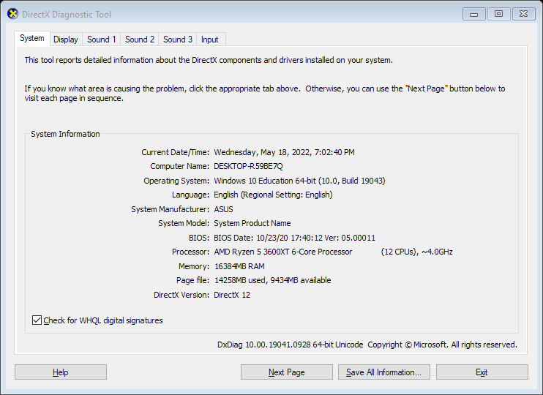



# Setup

1. Install Qt for Open Source from <https://www.qt.io/download-open-source>
   1. You will need to make an account in order to install
   2. Once downloaded, run the installer
   3. Select “MSVC 2019 64-bit” under “Qt 5.15” during the “Select Components” step  
      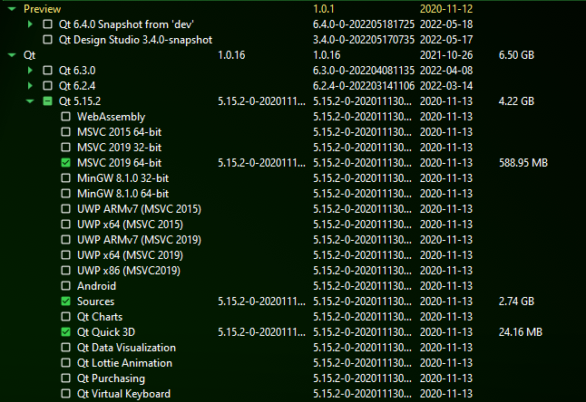
   4. Follow the prompts to install Qt
2. Install Microsoft Visual Studio 2022 Community from <https://visualstudio.microsoft.com/>
   1. 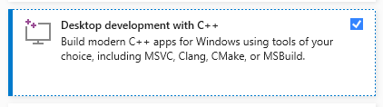Run the installer
   2. Make sure you have “Desktop development with C++” selected

# Compiling the code

There are two components to AiMNET, the client and server. Each must be built separately.

## Building InferenceEngine.exe

1. Open AiMNET-Server\AiMNET-Server.sln in Visual Studio
2. Make sure “Release” and “x64” are selected like in the screenshot:  
   
3. Then click “Local Windows Debugger”
4. If all goes well, it should take between 30 seconds and several minutes compiling the code
5. Once compiled, VS should launch InferenceEngine.exe. A black cmd.exe window will appear with a status message, and then the program will crash with this error:  
   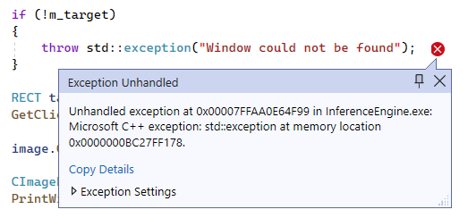
6. This is because you don’t have the game running—this should be expected. If you get to this error, that means everything is working correctly.

## Building Eagle-EYE-X.exe

Eagle EYE X was the old name for the client component. This you will need to build from Qt Creator.

1. Launch Qt Creator
2. Click “Open Project…” and navigate to Eagle-EYE-X.pro in the source code
3. Once the project is open, it will take a few seconds to index and load the code
4. Once that’s done, click the green arrow to run the code, or press Ctrl+R.
5. The green Eagle EYE X window should open, and after a few seconds you should see this output in the Qt Creator terminal:  
   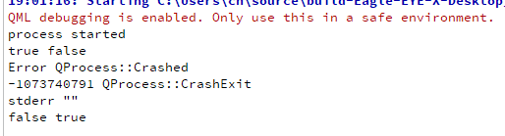
6. This means that InferenceEngine.exe crashed, which is what we expect to happen if the game isn’t running.

# Running AiMNET

To successfully use AiMNET you need to run the game Counter-Strike: Global Offensive. The game is free but you will need a Steam account to [download it](https://store.steampowered.com/app/730/CounterStrike_Global_Offensive/).

In order to avoid being banned by the VAC anti-cheat software, navigate to CS:GO in your Steam library, click the gear icon and then click “Properties”. Under “Launch Options” type “-insecure” without the quotes:  
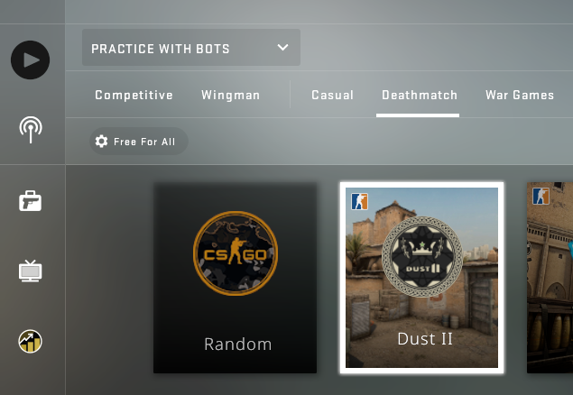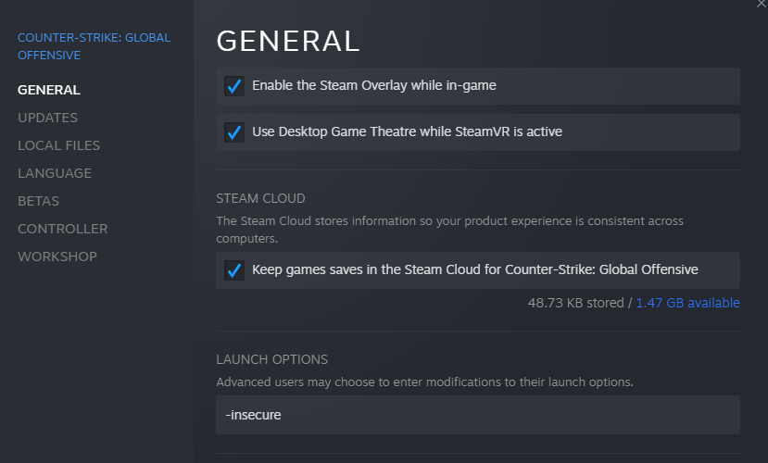



Then you can launch the game without any issues.

To get into a game to test AiMNET in, click the play icon, then select “Practice against bots”, then select “Deathmatch”, and finally pick a map to play on (Dust 2 is good). Then click “GO”

Once you’re in the game, choose a team. You are now ready to launch AiMNET. Go back to Qt Creator and click run again, after a few seconds the overlay window should pop up over the game, with status messages in the top-left corner.

AiMNET works best when you’re using a rifle or other powerful weapon in the game. If you are on the Terrorist side, press B then click Rifles, and click on the AK-47. On the Counter-Terrorist side, press B, click on Rifles, and click the M4-A4 or M4-A1S.

AiMNET will automatically aim and shoot at enemies when their heads appear in the yellow aiming reticle in the center of the screen. All you need to do is aim near the enemy and AiMNET will do the rest.

You are most accurate in CS:GO when standing still, so if you want AiMNET to have the best chance of hitting the enemy, stand still when you are ready to shoot.