Table of Contents

routerLift — Design and Implementation Plan
Document RTL-DESIGN-001 · Revision H (draft) · Date 2 September 2026, status updated 13 September 2026 · Status Issued for first review; bench bring-up in progress
Supersedes | Requirement Specification RevG (RTL-SPEC-001), Annexes B.8–B.10
Companion documents | SCHEMATIC-RevH.svg, WIRING-RevH.svg, PINOUT.svg, ARCHITECTURE-DIAGRAM.svg, BOM.md, DESIGN-QA.md
Repository | github.com/swissMack/routerLift @ c46ee84
Purpose of this issue | Review of the design before any firmware is written and before mechanical parts are ordered

1. Purpose and status
This document describes the design and implementation plan for an ESP32-based automated router lift, and is issued for first review. The electronics are largely in hand and bench bring-up has started (13 September 2026, recorded in BRINGUP-LOG.md): the FluidNC configuration is written and loads on the bare motion board, and the HMI firmware shows its display, reads touch and holds the UART link to FluidNC, including detecting link loss and recovering from it. Nothing is mounted on a lift and no cut has been made.
The design departs from Requirement Specification RevG in several recorded ways. Those departures are listed in section 5 and are the most important thing for a reviewer to challenge.

What is settled
The controller architecture, the I/O split, the communication protocol, the safety model, and the physical control panel are all decided and documented here. The host lift body is selected: the sauter FML-P, 1.5 mm screw lead and 65 mm travel.

What is open
steps_per_mm is 1066.67, derived from the FML-P’s published lead — not yet measured. The FML-P’s 65 mm travel is short of MEC-01’s ≥75 mm and needs a deliberate Rev H decision. The foot-switch dead-man behaviour and several other FluidNC details are still to be proven on the bench (section 14).

2. Executive summary
A single ESP32 cannot do this job. FluidNC — the motion firmware chosen for its proven homing, soft limits, probing and jog handling — does not run on the ESP32-S3, and the ESP32-S3 display board brings only ten GPIOs out to connectors, leaving it unable to carry the machine’s pin budget. The design therefore uses two controllers:
- A standard ESP32 running stock FluidNC for all motion and all safety enforcement. It is configured entirely by one YAML file; we write no code for it.
- An ESP32-S3 on a 4.3” touch panel as the operator interface, running our firmware. It acts as a GRBL sender over a UART link.
The governing principle is that the HMI proposes and FluidNC disposes. Soft limits, hard limits, homing and probing are enforced on the motion side. A fault in our HMI firmware can produce a wrong cutting depth; it cannot produce an unsafe move. The emergency stop is mains-rated hardware in series with the supply and is invisible to both controllers.
The design is more capable than the commercial FXBB FräsLift V3 it is modelled on — multi-pass cycles, probing, router interlocks, plural fault codes — but is honestly inferior in three respects: handwheel latency, a link-loss failure mode a single-board design cannot have, and the need for a computer to change commissioning values. These are discussed in section 11.

3. Architecture
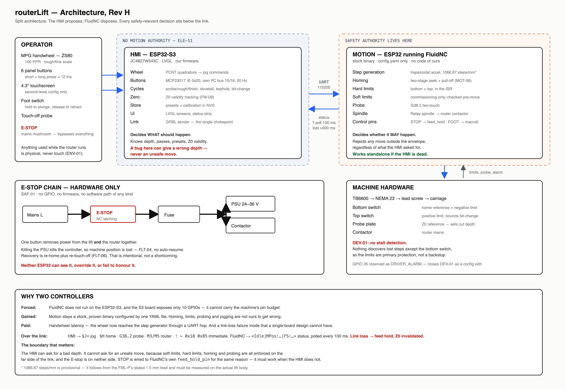
Architecture — ownership, the safety boundary, and what crosses the link

3.1 Why two controllers
Forced by | FluidNC does not run on the ESP32-S3, and the S3 board exposes only ten GPIOs on connectors
Gained | Motion stays a stock, proven binary configured by one file. Homing, limits, probing and jogging are not ours to get wrong
Paid | Handwheel latency through a UART hop, and a link-loss failure mode that a single-board design cannot have

3.2 The division of responsibility
The HMI (ESP32-S3) decides what should happen. It holds the cut depth, the pass schedule, the presets, and the Z0-validity state. It converts handwheel detents and button presses into GRBL commands.
FluidNC decides whether it may happen. It rejects any move outside the commissioned envelope regardless of what the HMI asked for, enforces limits in the stepper interrupt, and continues to work standalone if the HMI is dead.
The E-stop crosses neither boundary. It is an NC mains contact breaking the live feed to both the PSU and the router contactor. Neither controller can see it, override it, or fail to honour it.

4. Decisions taken
Decision | Choice | Rationale
Controller architecture | Split: FluidNC ESP32 + ESP32-S3 HMI | Forced — see 3.1
Old firmware | Retired to legacy/, kept unbuilt as reference | Preserves menu structure and NVS patterns worth porting
Display board | Guition JC4827W543C, NV3041A QSPI | The board in hand, as RevG records. Confirmed at bench bring-up 2026-09-13
I/O split | Operator inputs on the S3; every safety-relevant input on FluidNC | Keeps safety off the UART link
UART protocol | GRBL / G-code, HMI as sender | Keeps FluidNC stock — no fork, no custom build
Soft limits | Commissioning-only in config.yaml | An operator must not be able to widen their own envelope
Motor idle current | Permanently energised ($Stepper/IdleTime = 255) | Maximum holding stiffness; ENA wired so this stays changeable
Foot switch | Hold to plunge, release to retract | Dead-man behaviour
Link loss mid-cycle | Immediate feed hold, Z0 invalidated | No auto-resume; re-home and re-probe
Canned cycles in v1 | All four | Owner’s decision, full spec scope
Mechanics | Motorise a commercial manual lift body | Rigidity and guides bought in rather than engineered

5. Deviations from RevG — for review
These are the changes a reviewer should scrutinise most closely. Each was made for a stated engineering reason, and each will need a Rev H amendment to the specification.
# | RevG says | This design does | Why
1 | Display is a JC4827W543C with NV3041A QSPI panel (Annex B.10) | Withdrawn — no deviation | Rev H recorded an ESP32-4827S043 RGB parallel board here. That was mistaken: bench bring-up on 2026-09-13 confirmed the board in hand is the JC4827W543C, so RevG was correct
2 | Handwheel is a ZS61, 60 mm dial (Annex B.8) | ZS80, 80 mm dial | The unit in hand. Same 100 PPR and electricals, so scaling is unchanged; rim travel per detent improves from 1.88 mm to 2.51 mm
3 | HMI is display-only, no motion authority (ELE-11) | HMI owns the handwheel, buttons and cycle logic | A display-only HMI cannot host the operator controls the machine needs. ELE-11’s safety invariant is preserved; its scope wording is not
4 | TB6600 common anode at +5 V (Annex B.9) | +3.3 V | At 5 V the ESP32’s logic high leaves 1.7 V across the input optocoupler, above its LED drop, so it never fully turns off. Causes missed steps at rapid — silent depth error under DEV-01
5 | ENA± not connected (Annex B.9) | Wired to GPIO 14 | Without it the motor stays energised indefinitely with no way to de-energise, against ENV-03. Drive current is also cut from the RevG 2.8 A to 1.0–1.4 A/phase
6 | MPG on FluidNC GPIO 34/35 (Annex B.9) | HMI GPIO 6/7 behind a 74LVC14 on 3.3 V (corrected from 74HCT14, which needs 5 V and would drive 5 V into the S3) | Follows the I/O split. Flips MPG::SIGNALS_INVERTED to false, since a two-stage Schmitt buffer is non-inverting where the assumed PC817 optos were not
7 | Soft limits operator-editable (legacy Settings.cpp) | Commissioning-only | Prevents an operator widening their own protection, and keeps a safety-relevant setting out of HMI write access
Consequential reservation: GPIO 34 and 35, freed by deviation 6, are reserved rather than reused — 35 as DRIVER_ALARM, so that closing DEV-01 later is a configuration edit and not a rewire.

6. Pin assignment
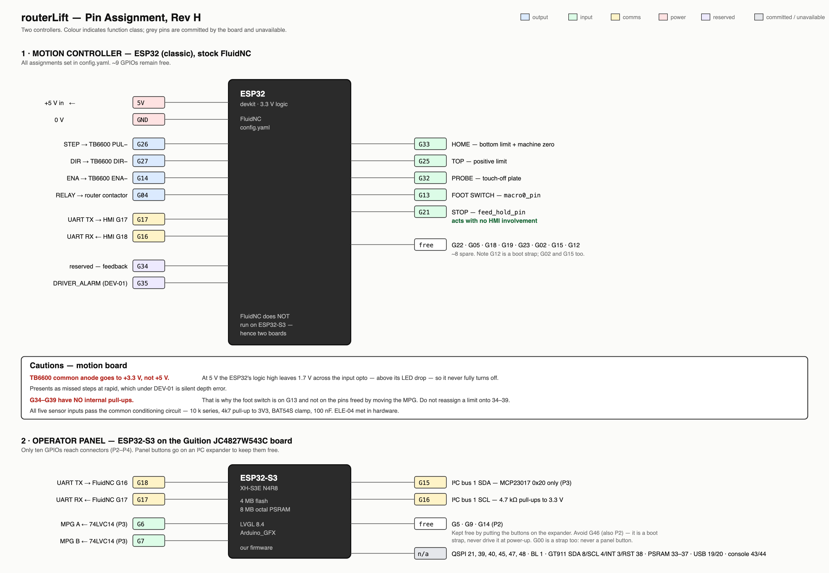
Pin assignment for both controllers. Greyed pins are committed by the display board and unavailable
The asymmetry is the point: the motion controller has roughly nine spare GPIOs, while the display board has three, one of which is a boot strap. This is why the panel buttons go on an I²C expander rather than on pins.

7. Schematic
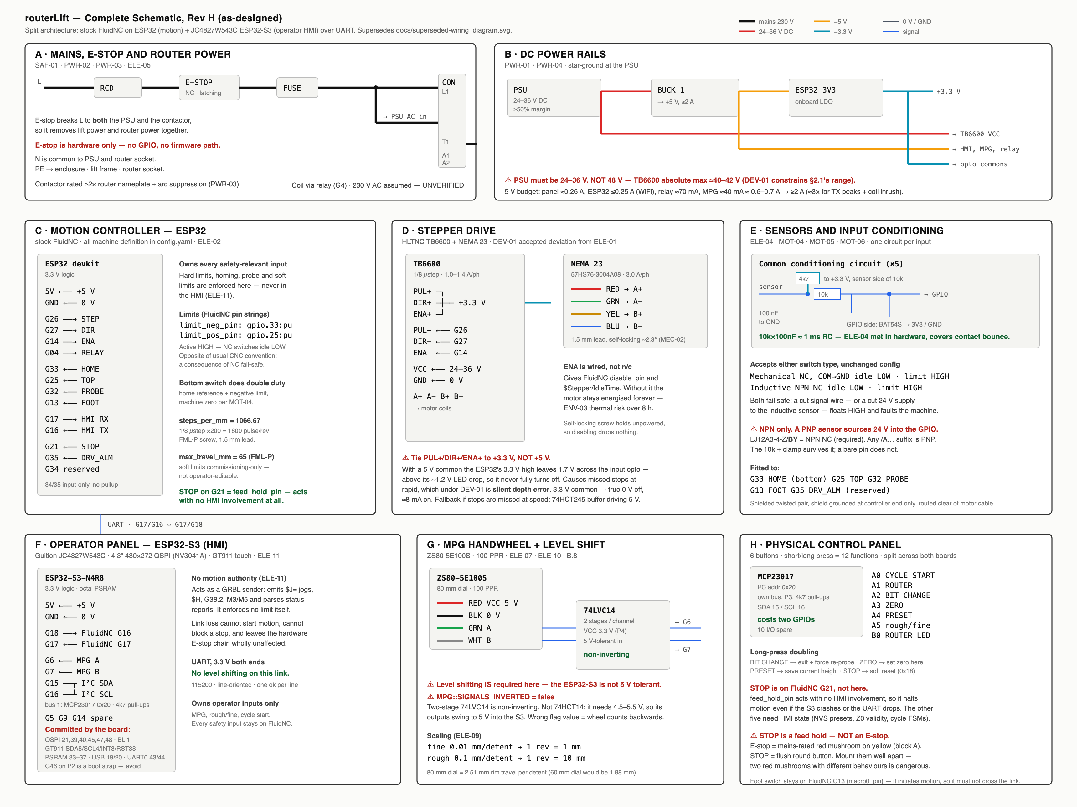
Complete schematic, blocks A–H

8. Wiring and installation
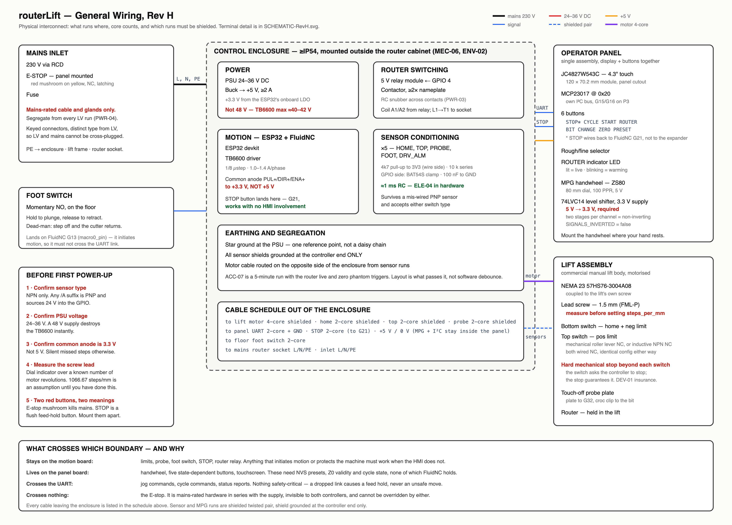
Physical wiring, cable schedule, and pre-power-up checks

9. Endstops, limits and safety
Three independent layers, owned by three different things. Nothing in the HMI appears in any of them.
Layer | Mechanism | Owner
E-stop | NC mains contact breaking L to PSU and contactor | Hardware only — no GPIO, no firmware path
Hard limits | limit_neg_pin: gpio.33, limit_pos_pin: gpio.25 | FluidNC — alarm state, motion halted in the ISR
Soft limits | Envelope from mpos_mm and max_travel_mm | FluidNC — move rejected before execution

9.1 Three tiers of limit
A distinction worth holding clearly, because conflating them leads to a design mistake:
Tier | Set by | Where | Changes
Hard limits | Physical switch position | Bolted to the machine | Never
Soft limits | Commissioning — travel and home reference | config.yaml | Once, at build
Job ceilings | Operator — presets and a teachable ceiling | HMI, in NVS | Every job
Job ceilings can only ever be narrower than the commissioned envelope, so the operator retains the useful affordance without being able to weaken the protection.

9.2 Why the limits carry unusual weight here
DEV-01 records that the TB6600 has no stall detection, so FLT-01 is unimplementable on this build. Open-loop stepping with no stall sensing lets position error accumulate silently — a step missed during a heavy plunge does not announce itself, it quietly shifts everything after it. Soft limits cannot catch this, because FluidNC trusts its own step count.
The bottom switch is the only thing that ever discovers the drift. Two consequences: the switches are primary protection here rather than a backstop, and the Z0-invalidation discipline of FW-09 must be strict, because a limit hit tells you something slipped but never how much.

9.3 Dual sensor support
Both mechanical and inductive switches have been bought, and the design accepts either with no configuration change. Wired normally-closed, both present identically:
 | Idle | At limit | Wire break
Mechanical NC, COM→GND | contact closed, LOW | opens, pull-up, HIGH | floats HIGH — reads as triggered
Inductive NPN NC | transistor conducting, LOW | turns off, pull-up, HIGH | floats HIGH — reads as triggered
Both fail safe; for the inductive sensor a severed supply wire also faults the machine. One common conditioning circuit — 10 kΩ series, 4k7 pull-up to 3V3, BAT54S clamp, 100 nF — serves all five inputs, satisfies ELE-04’s debounce and EMI requirement in hardware, and survives an accidentally fitted PNP sensor that would otherwise destroy the ESP32.

10. Physical control panel
Six buttons with short and long press, giving twelve functions, deliberately split across both boards.
Button | Board | Short press | Long press
STOP | FluidNC GPIO 21 (feed_hold_pin) | Feed hold; router stays on | Soft reset
CYCLE START | MCP23017 A0 | Start cycle / advance pass | —
ROUTER | MCP23017 A1 | Toggle router power | —
BIT CHANGE | MCP23017 A2 | Rapid to top, lock out | Exit, forcing re-probe
ZERO | MCP23017 A3 | Probe touch-off | Set zero here, no probe
PRESET | MCP23017 A4 | Recall active preset | Save current height
STOP is on the motion board on purpose. FluidNC’s native control pins act with no HMI involvement, so STOP halts motion even if the S3 has crashed or the UART has dropped. The other five depend on HMI state and cannot move without forking FluidNC.
STOP is a feed hold, not an emergency stop. The E-stop remains the mains-rated mushroom. The two must be physically unmistakable and mounted apart — two red mushrooms with different behaviours is a dangerous panel.
The expander (MCP23017 at 0x20) sits on its own I²C bus on GPIO 15/16, connector P3, because the touch controller’s bus is not brought out. It costs those two pins and gives back sixteen I/O: the five buttons, the rough/fine switch (A5), a foot-switch mirror (A6) and the ROUTER LED (B0).

11. Honest comparison with the FXBB FräsLift V3
The FXBB is a shipping commercial product and the reference for this design. Where it is better, that is worth knowing before committing.
 | FXBB | This design
Handwheel immediacy | Encoder to step generator on one MCU — sub-millisecond | Encoder → S3 → UART → FluidNC planner. Real added latency on the primary interaction
Failure modes | One board, no link to lose | A UART link that can drop mid-cycle
Field configuration | All 15 settings changed at the machine | config.yaml edited from a computer
Dust tolerance | Three physical buttons, no touch | Touch panel for second-level functions
Hazard surface | Never touches mains | Contactor, relay, mains wiring and compliance
Proven | Years in the field, with a manual and fault table | Bench bring-up only — boards, display and link proven; never cut
Depth cycles | None | Scribe/rough/finish scheduler, dovetail, keyhole, bit-change
Memory | One volatile slot | Named presets in NVS
Probing | None | Two-touch probe with plate thickness
Router control | None | Relay with interlocks
Fault handling | One code, ENDSTOP ERR | Plural codes with Z0 invalidation
Mitigations adopted from FXBB. A one-revolution look-ahead clamp on jog distance, so a fast wheel spin cannot queue a long move; live derived values while calibrating; an approaching-limit warning; and its stuck-switch diagnostic. The handwheel latency has no software fix and must be judged on the bench.

12. Implementation plan
Phase | Deliverable | Status
1 | Repo restructure — bespoke firmware retired to legacy/, new firmware/ and hmi/ trees | Complete (01511d2)
2 | firmware/config.yaml — FluidNC machine definition | Written; loads and bench-verified on the bare board (FluidNC v4.1.0, 13 Sept). steps_per_mm derived, not measured
3 | docs/UART-PROTOCOL.md — the HMI/controller protocol | Complete. Status polling and link-loss timing verified on the bench
4 | hmi/ — ESP32-S3 firmware | Increments 1–3 built and bench-verified for display, touch and link. Buttons and MPG coded, not yet wired. Increment 4 (cycles) and 5 (fault log, diagnostics) not started
5 | Rev H specification amendment | Not started — deviations pending, to follow bench testing
Phase 4 is the bulk of the remaining work. Phase 5 should follow bench testing so that the specification records what was proven rather than what was intended.

13. Verification plan
Each step gates the next. No router and no cutter until the final steps.
- Build — pio run -e hmi compiles; legacy/ is not built. Done.
- Panel bring-up — LVGL renders at 480×272 and touch tracks. Done 13 Sept.
- FluidNC standalone — bare board done 13 Sept (config loads, limit inputs behave); the rest needs motor and switches. Over USB, with the motor on the bench and the router unplugged: $$ reads back, $H homes, top limit faults, G38.2 probes, M3/M5 clicks the relay.
- Both sensor types — meter the conditioning circuit, confirm 0–3.3 V swing with the inductive sensor on 24 V, then pull the signal wire and confirm it faults rather than going quiet.
- Link — status tracks position live; handwheel moves the axis. Link up, loss and recovery done 13 Sept; handwheel not yet wired.
- Link loss — pull the cable mid-jog; motion must stop and must never start.
- Cycles dry-run — all four, air-cutting, router unplugged.
- Acceptance — ACC-01 to ACC-04 repeatability with a dial indicator, then ACC-06, 07, 10, 11.
Only then: router at lowest speed with no bit in the collet, then production cuts with the E-stop within reach.

14. Risks and open items
Risk | Impact | Mitigation
steps_per_mm (1066.67) is derived, not measured | Every depth figure is provisional | Measure the actual lead with a dial indicator before trusting any cut
MEC-01 travel | FML-P gives 65 mm against ≥75 mm | Deliberate Rev H revision, not silent absorption
MPG level shifter part | A 74HCT14 would drive 5 V into the S3 | Specify 74LVC14 on 3.3 V; check the part in hand before wiring
Ten connector GPIOs | Running out of pins | Panel and touch are proven; three GPIOs spare (5, 9, 14) plus ten expander I/O
FluidNC behaviour unverified | Foot-switch release edge (dead-man retract), $Macro0 rewrite over the wire, homing pull-off alarm code, soft-limit sign convention, Relay reporting non-zero S | Prove each on the bench. UART keys, Relay: key and status reporting already verified — reports are on change only, so the HMI polls ? every 100 ms
Cycle logic lives in the HMI | An HMI bug can give a wrong depth | Accepted — FluidNC independently enforces limits, homing and probing, so it cannot give an unsafe move
Handwheel latency | Poor feel on the primary control | Tune status poll rate and jog chunk size; judge at bench step 5
DEV-01 open | No stall detection; silent step loss | GPIO 35 reserved so a closed-loop driver closes it as a config edit

Open questions for the reviewer
- The sauter FML-P is selected. Is revising MEC-01 down to its 65 mm travel acceptable?
- Are the deviations in section 5 accepted, in particular the ELE-11 rewording?
- Should the specification be amended to Rev H now, or after bench testing?
- Is the handwheel latency trade acceptable in principle, given it cannot be removed without forking FluidNC?
Forty-four further questions across mechanics, motion, probing, interface and cycles are open in DESIGN-QA.md.

