Exercices 27th October

Workflow and Automation of a Laboratory Step
The goal of this hackathon is to design, and then simulate, the automation of a laboratory process that is currently performed manually. To do so, participants will use workflows as well as sensor and actuator programming.
The hackathon will follow these steps:
Process selection → Manual workflow → Choice of sensors/actuators → Automated workflow → Arduino simulation

Process Selection
The first step is to select a laboratory process that is not currently automated.
Here are a few examples for inspiration:
- Controlled evaporation of a solvent
- Heating a reaction with temperature control
- Automatic titration with pH measurement
- Automated sample preparation
The chosen process must remain simple enough to be represented as a workflow and simulated within the allotted time.

2. Creating the Manual Workflow
Once the process is selected, start by defining its manual workflow.
The goal is to clearly identify:
- the actions performed by the operator;
- the information or quantities the operator measures or observes;
- the decisions the operator makes during the process.
Here is a simple example inspired by everyday life:
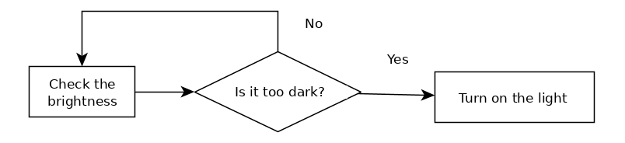
This step breaks the process down into a sequence of actions, measurements, and decisions. It will then serve as a basis for thinking about how to automate it.

3. Selecting Sensors and Actuators
The next step is to identify the components needed to replace some of the functions performed manually by the operator.
For example:
- an observation can be replaced by a sensor;
- a physical action can be performed by an actuator;
- a decision can be built into the program logic.
Once the sensors and actuators have been selected, the workflow can be adapted to represent how the automated process operates.
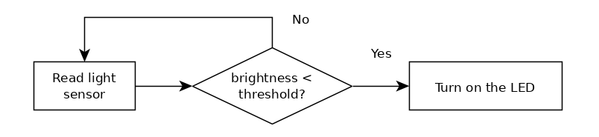

4. Simulation with Arduino
The next step is to simulate part of the automated process using a prototyping system based on an Arduino microcontroller.
To make this practical part easier, computers equipped with the Arduino IDE software, as well as Grove Beginner Kit for Arduino development kits, will be provided.
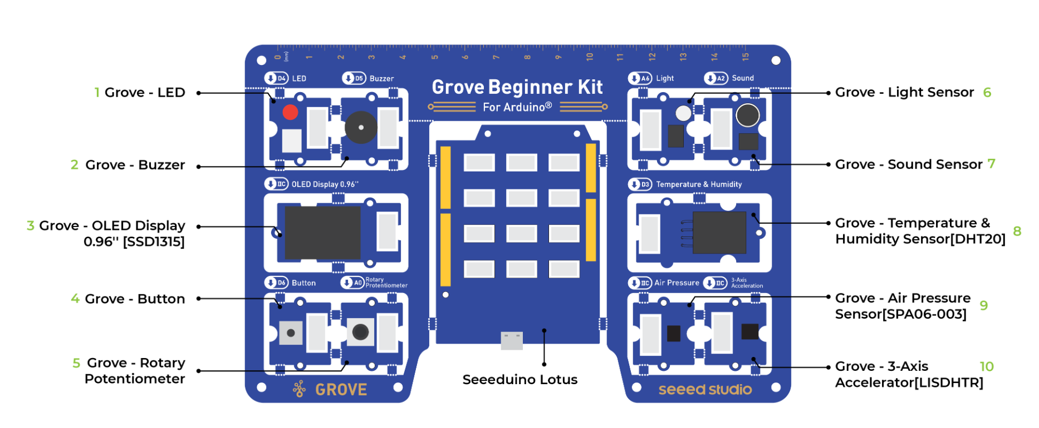
Each kit contains several sensors and actuators that can be used to represent the different functions of the automated process.

Three people will circulate among the groups to help with programming and with using the various modules.

5. Using Artificial Intelligence
The use of artificial intelligence tools is recommended to help program the Arduino.
Since the Arduino ecosystem is open source and widely documented online, AI tools can help in particular to:
- generate a first version of the program;
- explain how the code works;
- adapt the pins used;
- modify thresholds or parameters;
- identify and fix some errors.
However, it is important to test and understand the behavior of the generated program, and then adapt it to the system you are using.

Example
For a system that automatically turns on an LED when the brightness becomes too low, the following prompt can be used:
“Create an Arduino program that turns on an LED when the brightness is below a certain value. I want to be able to choose the pins used for the LED and the light sensor, as well as the brightness threshold.”
The following code was generated by an AI in instant mode:
// ===============================
// PARAMETERS TO MODIFY
// ===============================

// LED pin
const int LED_PIN = 4;

// Analog pin of the light sensor
const int LIGHT_SENSOR_PIN = A0;

// Brightness threshold
// Value between 0 and 1023
const int LIGHT_THRESHOLD = 400;

// ===============================
// INITIALIZATION
// ===============================

void setup() {
pinMode(LED_PIN, OUTPUT);

Serial.begin(9600);
}

// ===============================
// MAIN LOOP
// ===============================

void loop() {

// Read the light sensor
int lightValue = analogRead(LIGHT_SENSOR_PIN);

// Display the value to make it easier to set the threshold
Serial.print("Brightness: ");
Serial.println(lightValue);

// If the brightness is below the threshold
if (lightValue < LIGHT_THRESHOLD) {
digitalWrite(LED_PIN, HIGH); // Turn the LED on
}
else {
digitalWrite(LED_PIN, LOW); // Turn the LED off
}

delay(500);
}

