PRACTICAL WORK
Discovering Arduino
Sensors, actuators and the automation of a laboratory step
Master in Chemistry · 27 October · 1 h 30 · Grove Beginner Kit for Arduino
In the previous weeks, you described a laboratory process as a manual workflow: what the operator does, what they measure or observe, and what they decide. Today you will see how a small piece of it can be automated:
- what the operator observes is replaced by a sensor;
- what the operator does is replaced by an actuator;
- what the operator decides is replaced by a few lines of program.
You will work in groups on an Arduino-based kit. Nothing can break and nothing has to be handed in: the aim is to discover, experiment, and have fun. You will start with small exercises to get comfortable, then simulate a feature of your own process.

Roadmap (90 minutes)
Part | What you will do | Time
0. Getting started | Meet the kit, set up the Arduino IDE, upload a first program | 10 min
1. Button → LED | Run a provided program and play with it | 10 min
2. Light sensor | 2a see the measurements (Serial Monitor and Plotter, screen); 2b use a threshold to light the LED | 25 min
3. Creative challenge | Invent your own small device using several sensors and actuators | 15 min
4. Your lab process | Take a feature of your manual workflow, draw its automated version, and simulate it on the kit, with the help of an AI | 30 min

0. Getting started

The kit
The Grove Beginner Kit is a single plate: all the sensors and actuators are already wired, so there is no cable to connect. The brain of the kit is the board in the middle (a Seeeduino Lotus, which is an Arduino Uno).
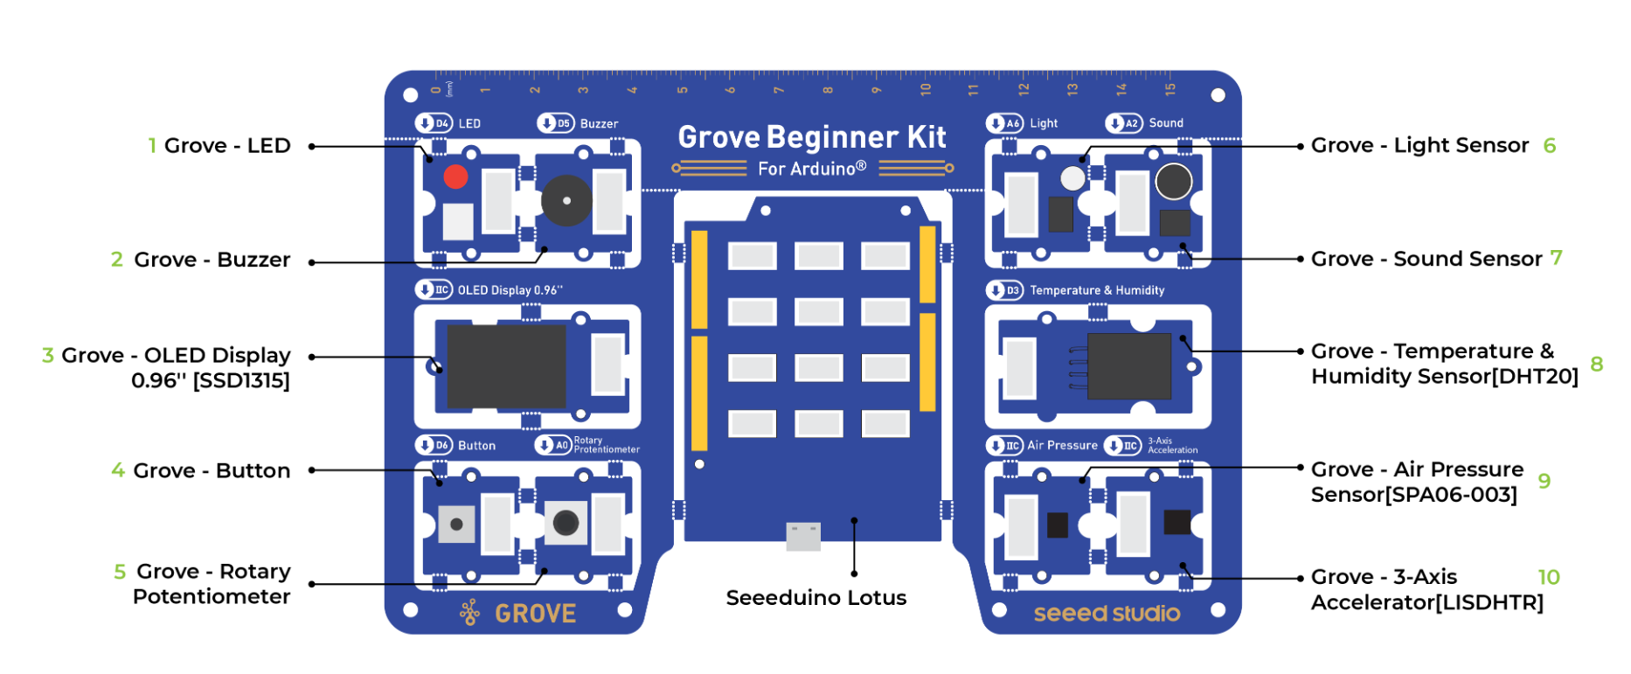
The Grove Beginner Kit. Pins are printed on the plate next to each module.
 | On the board
Sensors (inputs) | Button · Potentiometer (rotary knob) · Light · Sound · Temperature & humidity · Air pressure · 3-axis accelerometer
Actuators (outputs) | LED · Buzzer · OLED screen

Set up your computer
- Plug the kit into the computer with the USB cable.
- Open Arduino_Grove.ino in the Arduino IDE (your instructor tells you where it is). A second tab, sensors.h, opens next to it: you never need to touch it.
- Install the libraries (menu Tools → Manage Libraries..., search each name, click Install). Skip the ones that are already installed:
  - U8g2 by oliver (OLED screen)
  - DHT20 by Rob Tillaart (temperature and humidity)
  - Grove - Barometer Sensor BMP280 (air pressure)
  - Seeed Arduino LIS3DHTR (accelerometer)
- Select the board: Tools → Board → Arduino Uno, and the port: Tools → Port (the one that appears when the kit is plugged in).
- Click Upload (the arrow at the top left). When it is done, the OLED screen shows "Grove Kit / Ready!". You are ready.

How a program works
An Arduino program has two parts. setup() runs once at power-up (already done for you, do not touch it). loop() runs again and again, as long as the board is powered: this is where you write your code. Everything you write goes between the curly braces { } of loop().
The kit comes with simple functions you can call:
Function | Returns | Description
setLED(true) / setLED(false) | - | Turns the LED on / off
buzz(frequency, duration_ms) | - | Plays a sound, e.g. buzz(1000, 200)
isButtonPressed() | true / false | Is the button pressed right now?
readPotentiometer() | 0 – 1023 | Position of the knob
readLight() | 0 – 1023 | Light level
readSound() | 0 – 1023 | Sound level
readTemperature() | °C (decimal) | Air temperature
readHumidity() | % (decimal) | Air humidity
readPressure() | hPa (decimal) | Air pressure
readAcceleration(x, y, z) | - | Fills x, y, z (in g), declare them first: float x, y, z;
displayText("line 1", "line 2", "line 3") | - | Writes up to 3 lines on the OLED screen (16 characters per line, no accents)
Serial.println(value) | - | Sends a value to the computer (Serial Monitor / Plotter)
The complete list is in README.md.

1. Button → LED
Goal
Run a first program and see the full cycle of automation: the kit senses (button), decides (if...), and acts (LED).

Copy this code into loop() (replace the comment that is there), click Upload, and press the button on the kit.
void loop() {
if (isButtonPressed()) {
setLED(true); // button pressed: LED on
} else {
setLED(false); // otherwise: LED off
}
}

Predict, then test
- Replace setLED(true); with buzz(1000, 200);. What do you hear? Try other frequencies.
- Make the LED turn on when the button is not pressed. (Hint: ! means "not".)
- Delete the whole else { ... } part. What changes? Why?

Remember
A program is read from top to bottom, and loop() restarts as soon as it reaches the end: it checks the button thousands of times per second.

2. Light sensor

2a. See what the sensor measures (10 min)
Goal
Before you can decide at which light level something should happen, you need to see what the sensor measures. This is the same idea as a calibration in the lab.

Replace the content of loop() with:
void loop() {
int light = readLight();
Serial.println(light); // send the value to the computer
displayText("Light level:", String(light)); // and show it on the screen
delay(100); // wait 0.1 s
}
- Upload, then open the Serial Monitor (magnifying glass at the top right of the IDE). Set it to 115200 baud (bottom right of the panel). You should see numbers scrolling.
- Close it and open Tools → Serial Plotter (also 115200 baud). The values are now drawn as a live curve. Open only one of the two at a time.
- Cover the light sensor with your hand, then shine a phone torch on it. Fill the table below.

Situation | Value | Goes up or down?
Normal room light
Sensor covered by your hand
Phone torch right on the sensor

Question: does the number go up or down when it gets darker? Keep this in mind for 2b.

2b. Act: switch the LED on when it gets dark (15 min)
Goal
Use a threshold to turn a measurement into a decision: when the light drops below a chosen value, the LED switches on.

Replace your loop() with the code below (the const line goes just above it). This version runs, but does not do the right thing yet: your job is to fix it.
const int THRESHOLD = 0; // <-- 1) choose a value, using what you measured in 2a

void loop() {
int light = readLight();

if (light > THRESHOLD) { // <-- 2) is ">" the right comparison? Or "<" ?
setLED(true);
} else {
setLED(false);
}

// Plot the light and the threshold together
Serial.print("Light:");
Serial.print(light);
Serial.print(",Threshold:");
Serial.println(THRESHOLD);
delay(100);
}
- Pick a threshold between your "normal light" and "covered" values.
- Check the comparison sign so that the LED lights up when you cover the sensor. In the Serial Plotter you see the light curve cross the threshold line at the moment the LED switches.
- Upload and test by covering / uncovering the sensor.

If you have time
- Also make the buzzer beep when it gets dark.
- Put the threshold right at the level of the room light. What happens when the light hovers around it? Why would that be a problem in a real experiment?
- Replace THRESHOLD by readPotentiometer() so that you tune the threshold by turning the knob, and watch it move on the plot.
- Show the word "DARK" or "BRIGHT" on the screen with displayText(...).

3. Creative challenge
Goal
Be creative: invent a small device that uses several sensors and actuators together. Time limit: 15 minutes, so keep it simple. If you are not finished, that is fine: move on to part 4.

Your device must...
- use at least 2 sensors (inputs) and at least 2 actuators (outputs, the screen counts);
- take at least one decision based on a threshold;
- have one value adjustable with the potentiometer.

How to proceed
- Pick an idea from the list below, or invent your own (2 min).
- Sketch the flowchart on paper (3 min): rectangles for actions and measurements, a diamond for each decision, as in the examples of part 4.
- Write the code (10 min), by yourself or with the help of an AI (see "Using an AI" at the end of this document).

Idea | Inputs | Outputs | Twist
Breath detector | Humidity | LED, screen | Blow on the sensor: the LED lights when the humidity jumps above your threshold.
Clap switch | Sound | LED | One clap switches the LED on, the next one off. (You need a variable that remembers the state.)
Dark-box alarm | Light, button | Buzzer, LED | A light-sensitive sample is in a box. Alarm when someone opens it; the button resets the alarm.
Shake counter | Accelerometer, button | Screen | Count how many times the kit is shaken. The button resets the counter.
Fever alarm | Temperature, potentiometer | LED, buzzer, screen | The knob sets the alarm temperature. Warm the sensor with your finger.
Incubation timer | Button, potentiometer | Screen, buzzer | The knob sets a duration, the button starts it, the buzzer rings at the end. (Hint: millis().)

4. Your lab process
Goal
Take one feature of the manual workflow you built in the previous weeks, imagine how it could be automated, and simulate it on the kit. You will use an AI assistant to turn a photo of your workflow into code.

Step 1: choose one feature (5 min)
Do not try to automate the whole process. Pick one small piece that contains a measurement, a decision, and an action. For example: "check the temperature; if it is too high, stop the heating", or "detect the color change; when it happens, stop adding reagent".

Step 2: draw the automated workflow (10 min)
On paper, redraw that feature as a flowchart, once with the operator (manual version, if it helps) and once automated. Go through each box and ask:
- what the operator observes → which sensor could do it?
- what the operator does → which actuator could do it?
- what the operator decides → which threshold or rule in the program?
Write the kit component you choose in each box. Example, for a system that switches on a light when it gets too dark:
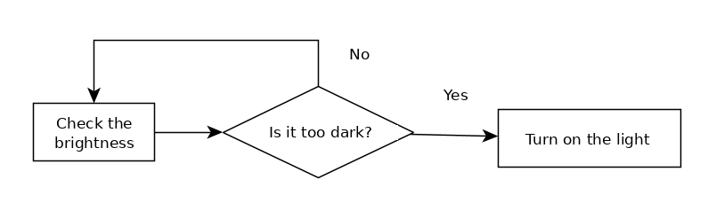
Manual workflow: the operator checks the brightness and decides.
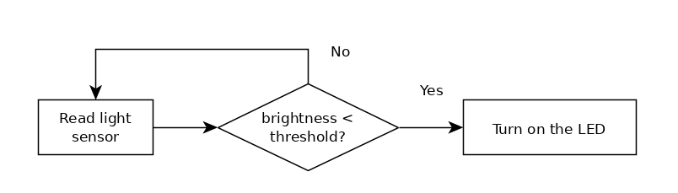
Automated workflow: a sensor, a threshold, an actuator.

From the real lab to the kit
The kit cannot heat a flask or read a real pH, but it can stand in for them. Use this table to choose your stand-ins:
In the real lab | On the kit
Operator confirms / starts a step | Button
Setpoint (target temperature, volume...) | Potentiometer (turn the knob)
Temperature probe | Temperature sensor (warm it with a finger)
pH probe, or any other analog probe | Potentiometer (turn it to "change the pH")
Color change, turbidity | Light sensor (cover it, or use a phone torch)
Vapor, evaporation, humidity | Humidity sensor (breathe on it)
Stirring, shaking, a sample being moved | Accelerometer (shake the kit)
Something happening in the room (door, noise) | Sound sensor (clap)
Heater, pump, valve, stirrer being switched on | LED
Alarm | Buzzer
Display of the values / log of the experiment | OLED screen and Serial Monitor

Step 3: let the AI write the code (10-12 min)
- Take a photo of your automated flowchart (with your phone, and send it to your computer, or use the AI assistant on your phone).
- Open the AI assistant of your choice. Follow PROMPT_AI.md: paste Message 1 (it teaches the AI the functions of the kit), then send Message 3 with your photo attached.
- The AI first gives a table: which component stands for which box, and how to trigger it. Read it and check it makes sense for your workflow before using the code.
- Copy the complete file it gives you into the Arduino IDE (Ctrl+A, Ctrl+V), Upload, and play your process by triggering the sensors by hand.

No AI? You can code by hand.
Using an AI is a choice, not an obligation. You can write the code yourself with what you learned in parts 1 to 3. Be aware that it is usually slower, so keep your feature very small.

Step 4: test, tweak, show (5 min)
- Does the simulation behave like your flowchart? If not, tell the AI what you see ("the LED stays on", "it is too sensitive") and ask for the complete file again.
- Adjust a threshold. Add a second feature (a buzzer alarm, a message on the screen...).
- Show your simulation to a neighboring group, and look at theirs.

Think about it (no need to write anything)
- What does the kit simulate, and what would you need in the real lab (a real probe, a relay for a heater, a safety limit...)?
- Which part of your process is the hardest to automate? Why?
- What did the sensor not see that a human operator would have noticed?

Using an AI to write the code
An AI assistant (ChatGPT, Claude, Gemini, Copilot...) can help you to:
- generate a first version of the program;
- explain how a piece of code works;
- change thresholds, messages or behaviors;
- find and fix errors: copy the error message from the IDE into the chat.
But it does not know your kit, and it can invent functions or use the wrong pins. This is why PROMPT_AI.md gives it the list of functions first. Always test the program, and make sure you understand what it does: ask the AI to explain if you do not.

A good request is specific
Vague | Specific
"Make a temperature alarm." | "When the temperature is above the value set with the potentiometer (between 20 and 40 °C), switch the LED on and beep every 2 seconds. Show the temperature and the limit on the screen."
"It does not work." | "The LED stays on all the time, even when I cover the sensor. The Serial Monitor shows values between 80 and 600."

Troubleshooting
Problem | What to try
No port in Tools → Port | Unplug and replug the USB cable, try another cable, then ask the instructor.
Error ... was not declared in this scope | A typo in a function or variable name (capital letters matter). Or a { or } is missing.
Error fatal error: ... .h: No such file | A library is missing: install it (Tools → Manage Libraries).
Upload worked but nothing changed | Did you click Upload after your last change? Check that the board and port are still selected.
Serial Monitor shows strange symbols | Set it to 115200 baud (bottom right of the panel).
Serial Plotter shows nothing | Close the Serial Monitor (only one at a time), and check 115200 baud.
Message "BMP280 pressure sensor not found" | Only the pressure measurement is affected. Ignore it unless you use readPressure().
Temperature / humidity look wrong | Ask the instructor: the kit may have a different temperature sensor.
Stuck? Ask the instructor, or ask a neighboring group. Enjoy!

