**Juliane Rebecca S. Dayandante**

**BSIT – 3C**

**Populating Pages**

This is the view ticket of our website

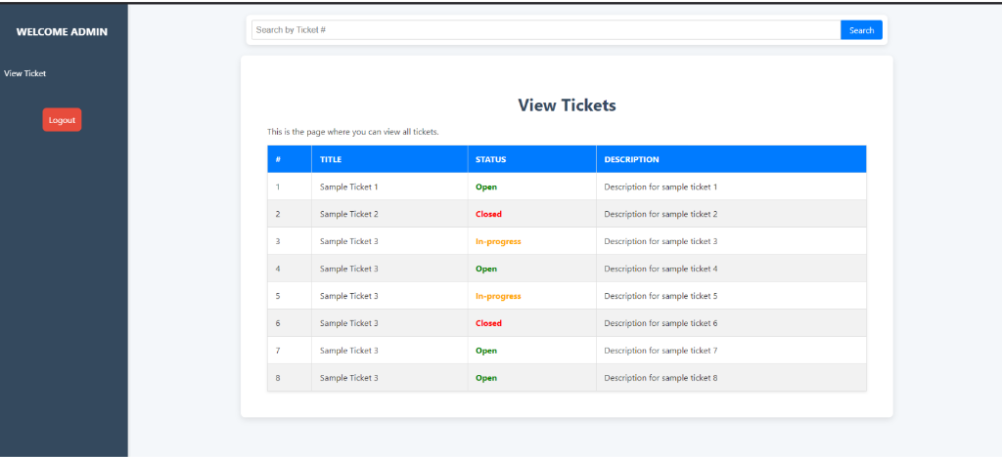

This code extends the main layout (layouts.app) and includes a table to show ticket details such as ID, Title, Status, and Description. If tickets exist, it loops through them using @foreach and displays each ticket's details, with the status dynamically styled and formatted. If no tickets are available, a message is displayed saying "No tickets found."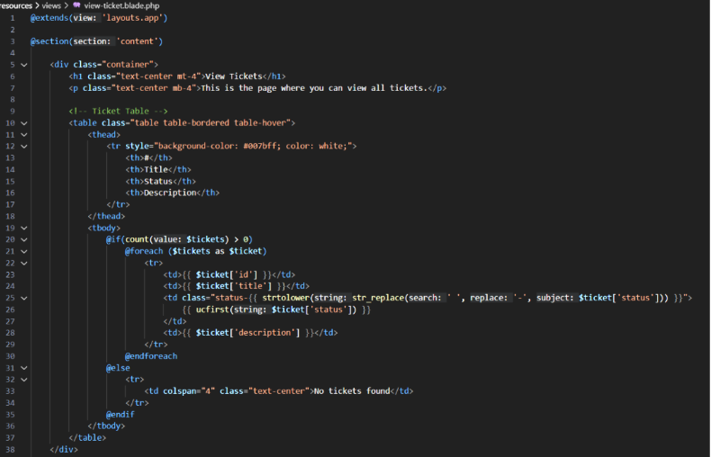

This code defines routes for our ticketing system. Some routes are restricted by roles, like user or admin, using middleware. Users can create tickets, view all tickets, and search for tickets. Admins can update ticket statuses. There are also routes for user registration, login, admin login, and logout. Each route is connected to specific methods in the controllers and uses clear names for easy access in the application.

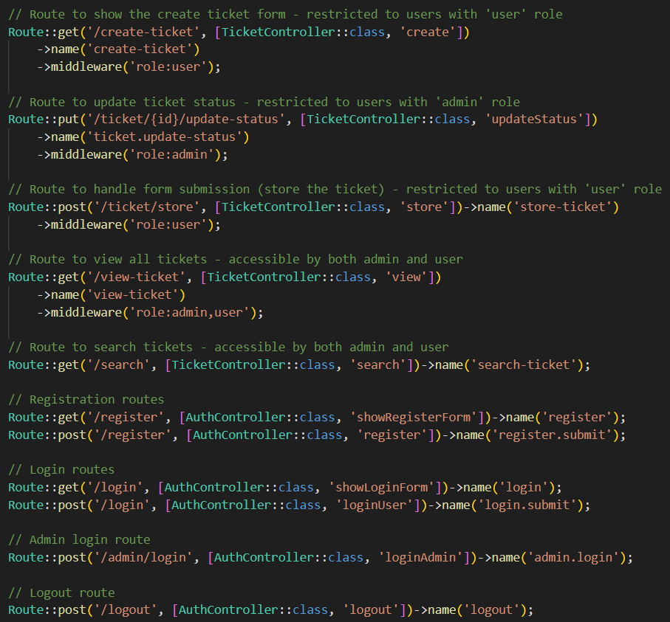

This is the routes

(web.php)