**Supplementary information:**

**Long-term transition of China’s power sector under carbon neutrality target and water withdrawal constraint**

Chao Zhang a,b,1, Gang He c,1,*, Josiah Johnston d,e, Lijin Zhong f

a. School of Economics and Management, Tongji University, Shanghai 200092, China

b. United Nation Environment-Tongji Institute of Environment for Sustainable Development, Tongji University, Shanghai 200092, China

c. Department of Technology and Society, College of Engineering and Applied Sciences, Stony Brook University, Stony Brook 11794, U.S.A

d. Josiah Johnston PhD Research & Consulting, Grass Valley 95945, U.S.A

e. Daikin U.S. Corporation, Santa Clara, CA 95054

f. Energy Foundation China Office, Beijing, 100004, China

1 These authors contribute equally.

* Corresponding to G.H., email: gang.he@stonybrook.edu

**Supplementary Tables**

**Supplementary Table S1.** Feasibility of cooling technologies for newly built thermal power plants in each spatial unit.

Notes:

** indicates this type of cooling technology has already existed in the spatial unit and new plants of the same type are feasible to be built in the future.

* indicates this type of cooling technology did not exist in the spatial unit in the base year but is technically feasible to be built in the future.

Feasibility of nuclear power plants is assigned according to current construction plans or proposals.

The spatial division of secondary basins is presented in Supplementary Fig. S1.

|  |  |  |  |  |  |  |  |  |  |
| --- | --- | --- | --- | --- | --- | --- | --- | --- | --- |
| **Province** | **Second-level river basin code** | **First-level river basin** | **Coal power (with or without CCS)** | | | **Natural gas power** | | **Nuclear power** | |
| **Recirculating cooling** | **Air cooling** | **Seawater cooling** | **Recirculating cooling** | **Seawater cooling** | **Seawater cooling** | **Recirculating cooling** |
| Beijing | 302 | Hai River Basin |  |  |  | ** |  |  |  |
| Tianjin | 302 | Hai River Basin | **\*\*** |  | **\*\*** | **\*\*** | **\*** |  |  |
| Tianjin | 304 | Hai River Basin | **\*\*** |  |  | * |  |  |  |
| Hebei | 206 | Liao River Basin | **\*\*** |  | **\*\*** | **\*** | **\*** |  |  |
| Hebei | 302 | Hai River Basin | **\*\*** | **\*\*** |  | * |  |  |  |
| Hebei | 303 | Hai River Basin | **\*\*** | **\*\*** |  | ** |  |  |  |
| Hebei | 301 | Hai River Basin | **\*\*** |  | **\*\*** | **\*** | **\*** |  |  |
| Hebei | 304 | Hai River Basin | **\*** |  | **\*\*** | **\*** | **\*** | **\*** |  |
| Shanxi | 302 | Hai River Basin | **\*\*** | **\*\*** |  | * |  |  |  |
| Shanxi | 303 | Hai River Basin | **\*\*** | **\*\*** |  | **\*** |  |  |  |
| Shanxi | 404 | Yellow River Basin | **\*\*** | **\*\*** |  | **\*** |  |  |  |
| Shanxi | 405 | Yellow River Basin | **\*\*** | **\*\*** |  | ** |  |  |  |
| Shanxi | 406 | Yellow River Basin | **\*\*** | **\*\*** |  | **\*** |  |  |  |
| East Inner Mongolia | 101 | Songhua River Basin | **\*\*** | **\*\*** |  | **\*** |  |  |  |
| East Inner Mongolia | 102 | Songhua River Basin | **\*\*** | **\*\*** |  | **\*** |  |  |  |
| East Inner Mongolia | 201 | Liao River Basin | **\*\*** | **\*\*** |  | **\*** |  |  |  |
| West Inner Mongolia | 407 | Yellow River Basin | **\*\*** | **\*\*** |  | **\*** |  |  |  |
| West Inner Mongolia | 302 | Hai River Basin | **\*** | **\*\*** |  | **\*** |  |  |  |
| West Inner Mongolia | 404 | Yellow River Basin | **\*\*** | **\*\*** |  | **\*** |  |  |  |
| West Inner Mongolia | 1002 | Northwestern Rivers | **\*\*** | **\*\*** |  | **\*** |  |  |  |
| West Inner Mongolia | 403 | Yellow River Basin | **\*\*** | **\*\*** |  | * |  |  |  |
| West Inner Mongolia | 301 | Hai River Basin | **\*** | **\*\*** |  | **\*** |  |  |  |
| West Inner Mongolia | 1001 | Northwestern Rivers | **\*\*** | **\*\*** |  | **\*** |  |  |  |
| Liaoning | 206 | Liao river basin | **\*\*** | **\*** | **\*\*** | **\*** | **\*** | **\*** |  |
| Liaoning | 204 | Liao river basin | **\*\*** | **\*** |  | **\*** |  |  |  |
| Liaoning | 203 | Liao river basin | **\*\*** | **\*\*** |  | * |  |  |  |
| Liaoning | 201 | Liao river basin | **\*\*** | **\*** |  | **\*** |  |  |  |
| Liaoning | 205 | Liao river basin | **\*\*** | **\*** |  | **\*** |  |  |  |
| Liaoning | 207 | Liao river basin | **\*\*** | **\*** | **\*\*** | **\*** | * | ** |  |
| Jilin | 103 | Songhua River Basin | **\*\*** | **\*** |  | **\*** |  |  |  |
| Jilin | 202 | Liao river basin | **\*\*** | **\*** |  | * |  |  |  |
| Jilin | 203 | Liao river basin | **\*\*** | **\*** |  | **\*** |  |  |  |
| Jilin | 102 | Songhua River Basin | **\*\*** | **\*\*** |  | **\*** |  |  |  |
| Jilin | 104 | Songhua River Basin | **\*\*** | **\*** |  | * |  |  |  |
| Jilin | 108 | Songhua River Basin | **\*\*** | **\*** |  | **\*** |  |  |  |
| Jilin | 201 | Liao river basin | **\*\*** | **\*** |  | **\*** |  |  |  |
| Jilin | 205 | Liao river basin | **\*\*** | **\*\*** |  | **\*** |  |  |  |
| Heilongjiang | 105 | Songhua River Basin | **\*\*** | **\*** |  | **\*** |  |  |  |
| Heilongjiang | 102 | Songhua River Basin | **\*\*** | **\*** |  | ** |  |  |  |
| Heilongjiang | 104 | Songhua River Basin | **\*\*** | **\*** |  | **\*** |  |  |  |
| Heilongjiang | 107 | Songhua River Basin | **\*** | **\*** |  | **\*** |  |  |  |
| Heilongjiang | 106 | Songhua River Basin | **\*\*** | **\*** |  | **\*** |  |  |  |
| Shanghai | 612 | Yangtze River Basin | **\*\*** |  | **\*\*** | **\*\*** | **\*\*** |  |  |
| Jiangsu | 608 | Yangtze River Basin | **\*** |  |  | * |  |  |  |
| Jiangsu | 611 | Yangtze River Basin | **\*\*** |  |  | ** |  |  |  |
| Jiangsu | 503 | Huai River Basin | **\*\*** |  | **\*\*** | **\*\*** | **\*** |  |  |
| Jiangsu | 612 | Yangtze River Basin | **\*\*** |  |  | ** |  |  |  |
| Jiangsu | 504 | Huai River Basin | **\*\*** |  |  | **\*** |  | **\*\*** |  |
| Zhejiang | 701 | Southeastern Rivers | **\*\*** |  |  | ** |  |  |  |
| Zhejiang | 612 | Yangtze River Basin | **\*\*** |  | **\*\*** | **\*\*** | **\*** | **\*\*** |  |
| Zhejiang | 702 | Southeastern Rivers | **\*\*** |  | **\*\*** | **\*\*** | **\*\*** | **\*\*** |  |
| Zhejiang | 703 | Southeastern Rivers | **\*\*** |  | **\*\*** | **\*** | **\*** |  |  |
| Anhui | 611 | Yangtze River Basin | **\*\*** |  |  | **\*** |  |  |  |
| Anhui | 502 | Huai River Basin | **\*\*** |  |  | **\*** |  |  |  |
| Fujian | 704 | Southeastern Rivers | **\*** |  | **\*\*** | **\*** | **\*** | **\*\*** |  |
| Fujian | 705 | Southeastern Rivers | **\*\*** |  |  | **\*** |  |  |  |
| Fujian | 706 | Southeastern Rivers | **\*\*** |  | **\*\*** | **\*\*** | **\*\*** | **\*\*** |  |
| Jiangxi | 609 | Yangtze River Basin | **\*\*** |  |  | **\*** |  |  | * |
| Jiangxi | 610 | Yangtze River Basin | **\*** |  |  | **\*** |  |  |  |
| Shandong | 303 | Hai River Basin | **\*\*** | **\*** |  | **\*** |  |  |  |
| Shandong | 406 | Yellow River Basin | **\*\*** | **\*** |  | **\*** |  |  |  |
| Shandong | 505 | Huai River Basin | **\*\*** | **\*** |  | **\*\*** |  | **\*\*** |  |
| Shandong | 304 | Hai River Basin | **\*\*** | **\*\*** |  | **\*** |  |  |  |
| Shandong | 504 | Huai River Basin | **\*\*** | **\*** |  | **\*** |  |  |  |
| Henan | 303 | Hai River Basin | **\*\*** | **\*** |  | **\*** |  |  |  |
| Henan | 608 | Yangtze River Basin | **\*\*** | **\*** |  | **\*** |  |  |  |
| Henan | 501 | Huai River Basin | **\*\*** | **\*** |  | ** |  |  |  |
| Henan | 502 | Huai River Basin | **\*\*** | **\*** |  | ** |  |  |  |
| Henan | 406 | Yellow River Basin | **\*\*** | **\*** |  | ** |  |  |  |
| Hubei | 608 | Yangtze River Basin | **\*\*** |  |  | **\*** |  |  |  |
| Hubei | 610 | Yangtze River Basin | **\*\*** |  |  | **\*** |  |  | * |
| Hunan | 607 | Yangtze River Basin | **\*\*** |  |  | **\*** |  |  | * |
| Hunan | 610 | Yangtze River Basin | **\*\*** |  |  | **\*** |  |  |  |
| Guangdong | 806 | Pearl River Basin | **\*\*** |  |  | ** |  |  |  |
| Guangdong | 807 | Pearl River Basin | **\*\*** |  | **\*\*** | **\*\*** | **\*** |  |  |
| Guangdong | 809 | Pearl River Basin | **\*\*** |  | **\*\*** | **\*\*** | **\*\*** | **\*\*** |  |
| Guangdong | 706 | Southeastern Rivers |  |  | **\*\*** | **\*** | **\*** |  |  |
| Guangdong | 805 | Pearl River Basin | **\*\*** |  |  | **\*** |  |  |  |
| Guangdong | 810 | Pearl River Basin | **\*\*** |  | **\*\*** | **\*\*** | **\*** | **\*\*** |  |
| Guangdong | 808 | Pearl River Basin | **\*\*** |  | **\*\*** | **\*\*** | **\*\*** | **\*\*** |  |
| Guangxi | 803 | Pearl River Basin | **\*\*** |  |  | **\*** |  |  |  |
| Guangxi | 804 | Pearl River Basin | **\*\*** |  |  | **\*** |  |  |  |
| Guangxi | 810 | Pearl River Basin |  |  | **\*\*** | **\*** | **\*** | **\*\*** |  |
| Hainan | 811 | Pearl River Basin | **\*\*** |  | **\*\*** | **\*\*** | **\*\*** | **\*\*** |  |
| Chongqing | 604 | Yangtze River Basin | **\*\*** |  |  | ** |  |  |  |
| Chongqing | 606 | Yangtze River Basin | **\*\*** |  |  | * |  |  |  |
| Sichuan | 604 | Yangtze River Basin | **\*\*** |  |  | ** |  |  |  |
| Sichuan | 602 | Yangtze River Basin | **\*\*** |  |  | * |  |  |  |
| Sichuan | 603 | Yangtze River Basin | **\*\*** |  |  | ** |  |  |  |
| Sichuan | 606 | Yangtze River Basin | **\*\*** |  |  | **\*** |  |  |  |
| Guizhou | 607 | Yangtze River Basin | **\*\*** |  |  | **\*** |  |  |  |
| Guizhou | 802 | Pearl River Basin | **\*\*** |  |  | **\*** |  |  |  |
| Guizhou | 605 | Yangtze River Basin | **\*\*** |  |  | **\*** |  |  |  |
| Guizhou | 606 | Yangtze River Basin | **\*\*** |  |  | **\*** |  |  |  |
| Yunnan | 602 | Yangtze River Basin | **\*\*** |  |  | **\*** |  |  |  |
| Yunnan | 802 | Pearl River Basin | **\*\*** |  |  | **\*** |  |  |  |
| Shaanxi | 407 | Yellow River Basin | **\*\*** | **\*** |  | **\*** |  |  |  |
| Shaanxi | 404 | Yellow River Basin | **\*\*** | **\*\*** |  | **\*** |  |  |  |
| Shaanxi | 405 | Yellow River Basin | **\*\*** | **\*\*** |  | **\*** |  |  |  |
| Gansu | 1002 | Northwestern Rivers | **\*\*** | **\*\*** |  | **\*** |  |  |  |
| Gansu | 403 | Yellow River Basin | **\*\*** | **\*\*** |  | **\*** |  |  |  |
| Gansu | 405 | Yellow River Basin | **\*\*** | **\*\*** |  | **\*** |  |  |  |
| Gansu | 402 | Yellow River Basin | **\*\*** | **\*\*** |  | **\*** |  |  |  |
| Qinghai | 402 | Yellow River Basin | **\*\*** | **\*** |  | **\*** |  |  |  |
| Ningxia | 403 | Yellow River Basin | **\*\*** | **\*\*** |  | ** |  |  |  |
| Xinjiang | 1010 | Northwestern Rivers | **\*\*** | **\*** |  | ** |  |  |  |
| Xinjiang | 1009 | Northwestern Rivers | **\*\*** | **\*\*** |  | **\*** |  |  |  |
| Xinjiang | 1005 | Northwestern Rivers | **\*\*** | **\*\*** |  | **\*** |  |  |  |
| Xinjiang | 1008 | Northwestern Rivers | **\*\*** | **\*** |  | **\*** |  |  |  |

**Supplementary Table S2. Heat rate and water withdrawal factor of thermal power technologies used in the model.**

Notes:

1) A coefficient of 2.78 kg-CO2/kgce is applied to calculate CO2 emission for coal-fired power generation, and 1.629 kg-CO2/kgce for natural gas-fired power generation.

2) RC – recirculating cooling; Air – air cooling; OT – once-through cooling; SEA – seawater-cooling.

|  |  |  |  |  |
| --- | --- | --- | --- | --- |
| **Fuel** | **Technology** | **Heat rate of net electricity supply**  **(kgce/MWh)** | **CO2 emission rate (kg-CO2/MWh)** | **Water withdrawal factor (m3/ MWh)** |
| Coal | ≥1000MW, OT | 283.85 | 789.1 | 82.8 |
| ≥1000MW, RC | 283.85 | 789.1 | 1.931 |
| ≥1000MW, SEA | 283.85 | 789.1 | 0.258 |
| ≥1000MW, AIR | 298.65 | 830.25 | 0.31 |
| 600-999 MW, OT | 304.08 | 845.34 | 100.6 |
| 600-999 MW, RC | 304.08 | 845.34 | 1.982 |
| 600-999 MW, SEA | 304.08 | 845.34 | 0.292 |
| 600-999 MW, AIR | 321.98 | 895.10 | 0.321 |
| 300-599 MW, OT | 321.28 | 893.16 | 103.1 |
| 300-599 MW, RC | 321.28 | 893.16 | 2.317 |
| 300-599 MW, SEA | 321.28 | 893.16 | 0.353 |
| 300-599 MW, AIR | 337.42 | 938.03 | 0.417 |
| 100-299 MW, OT | 357.53 | 993.93 | 103.1 |
| 100-299 MW, RC | 357.53 | 993.93 | 2.46 |
| 100-299 MW, SEA | 357.53 | 993.93 | 0.504 |
| 100-299 MW, AIR | 375.83 | 1044.81 | 0.59 |
| <100 MW, OT | 382.0 | 1061.96 | 120.84 |
| <100 MW, RC | 382.0 | 1061.96 | 3.93 |
| <100 MW, AIR | 400.0 | 1112.0 | 0.68 |
| Coal with carbon capture and storage (CCS) | ≥1000MW, RC | 360.46 | 1002.1 | 3.735 |
| ≥1000MW, SEA | 360.46 | 1002.1 | 1.847 |
| ≥1000MW, AIR | 384.67 | 1069.4 | 1.604 |
| 600-999 MW, RC | 393.73 | 1094.6 | 3.881 |
| 600-999 MW, SEA | 393.73 | 1094.6 | 1.578 |
| 600-999 MW, AIR | 424.27 | 1179.5 | 1.634 |
| 300-599 MW, RC | 423.05 | 1176.1 | 4.417 |
| 300-599 MW, SEA | 423.05 | 1176.1 | 1.673 |
| 300-599 MW, AIR | 451.49 | 1255.1 | 1.788 |
| Natural gas | CCGT, RC | 252.84 | 412.0 | 0.946 |
| CCGT, OT | 233.00 | 379.67 | 55.15 |
| Nuclear | SEA | N.A. | N.A. | 0.032 |
| RC | N.A. | N.A. | 3.913 |

**Supplementary Table S3. Investment cost of power technology and transmission technologies**

Notes:

1. RC – recirculating cooling; AIR – air cooling; OT – once-through cooling; SEA – seawater-cooling. Future technology of coal, gas, water, and uranium stay at the same level as those technology are commercially mature.
2. Unit investment cost of coal power capacity with CCS is assumed to be 23% higher than the counterpart traditional coal power capacity without CCS.

|  |  |  |
| --- | --- | --- |
| **Fuel** | **Technology** | **Cost ($2020/MW)** |
| Coal | ≥1000MW, OT/RC/SEA | 530,857 |
| ≥1000MW, AIR | 538,286 |
| 600-999 MW, OT/RC/SEA | 534,857 |
| 600-999 MW, AIR | 542,286 |
| 300-599 MW, OT/RC/SEA | 605,857 |
| 300-599 MW, AIR | 626,429 |
| Gas | CCGT, RC | 640,000 |
| CCGT, OT | 640,000 |
| Hydropower | Traditional hydropower | 1,338,000 |
| Pumped storage | 555,000 |
| Nuclear power | Nuclear_EP_SEA | 1,800,000 |
| Nuclear_RC | 1,800,000 |
| Nuclear_SEA | 1,800,000 |
| Wind | Onshore Wind | 1,150,000 |
| Offshore Wind | 2,200,000 |
| Solar PV | Central PV | 1,200,000 |
| Commercial PV | 1,500,000 |
| Residential PV | 2,500,000 |
| Storage | Battery Storage | 1,500,000 |

**Supplementary Table S4. Water withdrawal by river basin under different scenarios.**

|  |  |  |  |  |  |  |  |
| --- | --- | --- | --- | --- | --- | --- | --- |
| **Scenario** | **River Basin Name** | **Calculation year** | | | | | |
| **2025** | **2030** | **2035** | **2040** | **2045** | **2050** |
| S1: carbon constraint (reference scenario) | Songhua River Basin | 1490.1 | 1363.1 | 1314.4 | 743.4 | 745.5 | 538.3 |
| Liao River Basin | 679.1 | 696.2 | 930.7 | 1057.8 | 1023.7 | 758.6 |
| Hai River Basin | 1379.4 | 1219.9 | 1757.7 | 2349.2 | 2107.5 | 1461.7 |
| Yellow River Basin | 1753.8 | 1668.9 | 2890.2 | 5048.6 | 4545.9 | 3297.5 |
| Huai River Basin | 2301.4 | 2434.8 | 1448.6 | 1162.6 | 479.6 | 109.1 |
| Yangtze River Basin | 48214.8 | 45352.4 | 30879.4 | 26454.0 | 9864.2 | 42.1 |
| Southeastern Rivers | 2175.9 | 1927.9 | 1195.4 | 648.0 | 24.0 | 13.2 |
| Pearl River Basin | 4929.8 | 4499.6 | 1489.6 | 223.5 | 171.2 | 21.2 |
| Northwestern Rivers | 911.9 | 912.6 | 7688.0 | 8786.7 | 8485.1 | 5866.1 |
|  | | | | | | | |
| S2: carbon constraint + water constraint | Songhua River Basin | 1675.3 | 1550.4 | 1643.1 | 1494.7 | 1325.2 | 1095.8 |
| Liao River Basin | 459.9 | 426.9 | 383.0 | 342.0 | 304.3 | 223.1 |
| Hai River Basin | 1305.5 | 1282.9 | 1405.9 | 1257.4 | 1099.3 | 759.6 |
| Yellow River Basin | 1097.6 | 925.5 | 913.5 | 819.0 | 676.1 | 294.6 |
| Huai River Basin | 2317.1 | 2172.5 | 1823.1 | 1096.1 | 838.3 | 371.2 |
| Yangtze River Basin | 35690.9 | 32568.9 | 27660.7 | 21069.7 | 10708.9 | 4510.0 |
| Southeastern Rivers | 2031.2 | 1738.5 | 1160.5 | 668.2 | 28.9 | 18.9 |
| Pearl River Basin | 3489.4 | 2927.8 | 2167.9 | 261.8 | 106.7 | 19.0 |
| Northwestern Rivers | 813.6 | 745.3 | 691.0 | 619.5 | 548.1 | 447.9 |
|  | | | | | | | |
| S3: carbon constraint + low-cost renewables | Songhua River Basin | 1502.1 | 1323.5 | 1198.9 | 1092.0 | 571.8 | 428.8 |
| Liao River Basin | 707.1 | 700.3 | 658.3 | 483.4 | 376.7 | 229.6 |
| Hai River Basin | 1255.5 | 996.0 | 804.2 | 581.6 | 384.6 | 240.7 |
| Yellow River Basin | 1848.5 | 1802.2 | 1858.4 | 1546.8 | 1163.2 | 839.7 |
| Huai River Basin | 2101.0 | 1783.6 | 1440.7 | 1235.1 | 438.7 | 105.5 |
| Yangtze River Basin | 45502.4 | 37746.6 | 29891.5 | 25086.2 | 8510.7 | 91.3 |
| Southeastern Rivers | 1938.4 | 1555.2 | 1167.8 | 216.5 | 27.5 | 10.3 |
| Pearl River Basin | 4741.4 | 2962.8 | 2853.6 | 168.9 | 109.1 | 37.5 |
| Northwestern Rivers | 989.8 | 954.0 | 3072.0 | 2611.3 | 2399.9 | 1801.1 |
|  | | | | | | | |
| S4: carbon constraint + water constraint + low-cost renewables | Songhua River Basin | 1607.1 | 1440.0 | 1263.3 | 1215.2 | 688.3 | 503.6 |
| Liao River Basin | 461.9 | 423.3 | 383.3 | 322.3 | 269.3 | 138.5 |
| Hai River Basin | 1509.4 | 1498.2 | 1309.7 | 1004.1 | 730.7 | 573.5 |
| Yellow River Basin | 1101.4 | 1008.0 | 907.2 | 706.5 | 388.5 | 112.6 |
| Huai River Basin | 2333.5 | 1981.9 | 1652.0 | 1380.6 | 676.4 | 310.9 |
| Yangtze River Basin | 35687.1 | 31196.3 | 26260.6 | 22084.4 | 8099.2 | 111.2 |
| Southeastern Rivers | 1847.8 | 1531.2 | 1153.3 | 199.6 | 27.7 | 17.2 |
| Pearl River Basin | 3429.9 | 2374.6 | 2163.0 | 103.9 | 40.9 | 21.9 |
| Northwestern Rivers | 811.8 | 729.0 | 691.0 | 600.3 | 516.1 | 446.7 |

**Supplementary Figures**

**Supplementary Fig. S1. Division of secondary river basins in China.** Boundaries of ten primary river basins are illustrated by black lines, i.e., Songhua River Basin, Liao River Basin, Hai River Basin, Yellow River Basin, Huai River Basin, Yangtze River Basin, Southeastern Rivers, Pearl River Basin, Northwestern Rivers, Southwestern Rivers. Boundaries of secondary river basins are illustrated by light blue lines.

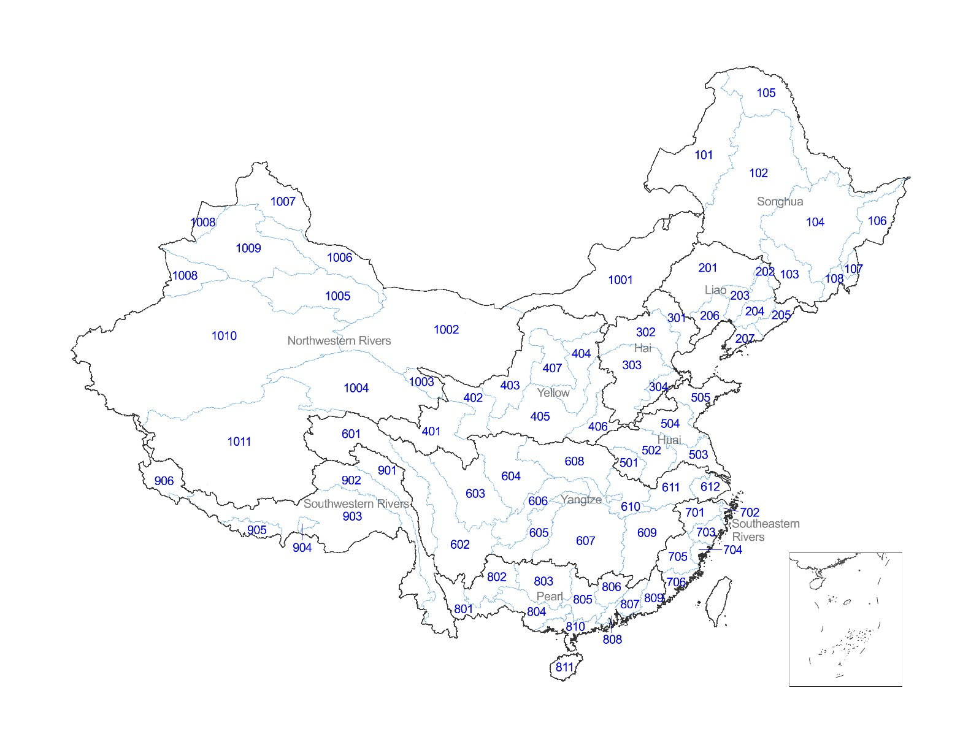

**Supplementary Fig. S2. Cost assumption for renewable power technologies over study period.**

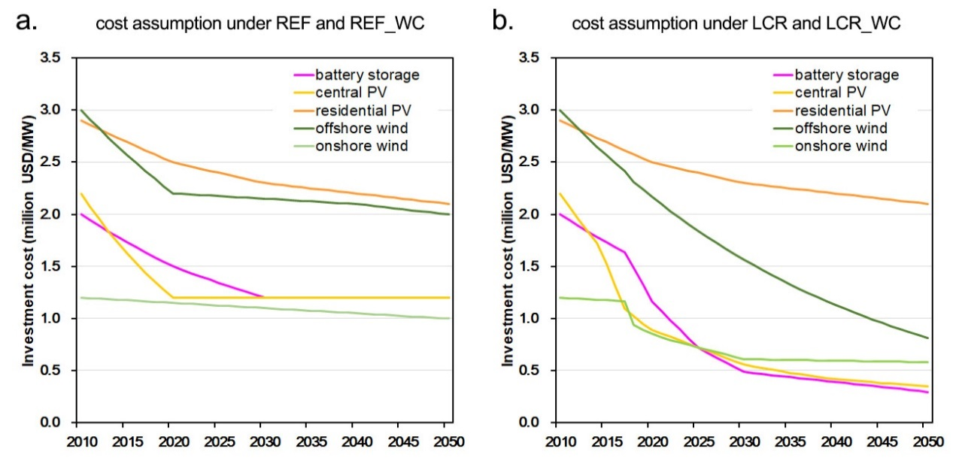

**Supplementary Fig. S3. Installed capacity by fuel under four scenarios.**

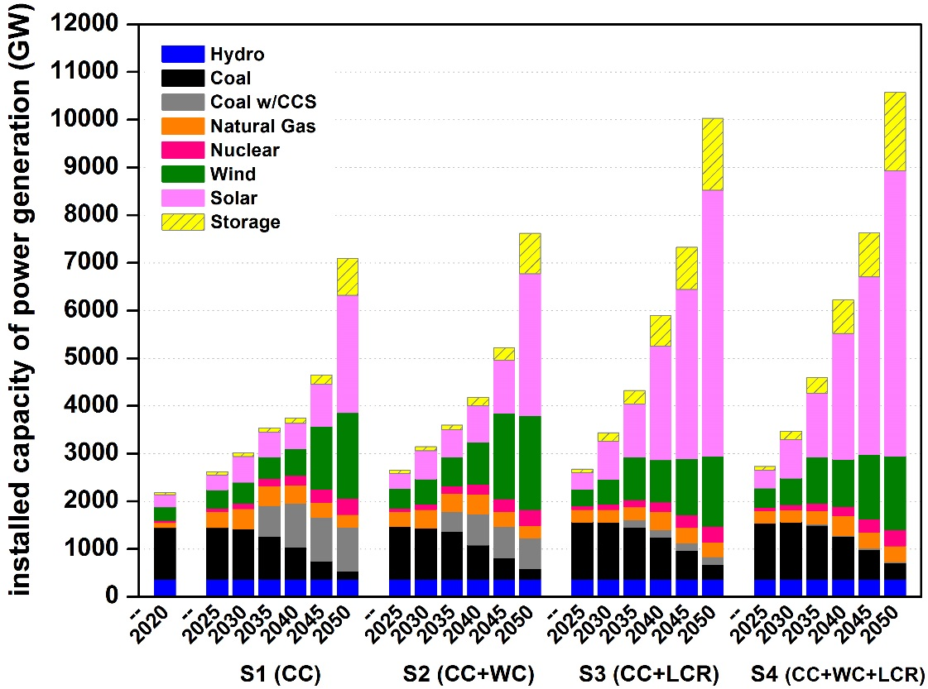

**Supplementary Fig. S4. Changes in coal power generation by province and by cooling technology between scenarios with and without water constraint in 2050**. **a**, changes between S2 (CC+WC) and S1(CC) scenario in 2050; **b,** changes between S4 (CC+WC+LCR) and S3 (CC+LCR) scenario in 2050.

