# CENG153 L04 –Control Logic

## Overview

In lab03 we returned fixed data values for the sensors. To test the logic of our controller we are now going to have the sensor routines return random values in the control range, making use of our **GhGetRandom** function. As well we are going to change the interface to our set control function to respond to these test values.

We are then going to use pointers to global variables to set and display data that will be used by environmental controls for temperature, and humidity.

Create a new folder in **labs** for **lab04**, and make the requisite changes after copying over the files from **lab03**.

## Task 1 – Simulating Reading Values

Declare the constants **SIMULATE** with a value **1**, **USTEMP** with a value **50**, **LSTEMP** with a value **-10**, **USHUMID** with a value **100**, **LSHUMID** with a value **0**, **USPRESS** with a value **1016**, and **LSPRESS** with a value **975**. Modify the following functions to the **ghcontrol.h/c** files. Use the preprocessor and the **SIMULATE** constant to control either returning a simulated range of reading values or the current single fixed value.

**float GhGetHumidity(void);**

When simulating this function returns a random value between **USHUMID** and **LSHUMID**.

**float GhGetPressure(void);**

When simulating this function returns a random value between **USPRESS** and **LSPRESS**

**float GhGetTemperature(void);**

When simulating this function returns a random value between **USTEMP** and **LSTEMP**.

## Task 2 – Display Targets Function

In **ghcontrol.h** define constants for the targets, **STEMP** with a value **25.0**, and **SHUMID** with a value **55.0**.In **ghcontrol.c**, in the **GhDisplayTargets** function, add an **fprintf** statement to print target data to the screen with these constants.

Show the output to your professor.

## Task 3 –Setting Controls

This function does the logic for controlling a heater and humidifier in response to target data and the current readings. Modify the current Set Controls function as follows:

**void GhSetControls(int * heater, int * humidifier, float readings[SENSORS]);**

1. This function is passed references to the environment controls, and current sensor readings.
2. Declare constants **ON** with a value of **1**, and **OFF** with a value of **0**.
3. If the temperature is less than **STEMP** then heater is set to **ON** else it is set to **OFF**.
4. If the humidity is less than **SHUMID** then humidifier is set to **ON** else it is set to **OFF**.

## Task 4 – Displaying Controls

Modify the **DisplayControls** function to have two pointer parameters with the control data and use these to print out this data to the screen.

**void GhDisplayControls(int * heater, int * humidifier);**

Create an **fprintf** statement to use the values passed to this function. Note that these parameters are memory addresses so to access the data you must use the dereferencing operator **\***.

## Task 5 – Calling The Functions

In the main function before the while loop create two integer variables **tempc**, and **humidc** and in the while loop pass the addresses of these as arguments to the controls functions.

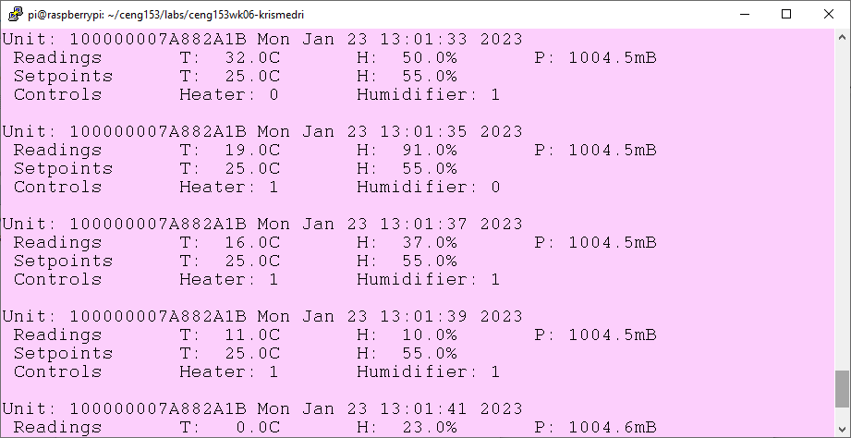

## Task 6 – Submitting Your Lab

1. Use **WinSCP** to transfer your **lab04** folder on the RPI and its contents to your folder **C:\Users\username\Documents\ceng153\labs**
2. Create a new word document and copy and paste the source code (please use Notepad++->Plugins->NppExport->Copy RTF to clipboard then paste) from **makefile, lab04.c, ghcontrol.c/.h, and an 80x24 character screen shot** of your program’s execution including the output of GhDisplayHeader into it.
3. Save the document with the file name **LastName153L04**, where you substitute your last name to your folder **C:\Users\username\Documents\ceng153\labs** before submitting it on Blackboard.