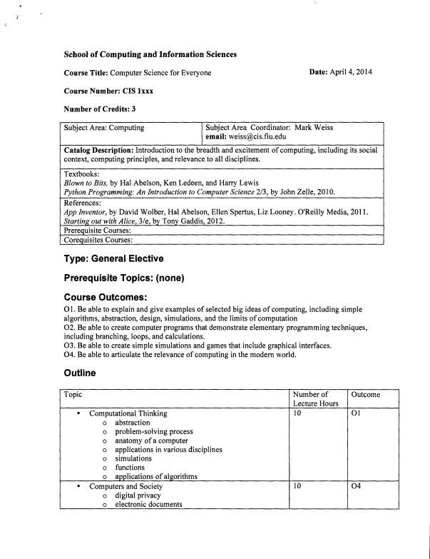
School of Computing and Information Sciences
Course Title: Computer Science for Everyone Date: April 4, 2014 Course Number: CIS lxxx
Number of Credits: 3
Subject Area: Computing Subject Area Coordinator: Mark Weiss email: weiss@cis.fiu.edu
Catalog Description: Introduction to the breadth and excitement of computing, including its social context, computing principles, and relevance to all disciplines.
Textbooks:
Blown to Bits, by Hal Abelson, Ken Ledeen, and Harry Lewis
Python Programming: An Introduction to Computer Science 2/3, by John Zelle, 2010. References:
App Inventor, by David Wolber, Hal Abelson, Ellen Spertus, Liz Looney. O'Reilly Media, 2011. Starting out with Alice, 3/e, by Tony Gaddis, 2012.
Prerequisite Courses:
Corequisites Courses:
Type: General Elective
Prerequisite Topics: (none)
Course Outcomes:
01. Be able to explain and give examples of selected big ideas of computing, including simple algorithms, abstraction, design, simulations, and the limits of computation
02. Be able to create computer programs that demonstrate elementary programming techniques, including branching, loops, and calculations.
03. Be able to create simple simulations and games that include graphical interfaces. 04. Be able to articulate the relevance of computing in the modern world.
Outline
Topic Number of Lecture Hours
Outcome
• Computational Thinking
o abstraction
o problem-solving process
o anatomy of a computer
o applications in various disciplines o simulations
o functions
o applications of algorithms
• Computers and Society
o digital privacy
o electronic documents
10 Ol 10 04
o web searches and page rankings o encryption
o intellectual property on the Web o digital expression and censorship • Programming in App Inventor
o creating mobile applications
o multimedia and game applications • Programming in Python
o variables
o loops
o decision structures
o arrays and lists
o graphics
15 02,03
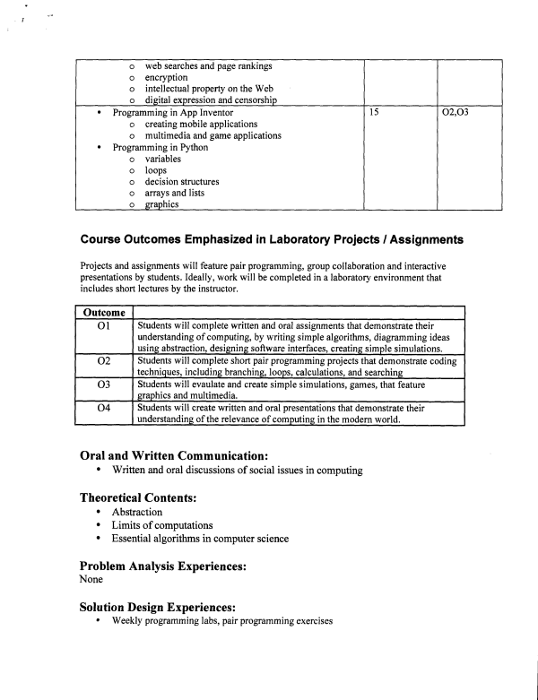
Course Outcomes Emphasized in Laboratory Projects / Assignments
Projects and assignments will feature pair programming, group collaboration and interactive presentations by students. Ideally, work will be completed in a laboratory environment that includes short lectures by the instructor.
Outcome
01 Students will complete written and oral assignments that demonstrate their understanding of computing, by writing simple algorithms, diagramming ideas using abstraction, designing software interfaces, creating simple simulations.
02 Students will complete short pair programming projects that demonstrate coding techniques, including branching, loops, calculations, and searching
03 Students will evaulate and create simple simulations, games, that feature graphics and multimedia.
04 Students will create written and oral presentations that demonstrate their understanding of the relevance of computing in the modern world.
Oral and Written Communication:
• Written and oral discussions of social issues in computing
Theoretical Contents:
• Abstraction
• Limits of computations
• Essential algorithms in computer science
Problem Analysis Experiences:
None
Solution Design Experiences:
• Weekly programming labs, pair programming exercises

