**SPRINT-1**

**Signs with Smart Connectivity for Better Road Safety**

**TEAM ID - PNT2022TMID08042**

Sprint Goals:

1. Create and Initialize accounts in various public APIs like Open weather API
2. Write a python code that output results given the inputs like weather and location

Code Flow:

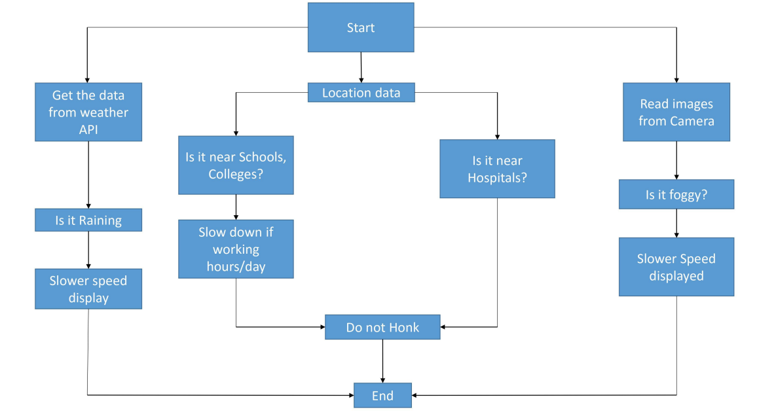

Program Code:

Node.js:

let weather = require("./API_modules/weather")

// let airpollution = require("./API_modules/airpollution")

let nearby = require("./API_modules/nearby")

let { app } = require("./API_modules/requiredFiles.js") //multiple objects can be imported

app.use(weather)

// app.use(airpollution)

app.use(nearby)

app.use("/", (req, res, next) => {

res.status(404).send("<h1>Result Not Found! Please append in URL</h1>")

})

//----------------------------------------------------------------------------------------------

Weather.js

let {app,dotenv,axios,express}=require('./requiredFiles')

const router = express.Router()

dotenv.config()

const lat = 28.7041,lon = 77.1025;

const url1 = `https://api.openweathermap.org/data/2.5/weather?appid=${process.env.API_KEY}&lat=${lat}&lon=${lon}&units=metric`

router.use("/weather",(req,resp)=>{

axios

.get(url1)

.then(function (response) {

// console.log(response.data);

resp.send(response.data)

})

.catch((err) => {

console.log(err)

})

})

module.exports = router;

Output Screenshot :

