Graphs
Weighted Edge List: Dijkstra's Algorithm

Given the weighted cities graph, we will use the weighted-edge-list representation to discover the shortest distance (lowest cost) from a specific starting vertex to all other reachable vertices, a.k.a the single-source shortest-path problem.
5 Pittsburgh
6 Princeton
1 Pensacola
2 Peoria
7 Pueblo
3 Phoenix
4 Pierre
0 Pendleton

2
3
8
3
3
10
5
5
4
2

Here is a sample run:
Ï §ÏDistance from Pendleton
ÏÏ§Ï to Pendleton: 0
ÏÏ§Ï to Pensacola: 13
ÏÏ§Ï to Peoria: 8
ÏÏ§Ï to Phoenix: 8
ÏÏ§Ï to Pierre: 2
ÏÏ§Ï to Pittsburgh: 13
ÏÏ§Ï to Princeton: 15
ÏÏ§Ï to Pueblo: 5
Compare the wVertex class below to the edge-list's Vertex class. We have added a minDistance field. ArrayList<Vertex> is changed to Map<wVertex, Integer> in order to store adjacent vertices and weights. The wVertex class must implement Comparable<wVertex> because we will be using it in a priority queue. The compareTo method returns which wVertex has the smaller minDistance.

class wVertex implements Comparable<wVertex>
{
private final String name;
private Map<wVertex, Integer> edges = new HashMap<wVertex, Integer>();
private int minDistance = Integer.MAX_VALUE;
public wVertex(String city) { }
public String toString() { }
public void addEdge( wVertex city, Integer weight ) { }
public Map<wVertex, Integer> getEdges() { }
public int getMinDistance() { }
public void setMinDistance( int d) { }
public int compareTo(wVertex other) { }
}
Every vertex begins with infinity as the minimum distance. As the algorithm progresses, each vertex's minDistance field is updated many times. The output, shown in the sample run above, is just the minDistance stored in, e.g., Pendleton's list of reachable vertices.
Just as Warshall’s Algorithm is similar to Floyd’s Algorithm, so is the edge-list reachability algorithm similar to Dijkstra’s Algorithm. The most obvious difference is that the edge-list reachability algorithm stores the still-unprocessed vertices in a stack (depth-first) or in a queue (breadth-first) while Dijkstra’s algorithm stores the vertices in a priority queue.

Removing the vertex from the priority queue will tell us the next vertex to be reached in the least amount of cost. This technique--simply taking the next step that seems best from the current choices, without resorting to any long-term planning--is known as the greedy algorithm. Dijkstra's Algorithm is a classic example of a greedy algorithm. It is also an example of dynamic programming, meaning, to arrive at the answer by successive approximation.

In general, dequeue a city and process its map. If the city's minDistance is less than the sum of the minDistance and the map's new minDistance, update the city's minDistance and enqueue the city. Similarly update the minDistances for all the cities in its map. Then dequeue the next city. When the priority queue is empty, you are done and can print the source city's map of cities and minDistances.
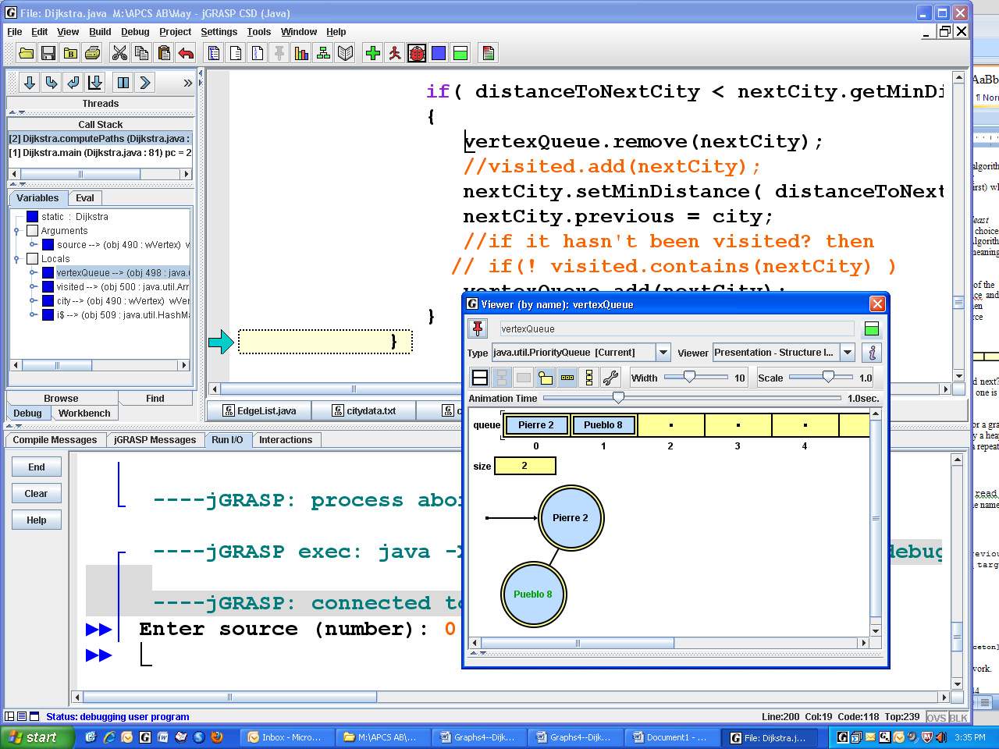
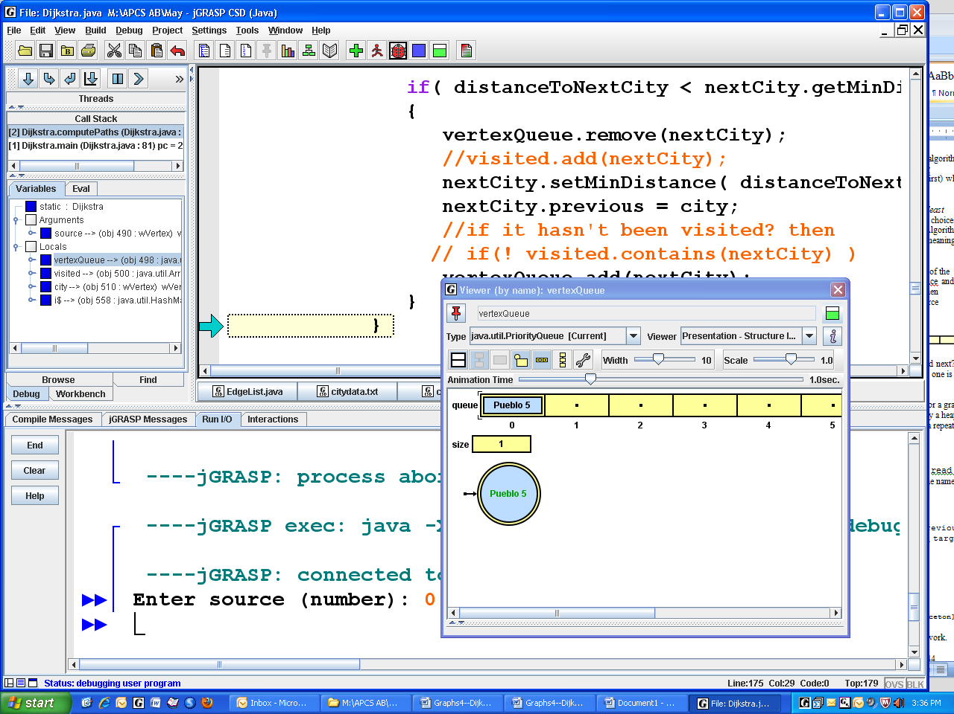
Specifically, the source Pendleton's minDistance is set to 0. It is enqueued, dequeued, and its map is processed: enqueue Pierre 2 and Pueblo 8. Pierre 2 is dequeued, and 0+2=2. Pueblo 8 is dequeued, but Pierre's 2 has a map with Pueblo 3, so Pendleton's Pueblo is updated to 5. Then Pueblo's map is processed. Pueblo's 5 plus 3 is less than Pendleton's Phoenix's infinity. And so forth.

The Big-O for Dijkstra's Algorithm depends crucially on the Big-O for the priority queue. For a graph of V vertices and E edges, Java's priority queue, which you may remember is implemented by a heap, gives O(E *log V). In contrast, if we use a regular queue, list, or set, the algorithm requires a repeated linear search of all the vertices, for a Big-O of O(E + V²) or O(V²).

Assignment
Complete the Dijkstra.java shell. The vertices and the edges should be hard-coded in read(). After that works, replace read() with read2(). The method read2() should read the names of the cities from cities.txt and the matrix data from citydataweighted.txt .

Extension 1
Dijkstra's algorithm can build the shortest path. Include a new field, public wVertex previous; and a new method public static List<wVertex> getShortestPathTo(wVertex target) that collects each vertex that was stored in previous. Here is a sample run:
Distance from Pendleton
to Pendleton: 0 [Pendleton]
to Pensacola: 13 [Pendleton, Pierre, Pueblo, Phoenix, Pensacola]
to Peoria: 8 [Pendleton, Pierre, Pueblo, Peoria]
to Phoenix: 8 [Pendleton, Pierre, Pueblo, Phoenix]
to Pierre: 2 [Pendleton, Pierre]
to Pittsburgh: 13 [Pendleton, Pierre, Pueblo, Peoria, Pittsburgh]
to Princeton: 15 [Pendleton, Pierre, Pueblo, Peoria, Pittsburgh, Princeton]
to Pueblo: 5 [Pendleton, Pierre, Pueblo]
Extension 2 Replace the priority queue with either a queue, list, set, or heap. Get it to work.
Additional Discussions: http://renaud.waldura.com/doc/java/dijkstra/
http://en.literateprograms.org/Dijkstra's_algorithm_(Java)?oldid=15444
A demo: http://www.unf.edu/~wkloster/foundations/DijkstraApplet/DijkstraApplet.htm

