**THE PENNSYLVANIA STATE UNIVERSITY**

**CSE585/EE555: Digital Image Processing II Report 5 Fractal Generation Using Iterated Function Systems**

**Wei-Kai Su, Yu-Hsuan Kuo**

**A. Objectives.**

This project is mainly focus on generating results for Algorithm RenderIFS() for the fern. The objectives of this project is listed as follows:

* Apply the Iterated Function System.
* Use Affine Transformation.
* Run the algorithm long enough to fill in the fern.

**B. Methods.**

Firstly, we used the Iterated Function System(IFS) approach in L23-12, which applying the Affine Transformations in L23-6. This is implemented in main.m file.

The Iterated Function System consists of two parts: (1) collection of contractive transformation, wi. , where the following affine linear transformation formula is used to compute wi.

w(x, y) = $\left[\begin{matrix}aoo & a01 \\ a10 & a11\end{matrix}\right]$ $\left[\begin{matrix}x \\ y\end{matrix}\right]$ + $\left[\begin{matrix}t0 \\ t1\end{matrix}\right]$

This affine linear transformation is used for each iteration to get the resulting coordinate. (2) set of probabilities pi associated with each wi, where i=1,2,…N, and $∑$ pi = 1.

The probabilities, matrix A, and w we used are as follows:

|  |  |  |  |  |  |  |  |
| --- | --- | --- | --- | --- | --- | --- | --- |
| w | a00 | a01 | a10 | a11 | t0 | t1 | Pi(set1) |
| 1 | 0 | 0 | 0 | 0.16 | 0 | 0 | 0.2 |
| 2 | 0.2 | -0.26 | 0.23 | 0.22 | 0 | 1.6 | 0.35 |
| 3 | -0.15 | 0.28 | 0.26 | 0.24 | 0 | 0.44 | 0.35 |
| 4 | 0.85 | 0.04 | -0.04 | 0.85 | 0 | 1.6 | 0.1 |

We also tried 4 sets of different probabilities:

|  |  |  |  |  |
| --- | --- | --- | --- | --- |
| w | pi (set 2) | pi (set 3) | pi (set 4) | pi (set 5) |
| 1 | 0.7 | 0.1 | 0.1 | 0.1 |
| 2 | 0.1 | 0.7 | 0.1 | 0.1 |
| 3 | 0.1 | 0.1 | 0.7 | 0.1 |
| 4 | 0.1 | 0.1 | 0.1 | 0.7 |

The seed point is (1, 1). After 100, 1000, 5000, 20000, 200000, 500000, 1000000 iterations, we found the minimum and maximum value and we defined the offset as the difference between the minimum value and 0. Then we scaled every point with this offset value, thus we got the normalization value between 1 to 512.

**C. Result/ Discussion.**

We found out that for different sets of probabilities: the more iteration we ran, the more points we got in the fern. But, for different sets of probabilities, the output fern is different. However, the 1000000 iteration results of Figure 8 does not have points at the bottom left of the fern and is sparse at the upper right of the fern. We got the perfect fern of the set 5 probability because all parts of the fern is dense. In conclusion, the results are similar for all set of probabilities’ result. That is to say, the shape of the fern is the same for different sets of probabilities. The only difference is the density of points in different parts of the fern.

**C-1. Probability set one: .**

|  |  |  |  |
| --- | --- | --- | --- |
| pi (set 1) | pi (set 2) | pi (set 3) | pi (set 4) |
| 0.2 | 0.35 | 0.35 | 0.1 |

The results are presented in Figure 1 to Figure 8.



Figure 1. Iteration = 100



Figure 2. Iteration = 1000

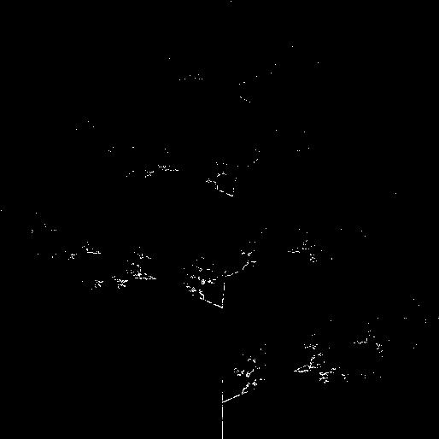

Figure 3. Iteration = 5000

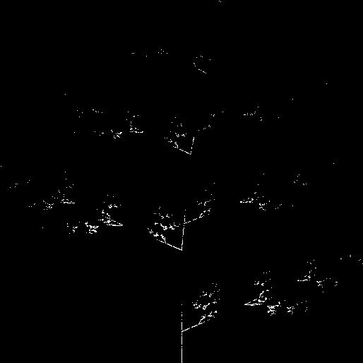

Figure 4. Iteration = 10000

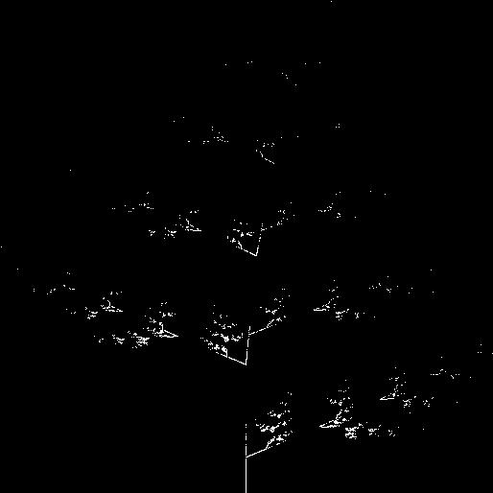

Figure 5. Iteration = 20000

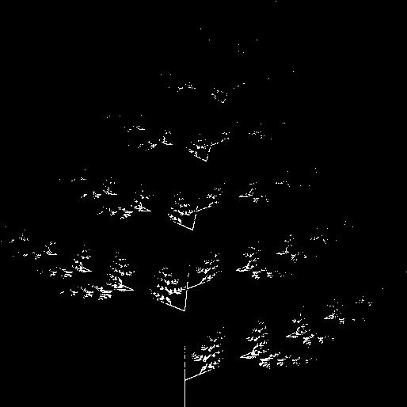

Figure 6. Iteration = 200000

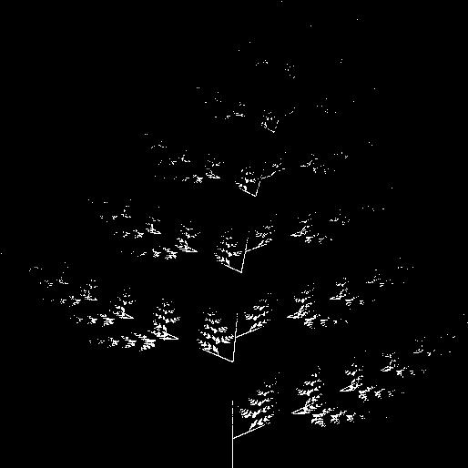Figure 7. Iteration = 500000

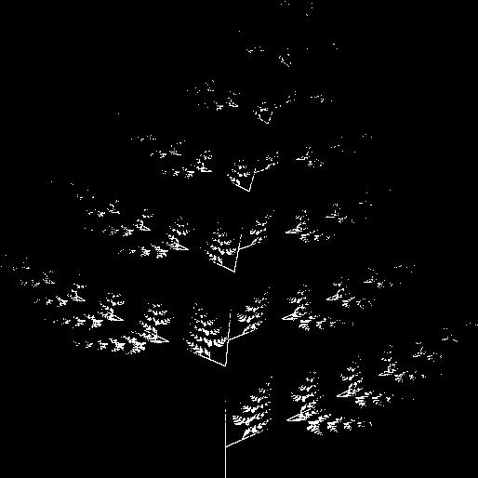

Figure 8. Iteration =1000000

**C-2. Probability set two .**

|  |  |  |  |
| --- | --- | --- | --- |
| pi (set 1) | pi (set 2) | pi (set 3) | pi (set 4) |
| 0.7 | 0.1 | 0.1 | 0.1 |

The results are presented in Figure 9 to Figure 16.



Figure 9. Iteration =100



Figure 10. Iteration =1000



Figure 11. Iteration =5000

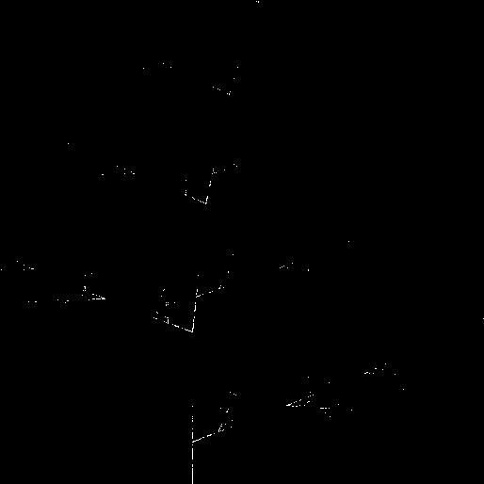

Figure 12. Iteration =10000

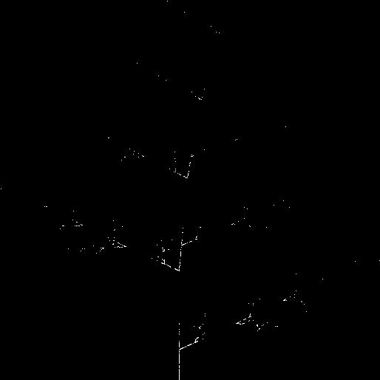

Figure 13. Iteration =20000

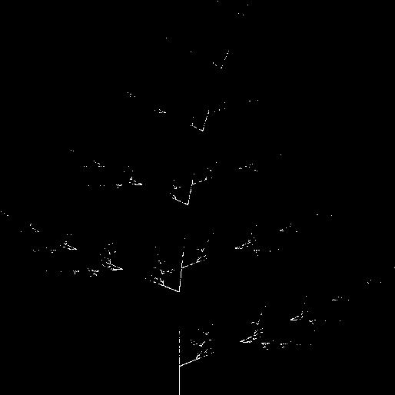

Figure 14. Iteration =200000

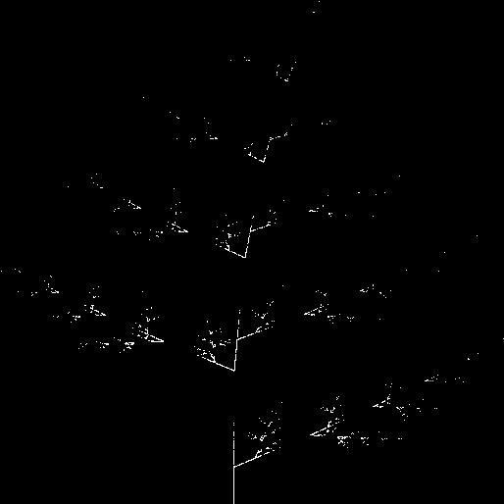

Figure 15. Iteration =500000

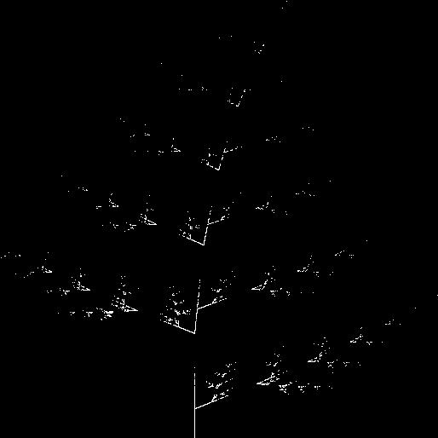

Figure 16. Iteration =1000000

**C-3. Probability set three .**

|  |  |  |  |
| --- | --- | --- | --- |
| pi (set 1) | pi (set 2) | pi (set 3) | pi (set 4) |
| 0.1 | 0.7 | 0.1 | 0.1 |

The results are presented in Figure 17 to Figure 24.



Figure 17. Iteration =100



Figure 18. Iteration =1000



Figure 19. Iteration =5000



Figure 20. Iteration =10000

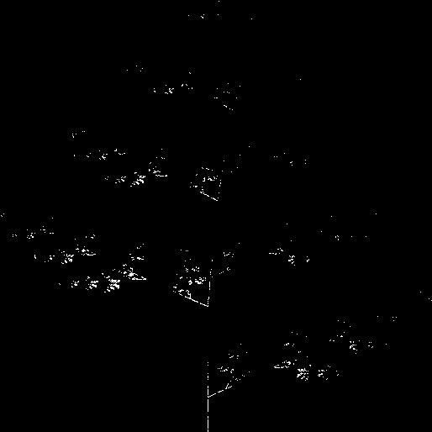

Figure 21. Iteration =20000

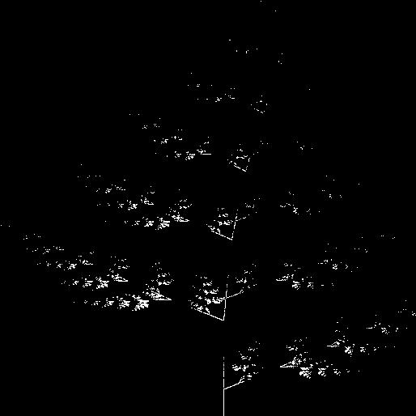

Figure 22. Iteration =200000

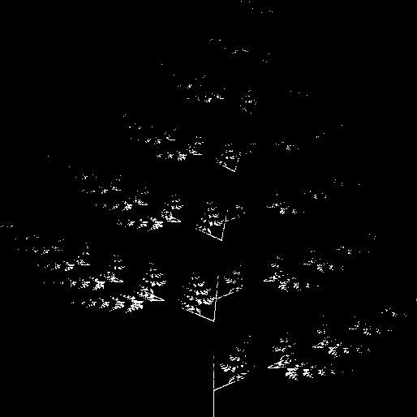

Figure 23. Iteration =500000

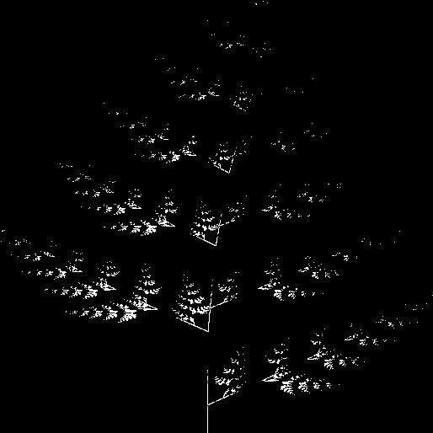

Figure 24. Iteration =1000000

**C-4. Probability set four .**

|  |  |  |  |
| --- | --- | --- | --- |
| pi (set 1) | pi (set 2) | pi (set 3) | pi (set 4) |
| 0.1 | 0.1 | 0.7 | 0.1 |

The results are presented in Figure 25 to Figure 32.



Figure 25. Iteration =100



Figure 26. Iteration =1000



Figure 27. Iteration =5000

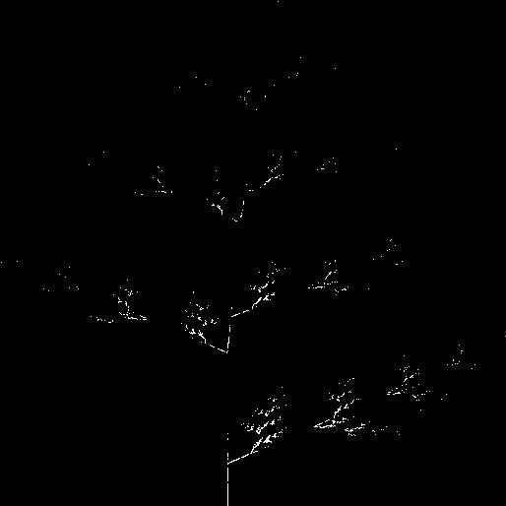

Figure 28. Iteration =10000

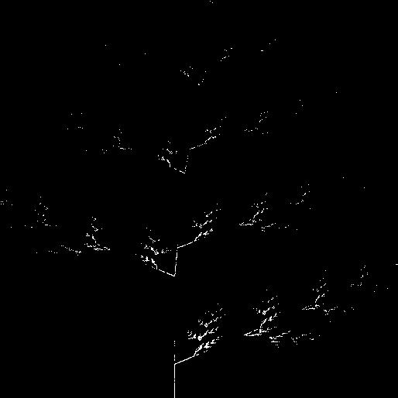

Figure 29. Iteration =20000

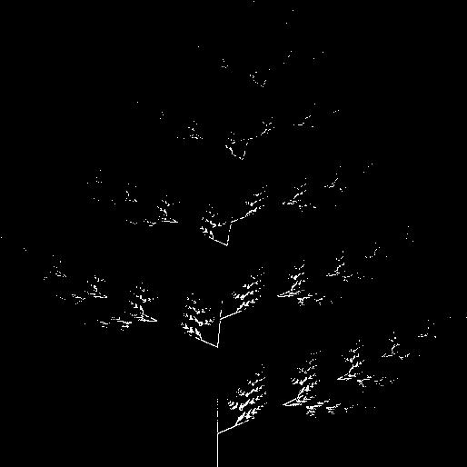

Figure 30. Iteration =200000

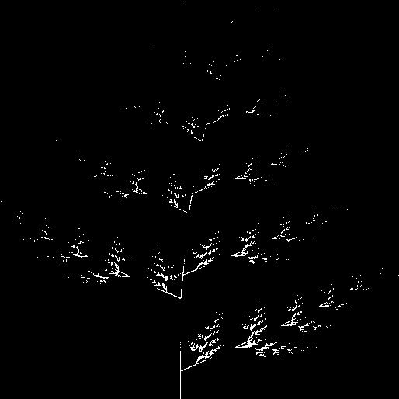

Figure 31. Iteration =500000

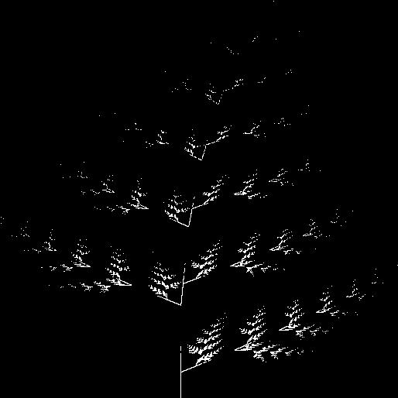

Figure 32. Iteration =1000000

**C-5. Probability set five.**

|  |  |  |  |
| --- | --- | --- | --- |
| pi (set 1) | pi (set 2) | pi (set 3) | pi (set 4) |
| 0.1 | 0.1 | 0.1 | 0.7 |

The results are presented in Figure 33 to Figure 40.

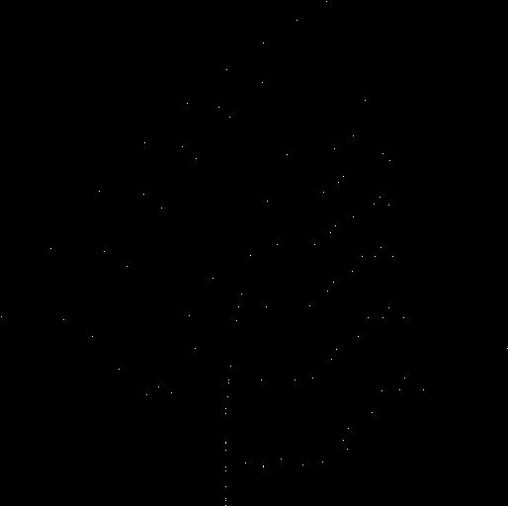

Figure 33. Iteration =100

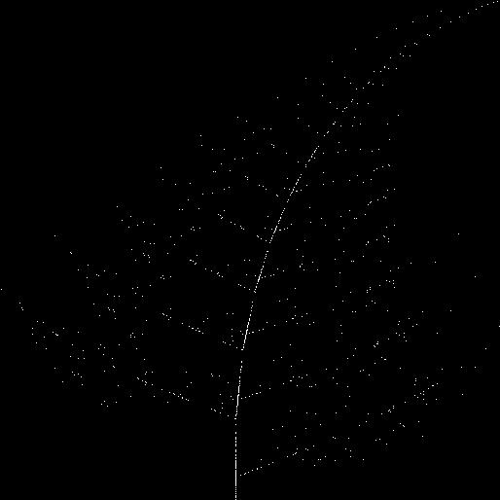

Figure 34. Iteration =1000

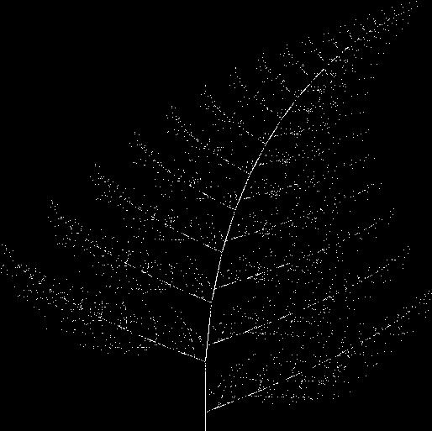

Figure 35. Iteration =5000

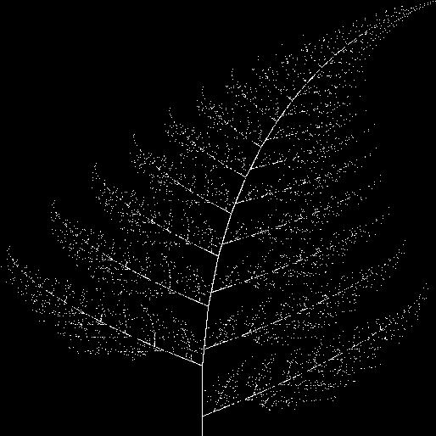

Figure 36. Iteration =10000

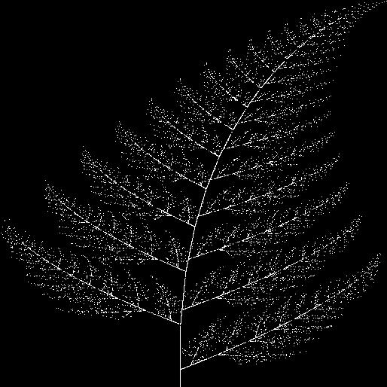

Figure 37. Iteration =20000

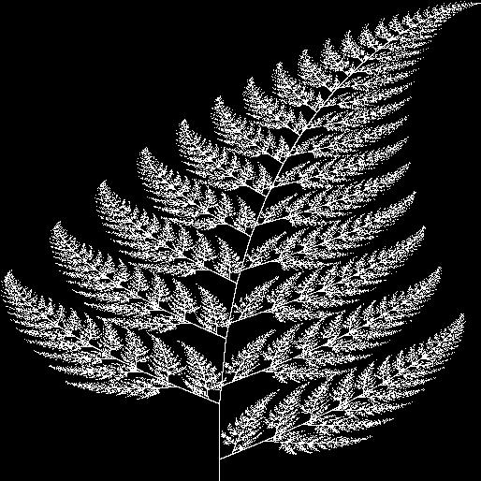

Figure 38. Iteration =200000

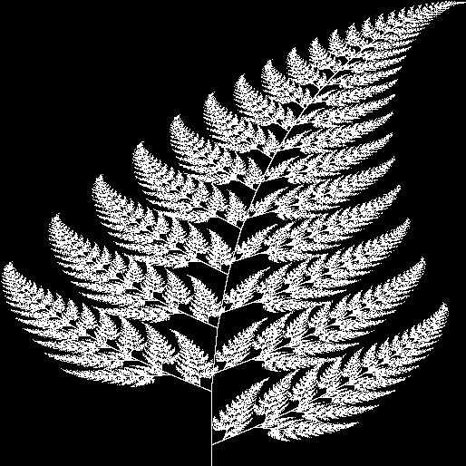

Figure 39. Iteration =500000



Figure 40. Iteration =1000000

**E. Conclusion.**

To conclude our project, we applied the iterated function system with affine linear transformation. Then we tried different probabilities and compared the results. Finally, we also want to thank professor Higgins for his lecture notes and hints.