ME491 : Programming Exercise 2

Due Date : Monday, 11 October 2021, 5 p.m.

1 Introduction

The goal of this programming exercise is to obtain an optimal policy and the corresponding value function using dynamic programming (DP). You will use **policy iteration**. Here are some general rules of the programming and results which have to be submitted:

• You have to use Python.

• The 19 states are numbered as shown in the Figure 1. The output numpy arrays (i.e., the value and

policy functions, path) must follow this convention. For example, using default settings(from Daejeon to Seoul)

– Optimal value, 19 values for state: (e.g. [0.0, -22.0, -55.0, -79.0, -139.0, -183.0, -88.5, -130.1, -209.09, -197.65, -281.88, -224.09, -238.18, -296.36, -308.7, -293.81, -258.68, -310.36, -290.36])

– Optimal policy, next state to go: (e.g. [1, 0, 0, 0, 0, 0, 2, 3, 7, 6, 9, 7, 8, 12, 10, 16, 11, 12, 12])

– Optimal path: (e.g. [7, 3, 0])

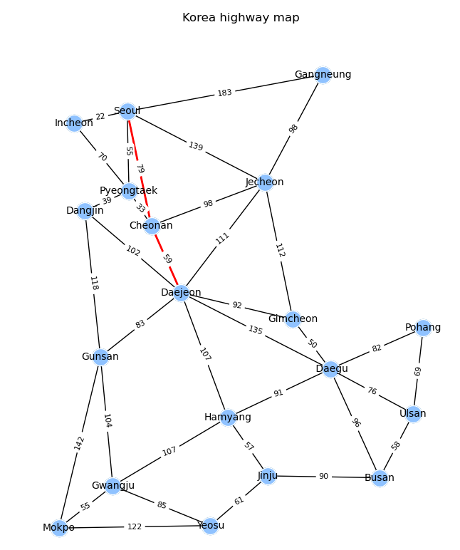

Figure1. Example path using policy iteration (Daejeon to Seoul)

2 Instruction

**A code template is same with previous exercise**. You can modify the code structure including function arguments or add functions, but returned optimal policy, optimal value, and optimal path should follow the given format.

• The given python script gets arguments from user input you can use -d and -t to set the departure node and destination node.

• The given .csv file has an adjacency matrix of weighted graph which is the distance from a node to node and can be a negative reward to go through it.

• The path should start from the user-defined departure node and end at the terminal node.

• A discount factor is 0.9

• You will get scores for optimal value, optimal policy, and optimal path. **Optimal value should be sufficiently converged. (<1e-3)**

• Evaluation will use this kind of command, ‘prob2_policy_iter.py -d 1 -t 17’ so check that command works.

Submit a zip file, consisting of 1 file

• The name of the zip file should be ‘(student number)_(name).zip’, and the 1 Python file name should be the same as below. An example of the final file is:

20200000_yourname.zip

* prob2_policy_iter.py