Student Name: | xxx
Student ID: | Sxxxx
Module Name: | Information Systems Modelling & Design
Course Title | 2025 ISMD UEL CS BRIDGING MODULE
Lecturer: | Dr Preethi Kesavan
Submission Date:
Assignment Report  Number of Pages | 330

UML class diagram

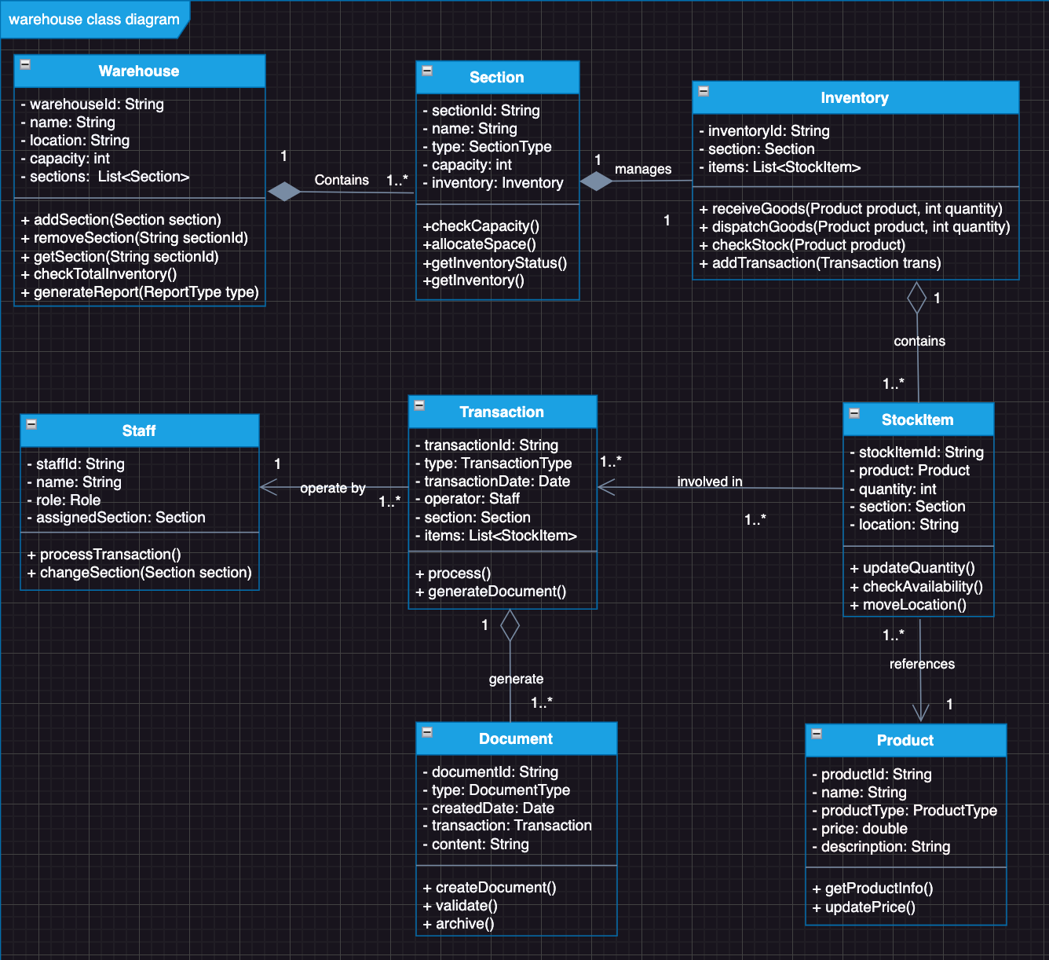

UML state diagram

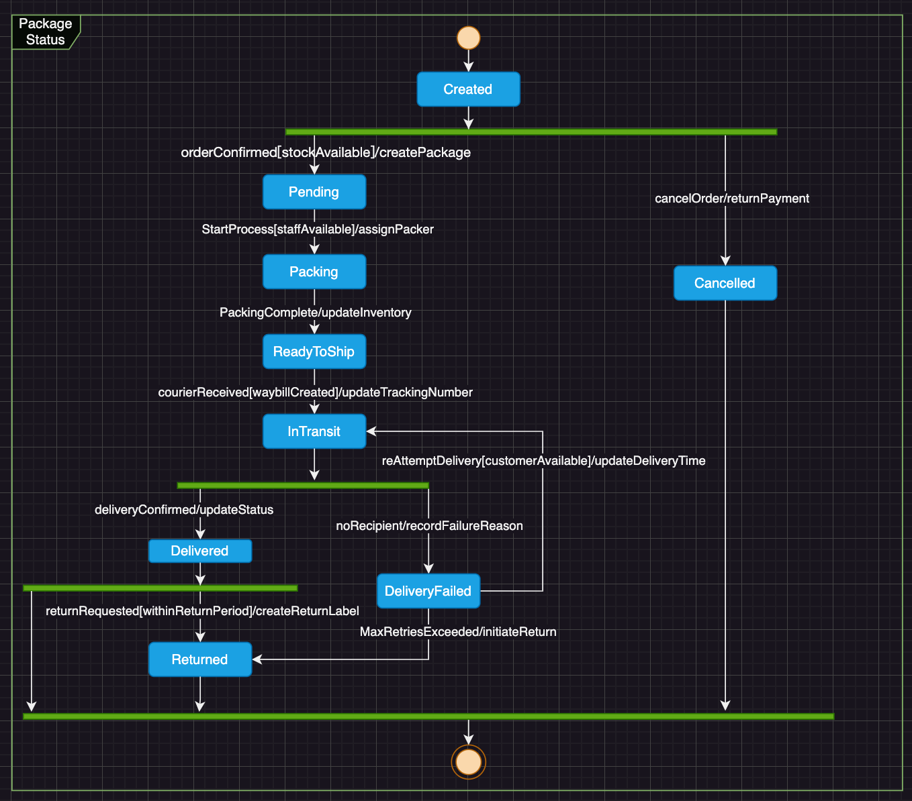

Requirements challenging to model in UML.

Inventory Alert and Replenishment Timing Rules:
- To prevent waste and financial losses, inventory must be replenished at optimal times. Specifically, stock levels should be increased prior to major holidays (e.g., Christmas) to meet peak sales demands.
- This rule incorporates temporal, seasonal, and predictive business logic.
- It encompasses complex decision-making factors such as holidays, historical sales data, and market forecasts.
- UML diagrams struggle to effectively capture these dynamic, time-dependent decision rules.
- It necessitates consideration of multiple variables and market conditions.

Product Discount and Promotion Strategy Rules
- Products pending clearance can be featured in special promotions, which customers generally find appealing particularly during major holidays.
- This rule encompasses intricate pricing strategies and promotional criteria.
- It involves multiple influencing factors, such as product expiration dates, storage duration, and market demand.
- It necessitates flexible business judgment and dynamic adjustments.
- UML diagrams are insufficient to effectively represent this type of conditional pricing and promotional logic.

Missing Requirement: Return Goods Management
The existing requirements do not cover how the warehouse manages customer - returned goods or supplier - rejected shipments. This is a vital process in warehouse management, which includes:

• Quality inspection of returned items
• Decision-making on whether items can be restocked
• Processing refunds or replacements
• Updating inventory records
• Managing damaged/defective inventory

Adding new classes and relationships for Return Goods Management.

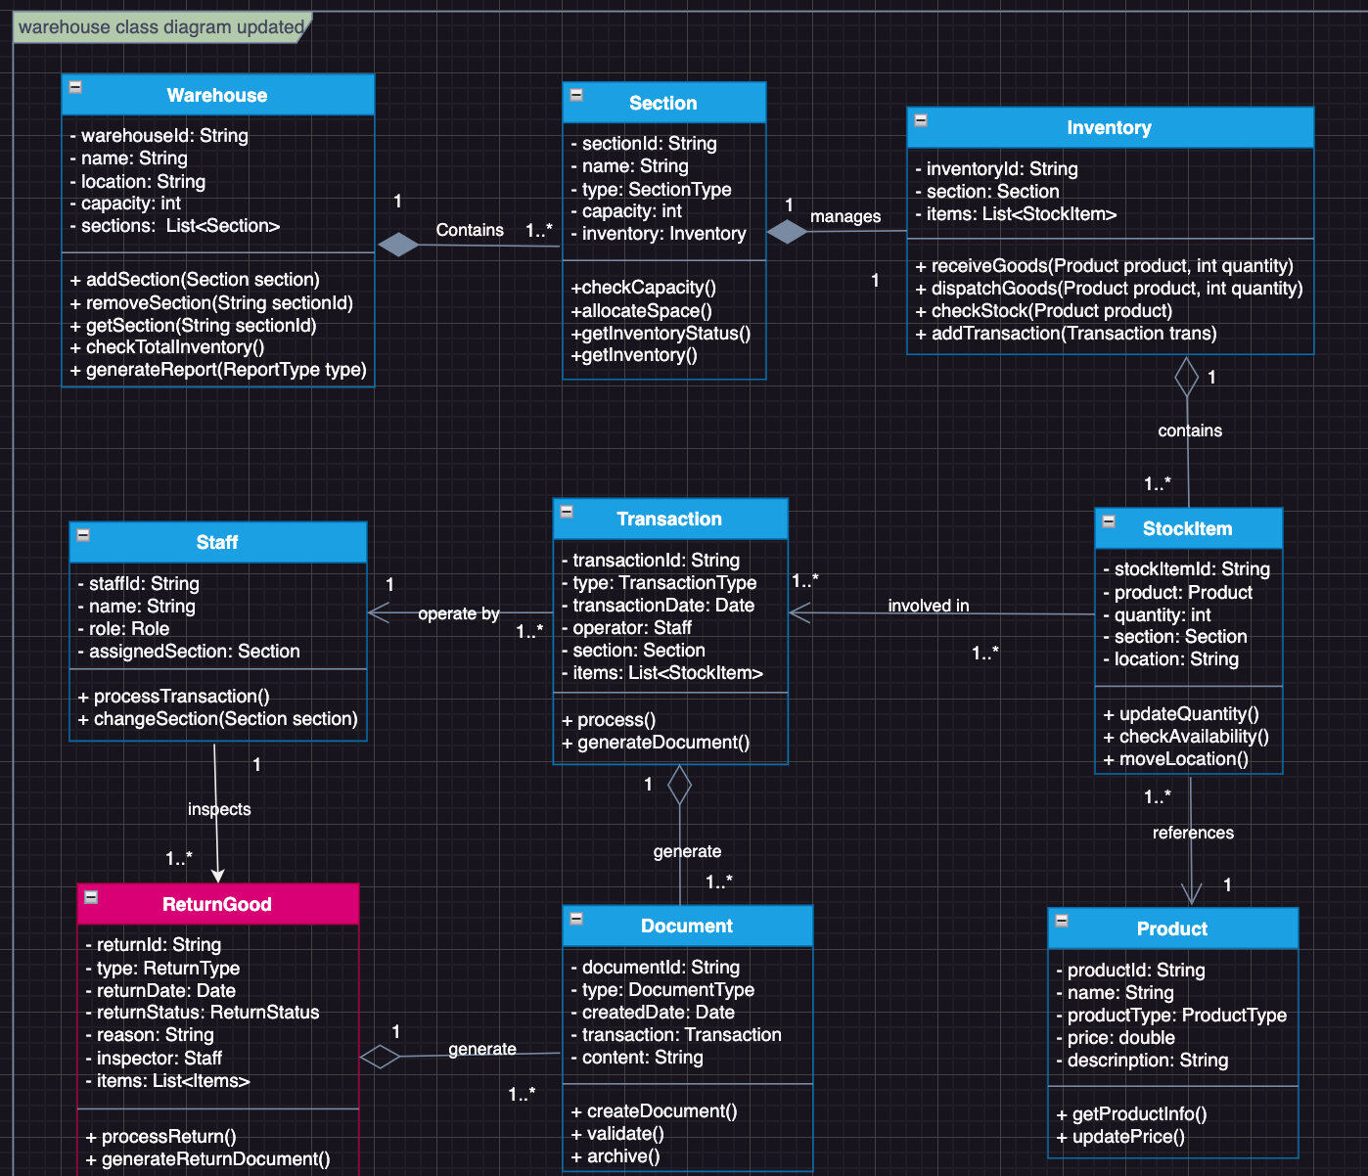

Reference
- Booch, G., Maksimchuk, R., Engle, M., Conallen, J., Houston, K., & Young, B., PhD. (2007). Object-Oriented Analysis and Design with Applications. Pearson Education.
- Gomaa, H. (2011). Software Modeling and Design: UML, Use Cases, Patterns, and Software Architectures. Cambridge University Press.
- Sommerville, I. (2017). Software Engineering.

Dupli Checker

