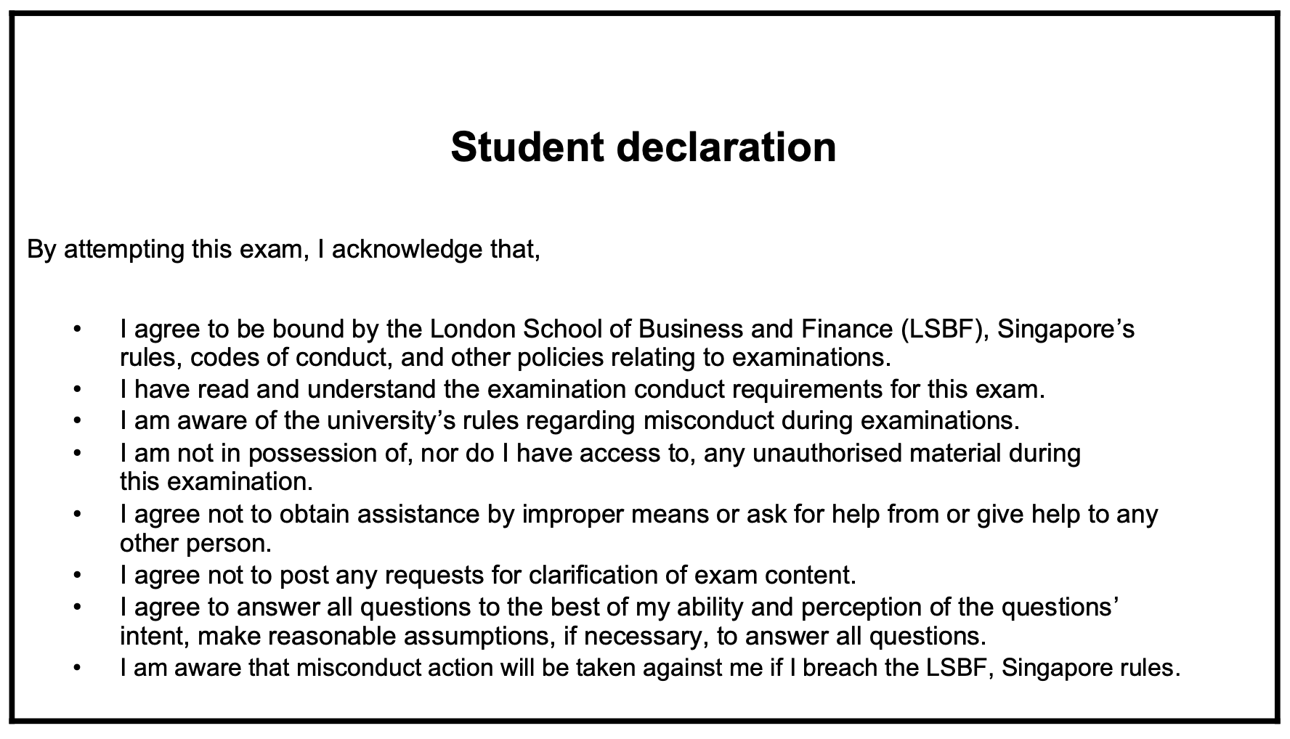

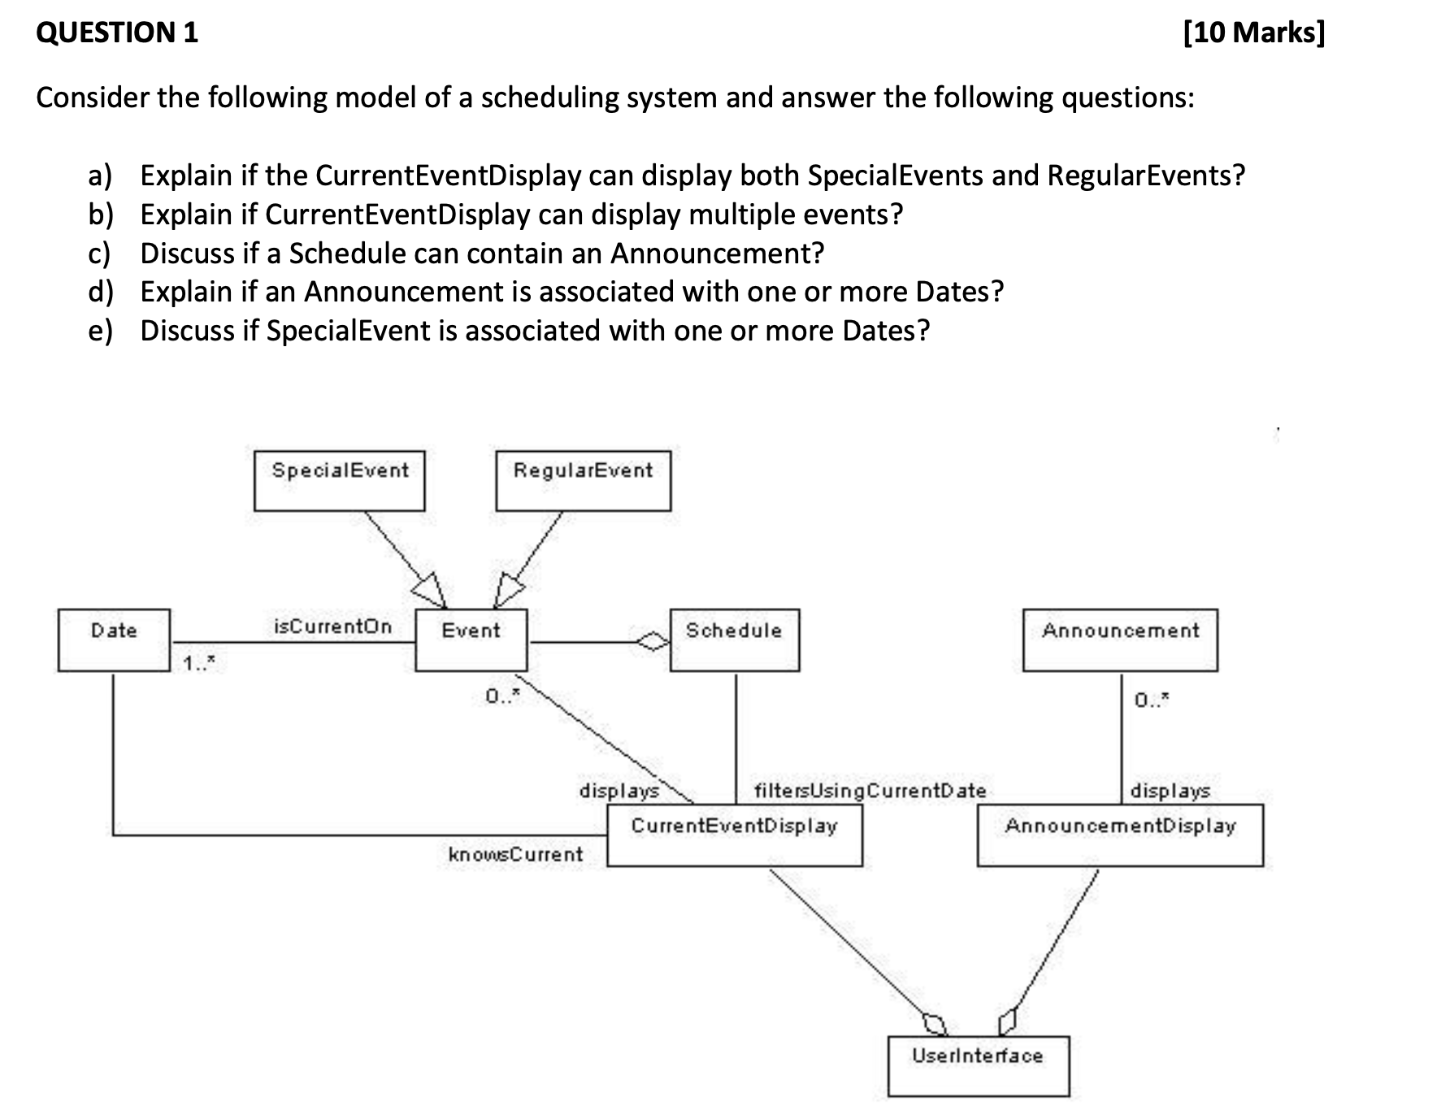
A: Yes, it can display both types because:
- Both SpecialEvent and RegularEvent inherit from Event class
- CurrentEventDisplay has a "displays" relationship with Event (0..)
Through polymorphism, CurrentEventDisplay can handle any subclass of Event
-------------------------------------------------------------------------------------------------------
B: Yes, it can display multiple events because:
- The multiplicity between CurrentEventDisplay and Event is "0.."
- This means zero to many events can be displayed
Through the "displays" association with multiplicity 0..
-------------------------------------------------------------------------------------------------------
C: No, the Schedule cannot contain Announcements because:
- There is no direct association between Schedule and Announcement
- Schedule only has a direct association with Event
Announcements are handled separately through AnnouncementDisplay
-------------------------------------------------------------------------------------------------------
D: No, based on the diagram:
- There is no direct or indirect association between Announcement and Date
- Only Events have the association with Date (1..)
-------------------------------------------------------------------------------------------------------
E: Yes, because:
- SpecialEvent inherits from Event
- Event has a "isCurrentOn" association with Date with multiplicity 1..
Through inheritance, SpecialEvent gets the same Date association as its parent class Event
-------------------------------------------------------------------------------------------------------
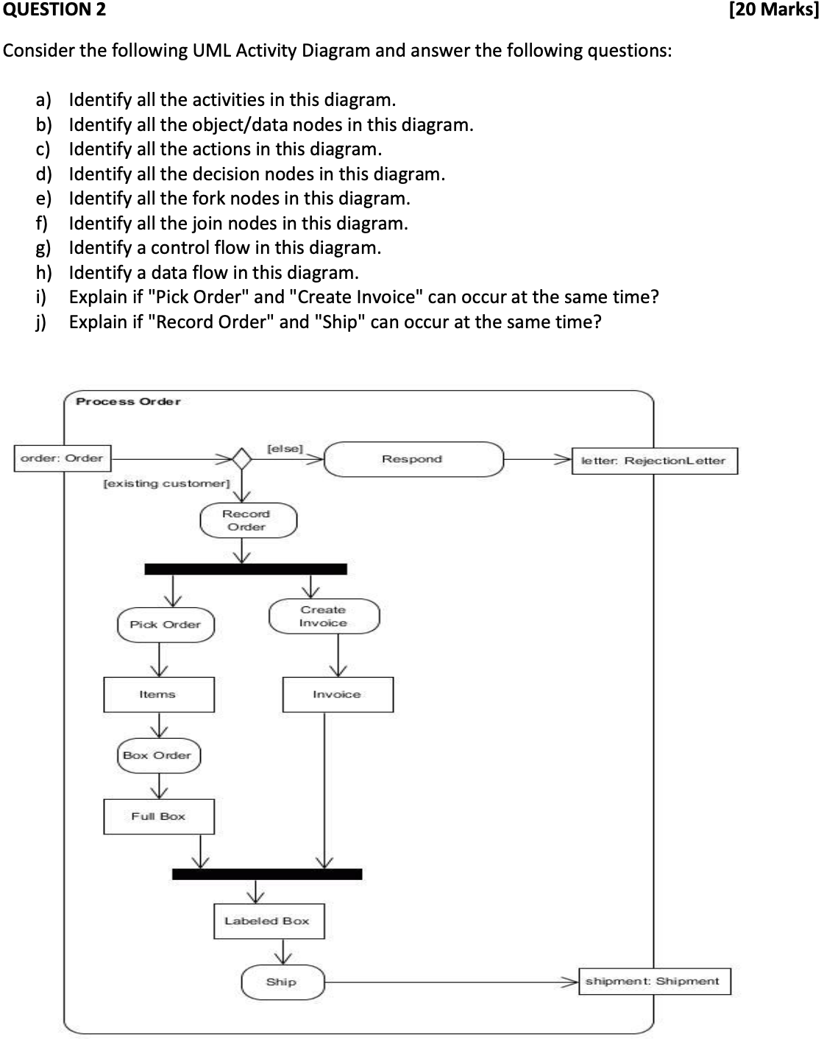
-------------------------------------------------------------------------------------------------------
A: Activities (rounded rectangles):
- Record Order
- Pick Order
- Create Invoice
- Box Order
- Respond
- Ship
-------------------------------------------------------------------------------------------------------

B: Object/Data nodes (rectangles):
- order: Order
- letter: Rejection_Letter
- Items
- Invoice
- Full Box
- Labeled Box
- shipment: Shipment
-------------------------------------------------------------------------------------------------------
C: Actions
- Record Order
- Pick Order
- Create Invoice
- Box Order
- Respond
- Ship
-------------------------------------------------------------------------------------------------------
D: Decision nodes (diamonds):
- The diamond after "order: Order" with guards [else] and [existing customer]
-------------------------------------------------------------------------------------------------------
E: Fork nodes (thick horizontal bars):
- The first bar after "Record Order" (splits flow into Pick Order and Create Invoice)
- The second bar before "Labeled Box" (joins the two parallel flows)
-------------------------------------------------------------------------------------------------------
F: Join nodes (thick horizontal bars): Same as fork nodes in this diagram (the second horizontal bar acts as a join)
- The flow from Full Box
- The flow from Invoice”
-------------------------------------------------------------------------------------------------------
G: Main Sequential Flow:
- order: Order → Decision Node
- Decision Node [existing customer] → Record Order
Represented by arrows (→) connecting elements
-------------------------------------------------------------------------------------------------------
H: "Record Order → Fork Node → Pick Order"
WHY this is a control flow:
- It shows the sequence of execution
- It uses arrows (→) to indicate direction
- It connects action nodes and control nodes
- It represents the process logic, not data movement
-------------------------------------------------------------------------------------------------------
I: Yes, because:
- They are connected by a fork node
- Fork nodes indicate parallel processing
After "Record Order", both activities can execute simultaneously
-------------------------------------------------------------------------------------------------------
J: No, because:
- They are in a sequential flow
- Ship can only occur after both parallel paths are complete
Ship must wait for the join node to synchronize both parallel paths
-------------------------------------------------------------------------------------------------------
Question 3

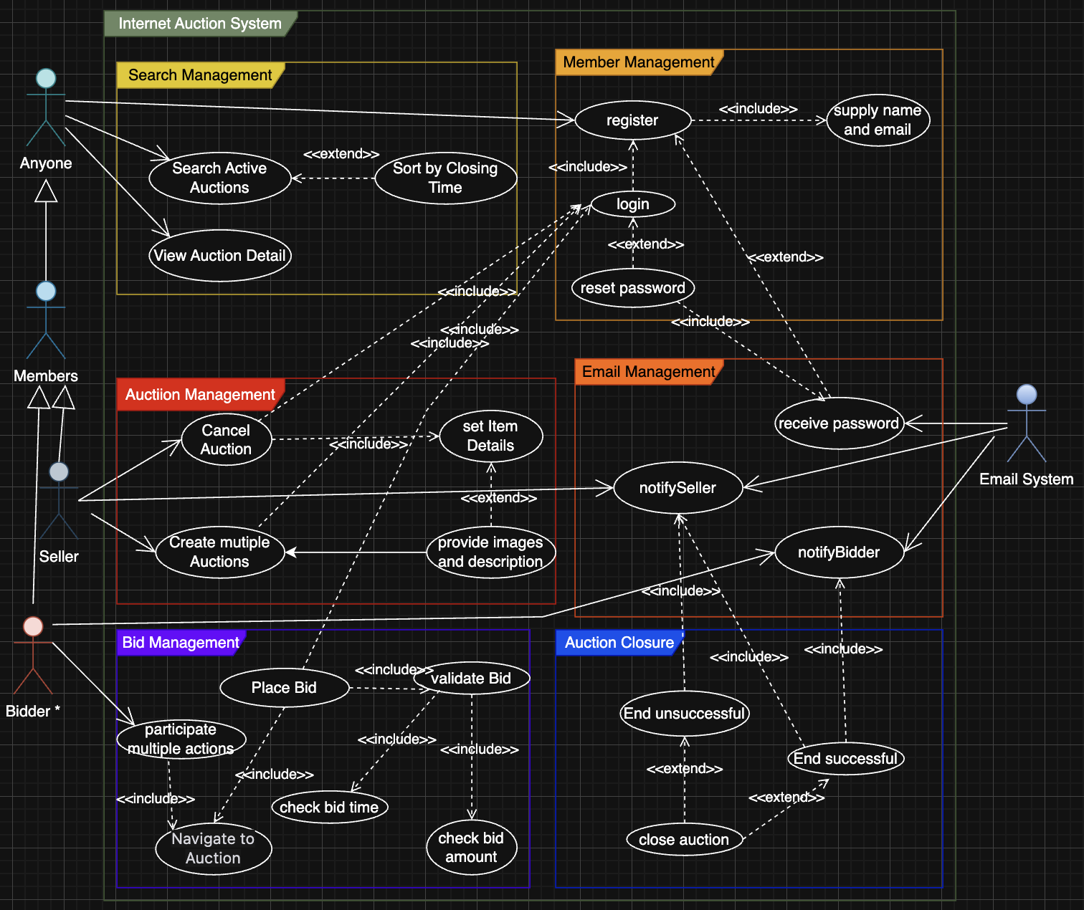

3.1 Stakeholders (Actors)

Anyone
- Can search for active auctions and view auction details.
Members
- Must register with name and email.
- Receive password via email.
- Must log in to bid or sell.
- Can reset password (receive via email).
- Can place bids and create auctions.
Seller (a type of Member)
- Can create multiple auctions.
- Can set item details, provide images/description.
- Can cancel auctions.
Bidder (a type of Member)
- Can participate in multiple auctions.
- Can place bids (must be valid and within time/amount constraints).
Email System
- Sends passwords, notifications to sellers and bidders.

3-2.Use Cases
1. Search Management
- Search Active Auctions: Anyone can search auctions by keyword.
- Sort by Closing Time: Results are sorted chronologically.
- View Auction Detail: Anyone can view details of any auction.
2. Member Management
- Register: Members must register with name and email.
- Login: Members must log in to access member features.
- Reset Password: Members can request password reset.
Supply Name and Email: Required for registration.
3. Auction Management
- Create Multiple Auctions: Sellers can create multiple auctions.
- Set Item Details: Each auction must have name, closing time, minimum bid.
- Provide Images and Description: Optional for each item.
- Cancel Auction: Sellers can cancel auctions (with notification to bidders).
4. Bid Management
- Place Bid: Members can place bids on auctions.
- Validate Bid: Bids must be above minimum and previous bids.
- Check Bid Time: Bids must be before closing time.
- Check Bid Amount: Bids must be valid.
- Navigate to Auction: Members can access auction pages.
5. Auction Closure
- Close Auction: Auctions are closed after end time or cancellation.
- End Successful: If there are valid bids, notify seller and winning bidder.
- End Unsuccessful: If no bids, notify seller.
6. Email Management
- Receive Password: Members receive password via email.
- Notify Seller: Seller receives notifications (e.g., auction end, cancellation).
- Notify Bidder: Bidders receive notifications (e.g., win, cancellation).

3-3.Assumptions
- Sellers and bidders are both members.
- Email notifications are handled by an external system.
- Only registered and logged-in members can bid or create auctions.
- Auctions can be cancelled only up to 24 hours before closing.
- All actions are logged and validated by the system.

3-4.Diagram-Scenario Mapping
- Anyone: Can search and view auctions.
- Members: Must register, log in, and can reset password.
- Sellers: Can create, manage, and cancel auctions.
- Bidders: Can participate and place bids.
- Email System: Handles all email notifications.

