|  |  |
| --- | --- |
| **Student Name:** | **LIU SHENGWEI** |
| **Student ID:** | **S1037766** |
| **Module Name:** | **Information Systems Modelling & Design** |
| **Course Title** | [**2025 ISMD UEL CS BRIDGING MODULE**](https://canvas.lsbf.edu.sg/courses/4012) |
| **Lecturer:** | **Dr Preethi Kesavan** |
| **Submission Date:** | **December 21, 2024** |
| **Assignment Report**  **Number of Pages** | **233** |

# UML class diagram

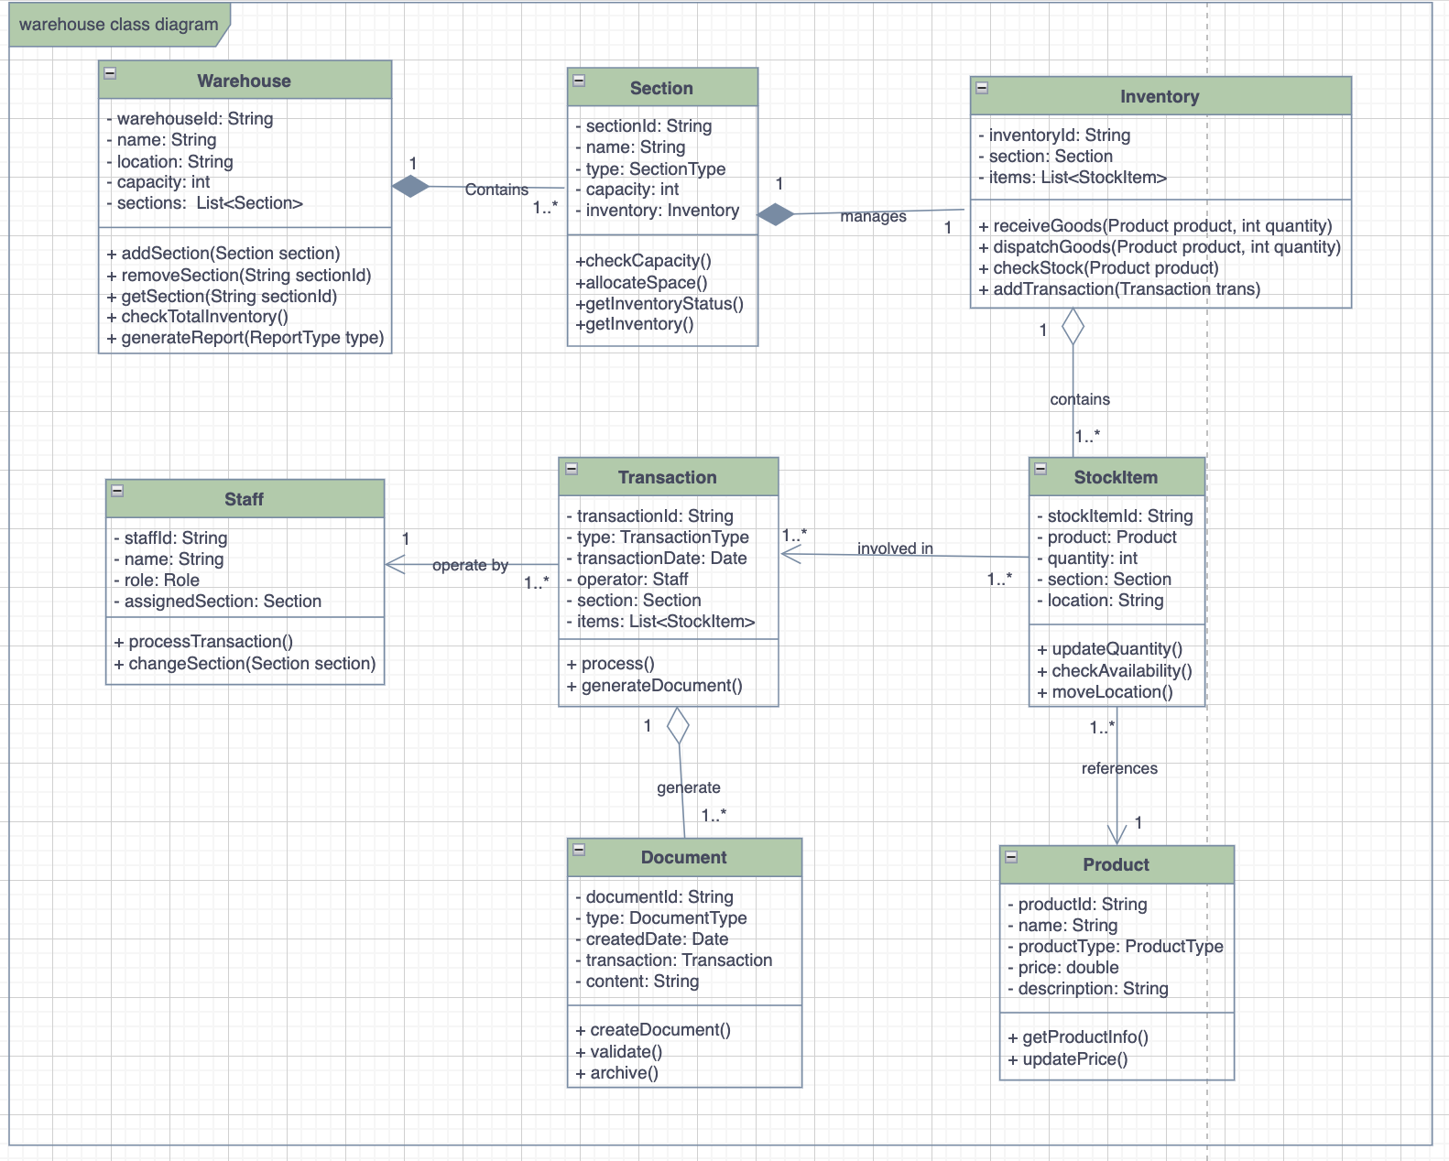

# UML state diagram

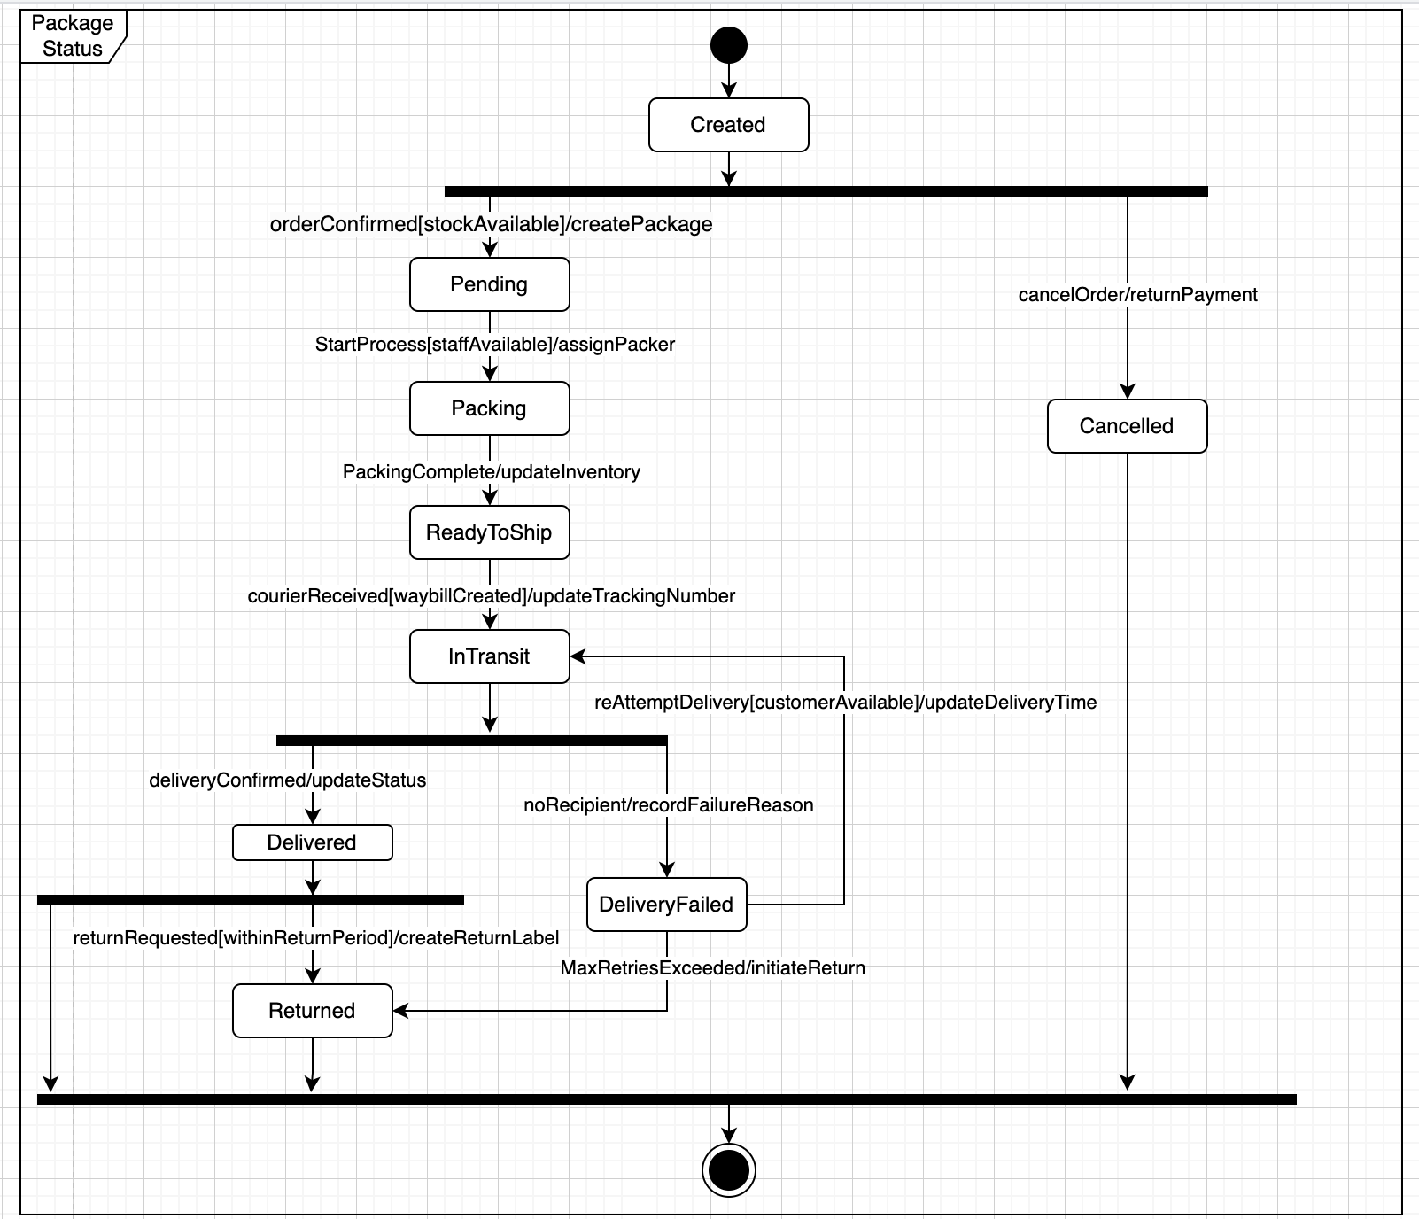

# Requirements that are difficult to represent in UML.

## Inventory Alert and Replenishment Timing Rules:

1. "To avoid waste and financial loss, inventory needs to be replenished at appropriate times. Particularly before major holidays (like Christmas), stock levels need to be increased in advance to meet peak sales demands."
2. This rule involves temporal, seasonal, and predictive business logic
3. Includes complex decision factors (holidays, historical sales data, market forecasts)
4. UML diagrams cannot easily express these dynamic, time-dependent decision rules
5. Requires consideration of multiple variables and market conditions

## Product Discount and Promotion Strategy Rules

1. "Products that need to be cleared can be put on special offers, and customers typically love special offers, especially during major holidays."
2. This rule involves complex pricing strategies and promotional conditions
3. Includes multiple influencing factors (product expiry dates, storage time, market demand)
4. Requires flexible business judgment and dynamic adjustments
5. UML diagrams cannot effectively represent this type of conditional pricing and promotional logic

# Missing Requirement: Return Goods Management

The current requirements don't address how the warehouse handles returned goods from customers or rejected shipments from suppliers. This is a critical process in warehouse management that involves:

• Quality inspection of returned items

• Decision-making on whether items can be restocked

• Processing refunds or replacements

• Updating inventory records

• Managing damaged/defective inventory

Adding new classes and relationships for Return Goods Management.

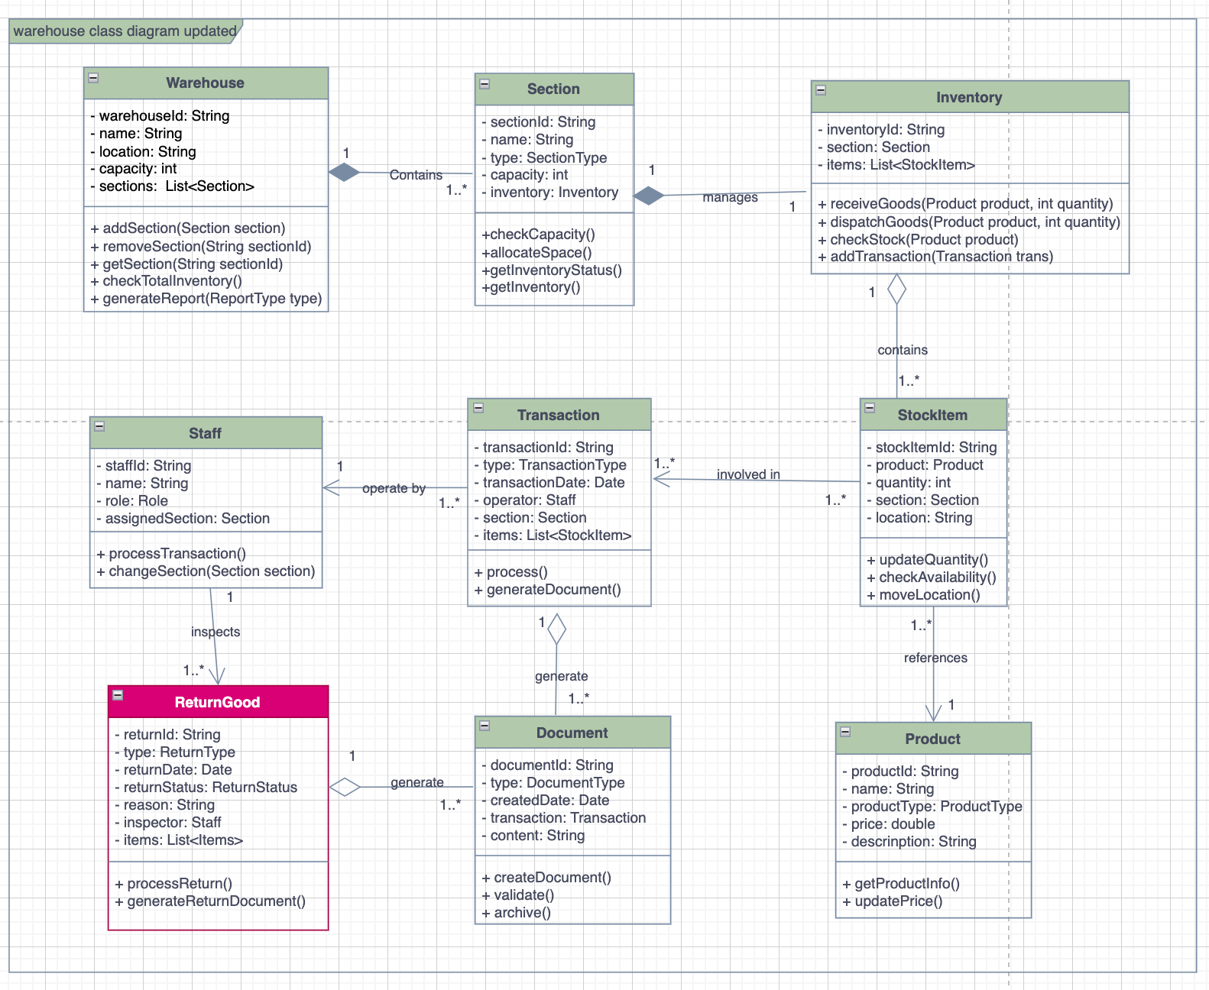

# Reference

1. Booch, G., Maksimchuk, R., Engle, M., Conallen, J., Houston, K., & Young, B., PhD. (2007). *Object-Oriented Analysis and Design with Applications*. Pearson Education.
2. Gomaa, H. (2011). *Software Modeling and Design: UML, Use Cases, Patterns, and Software Architectures*. Cambridge University Press.
3. Sommerville, I. (2017). *Software Engineering*.

# Dupli Checker

