|  |  |
| --- | --- |
| **Student Name:** | **Suntao** |
| **Student ID:** | **S1038988** |
| **Module Name:** | **Information Systems Modelling & Design** |
| **Course Title** | [**2025 ISMD UEL CS BRIDGING MODULE**](https://canvas.lsbf.edu.sg/courses/4012) |
| **Lecturer:** | **Dr Preethi Kesavan** |
| **Submission Date:** | **April 15, 2025** |
| **Assignment Report**  **Number of Pages** | **330** |

# UML class diagram

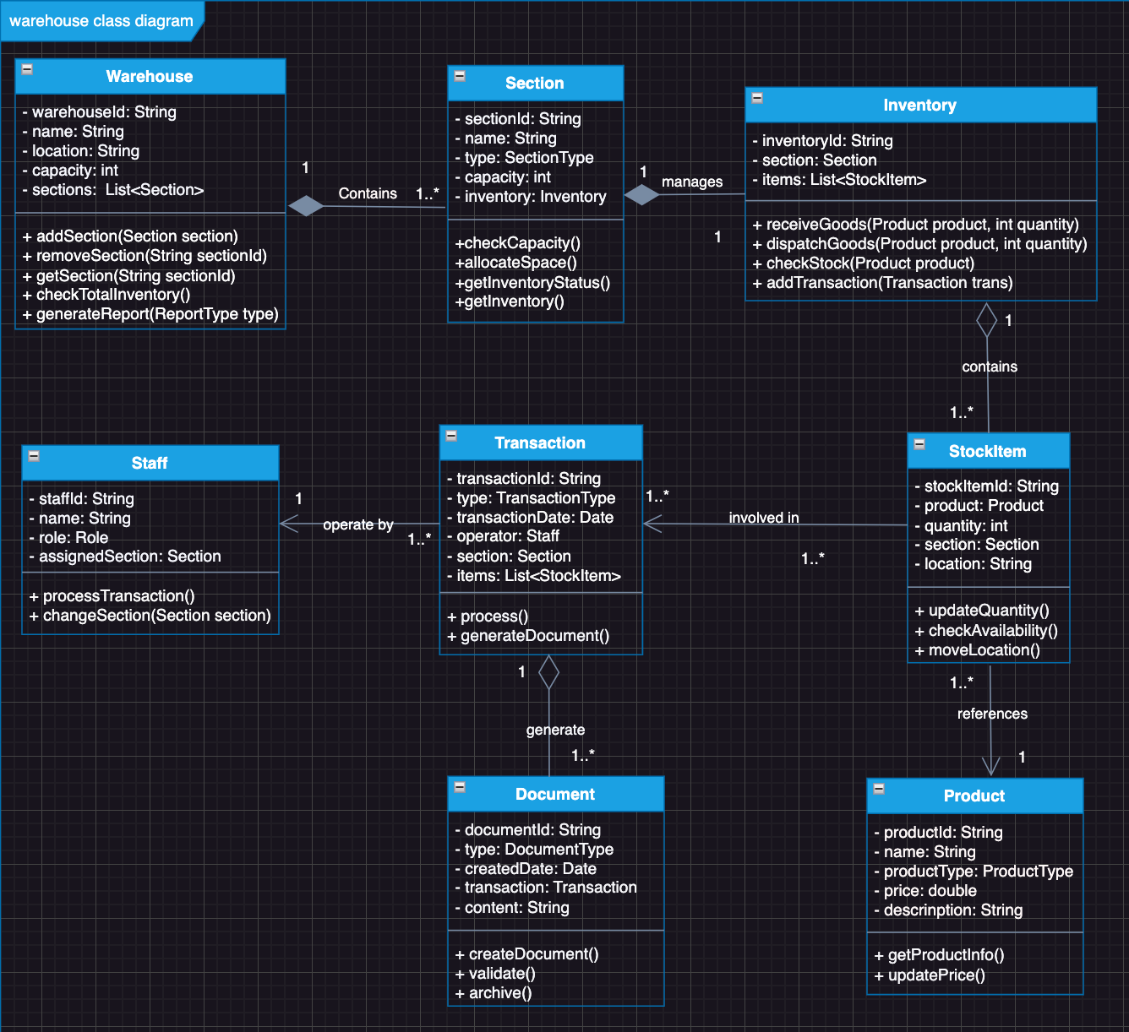

# UML state diagram

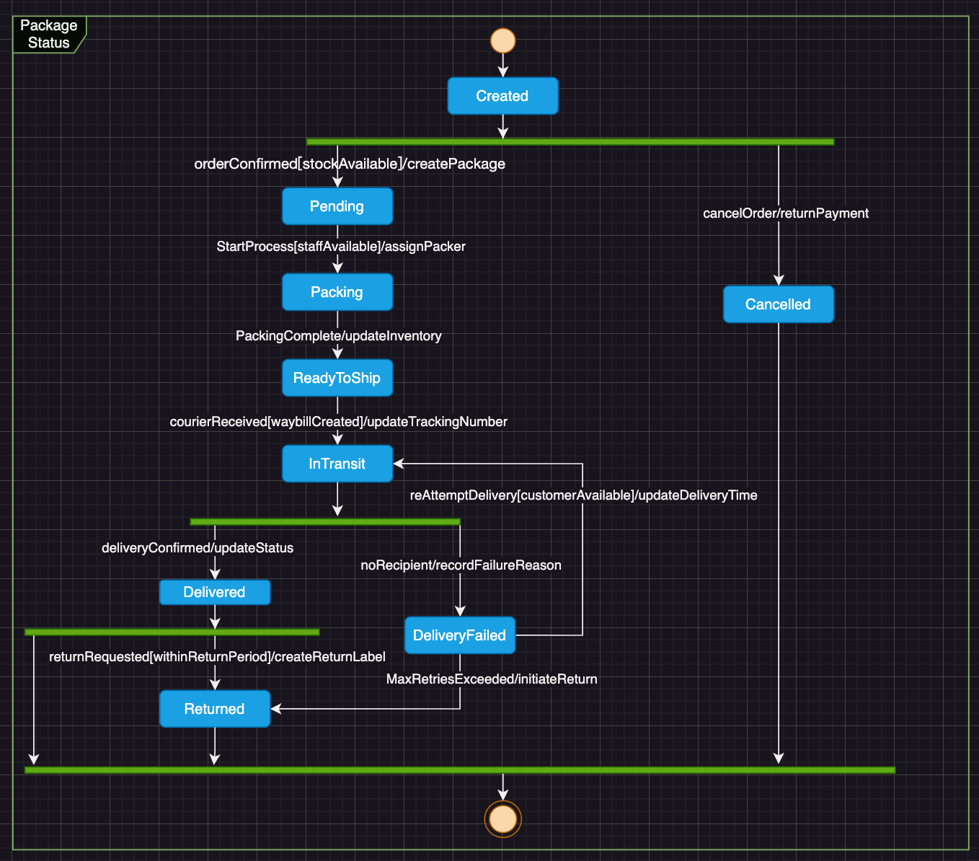

# Requirements challenging to model in UML.

## Inventory Alert and Replenishment Timing Rules:

1. To prevent waste and financial losses, inventory must be replenished at optimal times. Specifically, stock levels should be increased prior to major holidays (e.g., Christmas) to meet peak sales demands.
2. This rule incorporates temporal, seasonal, and predictive business logic.
3. It encompasses complex decision-making factors such as holidays, historical sales data, and market forecasts.
4. UML diagrams struggle to effectively capture these dynamic, time-dependent decision rules.
5. It necessitates consideration of multiple variables and market conditions.

## Product Discount and Promotion Strategy Rules

1. Products pending clearance can be featured in special promotions, which customers generally find appealing particularly during major holidays.
2. This rule encompasses intricate pricing strategies and promotional criteria.
3. It involves multiple influencing factors, such as product expiration dates, storage duration, and market demand.
4. It necessitates flexible business judgment and dynamic adjustments.
5. UML diagrams are insufficient to effectively represent this type of conditional pricing and promotional logic.

# Missing Requirement: Return Goods Management

The existing requirements do not cover how the warehouse manages customer - returned goods or supplier - rejected shipments. This is a vital process in warehouse management, which includes:

• Quality inspection of returned items

• Decision-making on whether items can be restocked

• Processing refunds or replacements

• Updating inventory records

• Managing damaged/defective inventory

Adding new classes and relationships for Return Goods Management.

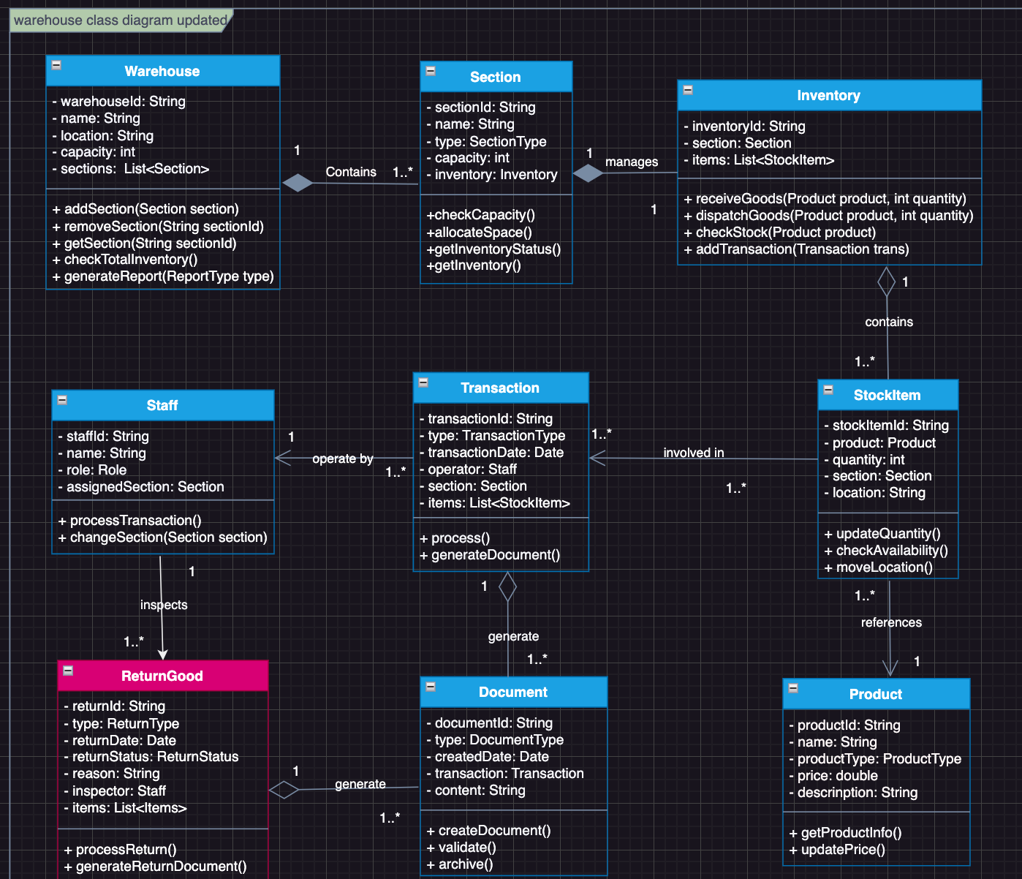

# Reference

1. Booch, G., Maksimchuk, R., Engle, M., Conallen, J., Houston, K., & Young, B., PhD. (2007). *Object-Oriented Analysis and Design with Applications*. Pearson Education.
2. Gomaa, H. (2011). *Software Modeling and Design: UML, Use Cases, Patterns, and Software Architectures*. Cambridge University Press.
3. Sommerville, I. (2017). *Software Engineering*.

# Dupli Checker

