**Student declaration**

By attempting this exam, I acknowledge that,

* I agree to be bound by the London School of Business and Finance (LSBF), Singapore’s rules, codes of conduct, and other policies relating to examinations.
* I have read and understand the examination conduct requirements for this exam.
* I am aware of the university’s rules regarding misconduct during examinations.
* I am not in possession of, nor do I have access to, any unauthorised material during this examination.
* I agree not to obtain assistance by improper means or ask for help from or give help to any other person.
* I agree not to post any requests for clarification of exam content.
* I agree to answer all questions to the best of my ability and perception of the questions’ intent, make reasonable assumptions, if necessary, to answer all questions.
* I am aware that misconduct action will be taken against me if I breach the LSBF, Singapore rules.

1. QUESTION 1

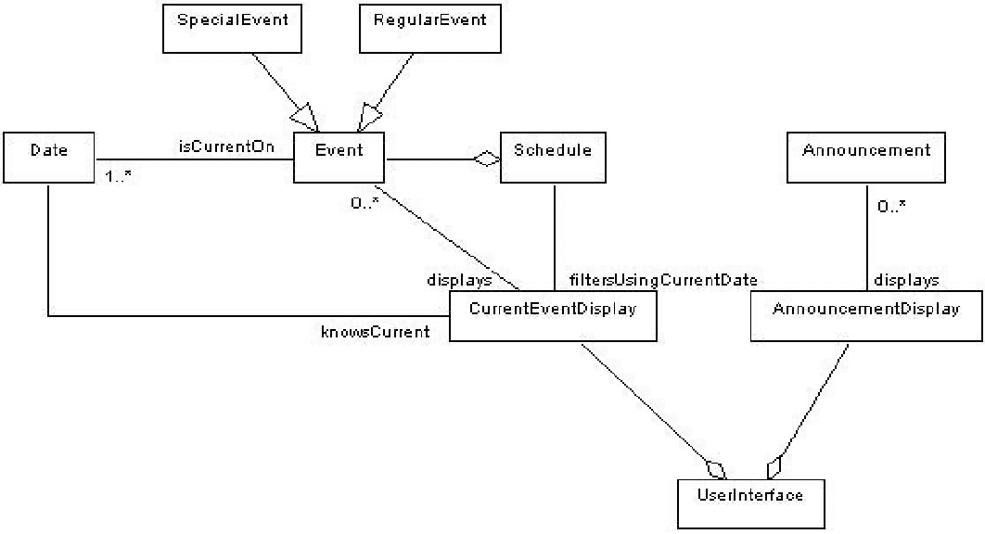

1. Explain if the CurrentEventDisplay can display both SpecialEvents and RegularEvents?

WHY: Yes, it can display both types because:

* Both SpecialEvent and RegularEvent inherit from Event class
* CurrentEventDisplay has a "displays" relationship with Event (0..)

HOW: Through polymorphism, CurrentEventDisplay can handle any subclass of Event

1. Explain if CurrentEventDisplay can display multiple events?

WHY: Yes, it can display multiple events because:

* The multiplicity between CurrentEventDisplay and Event is "0.."
* This means zero to many events can be displayed

HOW: Through the "displays" association with multiplicity 0..

1. Discuss if a Schedule can contain an Announcement?

WHY: No, the Schedule cannot directly contain Announcements because:

* There is no direct association between Schedule and Announcement
* Schedule only has a direct association with Event

HOW: Announcements are handled separately through AnnouncementDisplay

1. Explain if an Announcement is associated with one or more Dates?

WHY: No, based on the diagram:

* There is no direct or indirect association between Announcement and Date
* Only Events have the association with Date (1..)

1. Discuss if SpecialEvent is associated with one or more Dates?

WHY: Yes, because:

* SpecialEvent inherits from Event
* Event has a "isCurrentOn" association with Date with multiplicity 1..

HOW: Through inheritance, SpecialEvent gets the same Date association as its parent class Event

2. QUESTION 2

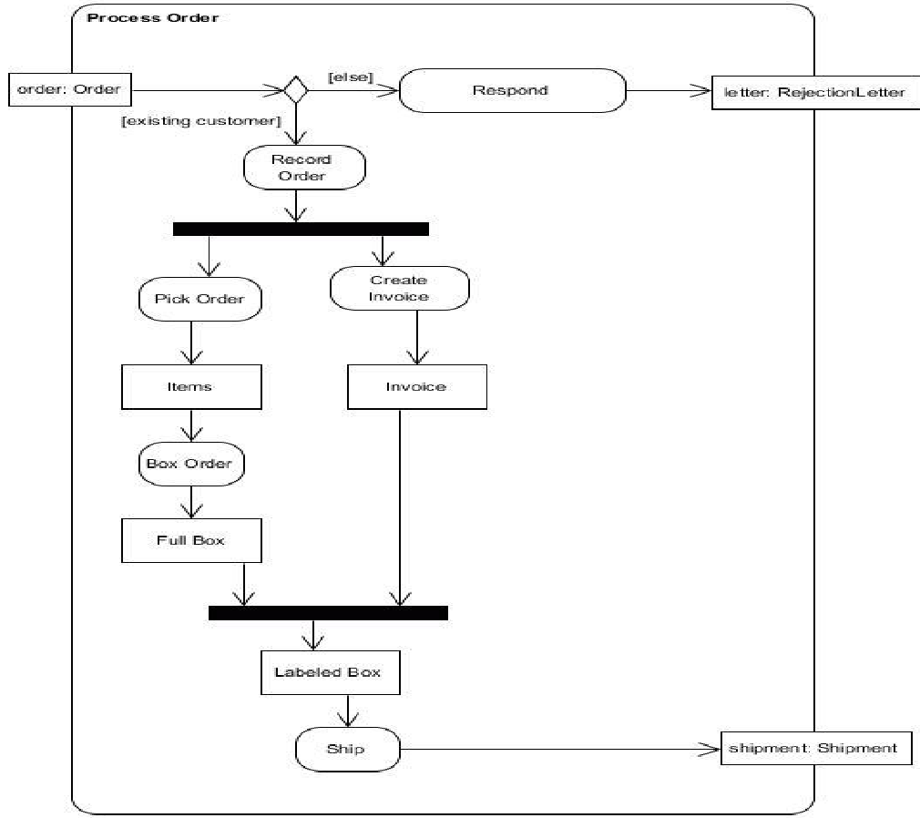

1. Identify all the activities in this diagram.

Activities (rounded rectangles):

* Record Order
* Pick Order
* Create Invoice
* Box Order
* Respond
* Ship

1. Identify all the object/data nodes in this diagram.

Object/Data nodes (rectangles):

* order: Order
* letter: Rejection_Letter
* Items
* Invoice
* Full Box
* Labeled Box
* shipment: Shipment

1. Identify all the actions in this diagram.

WHY: Actions are the executable behaviors

* Record Order
* Pick Order
* Create Invoice
* Box Order
* Respond
* Ship

Compare/Contrast with Activities:

1. Similarities:

* Both are represented by rounded rectangles
* Both show some kind of behavior

1. Differences:

* Actions are the most basic unit of behavior
* Actions cannot be broken down further
* In this diagram, each rounded rectangle actually represents an atomic action

1. Identify all the decision nodes in this diagram.

Decision nodes (diamonds):

* The diamond after "order: Order" with guards [else] and [existing customer]

1. Identify all the fork nodes in this diagram.

Fork nodes (thick horizontal bars):

* The first bar after "Record Order" (splits flow into Pick Order and Create Invoice)
* The second bar before "Labeled Box" (joins the two parallel flows)

1. Identify all the join nodes in this diagram.

Join nodes (thick horizontal bars): Same as fork nodes in this diagram (the second horizontal bar acts as a join)

* The flow from Full Box
* The flow from Invoice”

1. Identify a control flow in this diagram.

Control Flow Definition:

WHY: Control flows show the sequence and direction of execution between actions and other elements

HOW: Represented by arrows (→) connecting elements

Main Sequential Flow:

* order: Order → Decision Node
* Decision Node [existing customer] → Record Order

1. Identify a data flow in this diagram.

"Record Order → Fork Node → Pick Order"

WHY this is a control flow:

* It shows the sequence of execution
* It uses arrows (→) to indicate direction
* It connects action nodes and control nodes
* It represents the process logic, not data movement

1. Explain if "Pick Order" and "Create Invoice" can occur at the same time?

WHY: Yes, because:

* They are connected by a fork node
* Fork nodes indicate parallel processing

HOW: After "Record Order", both activities can execute simultaneously

1. Explain if "Record Order" and "Ship" can occur at the same time?

WHY: No, because:

* They are in a sequential flow
* Ship can only occur after both parallel paths are complete

HOW: Ship must wait for the join node to synchronize both parallel paths

Question 3

