Rookery Bay (RKB) NERR Water Quality Metadata
January – December, 2016
Latest Update: May 2, 2017

I. Dataset and Research Descriptors

1) Principal Investigator(s) and Contact Persons
a) Reserve Contacts
Brita Jessen Ph. D., Research Coordinator
Rookery Bay National Estuarine Research Reserve
300 Tower Road
Naples, FL 34113
Tel: (239) 530-5964
Fax: (239) 530-5983
Brita.Jessen@dep.state.fl.us

b) System-Wide Monitoring Technicians
Julie Brader Drevenkar, Water Quality Program Manager
Rookery Bay National Estuarine Research Reserve
300 Tower Road
Naples, FL 34113
Tel: (239) 530-5965
Fax: (239) 530-5983
Julie.Drevenkar@dep.state.fl.us

2) Entry verification
Deployment data are uploaded from the YSI data logger to a Personal Computer (IBM compatible). Files are exported from EcoWatch in a comma-delimited format (.CDF), EcoWatch Lite in a comma separated file (CSV) or KOR Software in an Excel File (.XLS) and uploaded to the CDMO where they undergo automated primary QAQC; automated depth/level corrections for changes in barometric pressure (cDepth or cLevel parameters); and become part of the CDMO’s online provisional database. All pre- and post-deployment data are removed from the file prior to upload. During primary QAQC, data are flagged if they are missing or out of sensor range. The edited file is then returned to the Reserve for secondary QAQC where it is opened in Microsoft Excel and processed using the CDMO’s NERRQAQC Excel macro. The macro inserts station codes, creates metadata worksheets for flagged data and summary statistics, and graphs the data for review. It allows the user to apply QAQC flags and codes to the data, remove any overlapping deployment data, append files, and export the resulting data file for upload to the CDMO. Upload after secondary QAQC results in ingestion into the database as provisional plus data, recalculation of cDepth or cLevel parameters, and finally tertiary QAQC by the CDMO and assimilation into the CDMO’s authoritative online database. Where deployment overlap occurs between files, the data produced by the newly calibrated sonde is generally accepted as being the most accurate. For more information on QAQC flags and codes, see Sections 11 and 12.

Julie Brader Drevenkar, Water Quality Program Manager, performed data management and reporting.

3) Research objectives
Beginning January 1, 2001, two existing water quality stations, Lower Henderson Creek and Middle Blackwater River were designated as the Reserve’s permanent System-Wide Monitoring Program (SWMP) sites for the National Estuarine Research Reserve Program. With the exception of turbidity, the dataset at these stations are nearly continuous beginning in April of 1996. The dataset from these monitoring stations represents the longest record of continuous water quality measurements of all the Rookery Bay NERR water quality stations. In January 2002 two additional sites, Faka Union Bay and Fakahatchee Bay, were designated as SWMP water quality stations. A fifth site, Pumpkin Bay, was established in November 2003 to augment the SWMP at Rookery Bay National Estuarine Research Reserve as well as biological, fisheries and shark monitoring data. In October of 2016, the Pumpkin Bay site was designated a Secondary SWMP station. All stations currently record temperature, turbidity, salinity, specific conductance, pH, dissolved oxygen, and depth at 15-minute intervals.
The five stations are in estuaries affected by watersheds demonstrating different patterns of land-use. Their placement addresses priority resource management issues that were identified in the Reserve’s management plan. Specifically, the data from these stations provide valuable information concerning the effects of land-use activities on the quantity, quality and timing of freshwater inflow into the Reserve. Each bay studied demonstrates a different pattern of altered freshwater inflow.
The Lower Henderson Creek station receives most of its freshwater from a canal system that drains a watershed area with approximately 50% developed versus natural landscape. Land-use in the developed area is divided equally between residential and agricultural activities. A weir controls most of the freshwater flowing into Henderson Creek. The Reserve obtained grant funding to upgrade the existing weir structure in May 2002 to allow for an automated control of water release. The dataset being obtained from the Lower Henderson Creek station, along with biological monitoring, and hydrologic modeling may be used to develop a water release strategy for Henderson Creek.
One of our primary study foci is to monitor the effects of the Picayune Strand Restoration Project, which is part of the Comprehensive Everglades Restoration Plan (CERP). Due to a failed housing development (Southern Golden Gate Estates) in the 1960’s, 48 miles of canals were constructed to drain an 85-square mile area. Historically, freshwater flowed southwest from this area via sheet flow into several receiving estuaries in the Ten Thousand Islands region. Restoration work is currently underway to restore a near- natural water flow regime to the watershed and the receiving estuaries. By the end of 2015, two of the four canals have been plugged and pump stations at the upper portion of the canals have been completed. In addition, a manatee mitigation area located off Faka Union Canal, near the Port of the Islands community, was completed in early 2016. Four water quality stations, three Primary SWMP stations (Middle Blackwater River, Faka Union Bay, and Fakahatchee Bay) and one Secondary SWMP station (Pumpkin Bay), were chosen to study the effects of this restoration project (before, during, and after).
The Middle Blackwater River station has a watershed that has 75% natural landscape. Agriculture dominates the land-use activities within the developed area of the Blackwater River watershed. The watershed lies to the west of the Picayune Strand (restoration site). Based on modeling of historic flow-way patterns, the watershed draining into Blackwater River has been significantly reduced resulting in higher than historical salinity values.
The Pumpkin Bay watershed lies directly to the southwest of the Picayune Strand (restoration site). Like Blackwater River, the modeling of historic flow-way patterns, show the watershed draining into Pumpkin Bay has been significantly reduced resulting in higher than historical salinity values.
The Faka Union Bay station is located immediately downstream of the failed housing development and current restoration project. Four canals constructed for the original project converge into one canal (Faka Union Canal) which drains into Faka Union Bay. Consequently, this station represents the most extreme state of altered freshwater inflow of the four monitoring sites in the Ten Thousand Islands. Faka Union Bay experiences lower than historical salinity values and extreme fluctuations in salinity during the wet season.
The Fakahatchee Bay station is the least disturbed system relative to the other sites in the Ten Thousand Islands. The Fakahatchee Bay watershed is primarily under Preserve status and has been relatively undisturbed by the hydrologic alteration of the Southern Golden Gate Estates canal system. The water quality data collected from this station serves as a reference for assessing the effectiveness of the Picayune Strand Restoration Project.

4) Research methods
In August 2016, data loggers at the Faka Union Bay and Fakahatchee Bay sites were upgraded from the YSI 6600 Extended Deployment System (EDS) to the YSI EXO2 model. In October 2016, the data loggers at the Pumpkin Bay site were likewise upgraded to the YSI EXO2 model. In January 2003, the Henderson Creek and Blackwater Creek sites were upgraded to the YSI 6600 Extended Deployment System (EDS) model. Prior to deployment, the sondes were calibrated for pH, specific conductivity, turbidity, dissolved oxygen, and depth following the procedures outlined in the YSI Operating and Service Manual. The thermistor accuracy was checked against a NIST calibrated thermometer.
A two-point calibration was used for pH (Biopharm buffer 7, Biopharm buffer 10 starting 7/15/2014) and turbidity [0 NTU (in-house deionized water) & 126 NTU YSI, Inc.]. A 0.5M KCL solution (Biopharm 50 mS/cm conductivity calibrator) was used to calibrate specific conductivity. Dissolved oxygen (DO) was calibrated in oxygen saturated water, using a bucket and an air-stone. ROX optical DO probes were deployed at all four permanent SWMP sites.
All sondes were deployed within 4-inch diameter PVC tubes, which were attached to “aid-to-navigation” pilings (Lower Henderson Creek, Middle Blackwater River, and Faka Union Bay), or attached to 6 inch PVC pipes hydro-jetted into the substrate (Fakahatchee Bay and Pumpkin Bay). The tubes were oriented vertically and were attached tightly with stainless steel hose clamps and large plastic zip ties. The bottom portion of the tube was open and sat approximately between 15 and 45 centimeters above the bottom. Probe readings were measured approximately 0.25 to 0.5 meter above the substrate.
Newly constructed PVC tubes were deployed at Middle Blackwater and Fakahatchee Bay sites on 4/21/2015, Lower Henderson site on 12/16/2016 and Faka Union site on 8/18/2016. The tubes were built using the “EXO Long Term Monitoring Guide, Vertical Tube Deployments" diagram. Thirty-two 1-inch diameter holes were drilled circumferentially around the lower 0.4 m of the tube and fourteen 2.25-inch diameter holes were drilled 180° apart circumferentially around the upper 1 m of the tube to ensure adequate water flow around the probes. The bottom two meters of the PVC housing tube were painted inside and outside with anti-fouling paint. Sondes were hung by plastic coated steel cable inside the tubes; the cable was bolted to the piling. At the bottom of the tubes, the sondes sat on a ½” stainless steel eyebolt. A lock was used to secure the sonde inside the housing. By January of 2016, Middle Blackwater (01/07/2016) and Fakahatchee Bay (01/26/2016) PVC tubes were lowered to approximately 0.25 meter off the bottom to reduce the frequency out of water events would occur at low tide.
Previously, PVC tubes with 0.6 m copper end-pieces were deployed on 5/27/2011 at Middle Blackwater River, 6/2/2011 at Lower Henderson Creek, and 6/9/2011 at Faka Union Bay, Fakahatchee Bay, and Pumpkin Bay. The copper end-pieces were added to prevent significant fouling and reduce the need for frequent tube maintenance. The tubes at each station had to be replaced with regular PVC pipes due to the copper end-piece breaking off (brass bolts did not hold up very long). The pipes were replaced on 11/10/2015 at Lower Henderson Creek, 8/18/2016 at Faka Union, 5/17/2012 at Fakahatchee Bay, 5/24/2012 at Middle Blackwater River, and 9/19/2013 at Pumpkin Bay. On 10/16/2012, the Lower Henderson Creek site was revamped with two stainless steel brackets, a PVC pipe with a copper end-piece (attached with bronze bolts), and a locked cap on the top of the pipe. On 12/14/2012 the Faka Union Bay station was revamped with two stainless steel brackets, a PVC pipe with a copper end-piece (attached with bronze bolts), and a locked cap on the top of the pipe.
The sondes were further protected from crabs and other live organisms by attempting to restrict the openings on the sonde guard with plastic mesh screening. The plastic mesh (with 1/8 inch diamond-shaped holes) was slid on the outside of the sonde guards’ circumference. The mesh was held together with lightweight fishing line or small zip ties to be able to maintain a cylindrical shape and slide on and off the guard. Electrical tape was used to secure the mesh at the top and bottom of the guard.
Sondes were deployed for 2 to 4 weeks at a time depending on season. During the heavy fouling season (April through October) the fouling on the probes can become problematic, therefore several antifouling products (copper tape, copper mesh screens on the pH and C-T probes, and copper alloy sonde guards) were used on the probes/sondes. The sampling period was set for 15-minute intervals (readings were made every 15 minutes). The following physical water quality parameters were recorded: temperature (degrees Celsius), specific conductivity (mS/cm), salinity (parts per thousand), dissolved oxygen (mg/l and % saturation), depth (m), pH and turbidity (NTU). To test how well the sondes held calibration, field measurements were performed using a handheld YSI instrument that served as a “spot check” at the time of retrieval. Additionally, a post-deployment calibration was done after the sonde was taken out of the water and brought back to the lab.
A Sutron Sat-Link2 transmitter was installed at the Lower Henderson Creek station on 12/06/06 and transmits data to the NOAA GOES Satellite, NESDIS ID#3B02E17C. (Where 3B02E17C is the GOES ID for that particular station.) The transmissions are scheduled hourly and contained four (4) data sets reflecting fifteen-minute data sampling intervals. Upon receipt by the CDMO, the data undergoes the same automated primary QAQC process detailed in Section 2 above. The “real-time” telemetry data become part of the provisional dataset until undergoing secondary and tertiary QAQC and assimilation in the CDMO’s authoritative online database. Provisional and authoritative data are available at http://cdmo.baruch.sc.edu. NOTE: All data associated with this metadata file are reported in Eastern Standard Time (EST).

5) Site location & character

Lower Henderson Creek (rkblhwq):

Lat/Long (Decimal Degrees): 26.0257 N, 81.7332 W

The “Lower Henderson” site is located at the mouth of Henderson Creek. The Lower Henderson Creek labeling is to clarify the site from other historical water quality stations. The sonde is affixed to a piling (manatee caution sign) located right of center (while facing downstream) of the creek channel, approximately 100 meters from RKB NERR’s boat dock. The monitoring site is approximately 5 km downstream of a four-lane highway (SR 951) that crosses Henderson Creek. The creek is 5.8 km long (mainstream linear dimension), has an average mid-channel depth of approximately 2 meters at MHW, and an average width of 239 meters. At the sampling site, the depth is 2 meters at MHW and the width is 600 meters. Tides at Lower Henderson Creek are mixed and range from 0.23 m to 1.50 m (average 0.84 m). Salinity at this site ranged from 1.9 to 36.6 ppt during the year. Creek bottom habitats are predominantly fine sand and there is no bottom vegetation. The dominant marsh vegetation near the sampling site is red mangrove. The dominant natural vegetation of the watershed is hydric pine and cypress.
Upland land use near the sampling site includes residential areas with septic systems. Watershed activities that potentially impact the site include non-point source pollution from road runoff, drift of mosquito control pesticides, runoff from upstream agricultural areas and leachate from nearby residential septic systems and a weir structure located at SR 41. The amount of water released from this weir can sometimes mask natural tidal salinity patterns. The historic Henderson Creek watershed was approximately 50% under State ownership and much of this protected area had intact cypress sloughs and other wetland vegetation. Canals and water use for agriculture and human consumption have altered the hydroperiod of this watershed. Consequently, the Henderson creek watershed may receive non-point source pollution runoff from a variety of sources.

Middle Blackwater River (rkbmbwq):

Lat/Long (Decimal Degrees): 25.9343 N, 81.5946 W

The “Middle Blackwater River” sonde is located at the mouth of the river. The Middle Blackwater River labeling is to clarify the site from other historical water quality stations. The sonde is affixed to navigational marker #17 within the river channel. The average depth at this marker is approximately 2 meters at MHW. The tidal range for Middle Blackwater River varies between 0.05 and 1.90 meters (average 0.95 m). Salinity at this site ranged from 1.5 to 37.0 ppt during the year. Salinities fluctuate with the tides and watershed rainfall. The substrate within the channel is a mixture of sand and silt with oyster shell with some organic matter mixed in. Mature red mangrove forests dominate the banks of the river.
Upstream influences consist of the Collier-Seminole State Park boat basin and upstream agricultural fields adjacent to Blackwater River’s main feeder canal (SR 41 canal). Nonpoint source pollution from agricultural operations and golf courses may affect this site. In addition, canals and roads built during the 1960’s (Picayune Strand, formerly Southern Golden Gate Estates) may have caused significant disruptions to overland sheet-flow reducing the amounts of freshwater flowing to this estuary. Despite these alterations, the salinity fluctuations of this site suggest that seasonal fluctuations in salinity are more closely correlated to watershed rainfall patterns than salinities of estuaries with water control structures, such as Henderson Creek.

Faka Union Bay (rkbfuwq):

Lat/Long (Decimal Degrees): 25.9005 N, 81.5159 W

The “Faka Union Bay” sonde is located at the mouth of the Faka Union Canal. The sonde is affixed to a manatee speed zone sign next to the main channel. The average depth at this site is approximately 2 meters at MHW. The tidal range for Faka Union Bay varies between 0.06 and 1.68 meters (average 0.79 m). Salinity at this site ranged from 0.3 to 35.3 ppt during the year. Salinities fluctuate daily with tides, seasonal rainfall, and management of upstream water control structures. The substrate within the channel is a mixture of sand and silt with some organic matter. Mature red mangrove forests and spoil islands dominate the banks of the canal.
Upstream influences consist of the Port of the Islands development and marina. The watershed consists of an elaborate canal system (Picayune Strand, formerly Southern Golden Gate Estates) which has altered natural water drainage patterns into Faka Union Bay.

Fakahatchee Bay (rkbfbwq):

Lat/Long (Decimal Degrees): 25.8922 N, 81.4770 W

The Fakahatchee Bay sonde is located at the mouth of two rivers, Fakahatchee River and East River. The sonde is placed in a 4” PVC housing secured to a 6” PVC pipe. The average depth at MHW is approximately 1.5 meters. The tide range for Fakahatchee varies between 0.00 and 1.84 meters (average 0.80 m). Salinity at this site ranged 0.6 to 35.6 ppt during the year. Salinities fluctuate daily with the tides and seasonal rainfall. The substrate within the channel is a mixture of sand, silt and some organic matter. Mature red mangrove forests dominate the banks of the rivers.
Upstream there are minimal influences from the Picayune Strand State Forest with non-point source pollutants possible from the culverts under I-75 and US 41. Fakahatchee Strand State Preserve and Big Cypress National Park manage the headwaters of Fakahatchee Bay. Fakahatchee Bay’s watershed is considered the least altered.

Pumpkin Bay (rkbpbwq):

Lat/Long (Decimal Degrees): 25.9141 N, 81.5404 W

The site is located at the mouth of the Pumpkin River. The tide range for Pumpkin Bay varies between 0.00 and 1.64 meters (average 0.64 m). Salinity at this site ranged from 0.3 to 37.1 ppt during the year. The bottom habitat is predominantly fine sand and there is no bottom vegetation. Mature red mangrove forests dominate the Pumpkin River and the bay. Upland land use is minimal with the main influence US 41 and the Picayune Strand State Forest canal system, which has diverted freshwater. Typically, this site does not receive enough freshwater inflow.

SWMP Station Timeline
Station Code | SWMP Status | Station Name | Location | Active Dates | Reason Decommissioned | Notes
FB | P | Fakahatchee Bay | 25.8922  81.477 | 01/01/2002 00:00 -current | NA | NA
FU | P | Faka Union Bay | 25.9005  81.5159 | 01/01/2002 00:00 –current | NA | NA
LH | P | Lower Henderson Creek | 26.0257  81.7332 | 01/01/2001 00:00 –current | NA | NA
MB | P | Middle Blackwater Creek | 25.9343  81.5946 | 01/01/2000 00:00 –current | NA | NA
PB | S | Pumpkin Bay | 25.9141  81.5404 | 07/06/2016 00:00 –current | NA | NA
BM | P | Big Marco Pass | 25.979  81.7375 | 01/01/1997 00:00 - 02/01/1998 00:00 | Funded by temporary grant
BR | P | Blackwater River | 25.9678  81.5908 | 02/01/1998 00:00 - 12/01/1999 00: | Location/Funding | This station was moved to a more permanent water quality monitoring station downstream. The downstream location, middle Blackwater River, is RBNERR’s long term biomonitoring program. There is hourly background data dating back to 1996. This site was chosen based on its compatible use with the biomonitoring program and stable funds
UH | P | Upper Henderson Creek | 26.049  81.7012 | 11/01/1996 00:00 - 12/01/2000 00:00 | Funded by temporary grant

6) Data collection period
Water quality data collection at Henderson Creek and Blackwater River began in 1996, while data collection at Faka Union and Fakahatchee began in 2000 and data collection at Pumpkin bay began in November 2003. In 2015, there were 18 deployments at all five sites.

Lower Henderson Creek (rkblhwq)
Deployment Start date/time End date/time
120215 12/02/2015 15:15 01/07/2016 08:45
010716 01/07/2016 09:00 02/03/2016 09:00
020316 02/03/2016 09:15 03/02/2016 13:00
030216 03/02/2016 13:30 04/11/2016 12:30
041116 04/11/2016 13:00 04/27/2016 12:00
042716 04/27/2016 12:30 05/17/2016 06:30
051716 05/17/2016 07:00 06/02/2016 06:30
060216 06/02/2016 07:15 06/14/2016 06:45
061416 06/14/2016 07:30 07/06/2016 10:30
070616 07/06/2016 11:00 07/26/2016 10:15
072616 07/26/2016 10:45 08/09/2016 06:15
080916 08/09/2016 07:00 08/24/2016 10:30
082416 08/24/2016 11:00 09/07/2016 11:15
090716 09/07/2016 11:30 09/21/2016 10:30
092116 09/21/2016 10:45 10/12/2016 07:00
101216 10/12/2016 07:15 10/26/2016 06:45
102616 10/26/2016 07:00 11/09/2016 07:15
110916 11/09/2016 07:45 12/07/2016 13:00
120716 12/07/2016 13:30 01/04/2017 12:45

Middle Blackwater River (rkbmbwq)
Deployment Start date/time End date/time
120215 12/02/2015 09:00 01/07/2016 10:30
010716 01/07/2016 11:00 02/03/2016 10:45
020316 02/03/2016 11:00 03/02/2016 09:15
030216 03/02/2016 09:30 04/11/2016 10:30
041116 04/11/2016 10:45 04/27/2016 08:15
042716 04/27/2016 08:30 05/17/2016 10:30
051716 05/17/2016 10:45 06/02/2016 11:00
060216 06/02/2016 11:15 06/14/2016 08:15
061416 06/14/2016 08:30 07/06/2016 09:00
070616 07/06/2016 09:15 07/26/2016 07:15
072616 07/26/2016 07:30 08/09/2016 08:00
080916 08/09/2016 08:15 08/24/2016 07:00
082416 08/24/2016 07:15 09/07/2016 07:00
090716 09/07/2016 07:30 09/21/2016 07:15
092116 09/21/2016 07:30 10/12/2016 10:45
101216 10/12/2016 11:00 10/26/2016 10:15
102616 10/26/2016 10:30 11/09/2016 09:30
110916 11/09/2016 09:45 12/07/2016 08:45
120716 12/07/2016 09:00 01/04/2017 08:30

Faka Union Bay (rkbfuwq)
Deployment Start date/time End date/time
120215 12/02/2015 10:30 01/07/2016 12:15
010716 01/07/2016 12:30 02/03/2016 12:00
020316 02/03/2016 12:15 03/02/2016 10:30
030216 03/02/2016 10:45 04/11/2016 09:00
041116 04/11/2016 09:30 04/27/2016 09:15
042716 04/27/2016 09:45 05/17/2016 09:15
051716 05/17/2016 10:00 06/02/2016 08:30
060216 06/02/2016 09:00 06/14/2016 09:15
061416 06/14/2016 09:45 07/06/2016 08:15
070616 07/06/2016 08:30 07/26/2016 08:00
072616 07/26/2016 08:15 08/09/2016 09:30
080916 08/09/2016 09:00 08/24/2016 08:00
082416* 08/24/2016 08:15 09/07/2016 08:15
090716 09/07/2016 08:30 09/21/2016 08:15
092116 09/21/2016 08:30 10/12/2016 09:30
101216 10/12/2016 09:45 10/26/2016 09:15
102616 10/26/2016 09:30 11/09/2016 10:30
110916 11/09/2016 10:45 12/07/2016 10:00
120716 12/07/2016 10:15 01/04/2017 10:15

Fakahatchee Bay (rkbfbwq)
Deployment Start date/time End date/time
120215 12/02/2015 11:00 01/07/2016 11:30
010716 01/07/2016 12:00 02/03/2016 12:30
020316 02/03/2016 12:45 03/02/2016 11:00
030216 03/02/2016 11:15 04/11/2016 09:30
041116 04/11/2016 10:00 04/27/2016 09:45
042716 04/27/2016 10:15 05/17/2016 08:45
051716 05/17/2016 09:15 06/02/2016 09:30
060216 06/02/2016 10:30 06/14/2016 09:45
061416 06/14/2016 10:15 07/06/2016 07:45
070616 07/06/2016 08:00 07/26/2016 08:15
072616 07/26/2016 08:30 08/09/2016 09:30
080916 08/09/2016 09:45 08/24/2016 08:30
082416* 08/24/2016 08:45 09/07/2016 09:00
090716 09/07/2016 09:15 09/21/2016 08:30
092116 09/21/2016 08:45 10/12/2016 09:00
101216 10/12/2016 09:15 10/26/2016 09:30
102616 10/26/2016 09:45 11/09/2016 11:00
110916 11/09/2016 11:15 12/07/2016 10:30
120716 12/07/2016 10:45 01/04/2017 10:45

Pumpkin Bay (rkbpbwq)
Deployment Start date/time End date/time
120215 12/02/2015 09:45 01/07/2016 12:45
010716 01/07/2016 13:00 02/03/2016 11:30
020316 02/03/2016 11:45 03/02/2016 10:00
030216 03/02/2016 10:15 04/11/2016 08:15
041116 04/11/2016 08:45 04/27/2016 08:45
042716 04/27/2016 09:15 05/17/2016 09:45
051716 05/17/2016 10:30 06/02/2016 10:30
060216 06/02/2016 11:00 06/14/2016 08:45
061416 06/14/2016 09:15 07/06/2016 07:00
070616 07/06/2016 07:15 07/26/2016 07:45
072616 07/26/2016 08:00 08/09/2016 08:30
080916 08/09/2016 08:45 08/24/2016 07:30
082416 08/24/2016 07:45 09/07/2016 07:45
090716 09/07/2016 08:00 09/21/2016 07:45
092116 09/21/2016 08:15 10/12/2016 10:00
101216* 10/12/2016 10:15 10/26/2016 08:30
102616 10/26/2016 09:00 11/09/2016 10:00
110916 11/09/2016 10:15 12/07/2016 09:30
120716 12/07/2016 09:45 01/04/2017 09:45

* Data sondes were switched to YSI EXO2 model.

7) Distribution
NOAA retains the right to analyze, synthesize and publish summaries of the NERRS System-wide Monitoring Program data. The NERRS retains the right to be fully credited for having collected and process the data. Following academic courtesy standards, the NERR site where the data were collected should be contacted and fully acknowledged in any subsequent publications in which any part of the data are used. The data set enclosed within this package/transmission is only as good as the quality assurance and quality control procedures outlined by the enclosed metadata reporting statement. The user bears all responsibility for its subsequent use/misuse in any further analyses or comparisons. The Federal government does not assume liability to the Recipient or third persons, nor will the Federal government reimburse or indemnify the Recipient for its liability due to any losses resulting in any way from the use of this data.

Requested citation format:
NOAA National Estuarine Research Reserve System (NERRS). System-wide Monitoring Program. Data accessed from the NOAA NERRS Centralized Data Management Office website: http://www.nerrsdata.org/; accessed 12 October 2012.

Also include the following excerpt in the metadata which will address how and where the data can be obtained.

NERR water quality data and metadata can be obtained from the Research Coordinator at the individual NERR site (please see Principal Investigators and Contact Persons), from the Data Manager at the Centralized Data Management Office (please see personnel directory under the general information link on the CDMO home page) and online at the CDMO home page www.nerrsdata.org. Data are available in comma delimited format.

8) Associated researchers & projects
As part of the SWMP long-term monitoring program, Rookery Bay NERR also monitors 15-minute meteorological along with monthly grab samples and diel sampling for nutrient data which may be correlated with this water quality dataset. These data are available at www.nerrsdata.org. Both water quality and nutrient data generated by Rookery Bay NERR are being used to analyze restoration targets established for the Picayune Strand Restoration Project (PSRP; formerly known as Southern Golden Gate Estates) which is a portion of the Comprehensive Everglades Restoration Plan (CERP). Additional datasets used in this analysis include a long-term fisheries survey (July 1998 to June 2013, October 2015 to the present), a shark demographics survey (May 2000 to the present), and an oyster reef/benthic crab survey (1999 to 2008). The fisheries data are obtained through monthly trawls in the bays corresponding with the SWMP water quality sites to document the population dynamics in a variety of fish species, as well as commercially important invertebrates such as stone crabs, blue crabs and pink shrimp. Shark demographic data are also collected monthly from the reference bays downstream of the Picayune Strand Restoration Project through long-line and gillnet ‘tag, measure and release’ surveys. Benthic crabs were collected from oyster reefs using Hester-Dendy collection substrates at the four SWMP water quality stations. The water quality data is also used by visiting investigators to support their work within the reserve.

II. Physical Structure Descriptors

9) Sensor specifications
RKB NERR deployed mainly 6600 EDS data sondes and three EXO data sondes in 2016. ROX DO sensors were deployed at LH and MB for all of 2016 and at FU, FB, and PB through 8/24/16 and 10/12/16. EXO deployments occurred at FU, FB, and PB and are marked with an asterisk in the data collection period section.

YSI data sondes:
YSI 6600 EDS data sonde: every other deployment at MB starting with 010716 and ending with 042716; every other deployment at FB starting with 120215 and ending with 072616; every other deployment at FU starting with 010716 and ending with 080916; all deployments at PB starting with 120215 and ending with 092116

YSI 6600 EDS – V2 (2) data sonde: all deployments at LH; every other deployment at MB starting with 120215; every other deployment at FB starting with 120215 and ending 072616; every other deployment at FU starting with 042115

YSI 6600 EDS – V2 (4) data sonde: every other deployment at MB starting with 060216; all deployments at FU ending with 040715; every other deployment at FB starting with 010715and ending with 080916

YSI EXO2 data sonde: all deployments at FB and FU starting with 082416; all deployments at PB starting with 101216

YSI 6600EDS Sonde:

Parameter: Temperature
Units: Celsius (C)
Sensor Type: Thermistor
Model#: 6560
Range: -5 to 50 C
Accuracy: +/- 0.15 C
Resolution: 0.01 C

Parameter: Conductivity
Units: milli-Siemens per cm (mS/cm)
Sensor Type: 4-electrode cell with autoranging
Model#: 6560
Range: 0 to 100 mS/cm
Accuracy: +/- 0.5% of reading + 0.001 mS/cm
Resolution: 0.001 mS/cm to 0.1 mS/cm (range dependant)

Parameter: Salinity
Units: parts per thousand (ppt)
Sensor Type: Calculated from conductivity and temperature
Range: 0 to 70 ppt
Accuracy: +/- 1.0% of reading or 0.1 ppt, whichever is greater
Resolution: 0.01 ppt

Sensor Type: Optical probe w/ mechanical cleaning
Model#: 6150 ROX
Range: 0 to 500% air saturation
Accuracy: 0-200% air saturation: +/- 1% of the reading or 1% air saturation, whichever is greater 200-500% air saturation: +/- 15% or reading
Resolution: 0.1% air saturation

Parameter: Dissolved Oxygen mg/L (Calculated from % air saturation, temperature, and salinity)
Units: milligrams/Liter (mg/L)

Units: milligrams/Liter (mg/L)
Sensor Type: Optical probe w/ mechanical cleaning
Model#: 6150 ROX
Range: 0 to 50 mg/L
Accuracy: 0-20 mg/L: +/- 0.1 mg/L or 1% of the reading, whichever is greater
20 to 50 mg/L: +/- 15% of the reading
Resolution: 0.01 mg/L

Parameter: Non-vented Level - Shallow (Depth)
Units: meters (m)
Sensor Type: Stainless steel strain gauge
Range: 0 to 30 ft (9.1 m)
Accuracy: +/- 0.06 ft (0.018 m)
Resolution: 0.001 ft (0.001 m)

Parameter: pH – bulb probe
Units: pH units
Sensor Type: Glass combination electrode
Model#: 6561
Range: 0 to 14 units
Accuracy: +/- 0.2 units
Resolution: 0.01 units

Parameter: Turbidity
Units: nephelometric turbidity units (NTU)
Sensor Type: Optical, 90 degree scatter, with mechanical cleaning
Model#: 6136
Range: 0 to 1000 NTU
Accuracy: +/- 2% of reading or 0.3 NTU (whichever is greater)
Resolution: 0.1 NTU

YSI EXO2 Sonde:

Parameter: Temperature
Units: Celsius (C)
Sensor Type: CT2 Probe, Thermistor
Model#: 599870
Range: -5 to 50 C
Accuracy: -5 to 35 C: +/- 0.01 C, 35 to 50 C: +/- .005 C
Resolution: 0.01 C

Parameter: Temperature
Units: Celsius (C)
Sensor Type: Wiped probe; Thermistor
Model#: 599827
Range: -5 to 50 C
Accuracy: ±0.2 C
Resolution: 0.001 C

Parameter: Conductivity
Units: milli-Siemens per cm (mS/cm)
Sensor Type: Wiped probe; 4-electrode cell with autoranging
Model#: 599827
Range: 0 to 100 mS/cm
Accuracy: ±1% of the reading or 0.002 mS/cm, whichever is greater
Resolution: 0.0001 to 0.01 mS/cm (range dependent)

Parameter: Salinity
Units: practical salinity units (psu)/parts per thousand (ppt)
Model#: 599827
Sensor Type: Wiped probe; Calculated from conductivity and temperature
Range: 0 to 70 ppt
Accuracy: ±2% of the reading or 0.2 ppt, whichever is greater
Resolution: 0.01 psu

Parameter: Dissolved Oxygen % saturation
Sensor Type: Optical probe w/ mechanical cleaning
Model#: 599100-01
Range: 0 to 500% air saturation
Accuracy: 0-200% air saturation: +/- 1% of the reading or 1% air saturation, whichever is greater 200-500% air saturation: +/- 5% or reading
Resolution: 0.1% air saturation
Parameter: Dissolved Oxygen mg/L (Calculated from % air saturation, temperature, and salinity)
Units: milligrams/Liter (mg/L)
Sensor Type: Optical probe w/ mechanical cleaning
Model#: 599100-01
Range: 0 to 50 mg/L
Accuracy: 0-20 mg/L: +/-0.1 mg/l or 1% of the reading, whichever is greater
20 to 50 mg/L: +/- 5% of the reading
Resolution: 0.01 mg/L

Parameter: Non-vented Level - Shallow (Depth)
Units meters (m)
Sensor Type: Stainless steel strain gauge
Range: 0 to 33 ft (10 m)
Accuracy: +/- 0.013 ft (0.004 m)
Resolution: 0.001 ft (0.001 m)

Parameter: pH
Units: pH units
Sensor Type: Glass combination electrode
Model#: 599701(guarded) or 599702(wiped)
Range: 0 to 14 units
Accuracy: +/- 0.01 units within +/- 10°C of calibration temperature, +/- 0.02 units for entire temperature range
Resolution: 0.01 units

Parameter: Turbidity
Units: formazin nephelometric units (FNU)
Sensor Type: Optical, 90 degree scatter
Model#: 599101-01
Range: 0 to 4000 FNU
Accuracy: 0 to 999 FNU: 0.3 FNU or +/-2% of reading (whichever is greater); 1000 to 4000 FNU +/-5% of reading
Resolution: 0 to 999 FNU: 0.01 FNU, 1000 to 4000 FNU: 0.1 FNU

Depth Qualifier:
The NERR System-Wide Monitoring Program utilizes YSI data sondes that can be equipped with either vented or non-vented depth/level sensors. Readings for both vented and non-vented sensors are automatically compensated for water density change due to variations in temperature and salinity; but for all non-vented depth measurements, changes in atmospheric pressure between calibrations appear as changes in water depth. The error is equal to approximately 1.03 cm for every 1 millibar change in atmospheric pressure, and is eliminated for vented sensors because they are vented to the atmosphere throughout the deployment time interval.

Beginning in 2006, NERR SWMP standard calibration protocol calls for all non-vented depth sensors to read 0 meters at a (local) barometric pressure of 1013.25 mb (760 mm/hg). To achieve this, each site calibrates their depth sensor with a depth offset number, which is calculated using the actual atmospheric pressure at the time of calibration and the equation provided in the SWMP calibration sheet or digital calibration log. This offset procedure standardizes each depth calibration for the entire NERR System. If accurate atmospheric pressure data are available, non-vented sensor depth measurements at any NERR can be corrected.

In 2010, the CDMO began automatically correcting depth/level data for changes in barometric pressure as measured by the Reserve’s associated meteorological station during data ingestion. These corrected depth/level data are reported as cDepth and cLevel, and are assigned QAQC flags and codes based on QAQC protocols. Please see sections 11 and 12 for QAQC flag and code definitions.

NOTE: older depth data cannot be corrected without verifying that the depth offset was in place and whether a vented or non-vented depth sensor was in use. No SWMP data prior to 2006 can be corrected using this method. The following equation is used for corrected depth/level data provided by the CDMO beginning in 2010:
((1013-BP) *0.0102)+Depth/Level = cDepth/cLevel.

Salinity Units Qualifier:
In 2013, EXO sondes were approved for SWMP use and began to be utilized by Reserves. While the 6600 series sondes report salinity in parts per thousand (ppt) units, the EXO sondes report practical salinity units (psu). These units are essentially the same and for SWMP purposes are understood to be equivalent, however psu is considered the more appropriate designation. Moving forward the NERR System will assign psu salinity units for all data regardless of sonde type.

Turbidity Qualifier:
In 2013, EXO sondes were approved for SWMP use and began to be utilized by Reserves. While the 6600 series sondes report turbidity in nephelometric turbidity units (NTU), the EXO sondes use formazin nephelometric units (FNU). These units are essentially the same but indicate a difference in sensor methodology, for SWMP purposes they will be considered equivalent. Moving forward, the NERR System will use FNU/NTU as the designated units for all turbidity data regardless of sonde type. If turbidity units and sensor methodology are of concern, please see the Sensor Specifications portion of the metadata.

10) Coded variable definitions
Sampling Station: Sampling site code: Station code:

Lower Henderson Creek LH rkblhwq
Middle Blackwater River MB rkbmbwq
Faka Union Bay FU rkbfuwq
Fakahatchee Bay FB rkbfbwq
Pumpkin Bay PB rkbpbwq

11) QAQC flag definitions
QAQC flags provide documentation of the data and are applied to individual data points by insertion into the parameter’s associated flag column (header preceded by an F_). During primary automated QAQC (performed by the CDMO), -5, -4, and -2 flags are applied automatically to indicate data that is missing and above or below sensor range. All remaining data are then flagged 0, passing initial QAQC checks. During secondary and tertiary QAQC 1, -3, and 5 flags may be used to note data as suspect, rejected due to QAQC, or corrected.

-5 Outside High Sensor Range
-4 Outside Low Sensor Range
-3 Data Rejected due to QAQC
-2 Missing Data
-1 Optional SWMP Supported Parameter
0 Data Passed Initial QAQC Checks
1 Suspect Data
2 Open - reserved for later flag
3 Calculated data: non-vented depth/level sensor correction for changes in barometric pressure
4 Historical Data: Pre-Auto QAQC
5 Corrected Data

12) QAQC Code definitions
QAQC codes are used in conjunction with QAQC flags to provide further documentation of the data and are also applied by insertion into the associated flag column. There are three (3) different code categories, general, sensor, and comment. General errors document general problems with the deployment or YSI datasonde, sensor errors are sensor specific, and comment codes are used to further document conditions or a problem with the data. Only one general or sensor error and one comment code can be applied to a particular data point, but some comment codes (marked with an * below) can be applied to the entire record in the F_Record column.

General Errors
GIC No instrument deployed due to ice
GIM Instrument malfunction
GIT Instrument recording error; recovered telemetry data
GMC No instrument deployed due to maintenance/calibration
GNF Deployment tube clogged / no flow
GOW Out of water event
GPF Power failure / low battery
GQR Data rejected due to QA/QC checks
GSM See metadata
Corrected Depth/Level Data Codes
GCC Calculated with data that were corrected during QA/QC
GCM Calculated value could not be determined due to missing data
GCR Calculated value could not be determined due to rejected data
GCS Calculated value suspect due to questionable data
GCU Calculated value could not be determined due to unavailable data

Sensor Errors
SBO Blocked optic
SCF Conductivity sensor failure
SCS Chlorophyll spike
SDF Depth port frozen
SDG Suspect due to sensor diagnostics
SDO DO suspect
SDP DO membrane puncture
SIC Incorrect calibration / contaminated standard
SNV Negative value
SOW Sensor out of water
SPC Post calibration out of range
SQR Data rejected due to QAQC checks
SSD Sensor drift
SSM Sensor malfunction
SSR Sensor removed / not deployed
STF Catastrophic temperature sensor failure
STS Turbidity spike
SWM Wiper malfunction / loss

Comments
CAB* Algal bloom
CAF Acceptable calibration/accuracy error of sensor
CAP Depth sensor in water, affected by atmospheric pressure
CBF Biofouling
CCU Cause unknown
CDA* DO hypoxia (<3 mg/L)
CDB* Disturbed bottom
CDF Data appear to fit conditions
CFK* Fish kill
CIP * Surface ice present at sample station
CLT* Low tide
CMC* In field maintenance/cleaning
CMD* Mud in probe guard
CND New deployment begins
CRE* Significant rain event
CSM* See metadata
CTS Turbidity spike
CVT* Possible vandalism/tampering
CWD* Data collected at wrong depth
CWE* Significant weather event

13) Post deployment information

Lower Henderson Creek (rkblhwq)
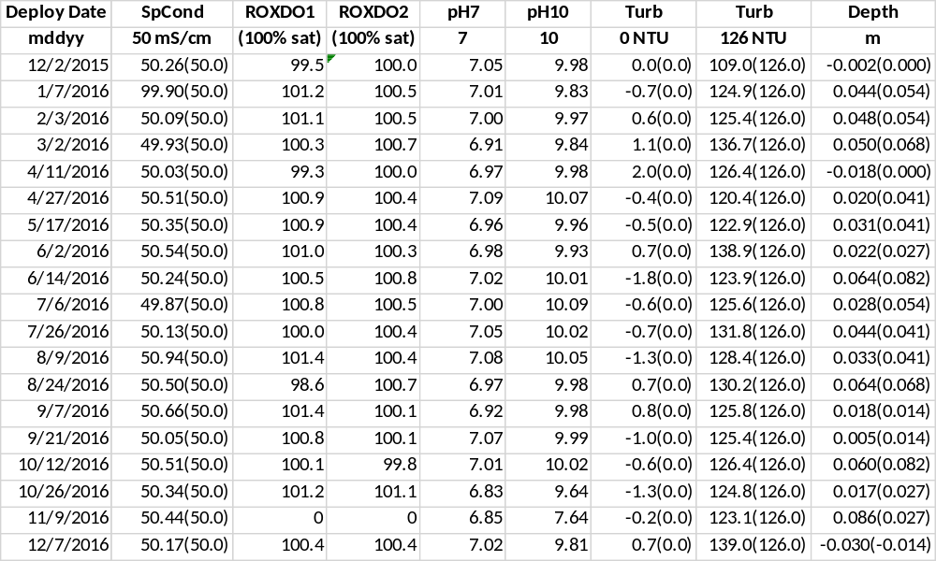

Middle Blackwater River (rkbmbwq)
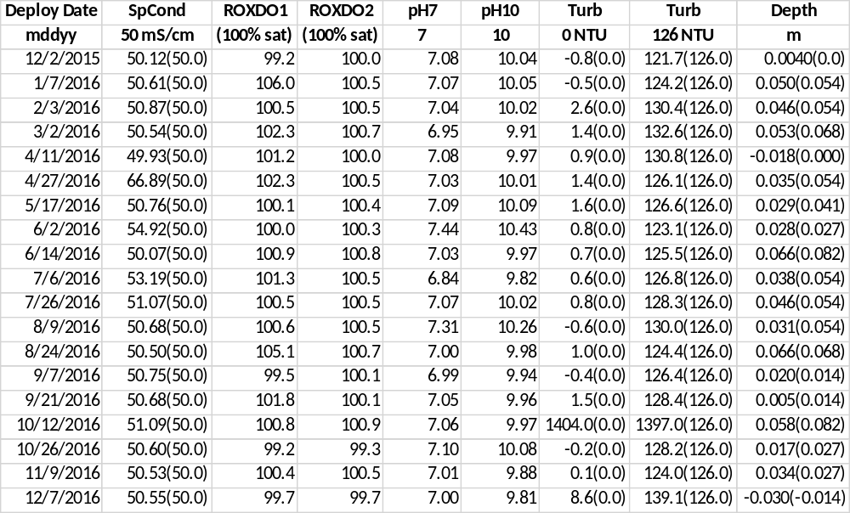

Faka Union Bay (rkbfuwq)
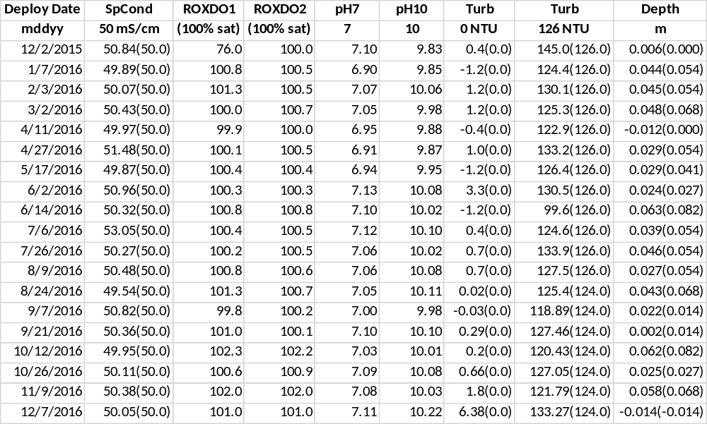

Fakahatchee Bay (rkbfbwq)
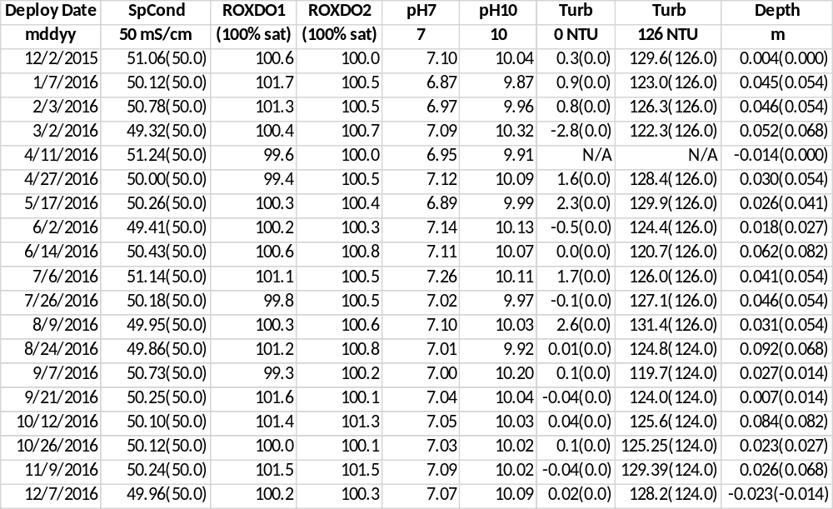

Pumpkin Bay (rkbpbwq)
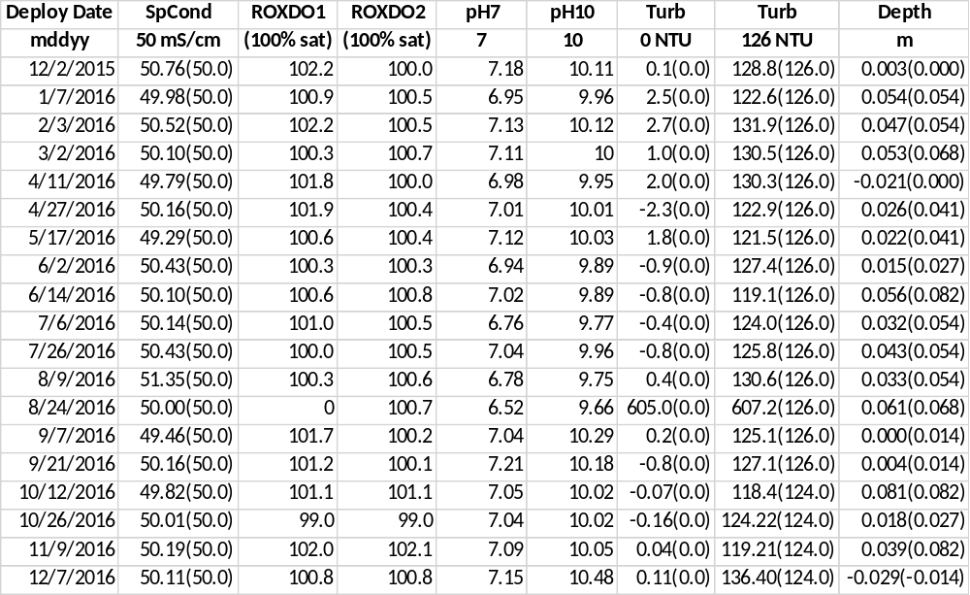

14) Other remarks/notes
Data are missing due to equipment or associated specific probes not being deployed, equipment failure, time of maintenance or calibration of equipment, or repair/replacement of a sampling station platform. Any NANs in the dataset stand for “not a number” and are the result of low power, disconnected wires, or out of range readings. If additional information on missing data is needed, contact the Research Coordinator at the reserve submitting the data.

Lower Henderson Creek (rkblhwq):
For the 120215 deployment, all Turbidity readings were flagged suspect due to the post-calibration value was out of range and the probe was retrieved with light algae on the wiper. In the beginning of the deployment, the data matched up with the previously deployed sonde and the field data. The probe was used for the subsequent deployment without any issues.

The 01/07/2016 08:45 reading for the 010716 deployment was removed due to an overlap and the depth was anomalous to the readings directly before and after.

On 01/17/2016 05:45 until 13:30 a Meteo-tsunami in the area caused a higher than usual tide.

From 02/20/2016 01:00 until 02/28/2016 11:45 all Turbidity readings were rejected for anomalous readings due to biofouling. The fouling seemed to be resolved for the remainder of the deployment and the readings were not rejected.

The readings on 03/02/2016 13:00 were removed because the readings overlapped with the previous sonde. The readings at 13:15 were rejected because the sonde seemed to not be deployed at the time the reading was taken.

From 03/26/2016 20:00 until 04/11/2016 12:30 all SpCond and Salinity readings were flagged suspect due to silt and biofouling on the probe.

From 03/28/2016 17:00 until 04/09/2016 16:30 all Turbidity readings were rejected because of drift due to silt and tunicates growing on the wiper.

On 04/06/2016 08:00 all readings were rejected because the sonde was not deployed. The sonde was not retrieved because the telemetry cable could not be removed from the sonde.

From 04/09/2016 16:45 until 04/11/2016 12:30 all Turbidity readings were rejected because of a probe malfunction from biofouling.

From 04/24/2016 18:00 until 04/27/2016 12:00 all Turbidity readings were rejected because of drift caused by algae biofouling on the guard and wiper.

From 04/25/2016 18:45 until 04/27/2016 12:00 all SpCond, Salinity and dependent parameter readings were rejected due to an anomalous drop in conductivity readings. The site might have received a slug of fresh water due to heavy rain in the area, low tides and north wind pushing the tide out. At pre-deployment calibration and post calibration, the probe calibrated without issue and the cell constant was within range.

For the 042716 and 060216 deployments, the SpCond, Salinity and dependent parameter readings were rejected due to a possible probe malfunction. At pre-deployment calibration and post calibration, the probe calibrated without issue and the cell constant was within range. The Turbidity probe was replaced for the 070616 deployment and all issues with the T/C probe were resolved.

From 05/11/2016 23:00 until 05/17/2016 06:30 all Turbidity readings were rejected because of drift caused by algae, bryozoan, and barnacle biofouling in the guard and on the probe. The post calibration reading was also out of range.

For the 060216 deployment, the Turbidity data were flagged suspect due to a post calibration that was out of range. The probe was replaced for the next deployment.

From 06/24/2016 10:45 until 07/06/2016 10:30 all Turbidity readings were rejected due to the optics were blocked from barnacle biofouling growing on the wiper.

From 07/23/2016 17:00 until 07/26/2016 10:15 all Turbidity readings were rejected because of drift caused by barnacle biofouling in the guard and on the probe.

From 07/26/2016 06:30 until 07/26/2016 10:15 DO readings were flagged suspect due to drift. Biofouling found on the probe when retrieved. At pre-deployment calibration and post calibration, the probe calibrated without issue and the optical DO gain was within range.

From 07/26/2016 10:45 until 08/05/2016 17:15 the Turbidity readings were flagged suspect and from 08/05/2016 17:30 until 08/09/2016 06:15 the Turbidity readings were rejected due to a post calibration that was out of range. Biofouling was found on the probe at retrieval. At pre-deployment calibration, the probe calibrated without issue.

From 08/29/2016 02:00 through 09/02/2016 19:00 data was flagged due to Hurricane Hermine.

On 09/02/2016 12:45 there were no readings because the battery in the telemetry unit was replaced.

From 10/05/2016 21:45 through 10/09/2016 05:00 data was flagged due to Hurricane Matthew.

From 11/27/2016 14:45 until 12/07/2016 13:00 all DO readings were rejected due to a probe malfunction. The probe did not function during post calibration and was replaced for the next deployment.

On 12/16/2016 from 9:17 until 9:53 the sonde was remove in order to replace the PVC tube.

From 12/20/2016 19:15 until 01/04/2017 12:45 Turbidity readings were rejected due to drift and a post calibration that was out of range. Biofouling was found on the probe at retrieval. At pre-deployment calibration, the probe calibrated without issue.

Middle Blackwater River (rkbmbwq):
For all deployments, anomalous Temperature and associated parameter readings that coincide with water depths that occur on or near low tide were flagged -3 GOW CLT.

For all deployments, anomalous SpCond and associated parameter readings that coincide with water depths that occur on or near low tide were flagged -3 SOW CLT.

For all deployments, low SpCond and Salinity readings located directly before or after an out of water event were flagged -3 SOW CSM. These low readings coincide with water depths that occur on or near low tide. The conductivity cells appear to be either completely or partially exposed and not in the water, causing readings that are lower than normally seen.

On 01/07/2016 from 10:35 until 10:50 the PVC tube was lowered to 0.25m. This was to reduce the amount of out of water events that occur at the site during low tides.

On 01/17/2016 05:45 until 12:00 a Meteo-tsunami in the area caused a higher than usual tide.

The 02/03/2016 10:45 reading for the 020316 deployment was removed due to an overlap and the depth was anomalous to the readings directly before and after.

From 04/02/2016 05:15 until 04/11/2016 10:30 all Turbidity readings were rejected because of drift due to silt and tunicates growing on the wiper and a post calibration that was out of range. At pre-deployment calibration, the probe calibrated without issue.
For the 041116 deployment, the Turbidity data were flagged suspect due to a post calibration that was out of range. At pre-deployment calibration, the probe calibrated without issue.

From 04/25/2016 19:30 until 04/27/2016 08:15 all SpCond, Salinity and dependent parameter readings were rejected due to an anomalous drop in conductivity readings. The site might have received a slug of fresh water due to heavy rain in the area, low tides and north wind pushing the tide out. At pre-deployment calibration and post calibration, the probe calibrated without issue and the cell constant was within range.

From 04/25/2016 19:45 until 04/25/2016 22:15 Turbidity readings were flagged due to a clear increase in readings. The site most likely received a slug of fresh water due to heavy rain in the area.

From 05/10/2016 00:00 to 05/17/2016 10:30 SpCond and salinity readings were flagged suspect due to issues with the post calibration which was reading 66.89. The sonde had a potentially corroded C/T port and this probe/sonde were sent to YSI after this deployment.

For the 060216 deployment, the SpCond and Salinity readings were flagged suspect due to a post calibration that was out of range. At pre-deployment calibration, the probe calibrated without issue and the cell constant was within range.

For the 070616 deployment, the SpCond and Salinity readings were flagged suspect due to a post calibration that was out of range. At pre-deployment calibration, the probe calibrated without issue and the cell constant was within range.

For the 080916 deployment, the Turbidity data were flagged suspect due to a post calibration that was out of range. At pre-deployment calibration, the probe calibrated without issue.

From 08/29/2016 02:15 through 09/02/2016 14:45 data was flagged due to Hurricane Hermine.

From 10/06/2016 05:15 through 10/09/2016 0714:15 data was flagged due to Hurricane Matthew.

From 10/14/2016 11:00 until 10/26/2016 10:15 Turbidity readings were rejected due a probe malfunction. At pre-deployment calibration, the probe calibrated without issue. The data sonde and probes were replaced for the next deployment.

From 12/03/2016 13:15 until 12/07/2016 08:45 SpCond and Salinity readings were flagged suspect due a shift in the readings from unknown causes. At pre-deployment calibration and post calibration, the probe calibrated without issue and the cell constant was within range. In addition, these readings were consistent with the deployment directly after.

Faka Union Bay (rkbfuwq):
From 12/26/2015 09:45 until 01/07/2016 12:15 all readings were rejected due to a catastrophic temperature failure. During troubleshooting, it was found that the SpCond/Temp probe was not working. The probe was replaced for the next deployment.

On 01/17/2016 06:00 until 12:45 a Meteo-tsunami in the area caused a higher than usual tide.

For the 042716 and 060216 deployments, the Turbidity data were flagged suspect due to a post calibration that was out of range. The turbidity probe was replaced for the next deployment.

For the 061416 deployment, the Turbidity data were flagged suspect or rejected due to a post calibration that was out of range. The turbidity wiper was also off the probe when the sonde was retrieved.

For the 072616 deployment, the Turbidity data were flagged suspect due to a post calibration that was out of range. At pre-deployment calibration, the probe calibrated without issue. The data sonde was replaced for the next deployment.

From 08/16/2016 10:00 until 08/24/2016 08:00 Turbidity readings were rejected due to sensor drift. At retrieval, the turbidity wiper pad was not touching the sensor allowing for a buildup of silt over the optics.

On 08/18/2016 from 09:00 through 09:30 the sonde tube was replaced.

Starting with the 082416 deployment, new YSI EXO2 model data loggers replaced the YSI 6600.

From 08/29/2016 09:30 through 09/02/2016 22:30 data was flagged due to Hurricane Hermine.

From 10/07/2016 06:30 through 10/09/2016 07:15 data was flagged due to Hurricane Matthew.

On 12/28/2016 09:30 SpCond and Salinity readings were rejected due to anomalous values not consistent with surrounding values. Cause is unknown.

Fakahatchee Bay (rkbfbwq):
For all deployments, anomalous Temperature and associated parameter readings that coincide with water depths that occur on or near low tide were flagged -3 GOW CLT.

For all deployments, anomalous SpCond and associated parameter readings that coincide with water depths that occur on or near low tide were flagged -3 SOW CLT.

For all deployments, low SpCond and Salinity readings located directly before or after an out of water event were flagged -3 SOW CSM. These low readings coincide with water depths that occur on or near low tide. The conductivity cells appear to be either completely or partially exposed and not in the water, causing readings that are lower than normally seen.

On 01/17/2016 06:00 until 12:30 a Meteo-tsunami in the area caused a higher than usual tide.

On 01/26/2016 from 09:54 until 10:17 the sonde was removed to lower the PVC tube to 0.25m. This was to reduce the amount of out of water events that occur during low tides.

On 01/26/2016 from 10:21 until 10:34 the PVC tube was scraped inside and out to remove barnacle growth.

On 01/26/2016 at 10:45 the Turbidity reading was rejected due to a spike from cleaning the PVC tube.

On 2/03/2016 12:45 SpCond/Salinity readings were flagged suspect due to a high reading compared to the field reading and the final reading from the previous sonde.

For the 020316 deployment, all zero ODO readings were rejected. The Turbidity probe was malfunctioning causing the zero ODO readings and was removed for the following deployment.

For the 041116 deployment, the turbidity probe was not deployed due to a malfunction in the probe at pre-calibration.

For the 041116 deployment, the SpCond and Salinity readings were rejected due to a probe malfunction. The probe was replaced for the next deployment.

For the 041116 deployment, the DO mg/L and Depth readings were rejected due to the SpCond probe malfunction and the readings from previously deployed sonde and the field data did not match up. At pre-deployment calibration and post calibration, the probe calibrated without issue and the optical DO gain was within range.

On 06/02/2016 09:45 until 10:15 there was no sonde deployed because the previous sonde was caught inside the PVC tube and the tube needed to be removed to retrieve the jammed sonde.

From 08/04/2016 23:45 until 08/09/2016 09:30 pH readings were rejected due to drift. At pre-deployment calibration and post calibration, the probe calibrated without issue and the pH slopes were within range. The sonde was replaced for the next deployment.

Starting with the 082416 deployment, new YSI EXO2 model data loggers replaced the YSI 6600.

From 08/29/2016 09:30 through 09/03/2016 00:00 data was flagged due to Hurricane Hermine.

From 10/07/2016 10:45 through 10/09/2016 03:15 data was flagged due to Hurricane Matthew.

Pumpkin Bay (rkbpbwq):
For all deployments, anomalous Temperature and associated parameter readings that coincide with water depths that occur on or near low tide were flagged -3 GOW CLT.

For all deployments, anomalous SpCond and associated parameter readings that coincide with water depths that occur on or near low tide were flagged -3 SOW CLT.

For all deployments, low SpCond and Salinity readings located directly before or after an out of water event were flagged -3 SOW CSM. These low readings coincide with water depths that occur on or near low tide. The conductivity cells appear to be either completely or partially exposed and not in the water, causing readings that are lower than normally seen.

On 01/17/2016 06:00 until 12:45 a Meteo-tsunami in the area caused a higher than usual tide.

From 01/22/2016 22:45 through 02/03/2016 11:30 SpCon and Salinity readings were flagged suspect due to drift. At pre-deployment calibration and post calibration, the probe calibrated without issue and the cell constant was within range.

On 01/26/2016 from 11:25 until 11:45 the PVC tube was lowered to 0.25m. This was to reduce the amount of out of water events that occurred at the site. From 11:45 until 11:50 the PVC tube was scraped inside and out to remove barnacle growth.

From 04/25/2016 18:45 until 04/27/2016 08:45 all SpCond, Salinity and dependent parameter readings were rejected due to an anomalous drop in conductivity readings. The site might have received a slug of fresh water due to heavy rain in the area, low tides and north wind pushing the tide out. At pre-deployment calibration and post calibration, the probe calibrated without issue and the cell constant was within range.

From 05/17/2016 06:15 until 09:45 DO readings were flagged suspect due to drift. At pre-deployment calibration and post calibration, the probe calibrated without issue and the optical DO gain was within range.

From 06/02/2016 06:15 until 10:30 DO readings were flagged suspect due to drift. At pre-deployment calibration and post calibration, the probe calibrated without issue and the optical DO gain was within range.

From 06/14/2016 04:15 until 08:45 DO readings were flagged suspect due to drift. At pre-deployment calibration and post calibration, the probe calibrated without issue and the optical DO gain was within range.

From 08/08/2016 23:45 until 08:45 DO readings were flagged suspect due to drift. At pre-deployment calibration and post calibration, the probe calibrated without issue and the optical DO gain was within range.

For the 080916 deployment, the Turbidity data were flagged suspect due to a post calibration that was out of range. At sonde retrieval, the wiper was not touching the probe. The probe was replaced for the next deployment.

From 08/24/2016 03:00 until 07:30 DO readings were flagged suspect due to drift. At pre-deployment calibration and post calibration, the probe calibrated without issue and the optical DO gain was within range.

From 08/29/2016 11:45 through 09/02/2016 14:00 data was flagged due to Hurricane Hermine.

From 08/30/2016 15:00 until 09/07/2016 07:45 Turbidity readings were rejected due to a broken probe. The Turbidity probe and sonde were replaced for the next deployment.

From 08/30/2016 15:45 until 09/07/2016 07:45 all DO readings were rejected due to a broken Turbidity probe. The DO probe and the sonde were replaced for the next deployment.

From 09/02/2016 16:45 until 17:15 all data was rejected due to a total sonde failure due to unknown reasons. The sonde was replaced for the next deployment.

On 09/21/2016 08:00 the data point was missing due to site repair to the tube cable.

From 10/06/2016 18:15 through 10/09/2016 07:00 data was flagged due to Hurricane Matthew.

From 10/11/2016 17:30 until 10/12/2016 10:00 DO readings were flagged suspect due to drift. At pre-deployment calibration and post calibration, the probe calibrated without issue and the optical DO gain was within range.

Starting with the 101216 deployment, new YSI EXO2 model data loggers replaced the YSI 6600.

On 12/10/2016 05:00 and 06:45 DO readings were elevated due to an out of water event.

Weather conditions based on Big Cypress Basin (BCB) Hydrologic Summary and Rainfall Reports:

January: The Big Cypress Basin [BCB] received record amounts of rainfall in January. Heavily influenced by the ongoing El Nino phenomenon, the prevailing weather pattern across south Florida remained wet and unseasonably warm throughout the month. Rainfall in the final week of January was particularly significant, pushing the monthly totals well beyond previous records held by the Basin. Rainfall recorded this past month exceeded the normal January average by over 500%. The basin-wide January average from twenty (20) stations topped 10.71 inches, fully 9 inches above the normal monthly average of 1.68 inches. This being of particular significance, since 9 inches represents a fair total for rainfall collected in a normal wet season summer month.
February: Weather conditions across the Big Cypress Basin [BCB] resumed a more normal pattern in February. Typical for winter, arriving cold fronts generated most of the rainfall, and monthly totals were slightly in excess of the norm. Canal levels and discharge rates continued to trend in the upper ranges throughout the month, as systems recovered from the record rainfall amounts received in late January. Rainfall recorded by 20 stations across the BCB registered an average of 2.43 inches, 27% more than the normal of 1.93 inches. Viewed in the historical perspective of the past twenty-five (25) years,
February 2016 rainfall was in the normal to upper range, however clearly below the high of February 1998, when the Basin received 5.27 inches.
March: Weather in March was relatively quiet across the Big Cypress Basin [BCB]. Incoming cold fronts failed to generate significant rainfall, and persistent dry conditions left monthly totals well below the statistical average. Although canal and groundwater levels also maintained a downward track during the month, the trend lines remained consistently positive with respect to the BCB historic averages for March. Rainfall patterns in March were typical for the winter-dry season - even if far less generous in terms of total precipitation. Rainfall recorded by 20 stations across the BCB registered an average of 0.55 inches, 76% less than the historic mean (2.26 inches). Notwithstanding the March deficit, the 2016 cumulative total for the BCB has now topped 13.73 inches, more than twice the normal expected by this time of year. Viewed in historical perspective, March 2016 rainfall was decidedly low range, well below 2010 when the Basin received a record 6.10 inches for the month.
April: Rainfall totals across the Big Cypress Basin [BCB] were below normal in April. Groundwater levels kept a steady downward trend, but finished the month within normal range for this time of year. A few brief showers and some minor frontal activity in the latter half of the month, were insufficient to alter dry conditions which persisted throughout April. Rainfall totals for the month remained below par, topping off at 1.12 inches, far less than the normal of 2.43 inches, as averaged across 20 BCB stations. This month’s tally brings the 2016 cumulative rainfall up to 14.90 inches, still above the totals expected by this time of year. Measured against the BCB period of record, conditions in April 2016 were dry, well below April 2010 when the Basin received a record 5.72 inches of rainfall.
May: Weather patterns turned decidedly wet this month as the Big Cypress Basin [BCB] transitioned out of the dry season. Changes in the weather became apparent early in the month, and by mid-May, the Basin felt a resurgence in humidity levels and higher daily temperatures, typical of the arriving wet season. This past month also marked the arrival of the second named Tropical Storm [TS] of the 2016 Season - Bonnie, which formed in the Atlantic but did not however threaten southwest Florida and the BCB area. Rainfall for the month was generous and exceeded the historic average. Groundwater levels in most of the monitored wells generally reflected this trend in the Collier County and Lower West Coast sites. Predictably, for the first time this year, increased runoff entering the canal system triggered outflows from the major BCB outfalls. By month’s end the BCB canal system had been transitioned to wet season operational criteria. Rainfall this month was significant, in particular for the latter half, which included some fairly well distributed frontal activity. Aggregate totals for May averaged 5.85 inches, well above the historic mean of 3.49 inches. The 20 rainfall stations monitored in the BCB have now registered a cumulative 20.70 inches thus far in 2016, well ahead of the 11.97 inches typically received in an average year. Taken in historical perspective, May 2016 rainfall was in the upper range, but yet insufficient to top 1991 when the Basin received a record 8.6 inches for the month.
June: Wet season conditions continued to develop across the Big Cypress Basin [BCB] during the month, with increased precipitation generally attributable to typical summer weather patterns. Rainfall for June, normally one of the wettest months of the season, was slightly in excess of the historic basin-wide average. Also consistent with the seasonal cycle, groundwater levels across the BCB maintained a generally positive trend throughout the month. Canal system operations remained under wet season criteria for the month, and water levels generally kept a positive trend, with outflow noted at all outfalls. Rainfall this month was significant, mostly due to an uptick in late afternoon and early evening thunderstorm activity. Aggregate totals for June averaged 9.81 inches, a modest increase of about 7% over the historic mean of 9.15 inches. Reviewed in this context, this past month was still fairly average, certainly well below June 2005, when the Basin averaged record rainfall amounts totaling 18.6 inches. The 20 rainfall stations monitored in the BCB have now registered a cumulative 30.06 inches thus far in 2016, significantly ahead of the 20.95 inches typically received for an average year.
July: Weather conditions throughout July were fairly typical across the Big Cypress Basin [BCB]. Absent any significant tropical activity impacting the area, the characteristic pattern of afternoon and early evening thunderstorms held sway for most of this period. By month’s end, the basin wide rainfall had tied the July statistical average, and all canal systems were outflowing. Consistent with the seasonal cycle, groundwater levels across the BCB maintained a generally upward trend for the month, and canal system operations were kept under wet season criteria. The competing influence of easterly / westerly sea breeze was sufficient to generate significant rainfall across the Basin. Rainfall observed at 20 reporting stations averaged 8.55 inches, inching past the normal average of 8.51 inches. Reviewed in historical context, July’s tally was fairly average, certainly well below 2001 when the Basin averaged record rainfall amounts totaling 14.6 inches. The accumulated precipitation for 2016 is now up to 39.06 inches, still well above the Basin’s typical 29.49 inches, the total normally expected by this time of year.
August: August is normally the season’s wettest month, and conditions this year did not disappoint. With the added emphasis of an active tropical season, rainfall across the Big Cypress Basin [BCB] easily exceeded the monthly average. Unsurprisingly, groundwater levels also remained positive for the month, and significant flow was recorded in all the BCB canals and outfalls. All systems were kept under wet season (flood control) operational status for the month. During August, the 2016 Atlantic hurricane season got under way in earnest, and by mid-month attention began to focus on a tropical wave, subsequently known as Tropical Depression #9, which was later upgraded to Hurricane Hermine on August 29th. Although Hermine spawned numerous rainfall-producing events across south Florida, it ultimately made landfall much further north in the panhandle, and well away from our area. Layered over the typical wet season weather pattern of late afternoon and early evening thunderstorms, additional weather disturbances in the Atlantic and the Gulf contributed significant rainfall across the Basin. August rainfall observed at 20 reporting stations averaged 10.69 inches, well past the normal average of 9.38 inches. Reviewed in historical context, the August tally was above average, even if well below the 1995 season when BCB averaged a record rainfall of 14.9 inches. The accumulated rainfall for 2016 is now 49.75 inches, notable if we recall that the typical BCB annual average is about 54 inches, a scant 4 inches of additional rain, with 4 months still left before the end of the year.
September: September is normally the last month of significant rainfall for the year, and conditions across the Big Cypress Basin [BCB] would generally bear this out. The basin-wide precipitation, which had been trending below normal earlier in the month, took a more positive turn, even if totals failed to match the BCB average by month’s end. Consistent with the seasonal cycle, groundwater levels were positive in September. Similarly, canal levels in the BCB remained in the normal-upper range for most of the month, operating under full wet season (flood control) criteria, with significant outflow noted at all system outfalls. In late September (9/28), the District came under threat from Hurricane Matthew, the 14th named storm of the 2016 Atlantic Season. Attention of the District and all south Florida residents became more focused by Tuesday (10/4), after its status was upgraded to a Category 4, and hurricane warnings were extended for Lake Okeechobee and portions of the east coast. Although it caused considerable damage in the Caribbean and other coastal communities along the eastern seaboard, its impact to the District remained somewhat tempered by its deliberate offshore track. After skirting northwards along the coast, its felt effects over south Florida were much diminished by Friday (10/7), when it moved out of the District, having kept well away from the Lower West Coast / BCB area. The typical sea breeze weather pattern of late afternoon and early evening thunderstorms showed signs of weakening by mid-September, indicating a possible early transition out of the wet season. Notwithstanding any effects from Matthew, which proved minimal, a noticeable uptick in late September helped shore up monthly totals, and rainfall for the month topped 7.41 inches, as measured at 20 reporting stations across the BCB. Although respectable, this amount failed to match the normal average of 8.62 inches, and remains well below the record set in 2001 when the Basin received 15.71 inches in September. Notably, the Basin’s 2016 rainfall through September now tops 56.93 inches, well above the historic average of 47.5 inches expected within this timeline, and by now well in excess of the 54 inches normally received during a typical year.
October: October 15th typically marks the official end of wet season, a reality borne out once again this year. After an initial spell of wet weather, conditions turned decidedly dry, and by month’s end the Big Cypress Basin [BCB] was firmly in the dry season, having registered below average rainfall. Following on weather patterns noted in late September, the typical sea breeze effect of late afternoon and early evening thunderstorms continued to diminish, effectively pointing to the start of dry season by mid-October. Rainfall for the month averaged 2.58 inches, as measured at 20 reporting stations across the BCB. This was 25% below the normal October average, far short of the 3.43 inches typically expected, and well below 1995 when the Basin received 13.3 inches for the month. Notably, the Basin’s 2016 rainfall through October now tops 59.51 inches, well above the historic average of 50.70 inches expected within this timeline, and far in excess of the 54 inches typically received during a normal year. Further analysis of the 2016 BCB rainfall data indicates that a total of 43.3 inches was received between May and October, closely tracking the normal wet season average of 43.4 inches. This dataset also highlights 1995 once again, as the year with record wet season rainfall, when the BCB received 67.4 inches of rain. Records for the month indicated significant spatial variation across the BCB area.
November: In November, the first full month since the official start of the winter dry season, the Big Cypress Basin [BCB] received almost no rainfall. Unsurprisingly, water levels in the BCB canals dropped throughout the month, although most major systems continued to track the historic average, albeit in the low ranges. Consistent with this trend, the BCB and Lower West Coast groundwater monitoring wells also recorded diminished levels for November. The lack of meaningful rainfall follows a Basin-wide pattern first noted last month, at the onset of the dry season. Basin-wide records for November were hardly more encouraging, registering an average 0.25 inches, as measured at twenty (20) reporting stations. This was well below the 1.84 inches typically expected, and far less than 1998 when the BCB received 7.5 inches, the period of record maximum for November. The cumulative rainfall for 2016 now stands at 59.77 inches, which still represents a net improvement over the 54 inches typically received Basin-wide over a full annual period. A review of previous dry season cycles, indicates that current conditions - although dismal in terms of rainfall - still look positive in historic terms.
December: Dry conditions continued to prevail across the Big Cypress Basin [BCB] in December. In a weather pattern noted since October, the absence of meaningful frontal activity resulted in dismally low precipitation through the final month of the year. Unsurprisingly, most water levels in the BCB canals also continued to drop throughout December, with some of the systems underperforming the historic average. Consistent with this trend, the BCB and Lower West Coast groundwater monitoring wells also showed diminished levels for the month. Low precipitation rates were noted Basin-wide, with most BCB stations receiving far less than one (1”) inch of rain. The December Basin average was hardly more encouraging, registering a mere 0.41 inches, as measured by twenty (20) reporting stations. This was well below the 1.60 inches typically expected, and far less than December 1997 when the BCB received a record 5.78 inches. A review of the past twelve months is somewhat more encouraging, the cumulative rainfall for 2016 now tops 60.2 inches, well in excess of the Basin-wide 54.3 inches typically received on an average year. Extending three months into the dry season, this weather pattern has now had measurable impacts, although current conditions have yet to match previous historic periods when drought conditions prevailed. As indicated by the US Drought Monitor Index, conditions during the past month slipped into “abnormally dry” over southwest Florida

Acknowledgement: The data included with this document were collected by the staff of the Florida Department of Environmental Protection at the Rookery Bay National Estuarine Research Reserve with funding through NOAA’s Estuarine Research Division. Any products derived from these data should clearly acknowledge this source (please use the attached logos). This recognition is important for ensuring that this long-term monitoring program continues to receive the necessary political and financial support.



