**Grand Bay (GND) NERR Nutrient Metadata**

**January - December 2019**

**Last Updated:** June 12, 2020

Note: This is a provisional metadata document; it has not been authenticated as of its download date. Contents of this document are subject to change throughout the QAQC process and it should not be considered a final record of data documentation until that process is complete. Contact the CDMO ([cdmosupport@belle.baruch.sc.edu](mailto:cdmosupport@belle.baruch.sc.edu)) or Reserve with any additional questions.

**I. Data Set and Research Descriptors**

**1) Principal Investigator(s) and Contact Persons:**

Address: Grand Bay National Estuarine Research Reserve

6005 Bayou Heron Road

Moss Point, MS 39562

Phone: (228) 475-7047

Fax: (228) 475-8097

Contact Persons: Dr. Mark Woodrey, Research Coordinator

E-mail: [mark.woodrey@msstate.edu](mailto:mark.woodrey@msstate.edu)

(228) 523-4001

Kim Cressman, SWMP Coordinator

E-mail: [kimberly.cressman@dmr.ms.gov](mailto:kimberly.cressman@dmr.ms.gov)

(228) 523-4193

Elizabeth Moore, SWMP Technician

E-mail: [elizabeth.moore@dmr.ms.gov](mailto:elizabeth.moore@dmr.ms.gov)

(228) 374-5010

**2) Research objectives:**

a) Monthly Grab Sampling Program

Monthly grab samples were collected to quantify the spatial variability of important nutrients in the water column between sites representing the local salinity gradient.

b) Diel Sampling Program

Once per month, samples were collected throughout a tidal cycle to quantify the temporal variability of important nutrients and sediment loading in the water column as a function of tidal forcing.

A spreadsheet was used to evenly space sample timing between two low tides, with the low tides being the first and last samples. Sample intervals used each month are noted in section 6 of this document. This is a slight methodology change from the diel sampling conducted through 2016, where samples were collected every 125 minutes unless noted.

**3) Research methods:**

a) Monthly Grab Sampling Program

Monthly grab samples were taken at six stations within the Grand Bay estuary. Samples were taken at the four Grand Bay data sonde (primary SWMP) stations: Bayou Heron (BH), Point Aux Chenes (PC), Bayou Cumbest (BC), and Bangs Lake (BL). Samples were also taken at two secondary SWMP sites: the surface of Bayou Heron (HS), due to stratification, and at a spill site in Bangs Lake called Bangs Lake North (BN). Attempts were made to collect grab samples within two hours of slack low tide. Rainfall conditions prior to grab sampling were not considered. When possible, grab samples were obtained in conjunction with diel samples (See 3b). Grab samples were collected at sonde depth, 0.25 meters from the bottom. Bayou Heron required the use of a Wildco Horizontal Beta Bottle to obtain these grab samples. Samples were collected in 500ml Nalgene HDPE (high-density polyethylene) wide-mouthed amber bottles. Prior to sampling, sample bottles were rinsed with 10% HCL and then with distilled water and allowed to air dry in the laboratory. Sample bottles were also rinsed three times with sample water at the sample site prior to sample collection. Samples were immediately placed on ice, stored in a dark cooler, and returned to the laboratory. Once in the laboratory samples were processed for nutrient and Chla analysis.

b) Diel Sampling Program

Twelve diel samples were collected each month at Bangs Lake using an ISCO 6712 portable auto-sampler 0.25m from the bottom. The sampler was programmed to take a 500ml collection at evenly spaced intervals throughout a complete tidal cycle (lunar day). First and last samples were on low tides. No distinction between neap and spring tide was considered. Prior to collection, 500 ml semi-transparent ISCO sample containers were rinsed with 10% HCL and then with distilled water and allowed to air dry in the laboratory. During collection, samples were stored on ice in these containers within the body of the sampler. The sampler was programmed to flush the collection line prior to collecting each sample. As soon as possible after the final collection time ended, the samples were returned to the laboratory for nutrient and Chla analysis.

**4) Site Location and Character**

The Grand Bay Delta was created by sediments from both the Pascagoula and Escatawpa Rivers several thousand to hundreds of years ago. Soon after the delta was created, the Escatawpa became a major tributary to the Pascagoula River when its flow was captured by the larger river system. With the Escatawpa’s freshwater inflow shunted to the Pascagoula River, sediment discharge to Grand Bay Delta and the delta’s further growth was terminated. The meandering delta channels of the Escatawpa became exclusively tidal water courses a few hundred years ago, after cessation of river flow (Otvos 2007). In 1999, the retrograding delta became home to the 24th National Estuarine Research Reserve, the Grand Bay NERR.

The Grand Bay NERR is part of the Coastal Stream Basin watershed, which consists of three primary sub-watersheds that provide much of the freshwater inputs into the system: Bayou Heron, Bayou Cumbest, and Bangs Lake.

The water quality monitoring sites within the Grand Bay NERR have a tidal range of approximately 0.5 m. Additional site specific characteristics are as follows:

a) Bayou Heron (BH) and Bayou Heron Surface (HS): [30.4178° N, 88.4054° W]

From the beginning of the nutrient sampling program in 2005 until early 2016, both surface and bottom samples from Bayou Heron were labeled gndbhnut in the data. Metadata records differentiated between the depths. Because there was not a straightforward way to differentiate between them in the data files themselves, the surface site was re-named Bayou Heron Surface, gndhsnut. It is considered a secondary SWMP station. The bottom site is at sonde depth (0.25 meters above the sediment) and will retain primary SWMP status and the name gndbhnut. Diel samples collected at this site have always been taken at sonde depth. Only surface samples will be affected by the change. We are in the process of re-naming the surface samples in older data files; *please read all metadata carefully*. Moving forward, surface samples will be gndhsnut.

The Bayou Heron site, located in the middle reaches of the Bayou Heron sub-watershed, monitors water quality for a semi-pristine area with little development and serves as a reference site for the reserve. Freshwater input is derived from several sources including networks of hydric drains, sheet flow from pine flatwoods/savannas, and groundwater. Hydric drains import large amounts of surface water from the sub-watershed, including water originating north of Hwy 90 and Interstate 10. Franklin Creek, located northeast of the reserve, flows WNW into the Escatawpa River. Franklin Creek drains a large portion of agricultural land on the Grand Bay plateau and periodically crests into the Bayou Heron sub-watershed during high water events via a small network of hydric drains. These drains eventually deposit water into numerous tidal creeks that enter Bayou Heron. Little is known about the quantity and quality of water flowing through these drains.

* Depth range: 0.16 – 1.69 m
* Bottom habitat: soft sediments
* Salinity range in 2019: 0.1 – 25.3 ppt
* Average Salinity in 2019: 14.7 (± 5.7) ppt
* Historical salinity distribution (histogram bin width = 0.5 psu):

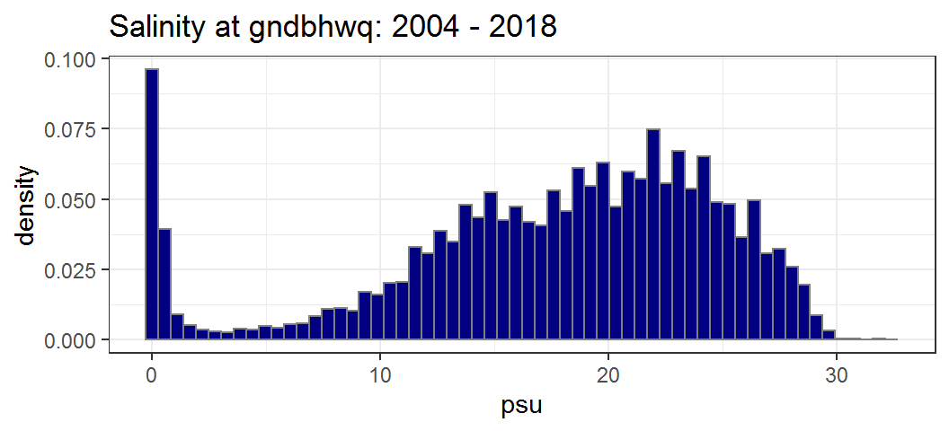

|  |  |  |  |  |  |  |  |  |  |  |
| --- | --- | --- | --- | --- | --- | --- | --- | --- | --- | --- |
| **Quantile** | **min** | **1%** | **5%** | **25%** | **median** | **75%** | **95%** | **99%** | **max** | **n** |
| psu | 0 | 0 | 0.2 | 13.6 | 18.9 | 23.1 | 27.2 | 28.6 | 32.4 | 456454 |

* Former summary values used in metadata were based on data from 2005-2011:
  + Typical salinity range: 5.9 – 27.6 ppt

The above typical salinity range represents 90% of the data points collected from 2005-2011 (n=217,996)

* + Median salinity from 2005-2011: 20.9 ppt

Due to water column stratification and poor mixing, this site can become naturally hypoxic during warmer months (March – October).

b) Point Aux Chenes (PC): [30.3486° N, 88.4185° W].

This is the most southern water quality site within the boundaries of Grand Bay NERR. It is located in Point Aux Chenes Bay, which is highly influenced by the Mississippi Sound and also receives inputs from waters to the east, including Mobile Bay. PC was established in 2005 to replace the Crooked Bayou water quality monitoring station. This site provides baseline data on the relative influence of marine inputs and tidal influence from the East Mississippi Sound.

* Depth range: 0.3 – 1.6 m
* Bottom habitat: soft sediments
* Salinity range in 2019: 3.3 – 27.5 ppt
* Average Salinity in 2019: 18.3 (± 6.4) ppt
* Historical Salinity Distribution (histogram bin width = 0.5 psu):

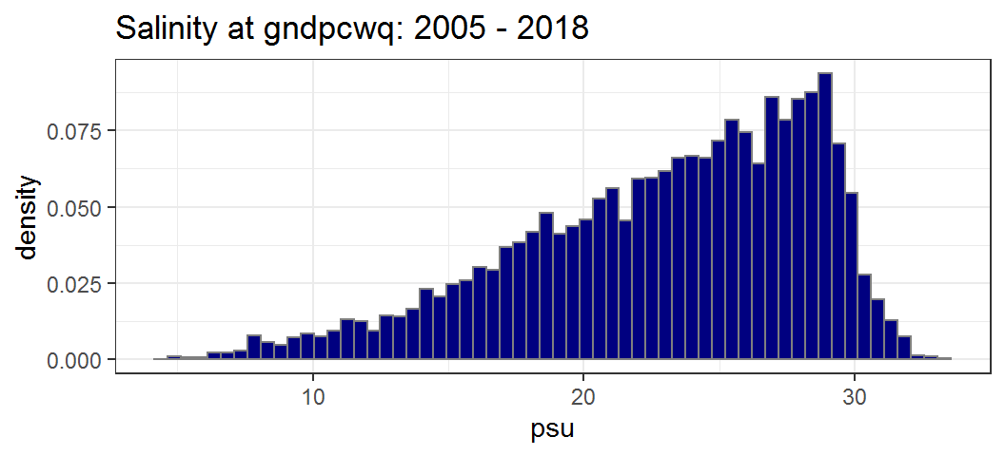

|  |  |  |  |  |  |  |  |  |  |  |
| --- | --- | --- | --- | --- | --- | --- | --- | --- | --- | --- |
| **Quantile** | **min** | **1%** | **5%** | **25%** | **median** | **75%** | **95%** | **99%** | **max** | **n** |
| psu | 4.3 | 8.2 | 12.6 | 19.4 | 24 | 27.3 | 29.8 | 31.2 | 33.2 | 345813 |

* Former summary values used in metadata were based on data from 2005-2011:
  + Typical salinity range: 12.4 – 29.7 ppt

The above typical salinity range represents 90% of the data points collected from 2005-2011 (n=195,836)

* + Median salinity from 2005-2011: 24.2

c) Bayou Cumbest (BC): [30.3836° N, 88.4364° W].

The Bayou Cumbest site monitors water quality for the Bayou Cumbest sub-watershed, which is a moderately impacted area with some residential housing development and non-point source pollution issues related to failing septic tanks (i.e., elevated levels of fecal coliforms; LaSalle 1997). A substantial canal, called the Nine Mile Canal, was built in the late 1930’s and connects the Escatawpa River to Bayou Cumbest upstream from the water quality station.

* Depth range: 0.0 – 1.10 m
* Bottom habitat: soft sediments with fringing oyster shell reefs
* Salinity range in 2019: 0.2 – 26.3 ppt
* Average Salinity in 2019: 14.2 (± 6.1) ppt
* Historical Salinity Distribution (histogram bin width = 0.5 psu):

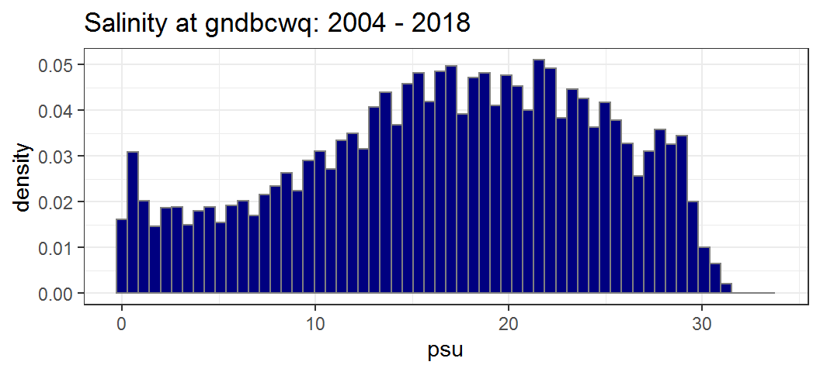

|  |  |  |  |  |  |  |  |  |  |  |
| --- | --- | --- | --- | --- | --- | --- | --- | --- | --- | --- |
| **Quantile** | **min** | **1%** | **5%** | **25%** | **median** | **75%** | **95%** | **99%** | **max** | **n** |
| psu | 0 | 0.3 | 2.1 | 11.3 | 17.4 | 22.9 | 28.4 | 29.9 | 33.5 | 436307 |

* Former summary values used in metadata were based on data from 2005-2011:
  + Typical salinity range: 3.8 – 28.4 ppt

The above typical salinity range represents 90% of the data points collected from 2005-2011 (n=211,045)

* + Median salinity from 2005-2011: 19.1

d) Bangs Lake (BL): [30.3571° N, 88.4629° W].

The Bangs Lake site is located towards the southern end of the Bangs Lake sub-watershed, an area with minimal residential development. Adjacent parcels include Chevron USA oil and gas refinery and the Mississippi Phosphates industrial facility. Both sites are surrounded by containment levees constructed to direct any contaminant spills towards Bayou Casotte, a heavily industrialized and impacted area to the west of these facilities. However, a spill from a gypsum pile at the phosphate facility was discharged into Bangs Lake in 2005 and had substantial negative impacts. A man-made drainage ditch runs into the north part of Bangs Lake and is believed to drain a residential area, which may have failing septic tanks (LaSalle 1997). The ditch is also adjacent to the Jackson County Industrial Water Plant. Bangs Lake has been impacted by high fecal coliform counts and a fecal coliform TMDL was developed for the Bayou Cumbest and Bangs Lake watersheds in 2000 (MSU-CREC 2000).

* Depth range: 0.0 – 1.37 m
* Bottom habitat: soft sediments
* Salinity range in 2019: 3.8 – 26.8 ppt
* Average Salinity in 2019: 17.5 (± 5.5) ppt
* Historical Salinity Distribution (histogram bin width = 0.5 psu):

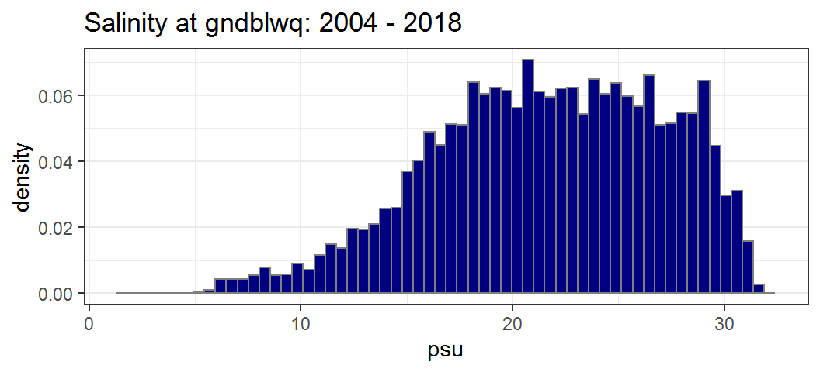

|  |  |  |  |  |  |  |  |  |  |  |
| --- | --- | --- | --- | --- | --- | --- | --- | --- | --- | --- |
| **Quantile** | **min** | **1%** | **5%** | **25%** | **median** | **75%** | **95%** | **99%** | **max** | **n** |
| psu | 1.5 | 8 | 12.2 | 17.9 | 22 | 26 | 29.6 | 30.8 | 32.1 | 420746 |

* Former summary values used in metadata were based on data from 2005-2011:
  + Typical salinity range: 13.1 – 29.6 ppt

The above typical salinity range represents 90% of the data points collected from 2005-2011 (n=201,833)

* + Median salinity from 2005-2011: 23.1

e) Bangs Lake North (BN): [30.36695° N, 88.47100° W].

The Bangs Lake North site monitors the water quality of the north end of Bangs Lake. This site was added in order to monitor the effects of millions of gallons of highly acidic runoff that breached a nearby fertilizer manufacturer’s containment system and entered the lake during an extremely heavy rain event in April 2005. This site is very similar to Bangs Lake (BL) in water depth, salinity range and bottom habitat.

*Sources cited within this section:*

LaSalle, M.W. (1997). Water Quality Monitoring of Shellfish Growing Waters and Residential Rock-Reed Wastewater Treatment Systems at Bayou Cumbest, Mississippi. Final Report to the Gulf of Mexico Program. 58 pp.

Mississippi State University Coastal Research and Extension Center (MSU-CREC). (2000). Fecal Coliform TMDL for Bayou Cumbest/Bangs Lake Watershed, Coastal Streams Basin, Jackson County, MS. Prepared for the Mississippi Department of Environmental Quality. Approved Final Version May 5, 2000.

Otvos, E.G. (2007). Geological Framework and Evolution History. Pages 22-46 in Grand Bay National Estuarine Research Reserve: An Ecological Characterization (Peterson, M.S., G.L. Waggy and M.S. Woodrey, editors). Grand Bay National Estuarine Research Reserve, Moss Point, Mississippi.

**5) Coded variable definitions**

a) Station codes (column ‘A’ of nutrient data report):

gndbhnut = Grand Bay NERR, site Bayou Heron (sonde depth) nutrient data

gndhsnut = Grand Bay NERR, site Bayou Heron Surface nutrient data

gndpcnut = Grand Bay NERR, site Point Aux Chenes nutrient data

gndbcnut = Grand Bay NERR, site Bayou Cumbest nutrient data

gndblnut = Grand Bay NERR, site Bangs Lake nutrient data

gndbnnut= Grand Bay NERR, site Bangs Lake North nutrient data

b) Monitoring program (column “C” of nutrient data report):

1 = Monthly grab sample

2 = Diel grab sample

c) Nutrient parameter comment code columns (denoted with a ‘F_’ and found in columns immediately following reported data variable. Refer to section 10 for parameter titles and variable names by data category.)

**6) Data collection period**

The first nutrient samples were collected at all sites in March 2005. Individual collection dates and times for both the monthly grab program and diel program are reported in column B of the nutrient database.

***Monthly Grab Samples***

**Site Date Rep 1 Rep 2**

**gndhsnut**

1/10/2019 13:08 13:10

2/22/2019 12:27 12:28

3/21/2019 10:35 10:37

4/15/2019 6:32 6:36

5/14/2019 16:05 16:06

6/12/2019 14:16 14:17

7/25/2019 14:25 14:26

8/22/2019 13:25 13:26

9/18/2019 10:35 10:36

10/17/2019 8:15 8:16

11/20/2019 14:12 14:13

12/19/2019 13:56 13:57

**gndbhnut**

1/10/2019 13:43 13:44

2/22/2019 12:32 12:33

3/21/2019 10:40 10:41

4/15/2019 6:37 6:38

5/14/2019 16:10 16:11

6/12/2019 14:22 14:23

7/25/2019 14:31 14:32

8/22/2019 13:31 13:32

9/18/2019 10:41 10:42

10/17/2019 8:21 8:22

11/20/2019 14:18 14:19

12/19/2019 14:01 14:02

**gndpcnut**

1/10/2019 11:38 11:39

2/22/2019 10:29 10:31

3/21/2019 9:02 9:04

4/15/2019 7:11 7:12

5/14/2019 13:48 13:49

6/12/2019 16:08 16:09

7/25/2019 14:00 14:01

8/22/2019* 12:08 12:09

9/18/2019 9:31 9:32

10/17/2019 8:59 9:00

11/20/2019 13:00 13:01

12/19/2019 12:22 12:23

* too rough to reach site; no sample taken. Time given is approximate time sample would have been taken.

**gndbcnut**

1/10/2019 10:23 10:25

2/22/2019 8:42 8:45

3/21/2019 7:31 7:35

4/15/2019 7:35 7:37

5/14/2019 14:47 14:48

6/12/2019 15:37 15:38

7/25/2019 13:22 13:23

8/22/2019 15:38 15:39

9/18/2019 9:07 9:08

10/17/2019 9:30 9:31

11/20/2019 16:16 16:17

12/19/2019 13:00 13:01

**gndblnut**

1/10/2019 9:16 9:12

2/22/2019 9:01 9:02

3/21/2019 8:03 8:06

4/15/2019 8:17 8:18

5/14/2019 14:14 14:15

6/12/2019 17:21 17:22

7/25/2019 16:01 16:02

8/22/2019 14:48 14:49

9/18/2019 8:34 8:35

10/17/2019 10:23 10:24

11/20/2019 15:50 15:51

12/19/2019 12:00 12:01

**gndbnnut**

1/11/2019 11:29 11:31

2/22/2019 9:33 9:35

3/21/2019 8:32 8:34

4/15/2019 8:05 8:07

5/14/2019 15:20 15:21

6/12/2019 16:46 16:47

7/25/2019 15:48 15:49

8/22/2019 14:31 14:32

9/18/2019 8:47 8:48

10/17/2019 10:12 10:13

11/20/2019 15:33 15:34

12/19/2019 12:10 12:11

***Monthly Diel Samples***

|  |  |  |  |
| --- | --- | --- | --- |
| Station | Start | End | Sample Interval |
| gndblnut | 1/10/2019 9:44 | 1/11/2019 9:56 | 2:12 |
| gndblnut | 2/23/2019 22:27 | 2/25/2019 0:51 | 2:24 |
| gndblnut | 3/25/2019 23:45 | 3/27/2019 0:52 | 2:17 |
| gndblnut | 4/14/2019 2:56 | 4/15/2019 3:41 | 2:15 |
| gndblnut | 5/14/2019 15:24 | 5/15/2019 16:31 | 2:17 |
| gndblnut | 6/11/2019 22:12 | 6/12/2019 16:43 | 1:41 |
| gndblnut | 7/24/2019 18:52 | 7/25/2019 16:52 | 2:00 |
| gndblnut | 8/21/2019 15:17 | 8/22/2019 13:50 | 2:03 |
| gndblnut | 9/18/2019 8:57 | 9/19/2019 10:48 | 2:21 |
| gndblnut | 10/16/2019 7:59 | 10/17/2019 9:06 | 2:17 |
| gndblnut | 11/19/2019 12:49 | 11/20/2019 13:34 | 2:15 |
| gndblnut | 12/19/2019 12:02 | 12/20/2019 10:24 | 2:02 |

**7) Associated researchers and projects**

Several research and monitoring projects, in addition to educational workshops and outreach events, are currently using nutrient data from the Grand Bay NERR. In addition to nutrient data, the NERR SWMP program also generates meteorological and water quality data sets that are available for use.

* **Site Selection for Natural Resource Damage Assessment (NRDA) funded subtidal and intertidal reefs in the Grand Bay NERR** –Mississippi Department of Environmental Quality (MDEQ) and Mississippi Department of Marine Resources (MDMR)
* **Long-term monitoring of artificial reef fish communities in the Grand Bay NERR**. – Dr. Jonathan Pitchford, Michael Archer, Michael Brochard (Grand Bay NERR)
* **GNDNERR Sentinel Site Initiative: A program to better understand SLR and its effects on coastal environments** – Dr. Jonathan Pitchford, Will Underwood, Jay McIlwain, Michael Archer, Cher Griffin, Michael Brochard (Grand Bay NERR)
* **Will Reintroduction of Fire along Coastal Gradients Promote Lateral Migration of Marsh and Enhance Biodiversity?** – Mike Smith (Gulf of Mexico Foundation), Dr. Loretta Battaglia (University of Southern Illinois-Carbondale), Dr. Julia Cherry (University of Alabama), Will Underwood (Alabama Department of Conservation and Natural Resources), Dr. Mark Woodrey (Grand Bay NERR/Mississippi State University)
* **Erosion Monitoring - 11 Shorelines are monitored to Estimate the Rate of Erosion at Sites Representing Varying Degrees of Wave Exposure and Geological Substrates** - Jay McIlwain, Michael Archer, Cher Griffin, Michael Brochard, Dr. Jonathan Pitchford, Will Underwood (Grand Bay NERR)
* **Fish Communities of Nearshore Habitats within the Grand Bay NERR/NWR** – Cher Griffin (Grand Bay NERR), Kim Cressman (Grand Bay NERR), Michael Brochard (Grand Bay NERR), Dr. Ayesha Gray (Grand Bay NERR), Dr. Mark Woodrey (Grand Bay NERR/Mississippi State University)
* **Distribution and Abundance of Winter Marsh Birds Across Coastal Mississippi Tidal Marshes –** Dr. Mark Woodrey (Grand Bay NERR/Mississippi State University), Dr. Ray Iglay (Mississippi State University), Dr. Kristine Evans (Mississippi State University), Dr. Scott Rush (Mississippi State University), Jared Feura (Mississippi State University), Spencer Weitzel (Mississippi State University)
* **Distribution and Abundance of Breeding Marsh Birds Across Coastal Mississippi Tidal Marshes –** Dr. Mark Woodrey (Grand Bay NERR/Mississippi State University), Dr. Ray Iglay (Mississippi State University), Dr. Kristine Evans (Mississippi State University), Dr. Scott Rush (Mississippi State University), Jared Feura (Mississippi State University), Spencer Weitzel (Mississippi State University)
* **Fire Effects in Gulf of Mexico Marshes: Historical Perspectives, Management, and Monitoring of Mottled Ducks and Black and Yellow Rails** - Dr. Auriel Fournier (Illinois Natural History Survey), Dr. Mark Woodrey (Mississippi State University), and Dr. Kristine Evans (Mississippi State University)
* **The Feasibility of Hard Clam Aquaculture in Coastal Mississippi –**Dr. Ayesha Gray (Grand Bay NERR), Dr. Eric Sparks (Mississippi State University), Dr. William Walton (Auburn University Shellfish Lab), Dr. Mark Woodrey (Grand Bay NERR/Mississippi State University, Dr. Paul Mickle (MS Department of Marine Resources), and Brianna Andrews (Mississippi State University/Grand Bay NERR).
* **Seasonal and Interannual Variability in Net Ecosystem Production of a Subtropical Coastal Lagoon Inferred from Monthly Oxygen Surveys -** Lauren E. Seidensticker (The Pennsylvania State University), Raymond G. Najjar (Penn State), Maria Herrmann (Penn State), Joseph N. Boyer (Plymouth State University), Henry O. Briceño (Southeast Environmental Research Center, Florida International University), W. Michael Kemp (Horn Point Laboratory, U of MD Center for Environmental Science), and Daniel J. Tomaso (Penn State). Estuaries and Coasts, 2019: doi 10.1007/s12237-018-0482-8
* **Estuary Trends: Weather and Water Quality** – SWMP Status Reports, Grand Bay NERR Version
* **Conceptualizing Human Alteration and Natural Growth in Estuaries and Savannas (CHΔNGES)** – Sandra Huynh, Dennis McGrury (Grand Bay NERR)
* **Working with data and graphing in R** – Workshop at Grand Bay NERR; Dr. Auriel Fournier (Mississippi State University Coastal Research and Extension Center), Kim Cressman (Grand Bay NERR)
* **Next Step with R: Data Management, Graphics, and Functions** – Workshop at CERF 2019 in Mobile, AL; Kim Cressman (Grand Bay NERR) and Shannon Dunnigan (GTM NERR)
* **Integrating R into your work with RStudio and the tidyverse** – 2-day workshop at Grand Bay NERR; Kim Cressman (Grand Bay NERR) and Shannon Dunnigan (GTM NERR)

**8) Distribution**

NOAA retains the right to analyze, synthesize and publish summaries of the NERRS System-wide Monitoring Program data.  The NERRS retains the right to be fully credited for having collected and process the data.  Following academic courtesy standards, the NERR site where the data were collected should be contacted and fully acknowledged in any subsequent publications in which any part of the data are used.  The data set enclosed within this package/transmission is only as good as the quality assurance and quality control procedures outlined by the enclosed metadata reporting statement.  The user bears all responsibility for its subsequent use/misuse in any further analyses or comparisons.  The Federal government does not assume liability to the Recipient or third persons, nor will the Federal government reimburse or indemnify the Recipient for its liability due to any losses resulting in any way from the use of this data.

***Requested citation format:***

NOAA National Estuarine Research Reserve System (NERRS). System-wide Monitoring Program. Data accessed from the NOAA NERRS Centralized Data Management Office website: www.nerrsdata.org; *accessed* 12 October 2018.

NERR nutrient data and metadata can be obtained from the Research Coordinator at the individual NERR site (please see Principal investigators and contact persons), from the Data Manager at the Centralized Data Management Office (please see personnel directory under the general information link on the CDMO home page) and online at the CDMO home page www.nerrsdata.org. Data are available in comma separated version format.

**II. Physical Structure Descriptors:**

**9) Entry verification**

Samples were collected and analysis performed in accordance with Grand Bay National Estuarine Research Reserve’s Standard Operating Procedures for Water Chemistry. Analysis data was recorded in both a laboratory log book and electronically in spreadsheet form. This data was then transferred in general formatting into the comprehensive Excel form employed by the NERR system for yearly reporting purposes. Data was checked twice for transfer accuracy. Kim Cressman was responsible for these tasks.

Nutrient data are entered into a Microsoft Excel worksheet and processed using the NutrientQAQC Excel macro. The NutrientQAQC macro sets up the data worksheet, metadata worksheets, and MDL worksheet; adds chosen parameters and facilitates data entry; allows the user to set the number of significant figures to be reported for each parameter and rounds using banker’s rounding rules; allows the user to input MDL values and then automatically flags/codes measured values below MDL and inserts the MDL; calculates parameters chosen by the user and automatically flags/codes for component values below MDL, negative calculated values, and missing data; allows the user to apply QAQC flags and codes to the data; produces summary statistics; graphs selected parameters for review; and exports the resulting data file to the CDMO for tertiary QAQC and assimilation into the CDMO’s authoritative online database. Kim Cressman was responsible for these tasks.

**10) Parameter titles and variable names by data category**

Required NOAA/NERRS System-wide Monitoring Program nutrient parameters are denoted by an asterisk “*”.

Laboratory parameters

Data Category Parameter Variable Unit

Phosphorus *Orthophosphate, filtered PO4F mg/L as P

Nitrogen *Nitrite + Nitrate, filtered NO23F mg/L as N

*Nitrite, filtered NO2F mg/L as N *Nitrate, filtered NO3F mg/L as N *Ammonium, filtered NH4F mg/L as N Dissolved Inorganic Nitrogen DIN mg/L as N

Plant pigments *Chlorophyll a CHLA N g/L

Notes:

1. Time is coded based on a 2400 clock and is referenced to Central Standard Time.

2. Reserves have the option of measuring either NO2 and NO3 or they may substitute NO23 for individual analyses if they can show that NO2 is a minor component relative to NO3. NO2 has been shown to be a minor component in the Grand Bay NERR system by data from 2005-2011. Through July 2012, NO2 was measured when NO23 was above the detection limit. The majority of NO2 samples measured during this time period were below detection. In August 2012, Grand Bay NERR completely stopped measuring NO2 as a separate parameter and began measuring NO23 exclusively.

**11) Measured and Calculated Laboratory Parameters**

1. Parameters measured directly

Nitrogen species: NO23F, NH4F

Phosphorus species: PO4F

Other: CHLA N

b) Calculated parameters

Nitrogen species: DIN = NO23F + NH4F

**12) Limits of detection**

Method Detection Limit (MDL), the lowest concentration of a parameter that an analytical procedure can reliably detect, has been established by the Grand Bay laboratory technicians for each parameter. The MDL is determined as 3 times the standard deviation of a minimum of 7 replicates of a single low concentration sample. These values are reviewed and revised periodically.

|  |  |  |  |  |  |
| --- | --- | --- | --- | --- | --- |
| Parameter | Start Date | End Date | MDL | Revisited | |
| CHLA_N | 01/01/19 | 12/31/19 | 0.01 | 10/26/16 | |
| NH4F | 01/01/19 | 12/31/19 | 0.002 | 12/6/19 | |
| NO23F | 01/01/19 | 12/31/19 | 0.005 | 4/25/19 | |
| PO4F | 01/01/19 | 12/31/19 | 0.002 | 12/3/19 | |
|  |  |  |  |  | |
|  |  |  |  |  |

**13) Laboratory Methods**

a) Parameter: **Chlorophyll *a***

Method References:

Grand Bay National Estuarine Research Reserve - SOP

Standard Methods for the Examination of Water and Wastewater, 20th edition. p 10-18. 10200 H. Chlorophyll - Fluorometric Determination of Chlorophyll.

EPA Method 445.0 *In Vitro* Determination of Chlorophyll *a* by Fluorescence revision 1.2 pp. 22.

Method Descriptor:

Instrumentation: Fluorometer (Turner Designs Trilogy)

The method used requires filtering a known quantity of water through a glass fiber filter (4.7 cm GF/F). This filter is stored dry in a freezer at -20°C until extraction. In preparation for extraction, the filter is placed in a 15 mL centrifuge tube with 10mL of 90% aqueous acetone. The tube is then placed in a dark refrigerator for 18-24 hours. After extraction is complete, the tube is removed from the freezer and stored in a dark room for 30 minutes to allow for temperature equilibration. Three milliliters of the sample is then removed from the tube and placed in a 1.0 cm glass (or methacrylate) fluorometer cell. Fluorescence is read at excitation = 485 nm and emission = 685 nm (note: emission filter must be accurate to within 10 nm). Chlorophyll *a* concentration of the sample is determined by comparison with a standard curve of known chlorophyll *a* concentrations. The Turner Designs Trilogy performs this determination automatically against a standard curve with known concentrations that has been programmed into its memory.

Preservation Method:

A known quantity of water is filtered through a glass fiber filter (4.7 cm GF/F). This filter is stored dry in a freezer at -20°C until extraction.

b) Parameter: **Ammonia**

# Method References:

Grand Bay National Estuarine Research Reserve - SOP

Standard Methods for the Examination of Water and Wastewater, 20th edition. p 4-108. 4500-NH3 F. Phenate Method.

Method Descriptor:

Instrumentation: Spectrophotometer (Shimadzu UV-2550).

An intensely blue compound, indophenol, is formed by the reaction of ammonia, hypochlorite, and phenol catalyzed by sodium nitroprusside. The indophenol blue is proportional to the ammonia concentration. The color develops at room temperature (22 to 27oC) in subdued light after 1 hour and is stable for 24 hours. Absorbance is measured with a spectrophotometer at 640 nm.

Preservation Method:

Sample is filtered as soon as possible after collection. Ammonia analysis is begun as soon after filtering as possible. If necessary, samples can be held in a refrigerator at 4oC for a short period of time until analysis.

c) Parameter: **Nitrite**

NOTE: NO2 is a minor component of NO23 in the Grand Bay NERR system, as evidenced by data from 2005-2011. Through July 2012, NO2 was measured when NO23 was above the detection limit and was otherwise assumed to be below detection. The majority of NO2 samples measured during this time period were below detection. In August 2012, Grand Bay NERR completely stopped measuring NO2 as a separate parameter and began measuring NO23 exclusively.

# Method References:

Grand Bay National Estuarine Research Reserve - SOP

Standard Methods for the Examination of Water and Wastewater, 20th edition. p 4-112. 4500-NO2- B. Colorimetric Method.

Method Descriptor:

Instrumentation: Spectrophotometer (Shimadzu UV-2550).

Nitrite is determined through formation of a reddish purple dye produced at pH 2.0 to 2.5 by coupling diazotized sulfanilamide with N-(1-naphthyl)-ethylenediamine dihydrochloride (NED dihydrochloride). The color system obeys Beer’s law up to 180 ug N/L with a 1-cm light path at 543 nm.

Preservation Method:

Sample is filtered as soon as possible after collection. Nitrite analysis is begun as soon after filtering as possible. If necessary, samples can be held in a refrigerator at 4oC for a short period of time until analysis.

d) Parameter: **Nitrite + Nitrate**

NOTE: NO2 is a minor component of NO23 in the Grand Bay NERR system, as evidenced by data from 2005-2011. Through July 2012, NO2 was measured when NO23 was above the detection limit and was otherwise assumed to be below detection. The majority of NO2 samples measured during this time period were below detection. In August 2012, Grand Bay NERR completely stopped measuring NO2 as a separate parameter and began measuring NO23 exclusively.

# Method References:

Grand Bay National Estuarine Research Reserve - SOP

Standard Methods for the Examination of Water and Wastewater, 20th edition. p 4-117. 4500-NO3- E. Cadmium Reduction Method.

Method Descriptor:

Instrumentation: Spectrophotometer (Shimadzu UV-2550).

Nitrate is reduced almost quantitatively to nitrite in the presence of cadmium (Cd). This method uses commercially available Cd granules treated with copper sulfate and packed in a glass column. The nitrite produced thus is determined by diazotizing with sulfanilamide and coupling with N-(1-naphthyl)-ethylenediamine dihydrochloride to form a highly colored azo dye that is measured colorimetrically.

Preservation Method:

Sample is filtered as soon as possible after collection. Analysis is begun as soon after filtering as possible. If necessary, samples can be held in a refrigerator at 4oC for a short period of time until analysis.

e) Parameter: **Dissolved Reactive Phosphorus**

# Method References:

Grand Bay National Estuarine Research Reserve - SOP

Standard Methods for the Examination of Water and Wastewater, 20th edition. p 4-146. 4500-P E. Ascorbic Acid Method.

Method Descriptor:

Instrumentation: Spectrophotometer (Shimadzu UV-2550).

Ammonium molybdate and potassium antimonyl tartrate react in acid medium with orthophosphate to form a heteropoly acid – phosphomolybdic acid – that is reduced to intensely colored molybdenum blue by ascorbic acid. Measure absorbance of each sample at 880 nm.

Preservation Method:

Sample is filtered as soon as possible after collection. Analysis is begun as soon after filtering as possible. If necessary, samples can be held in a refrigerator at 4oC for a short period of time until analysis.

**14) Field and Laboratory QA/QC programs**

* 1. Precision:

1. Field Variability – True field replicates are taken at each site during grab sampling. The one replicate is a successive grab. Sample XXXXXX-G1 is taken and then sampler emptied. The grab sampler is deployed once again to acquire XXXXXX-G2.

ii) Laboratory variability – Duplicates and spikes are analyzed with each monthly batch of samples.

iii) Inter-organizational splits – Grand Bay participated in the NERRS Interlaboratory Comparison in 2018.

* 1. Accuracy:

1. Sample spikes – Spikes are performed monthly. 0.5 mL of 1 mg/L standard is added to a replicate sample, which should increase the concentration of the analyte by ~0.02 mg/L.
2. Standard reference material analysis – QC standards are ordered from North Central Labs for NO23, NH4, and PO4 annually.
3. Cross calibration exercises – GND NERR did not participate in cross calibration exercises in 2018.

**15) QAQC flag definitions**

QAQC flags provide documentation of the data and are applied to individual data points by insertion into the parameter’s associated flag column (header preceded by an F_). QAQC flags are applied to the nutrient data during secondary QAQC to indicate data that are out of sensor range low (-4), rejected due to QAQC checks (-3), missing (-2), optional and were not collected (-1), suspect (1), and that have been corrected (5). All remaining data are flagged as having passed initial QAQC checks (0) when the data are uploaded and assimilated into the CDMO ODIS as provisional plus data. The historical data flag (4) is used to indicate data that were submitted to the CDMO prior to the initiation of secondary QAQC flags and codes (and the use of the automated primary QAQC system for WQ and MET data). This flag is only present in historical data that are exported from the CDMO ODIS.

-4 Outside Low Sensor Range

-3 Data Rejected due to QAQC

-2 Missing Data

-1 Optional SWMP Supported Parameter

0 Data Passed Initial QAQC Checks

1 Suspect Data

4 Historical Data: Pre-Auto QAQC

5 Corrected Data

**16) QAQC code definitions**

QAQC codes are used in conjunction with QAQC flags to provide further documentation of the data and are also applied by insertion into the associated flag column. There are three (3) different code categories, general, sensor, and comment. General errors document general problems with the sample or sample collection, sensor errors document common sensor or parameter specific problems, and comment codes are used to further document conditions or a problem with the data. Only one general or sensor error and one comment code can be applied to a particular data point. However, a record flag column (F_Record) in the nutrient data allows multiple comment codes to be applied to the entire data record.

General errors

GCM Calculated value could not be determined due to missing data

GCR Calculated value could not be determined due to rejected data

GDM Data missing or sample never collected

GQD Data rejected due to QA/QC checks

GQS Data suspect due to QA/QC checks

GSM See metadata

Sensor errors

SBL Value below minimum limit of method detection

SCB Calculated value could not be determined due to a below MDL component

SCC Calculation with this component resulted in a negative value

SNV Calculated value is negative

SRD Replicate values differ substantially

SUL Value above upper limit of method detection

Parameter Comments

CAB Algal bloom

CDR Sample diluted and rerun

CHB Sample held beyond specified holding time

CIP Ice present in sample vicinity

CIF Flotsam present in sample vicinity

CLE Sample collected later/earlier than scheduled

CRE Significant rain event

CSM See metadata

CUS Lab analysis from unpreserved sample

Record comments

CAB Algal bloom

CHB Sample held beyond specified holding time

CIP Ice present in sample vicinity

CIF Flotsam present in sample vicinity

CLE Sample collected later/earlier than scheduled

CRE Significant rain event

CSM See metadata

CUS Lab analysis from unpreserved sample

*Cloud cover*

CCL clear (0-10%)

CSP scattered to partly cloudy (10-50%)

CPB partly to broken (50-90%)

COC overcast (>90%)

CFY foggy

CHY hazy

CCC cloud (no percentage)

*Precipitation*

PNP none

PDR drizzle

PLR light rain

PHR heavy rain

PSQ squally

PFQ frozen precipitation (sleet/snow/freezing rain)

PSR mixed rain and snow

*Tide stage*

TSE ebb tide

TSF flood tide

TSH high tide

TSL low tide

*Wave height*

WH0 0 to <0.1 meters

WH1 0.1 to 0.3 meters

WH2 0.3 to 0.6 meters

WH3 0.6 to > 1.0 meters

WH4 1.0 to 1.3 meters

WH5 1.3 or greater meters

*Wind direction*

N from the north

NNE from the north northeast

NE from the northeast

ENE from the east northeast

E from the east

ESE from the east southeast

SE from the southeast

SSE from the south southeast

S from the south

SSW from the south southwest

SW from the southwest

WSW from the west southwest

W from the west

WNW from the west northwest

NW from the northwest

NNW from the north northwest

*Wind speed*

WS0 0 to 1 knot

WS1 > 1 to 10 knots

WS2 > 10 to 20 knots

WS3 > 20 to 30 knots

WS4 > 30 to 40 knots

WS5 > 40 knots

**17) Other remarks/notes**

Data may be missing due to problems with sample collection or processing. Laboratories in the NERRS System submit data that are censored at a lower detection rate limit, called the Method Detection Limit or MDL. MDLs for specific parameters are listed in the Laboratory Methods and Detection Limits Section (Section II, Part 12) of this document. Concentrations that are less than this limit are censored with the use of a QAQC flag and code, and the reported value is the method detection limit itself rather than a measured value. For example, if the measured concentration of NO23F was 0.0005 mg/l as N (MDL=0.0008), the reported value would be 0.0008 and would be flagged as out of sensor range low (-4) and coded SBL. In addition, if any of the components used to calculate a variable are below the MDL, the calculated variable is removed and flagged/coded -4 SCB. If a calculated value is negative, it is rejected and all measured components are marked suspect. If additional information on MDL’s or missing, suspect, or rejected data is needed, contact the Research Coordinator at the Reserve submitting the data.

Note: The way below MDL values are handled in the NERRS SWMP dataset was changed in November of 2011. Previously, below MDL data from 2007-2010 were also flagged/coded, but either reported as the measured value or a blank cell. Any 2007-2011 nutrient/pigment data downloaded from the CDMO prior to November of 2011 will reflect this difference.

**Tropical Activity**

***Hurricane Barry*** – made landfall over Louisiana as a Category 1 Hurricane on 7/13/2019. Named hurricane from 7/11-7/15. Our stations did experience effects from this storm. The code {CWE} has been used in the F_Record column for all water quality stations from 7/12 – 7/14.

**Harmful Algal Bloom**

For most of the summer, there was a blue-green algae bloom in the Mississippi Sound. On our grab sample trip on 8/22, the handheld YSI’s DO readings matched those in the field at all stations; at both Bangs Lake Point aux Chenes these were around 200% saturation. Water quality data have been flagged at Bangs Lake and Bayou Cumbest; these stations exhibited the clearest signals. However, data from Point aux Chenes and Bayou Heron may also have been affected. In the nutrient dataset, all samples have been flagged in the F_Record column.

***March:***

3/26/19 2:02 and 3/27/19 0:52 – both ISCO samples missing because tide was below intake hose

***April:***

4/14/19 9:41 – data missing because ISCO bottle cracked and leaked.

***July:***

7/24/19 18:52 – 7/25/19 16:52 – ISCO was mis-programmed – when filling in the Excel spreadsheet to calculate sample times, CDT was used rather than CST. Sample times in the data and metadata are correct; however, all samples *should* have been taken one hour earlier to coincide with the normal low-to-low-tide schedule.

7/25/19 14:00 and 14:01 – GNDPCNUT samples not collected because water was too rough to reach site.

7/25/19 16:52 – sample not collected because the ISCO had been programmed in CDT rather than CST and was retrieved before this sample collection.

***August:***

8/22/19 13:31 – NO23 sample not run due to lab error

All samples – flagged in F_Record column due to algae bloom; see further details above.

***September:***

9/19/19 10:48 – last ISCO sample not collected due to impending storms

***October:***

10/17/19 8:16 – NH4 flagged suspect because dilution factor was not noted in the lab file. It is believed to be the same as the sample before it, and was calculated based on that dilution; the value seems to make sense. However, the dilution factor for the following samples was different so we are not 100% sure.

***November:***

NO23 samples were not analyzed. DI water system problems began in early December and were not resolved until February due to repair and purchasing delays. When we were able to start running samples again, we focused on those that were still within hold times. Once the pandemic hit, everything stopped, and as of this writing, the samples are still in the freezer.

***December:***

NO23, NH4, and PO4 samples were not analyzed. DI water system problems began in early December and were not resolved until February due to repair and purchasing delays. When we were able to start running samples again, we focused on those that were still within hold times. Once the pandemic hit, everything stopped, and as of this writing, the samples are still in the freezer.