SET Rate Calculations

2019-06-18

Everything in this report currently uses ALL reported data values. Quality flags were ignored, which may lead to differences in final numbers once we deal with QA/QC issues.

Also, be aware that linear models are not appropriate for calculating rates of change at all sites. Use discretion when interpreting these results.

# Setup

## Read in data and metadata

This reads in the long dataset, converted from other formats by earlier scripts. It also converts pin heights to mm if they weren’t already in those units.

### Sanity checks

This analysis was run on set_processed.csv on 2019-06-18.

Make sure a metadata file exists:

Make sure the same SET IDs exist in both the data and metadata file:

## [1] "SET IDs match in your data and metadata files."

Read in general sea-level rates sheet and pull out the rate that matches the reserve.

Pull out the information relevant to the current reserve. Assign relevant values to objects and print out the table with information about the site.

# Background information

## Reserve-level

* Local rate of sea level change is **3.61** +/- **0.59** mm/yr.
* This rate is reported by Dauphin Island, Alabama, NWLON station number 8735180 based on data from *1966* to *2017*.

## SET-level characteristics

### setting

| SET_ID | Type | Lat | Long | Main_Veg |
| --- | --- | --- | --- | --- |
| SPALT-1 | Deep ROD SET | 30.362 | -88.414 | Spartina alterniflora |
| JURO_High-1 | Deep ROD SET | 30.400 | -88.415 | Juncus roemerianus |
| CLMAJ-3 | Deep ROD SET | 30.409 | -88.414 | Cladium jamaicense |
| SJIP_shallow | Deep Rod w/ Shallow SET | 30.376 | -88.414 | Spartina alterniflora (shortform) |
| BBLR_shallow | Deep Rod w/ Shallow SET | 30.376 | -88.412 | Scirpus americanus |
| an_7 | Deep ROD SET | 30.397 | -88.413 | Zostera japonica |
| pn_13 | Deep ROD SET | 30.398 | -88.414 | Zostera japonica |

### sampling information

| set_id | first_sampled | last_sampled | years_sampled | sample_events |
| --- | --- | --- | --- | --- |
| an_7 | 2002-08-20 | 2016-06-20 | 13.834 | 14 |
| BBLR_shallow | 2005-10-21 | 2015-08-14 | 9.812 | 19 |
| CLMAJ-3 | 2012-02-29 | 2016-11-21 | 4.728 | 19 |
| JURO_High-1 | 2012-02-28 | 2016-11-22 | 4.734 | 19 |
| pn_13 | 2002-08-18 | 2016-06-20 | 13.840 | 14 |
| SJIP_shallow | 2007-06-18 | 2016-08-22 | 9.180 | 18 |
| SPALT-1 | 2012-03-02 | 2016-11-23 | 4.728 | 19 |

Still on wish list to include:

* NAVD88 elevation (and year determined)
* Distance from closest water body

# Rate Calculations

These rates were generated using linear mixed models. See Zuur et al. 2009 and Cahoon et al. 2019 for details.

Cahoon, D.R., Lynch, J.C., Roman, C.T. et al. Estuaries and Coasts (2019) 42: 1. <https://doi.org/10.1007/s12237-018-0448-x>

Zuur, A.F., E.N. Ieno, N.J. Walker, A.A. Saveliev, and G.M. Smith. 2009. Mixed effects models and extensions in ecology with R. New York: Springer.

The following is directly excerpted from Cahoon et al. 2019:

Linear mixed models (LMMs, Zuur et al. 2009) were chosen to analyze the surface elevation data. LMMs are ideal for analyzing the nested longitudinal data that is produced by the SET device. Rather than averaging the pin heights from each SET prior to analysis, the measurements from each pin are used as separate replicates. This preserves the variation found within each SET and also maximizes statistical power. Effects which are specific to each SET, direction within each SET, and pin within each direction are treated as random effects, which account for the lack of independence among pins on the same SET. Analysis was performed using mixed-effect models in the nlme package (Pinheiro et al. 2016) in R version 3.3.2 (R Core Team 2016). Data from each of the five sites were analyzed separately. Pin height (m, NAVD88) served as the response variable, and the fixed effects were the number of days since the initial reading was taken. To account for a potential reduction of independence among pins on the same SET, the model included a random slope and intercept for each pin, nested in the SET position on the benchmark (typically, four positions were read during each sampling event), nested in the SET. This model was first fit using maximum likelihood. It was then compared to a model with identical random effects but an intercept-only fixed effect using the corrected form of Akaike’s information criterion (AICc, Akaike 1974, Burnham and Anderson 2004). If the intercept-only model was superior, this indicated that there is no trend in elevation over time. The model including a trend through time was then refit using restricted maximum likelihood to estimate the coefficients of the regression. For comparative purposes, this was done even in cases where the intercept-only model was superior.

In our case, we have, for each SET:

* **response variable:** pin_height
* **fixed effect:** date
* **random effects:** arm_position, pin_number (note, these are nested)

## Rates of change

These rates were generated using the lme() function in the nlme package. Confidence intervals were generated using the intervals() function, also in the nlme package.

All calculations generated output in *mm/day* and were converted to *mm/yr* by multiplying by 365.25 (this accounts for leap years).

| reserve | set_id | rate | CI_low | CI_high |
| --- | --- | --- | --- | --- |
| AAA | an_7 | -3.674 | -3.827 | -3.521 |
| AAA | BBLR_shallow | 10.984 | 10.082 | 11.886 |
| AAA | CLMAJ-3 | 4.303 | 3.521 | 5.085 |
| AAA | JURO_High-1 | 0.270 | -0.119 | 0.659 |
| AAA | pn_13 | -3.996 | -4.151 | -3.842 |
| AAA | SJIP_shallow | 22.182 | 21.574 | 22.790 |
| AAA | SPALT-1 | 6.786 | 6.060 | 7.513 |

### Additional model diagnostics

| reserve | set_id | sigma | logLik | AIC | BIC | deviance |
| --- | --- | --- | --- | --- | --- | --- |
| AAA | an_7 | 7.631 | -1752.269 | 3514.539 | 3535.632 |  |
| AAA | BBLR_shallow | 36.197 | -3102.447 | 6214.894 | 6236.961 |  |
| AAA | CLMAJ-3 | 15.091 | -2873.738 | 5757.476 | 5780.102 |  |
| AAA | JURO_High-1 | 7.527 | -2384.152 | 4778.305 | 4800.930 |  |
| AAA | pn_13 | 7.705 | -1751.103 | 3512.207 | 3533.290 |  |
| AAA | SJIP_shallow | 19.993 | -2391.373 | 4792.746 | 4814.185 |  |
| AAA | SPALT-1 | 13.986 | -2791.472 | 5592.943 | 5615.546 |  |

### Combine information from rate calculations, metadata, and SLR into one file

# Increasing/Decreasing (Comparison to 0)

The following tables break the SETs into groups where the rate of SET elevation change is *lower than* / *higher than* / *not different from* 0. *Lower than* and *higher than* tables imply that the 95% confidence intervals for the SET’s rate of change do not include 0. *Not different from* means that 0 *is* included.

## SET Elevation Change < 0 mm/yr

| reserve | set_id | rate | CI_low | CI_high |
| --- | --- | --- | --- | --- |
| AAA | an_7 | -3.674 | -3.827 | -3.521 |
| AAA | pn_13 | -3.996 | -4.151 | -3.842 |

## SET Elevation Change > 0 mm/yr

| reserve | set_id | rate | CI_low | CI_high |
| --- | --- | --- | --- | --- |
| AAA | BBLR_shallow | 10.984 | 10.082 | 11.886 |
| AAA | CLMAJ-3 | 4.303 | 3.521 | 5.085 |
| AAA | SJIP_shallow | 22.182 | 21.574 | 22.790 |
| AAA | SPALT-1 | 6.786 | 6.060 | 7.513 |

## SET Elevation Change 95% CI Includes 0 mm/yr

| reserve | set_id | rate | CI_low | CI_high |
| --- | --- | --- | --- | --- |
| AAA | JURO_High-1 | 0.270 | -0.119 | 0.659 |

# Sea Level Rise Comparisons

The long-term local rate of sea level rise is **3.61 +/- 0.59 mm/yr** .

This rate is reported by Dauphin Island, Alabama, NWLON station number 8735180 based on data from *1966* to *2017*.

The following tables break the SETs into groups where the rate of SET elevation change is *lower than* / *higher than* / *not different from* this SLR rate. *Lower than* and *higher than* tables imply that 95% confidence intervals do not overlap between the SET and SLR. *Not different from* means that confidence intervals *do* overlap.

## SET Elevation Change < SLR; CIs don’t overlap

| reserve | set_id | rate | CI_low | CI_high | set_slr_ratio |
| --- | --- | --- | --- | --- | --- |
| AAA | an_7 | -3.674 | -3.827 | -3.521 | -1.018 |
| AAA | JURO_High-1 | 0.270 | -0.119 | 0.659 | 0.075 |
| AAA | pn_13 | -3.996 | -4.151 | -3.842 | -1.107 |

## SET Elevation Change > SLR; CIs don’t overlap

| reserve | set_id | rate | CI_low | CI_high | set_slr_ratio |
| --- | --- | --- | --- | --- | --- |
| AAA | BBLR_shallow | 10.984 | 10.082 | 11.886 | 3.043 |
| AAA | SJIP_shallow | 22.182 | 21.574 | 22.790 | 6.145 |
| AAA | SPALT-1 | 6.786 | 6.060 | 7.513 | 1.880 |

## SET Elevation Change and SLR CIs overlap

| reserve | set_id | rate | CI_low | CI_high | set_slr_ratio |
| --- | --- | --- | --- | --- | --- |
| AAA | CLMAJ-3 | 4.303 | 3.521 | 5.085 | 1.192 |

## Graphical Comparison to Sea Level Rise and 0

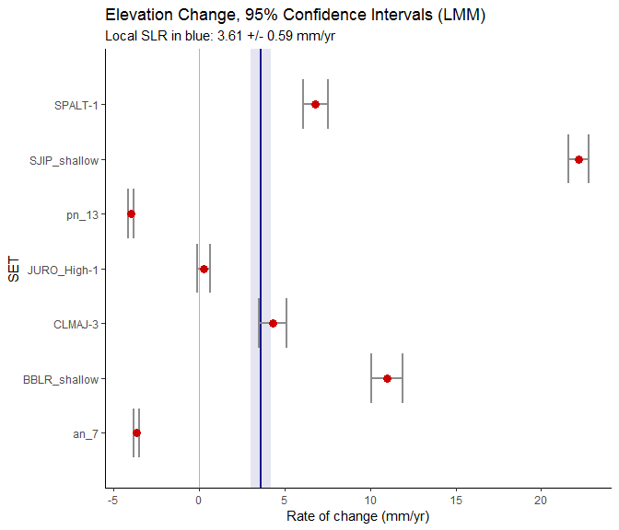

In order, according to specifications in the metadata; and labeled with user-friendly names. Note that no plot will be produced if there are any NAs in the metadata fields numerical_order or user_friendly_set_name.

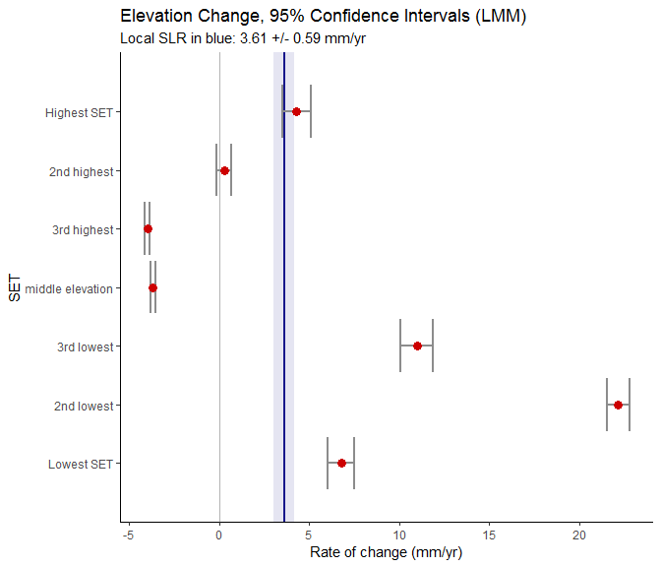

### Cumulative change snapshot

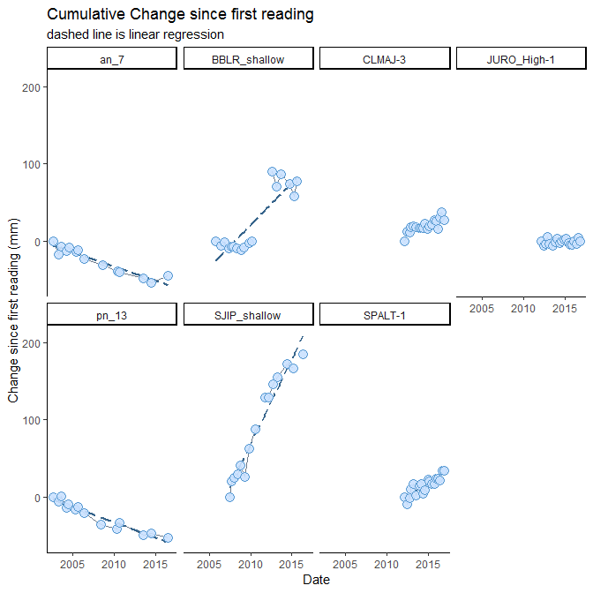

## MAPS

### Comparisons to 0

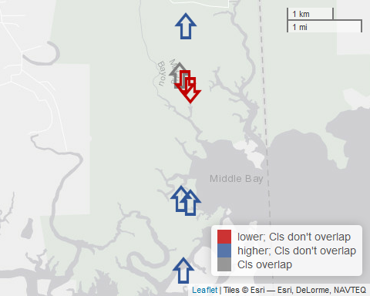

### Comparisons to SLR

