SET Rate Calculations

2020-01-24

In this report, the user may have chosen to exclude data associated with certain QA/QC codes. Any values that have been removed are listed in the appropriate section below.

Also, be aware that linear models are not appropriate for calculating rates of change at all sites. Use discretion when interpreting these results.

# Background on the data

## Data and metadata setup

We start by reading in the long SET measurement dataset, converted from other formats by earlier scripts. Pin heights have also been converted to mm if they weren’t already in those units.

This dataset spans the dates **2012-02-28** to **2016-11-23**.

If custom start and/or end dates were specified for this analysis, the dataset is subsetted here and the chosen date range will be printed below this paragraph. These options can be changed in the file metadata/user_defined_inputs.xlsx.

## QA/QC codes

In the same user_defined_inputs spreadsheet, certain qa/qc codes may have been specified for removal in this analysis. In the qaqc_codes worksheet, they were labeled with “-3”, to be consistent with SWMP’s water quality/weather/nutrient “reject” flagging. If such values are present, they will be printed below, then turned into NAs so they are not used in the analysis.

**Note** that the code looks for an EXACT match. e.g., if “LHE” is specified for removal, only values with “LHE” will be removed. “LHE CB” and “CRM LHE” will *not* be removed. To remove a combination of codes, a new line may need to be created in the qaqc_codes tab of the input spreadsheet.

## No QA/QC codes were labeled for exclusion. All data values are present.

### File Matching checks

This analysis was run on **gndset_processed.csv** on *2020-01-24*.

If any mismatches between the data and metadata files are present, they will be noted below. The user of this report will need to make any necessary changes in the data/metadata files.

## SET IDs match in your data and metadata files.

# Background information

## Reserve-level characteristics

* The local, long-term rate of sea level change is **3.61** +/- **0.59** mm/yr.
* This rate is reported by Dauphin Island, Alabama, NWLON station number 8735180 based on data from *1966* to *2017*.
* A shorter-term rate of water level change based on 19 years of data from the same NWLON station, using the same methods NOAA uses to calculate long-term sea level rise, is **7.37** +/- **3.18** mm/yr. This date range is from *1998* to *2017*.
* The technical report on NOAA’s calculation of long-term SLR trends, *Technical Report NOS CO-OPS 053; Sea Level Variations of the United States 1854-2006* can be found here: <https://tidesandcurrents.noaa.gov/publications/Tech_rpt_53.pdf> (possibly cite as Zervas 2009?)

# KIM CHECK ON CITATION ABOVE

## SET-level characteristics

### setting

| SET_ID | Type | Main_Veg |
| --- | --- | --- |
| CLMAJ-1 | Deep ROD SET | Cladium jamaicense |
| CLMAJ-2 | Deep ROD SET | Cladium jamaicense |
| CLMAJ-3 | Deep ROD SET | Cladium jamaicense |
| JURO_High-1 | Deep ROD SET | Juncus roemerianus |
| JURO_High-2 | Deep ROD SET | Juncus roemerianus |
| JURO_High-3 | Deep ROD SET | Juncus roemerianus |
| JURO_Mid-1 | Deep ROD SET | Juncus roemerianus |
| JURO_Mid-2 | Deep ROD SET | Juncus roemerianus |
| JURO_Mid-3 | Deep ROD SET | Juncus roemerianus |
| JURO_Low-1 | Deep ROD SET | Juncus roemerianus |
| JURO_Low-2 | Deep ROD SET | Juncus roemerianus |
| JURO_Low-3 | Deep ROD SET | Juncus roemerianus |
| SPALT-1 | Deep ROD SET | Spartina alterniflora |
| SPALT-2 | Deep ROD SET | Spartina alterniflora |
| SPALT-3 | Deep ROD SET | Spartina alterniflora |

### sampling information

| set_id | first_sampled | last_sampled | years_sampled | sample_events |
| --- | --- | --- | --- | --- |
| CLMAJ-1 | 2012-02-29 | 2016-11-21 | 4.728 | 19 |
| CLMAJ-2 | 2012-02-29 | 2016-11-21 | 4.728 | 19 |
| CLMAJ-3 | 2012-02-29 | 2016-11-21 | 4.728 | 19 |
| JURO_High-1 | 2012-02-28 | 2016-11-22 | 4.734 | 19 |
| JURO_High-2 | 2012-02-28 | 2016-11-22 | 4.734 | 19 |
| JURO_High-3 | 2012-02-28 | 2016-11-22 | 4.734 | 19 |
| JURO_Mid-1 | 2012-02-28 | 2016-11-22 | 4.734 | 19 |
| JURO_Mid-2 | 2012-02-28 | 2016-11-22 | 4.734 | 19 |
| JURO_Mid-3 | 2012-02-28 | 2016-11-22 | 4.734 | 19 |
| JURO_Low-1 | 2012-03-02 | 2016-11-23 | 4.728 | 19 |
| JURO_Low-2 | 2012-03-02 | 2016-11-23 | 4.728 | 19 |
| JURO_Low-3 | 2012-03-02 | 2016-11-23 | 4.728 | 19 |
| SPALT-1 | 2012-03-02 | 2016-11-23 | 4.728 | 19 |
| SPALT-2 | 2012-03-02 | 2016-11-23 | 4.728 | 19 |
| SPALT-3 | 2012-03-02 | 2016-11-23 | 4.728 | 19 |

### Cumulative change snapshot

Take a look at your overall change since the first reading - make sure the change looks generally linear, and make sure there are no big breaks in the data that could influence the outputs. Output will be generated even if it is not appropriate - **it is up to you to use discretion and make sure a linear model is appropriate for the data!**

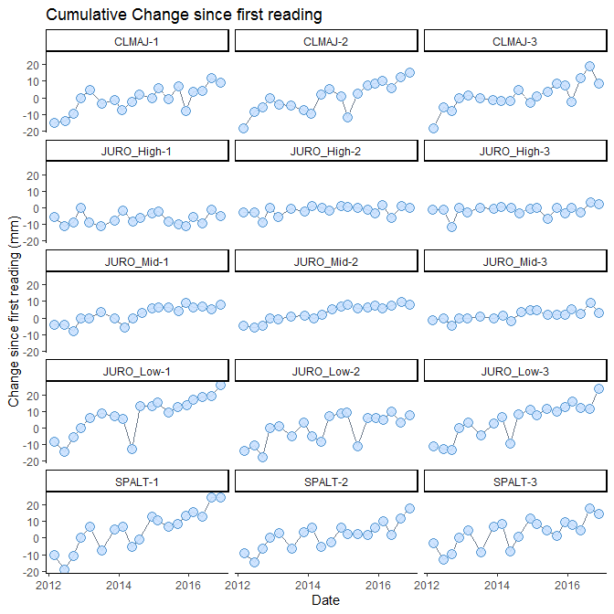

**The above graph is saved as:**  
*R_output/figures/cumu_change_plots/cumu_change_noLine.png*

Graphs for each SET individually are not shown here but have been saved in *R_output/figures/cumu_change_plots/individual_sets*

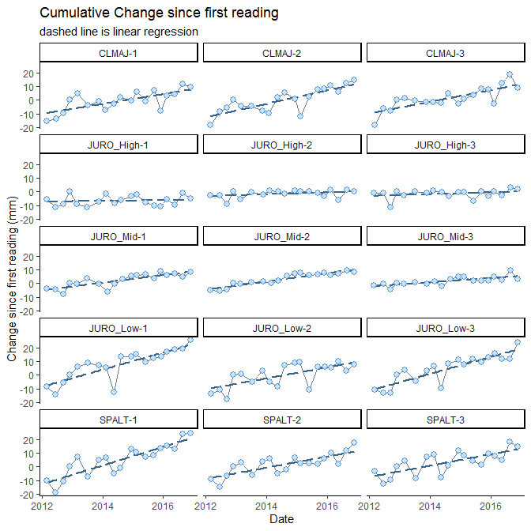

**The above graph is saved as:**  
*R_output/figures/cumu_change_plots/cumu_change_withLine.png*

Graphs for each SET individually are not shown here but have been saved in *R_output/figures/cumu_change_plots/individual_sets*

### Plus Sea Level Rise Line

**This is an oversimplification of sea level rise**

It is only meant to illustrate and give context for SET elevation change

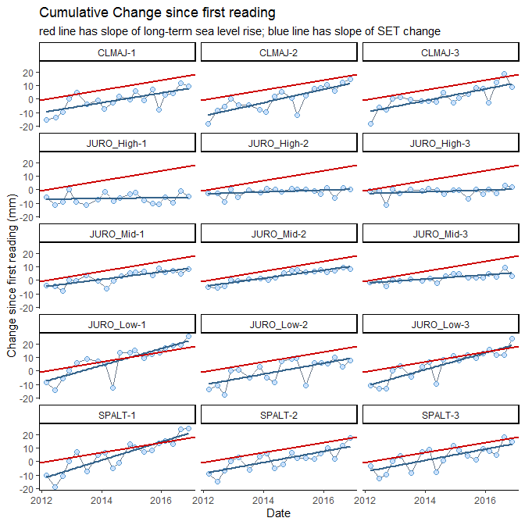

**The above graph is saved as:**  
R_output/figures/cumu_change_plots/cumu_change_withLineAndSLR.png

Graphs for each SET individually are not shown here but have been saved in *R_output/figures/cumu_change_plots/individual_sets*

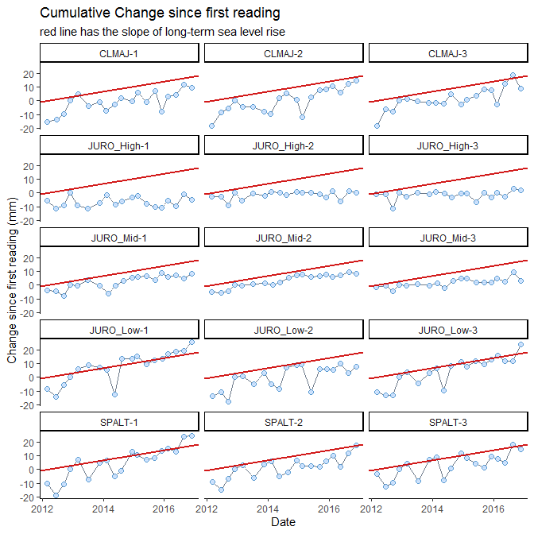

**The above graph is saved as:**  
R_output/figures/cumu_change_plots/cumu_change_withSLR.png

Graphs for each SET individually are not shown here but have been saved in *R_output/figures/cumu_change_plots/individual_sets*

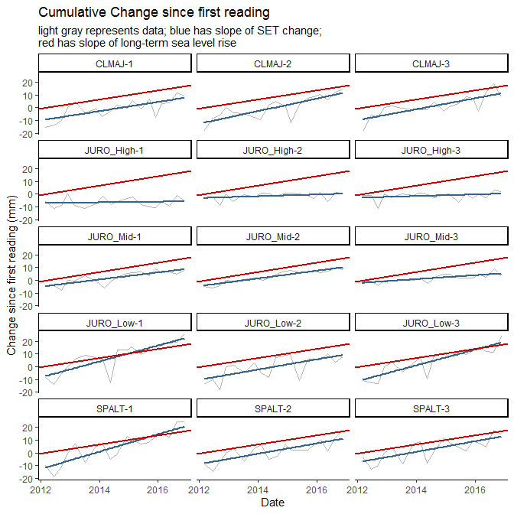

**The above graph is saved as:**  
R_output/figures/cumu_change_plots/cumu_change_linesOnly.png

Graphs for each SET individually are not shown here but have been saved in *R_output/figures/cumu_change_plots/individual_sets*

## Cumulative change along the elevation gradient

The following graph shows cumulative elevation change at all SETs in one graph panel. If NAVD88 information was present in metadata, the first reading at each SET was placed at that point on the y-axis. Otherwise, the SET cumulative change lines start at 0.

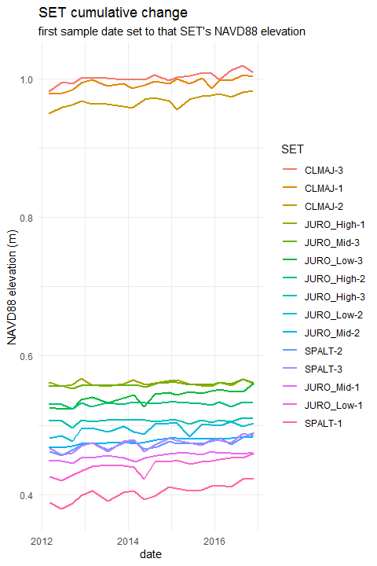

**The above graph is saved as:**  
*R_output/figures/cumu_change_plots/cumu_change_NAVD88.png*

# Rate Calculations

From this point on, **only SETs with 5 or more measurements over 4.5 or more years will be analyzed**. If you do not have any SETs that have been measured for this amount of time, you will NOT see analyses or graphs below.

### SETs that are included in the following analyses

## CLMAJ-1, CLMAJ-2, CLMAJ-3, JURO_High-1, JURO_High-2, JURO_High-3, JURO_Low-1, JURO_Low-2, JURO_Low-3, JURO_Mid-1, JURO_Mid-2, JURO_Mid-3, SPALT-1, SPALT-2, SPALT-3

### SETs that are not included in analyses

These rates were generated using random-intercept linear mixed models. See Zuur et al. 2009 and Cahoon et al. 2019 for details.

Cahoon, D.R., Lynch, J.C., Roman, C.T. et al. Estuaries and Coasts (2019) 42: 1. <https://doi.org/10.1007/s12237-018-0448-x>

Zuur, A.F., E.N. Ieno, N.J. Walker, A.A. Saveliev, and G.M. Smith. 2009. Mixed effects models and extensions in ecology with R. New York: Springer.

# LMM wording; clean up (also just above)

Linear mixed models extend traditional linear regression models by allowing for the inclusion of both fixed and random effects. These types of models are particularly useful when the data are structured hierarchically, as with SET data. Data for each SET is analyzed separately using pin height as the response variable; arm and pin nested in arm are treated as random effects, while date since initial measurement is considered a numeric covariate. As both the intercept and slope include random effects, methods other than least squares must be employed. Next discuss model fitting… All models were fit in R (reference…) using the nlme package (reference…). This type of approach is similar to the analysis performed in Cahoon 2019.

For each SET, we initially considered two LMMs: a LMM that includes a random intercept (with a random effects for arm and for pin nested in arm) and a LMM that includes both a random slope and a random intercept (with random effects for arm and for pin nested in arm). For many SETs, we observed that the random intercept model fit better. At other SETs, the random slope and intercept model seemed to fit better; however, the resulting point estimates showed only small differences. As the random intercept models did not require the same degree of scrutiny when model fitting, we exclusively employed random intercept models in our automated R scripts.

In our case, we have, for each SET:

* **response variable:** pin_height
* **fixed effect:** date
* **random effects:** arm_position, pin_number (note, these are nested)

## Rates of change

The LMMs were run using the lme() function in the nlme package. Confidence intervals were generated using the intervals() function, also in the nlme package.

All calculations generated output in *mm/day* and were converted to *mm/yr* by multiplying by 365.25 to account for leap years.

| reserve | set_id | rate | CI_low | CI_high |
| --- | --- | --- | --- | --- |
| GND | CLMAJ-1 | 3.627 | 2.820 | 4.434 |
| GND | CLMAJ-2 | 4.888 | 3.998 | 5.778 |
| GND | CLMAJ-3 | 4.303 | 3.521 | 5.085 |
| GND | JURO_High-1 | 0.270 | -0.119 | 0.659 |
| GND | JURO_High-2 | 0.699 | 0.391 | 1.007 |
| GND | JURO_High-3 | 0.663 | 0.371 | 0.955 |
| GND | JURO_Mid-1 | 2.808 | 2.432 | 3.183 |
| GND | JURO_Mid-2 | 3.030 | 2.765 | 3.295 |
| GND | JURO_Mid-3 | 1.547 | 1.094 | 2.001 |
| GND | JURO_Low-1 | 6.264 | 5.399 | 7.129 |
| GND | JURO_Low-2 | 3.998 | 3.152 | 4.844 |
| GND | JURO_Low-3 | 6.080 | 5.353 | 6.808 |
| GND | SPALT-1 | 6.786 | 6.060 | 7.513 |
| GND | SPALT-2 | 4.039 | 3.341 | 4.736 |
| GND | SPALT-3 | 4.159 | 3.445 | 4.874 |

### Additional model diagnostics

| reserve | set_id | sigma | AIC | BIC | logLik |
| --- | --- | --- | --- | --- | --- |
| GND | CLMAJ-1 | 15.555 | 5741.839 | 5764.457 | -2865.919 |
| GND | CLMAJ-2 | 17.174 | 5904.238 | 5926.864 | -2947.119 |
| GND | CLMAJ-3 | 15.091 | 5757.476 | 5780.102 | -2873.738 |
| GND | JURO_High-1 | 7.527 | 4778.305 | 4800.930 | -2384.152 |
| GND | JURO_High-2 | 5.953 | 4449.942 | 4472.560 | -2219.971 |
| GND | JURO_High-3 | 5.642 | 4367.162 | 4389.779 | -2178.581 |
| GND | JURO_Mid-1 | 7.252 | 4732.644 | 4755.269 | -2361.322 |
| GND | JURO_Mid-2 | 5.123 | 4271.926 | 4294.551 | -2130.963 |
| GND | JURO_Mid-3 | 8.762 | 4961.819 | 4984.444 | -2475.910 |
| GND | JURO_Low-1 | 16.653 | 5822.631 | 5845.234 | -2906.316 |
| GND | JURO_Low-2 | 16.312 | 5799.531 | 5822.149 | -2894.766 |
| GND | JURO_Low-3 | 13.999 | 5605.843 | 5628.454 | -2797.922 |
| GND | SPALT-1 | 13.986 | 5592.943 | 5615.546 | -2791.472 |
| GND | SPALT-2 | 13.390 | 5479.179 | 5501.730 | -2734.589 |
| GND | SPALT-3 | 13.784 | 5601.194 | 5623.819 | -2795.597 |

# **FEEDBACK OPPORTUNITY**

Do you like having separate tables for each comparison (below), or would you rather collapse this into one simple table? e.g.

|  |  |  |  |  |  |  |
| --- | --- | --- | --- | --- | --- | --- |
| SET ID | Comp to 0 | CI overlaps 0? | Comp to SLR | CI overlaps SLR CI? | Comp to 19-yr | CI overlaps 19-yr CI? |
| SET-1 | higher | no | higher | no | lower | yes |
| SET-2 | higher | yes | lower | yes | lower | yes |
| SET-3 | lower | yes | lower | no | lower | no |

This could take some explaining. Essentially, if the 95% CI doesn’t include 0, that’s the same as p < 0.05; slope differs significantly from 0. Comparisons to sea level change get more complicated because there’s not a single number we’re comparing to; there’s a number and a confidence interval. And they’re generated using different methods than what we’ve used to calculate the SET rates of change. So the closest we can get to “is this a significant difference” is “do the CIs overlap?” It’s not exactly the same as a t-test, but it’s the general idea of, “how confident are we”. This same idea plays into everything else below; it’s just a matter of how it’s represented. So please share your thoughts.

# Increasing/Decreasing (Comparison to 0)

The following tables break the SETs into groups where the rate of SET elevation change is *lower than* / *higher than* / *not different from* 0. *Lower than* and *higher than* tables imply that the 95% confidence intervals for the SET’s rate of change do not include 0. *Not different from* means that 0 *is* included.

## SET Elevation Change < 0 mm/yr

| reserve | set_id | rate | CI_low | CI_high |
| --- | --- | --- | --- | --- |

## SET Elevation Change > 0 mm/yr

| reserve | set_id | rate | CI_low | CI_high |
| --- | --- | --- | --- | --- |
| GND | CLMAJ-1 | 3.627 | 2.820 | 4.434 |
| GND | CLMAJ-2 | 4.888 | 3.998 | 5.778 |
| GND | CLMAJ-3 | 4.303 | 3.521 | 5.085 |
| GND | JURO_High-2 | 0.699 | 0.391 | 1.007 |
| GND | JURO_High-3 | 0.663 | 0.371 | 0.955 |
| GND | JURO_Mid-1 | 2.808 | 2.432 | 3.183 |
| GND | JURO_Mid-2 | 3.030 | 2.765 | 3.295 |
| GND | JURO_Mid-3 | 1.547 | 1.094 | 2.001 |
| GND | JURO_Low-1 | 6.264 | 5.399 | 7.129 |
| GND | JURO_Low-2 | 3.998 | 3.152 | 4.844 |
| GND | JURO_Low-3 | 6.080 | 5.353 | 6.808 |
| GND | SPALT-1 | 6.786 | 6.060 | 7.513 |
| GND | SPALT-2 | 4.039 | 3.341 | 4.736 |
| GND | SPALT-3 | 4.159 | 3.445 | 4.874 |

## SET Elevation Change 95% CI Includes 0 mm/yr

| reserve | set_id | rate | CI_low | CI_high |
| --- | --- | --- | --- | --- |
| GND | JURO_High-1 | 0.270 | -0.119 | 0.659 |

# Sea Level Rise Comparisons

## Period of Record (long-term SLR)

The long-term local rate of sea level rise is **3.61 +/- 0.59 mm/yr** .

This rate is reported by Dauphin Island, Alabama, NWLON station number 8735180 based on data from *1966* to *2017*.

The following tables break the SETs into groups where the rate of SET elevation change is *lower than* / *higher than* / *not different from* this SLR rate. *Lower than* and *higher than* tables imply that 95% confidence intervals do not overlap between the SET and SLR. *Not different from* means that confidence intervals *do* overlap.

## SET Elevation Change < SLR; CIs don’t overlap

| reserve | set_id | rate | CI_low | CI_high |
| --- | --- | --- | --- | --- |
| GND | JURO_High-1 | 0.270 | -0.119 | 0.659 |
| GND | JURO_High-2 | 0.699 | 0.391 | 1.007 |
| GND | JURO_High-3 | 0.663 | 0.371 | 0.955 |
| GND | JURO_Mid-3 | 1.547 | 1.094 | 2.001 |

## SET Elevation Change > SLR; CIs don’t overlap

| reserve | set_id | rate | CI_low | CI_high |
| --- | --- | --- | --- | --- |
| GND | JURO_Low-1 | 6.264 | 5.399 | 7.129 |
| GND | JURO_Low-3 | 6.080 | 5.353 | 6.808 |
| GND | SPALT-1 | 6.786 | 6.060 | 7.513 |

## SET Elevation Change and SLR CIs overlap

| reserve | set_id | rate | CI_low | CI_high |
| --- | --- | --- | --- | --- |
| GND | CLMAJ-1 | 3.627 | 2.820 | 4.434 |
| GND | CLMAJ-2 | 4.888 | 3.998 | 5.778 |
| GND | CLMAJ-3 | 4.303 | 3.521 | 5.085 |
| GND | JURO_Mid-1 | 2.808 | 2.432 | 3.183 |
| GND | JURO_Mid-2 | 3.030 | 2.765 | 3.295 |
| GND | JURO_Low-2 | 3.998 | 3.152 | 4.844 |
| GND | SPALT-2 | 4.039 | 3.341 | 4.736 |
| GND | SPALT-3 | 4.159 | 3.445 | 4.874 |

## 19-year water level change

The local, 19-year rate of water level change is **7.37 +/- 3.18 mm/yr** .

This rate uses data reported by Dauphin Island, Alabama, NWLON station number 8735180 based on data from *1998* to *2017*.

The following tables break the SETs into groups where the rate of SET elevation change is *lower than* / *higher than* / *not different from* this 19-year rate. *Lower than* and *higher than* tables imply that 95% confidence intervals do not overlap between the SET and water level change. *Not different from* means that confidence intervals *do* overlap.

## SET Elevation Change < 19-year water level change; CIs don’t overlap

| reserve | set_id | rate | CI_low | CI_high |
| --- | --- | --- | --- | --- |
| GND | JURO_High-1 | 0.270 | -0.119 | 0.659 |
| GND | JURO_High-2 | 0.699 | 0.391 | 1.007 |
| GND | JURO_High-3 | 0.663 | 0.371 | 0.955 |
| GND | JURO_Mid-1 | 2.808 | 2.432 | 3.183 |
| GND | JURO_Mid-2 | 3.030 | 2.765 | 3.295 |
| GND | JURO_Mid-3 | 1.547 | 1.094 | 2.001 |

## SET Elevation Change > 19-year water level change; CIs don’t overlap

| reserve | set_id | rate | CI_low | CI_high |
| --- | --- | --- | --- | --- |

## SET Elevation Change and 19-year water level change CIs overlap

| reserve | set_id | rate | CI_low | CI_high |
| --- | --- | --- | --- | --- |
| GND | CLMAJ-1 | 3.627 | 2.820 | 4.434 |
| GND | CLMAJ-2 | 4.888 | 3.998 | 5.778 |
| GND | CLMAJ-3 | 4.303 | 3.521 | 5.085 |
| GND | JURO_Low-1 | 6.264 | 5.399 | 7.129 |
| GND | JURO_Low-2 | 3.998 | 3.152 | 4.844 |
| GND | JURO_Low-3 | 6.080 | 5.353 | 6.808 |
| GND | SPALT-1 | 6.786 | 6.060 | 7.513 |
| GND | SPALT-2 | 4.039 | 3.341 | 4.736 |
| GND | SPALT-3 | 4.159 | 3.445 | 4.874 |

## Graphical Comparison to Sea Level Rise and 0

## Sites in R’s default order

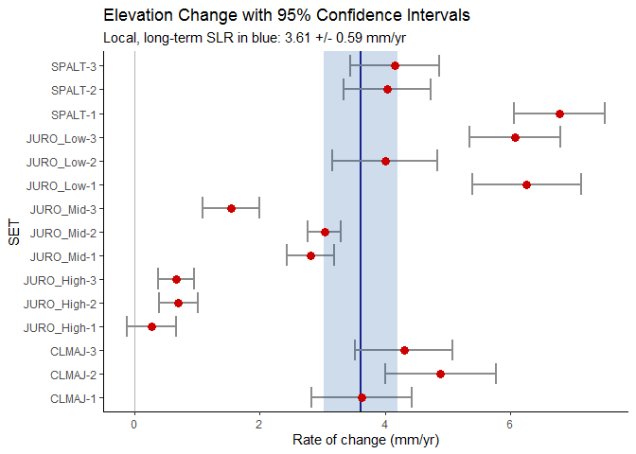

## The above graph is saved as: R_output/figures/summary_plots/summary_plot.png

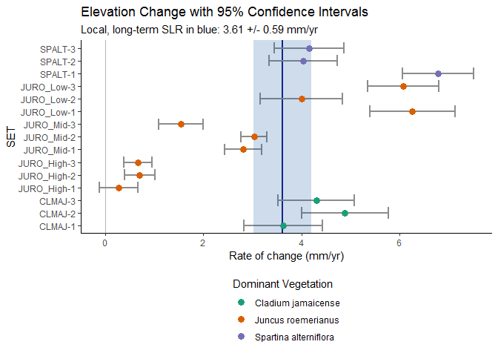

## The above graph is saved as: R_output/figures/summary_plots/summary_plot_veg.png

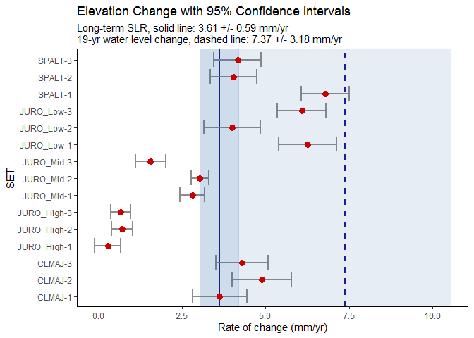

## The above graph is saved as: R_output/figures/summary_plots/summary_plot_bothSLRs.png

# note to self - make a user input option for dimensions of the veg-graph too

because of the options for legend placement, the same dimensions used above don’t work quite as well with these. Note to users, I’ll try to improve this and add it in to the documentation.

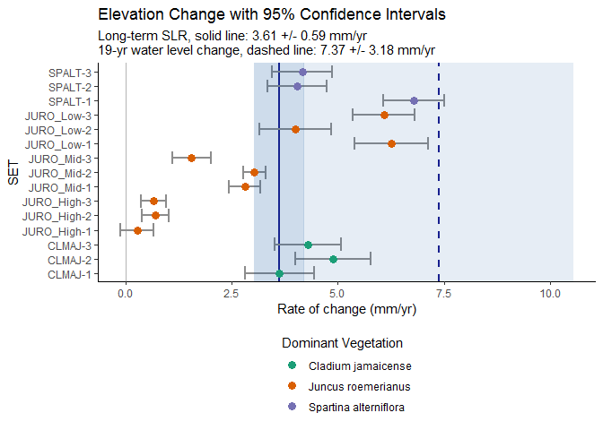

## The above graph is saved as: R_output/figures/summary_plots/summary_plot_veg_19yr.png

# Ordered (categorically) by NAVD88 elevation

If NAVD88 elevations were provided in the metadata, two more versions of the graph above are produced below. The SETs are ordered along the y-axis from highest to lowest elevation.

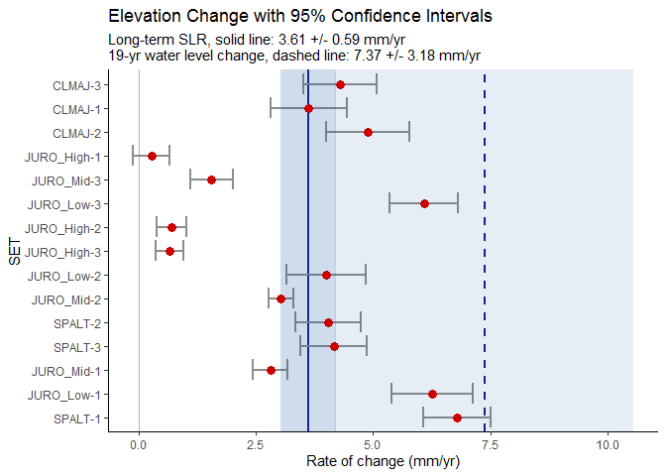

## The above graph is saved as: R_output/figures/summary_plots/summary_plot_bothSLRs_navd88ordering.png

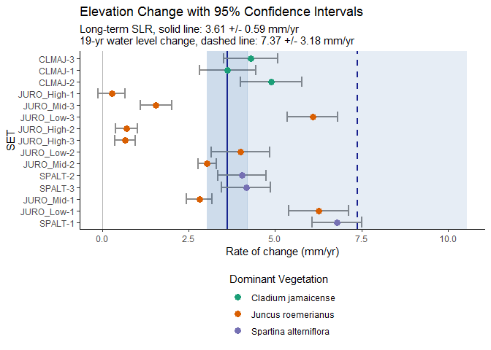

## The above graph is saved as: R_output/figures/summary_plots/summary_plot_bothSLRs_navd88ordering_veg.png

## Sites by a user-specified order

In order, according to specifications in the metadata; and labeled with user-friendly names. Note that no plot will be produced if there are any NAs in the metadata fields numerical_order or user_friendly_set_name.

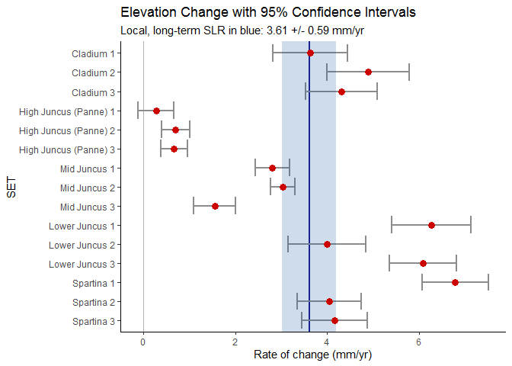

## The above graph is saved as: R_output/figures/summary_plots/summary_plot_ordered.png

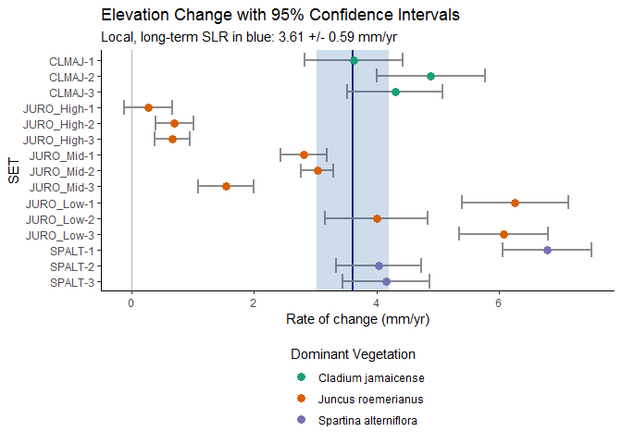

## The above graph is saved as: R_output/figures/summary_plots/summary_plot_ordered_veg.png



## The above graph is saved as: R_output/figures/summary_plots/summary_plot_ordered_friendly_names.png

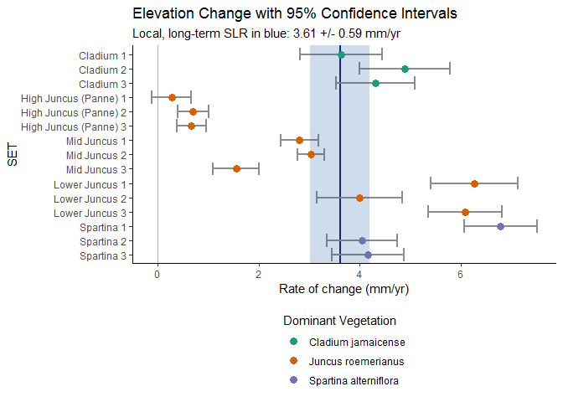

## The above graph is saved as: R_output/figures/summary_plots/summary_plot_ordered_friendly_names_veg.png

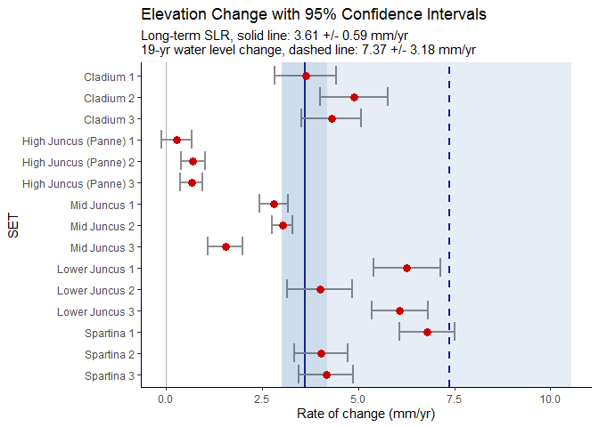

## The above graph is saved as: R_output/figures/summary_plots/summary_plot_ordered_with19yr.png

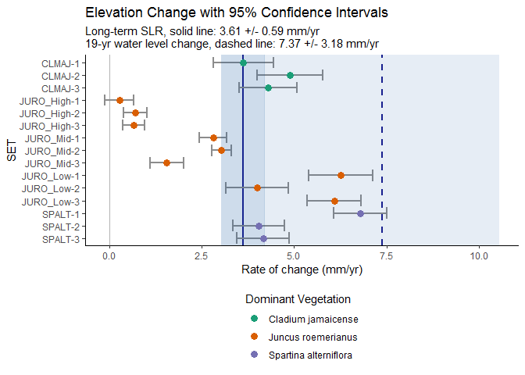

## The above graph is saved as: R_output/figures/summary_plots/summary_plot_ordered_with_19yr_veg.png



## The above graph is saved as: R_output/figures/summary_plots/summary_plot_ordered_friendly_names_with_19yr.png

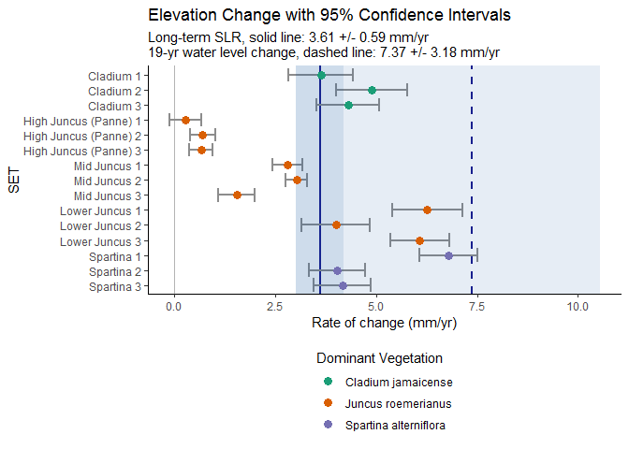

## The above graph is saved as: R_output/figures/summary_plots/summary_plot_ordered_friendly_names_with19yr_veg.png

## MAPS

The way these maps are rendered below (and even *if* they are rendered) depends on many things. The script R_scripts/04_interact_maps.R will let you interact with the maps, and you can either take a screenshot or use the Export command from RStudio’s Viewer pane to save a version that looks better.

### Comparisons to 0

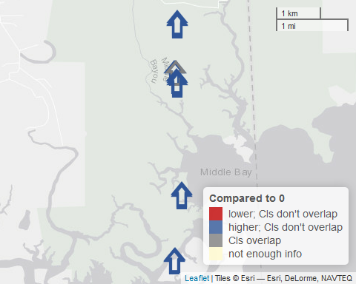

### Comparisons to long-term SLR

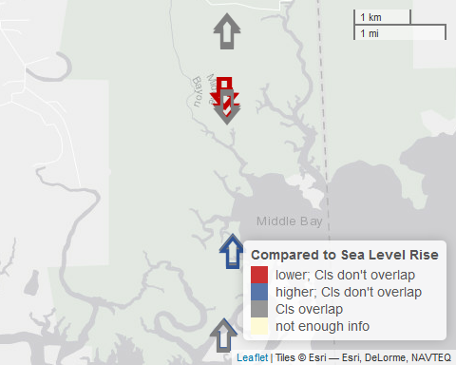

### Comparisons to 19-yr water level change

