SET Rate Calculations

2020-02-26

*This document was designed for use by National Estuarine Research Reserve (NERR) technical staff and may also be useful to other Surface Elevation Table (SET) data analysts. It is meant to calculate, visualize, and describe rates of elevation change at SET stations in a given area (such as an individual NERR or reserve component). These products are output from a 2018-2019 NERRS Science Collaborative Catalyst Grant project nicknamed “SETr”. For information on options to customize this report, see the document “Guide to the SETr Workflow” in the main folder of SETr outputs.*

# Background on the data

This analysis was run on **gndset_processed.csv** on *2020-02-26*.

In this report, the user may have chosen to exclude data associated with certain QA/QC codes. Any values that have been removed are listed in the appropriate section below.

## Data and metadata setup

We start by reading in the long SET measurement dataset, converted from other formats by earlier SETr scripts. See the “Guide to the SETr Workflow” document for more detail on data formatting. In this step, pin heights were converted to mm if they were previously in cm.

This dataset spans the dates **2012-02-28** to **2016-11-23**.

If custom start and/or end dates were specified for this analysis, the dataset is subsetted here and the chosen date range will be printed below this paragraph. These options can be changed in the file metadata/user_defined_inputs.xlsx, general tab.

## QA/QC codes

In the same user_defined_inputs spreadsheet, certain QA/QC codes may have been specified for removal in this analysis. In the qaqc_codes worksheet, they were labeled with “-3”, to be consistent with SWMP’s water quality/weather/nutrient “reject” flagging. If such values are present, they will be printed below, then turned into NAs so they are not used in the analysis.

**Note** that the R code dealing with these flags looks for an EXACT match in the qaqc_codes worksheet, and matches are case-sensitive (all codes should be in all caps). If “LHE” is specified for removal, only values with “LHE” will be removed. “LHE CB” and “CRM LHE” will *not* be removed if only “LHE” is specified; combinations of codes need to be specified on their own line in the input spreadsheet. If you are using a new combination of codes, you may need to create a new row in that spreadsheet See the “Guide to the SETr Workflow” document for more information.

## No QA/QC codes were labeled for exclusion. All data values are present.

### File Matching checks

If any mismatches in SET stations between the data and metadata files are present, they will be noted below. The user of this report will need to make any necessary changes in the data/metadata files.

## SET IDs match in your data and metadata files.

# Background information

## Reserve-level characteristics

* The local, long-term rate of sea level change is **3.61** +/- **0.59** mm/yr.
* This rate is reported by Dauphin Island, Alabama, NWLON station number 8735180 based on data from *1966* to *2017*.
* A shorter-term rate of water level change based on 19 years of data from the same NWLON station, using the same methods NOAA uses to calculate long-term sea level rise (ARIMA 1,0,0), is **7.37** +/- **3.18** mm/yr. This date range is from *1998* to *2017*.
* The technical report on NOAA’s calculation of long-term SLR trends, *Technical Report NOS CO-OPS 053 - Sea Level Variations of the United States 1854-2006* can be found here (accessed 2020-02-25): <https://tidesandcurrents.noaa.gov/publications/Tech_rpt_53.pdf>

## SET-level characteristics

### Setting

| SET_ID | Type | Main_Veg |
| --- | --- | --- |
| CLMAJ-1 | Deep ROD SET | Cladium jamaicense |
| CLMAJ-2 | Deep ROD SET | Cladium jamaicense |
| CLMAJ-3 | Deep ROD SET | Cladium jamaicense |
| JURO_High-1 | Deep ROD SET | Juncus roemerianus |
| JURO_High-2 | Deep ROD SET | Juncus roemerianus |
| JURO_High-3 | Deep ROD SET | Juncus roemerianus |
| JURO_Mid-1 | Deep ROD SET | Juncus roemerianus |
| JURO_Mid-2 | Deep ROD SET | Juncus roemerianus |
| JURO_Mid-3 | Deep ROD SET | Juncus roemerianus |
| JURO_Low-1 | Deep ROD SET | Juncus roemerianus |
| JURO_Low-2 | Deep ROD SET | Juncus roemerianus |
| JURO_Low-3 | Deep ROD SET | Juncus roemerianus |
| SPALT-1 | Deep ROD SET | Spartina alterniflora |
| SPALT-2 | Deep ROD SET | Spartina alterniflora |
| SPALT-3 | Deep ROD SET | Spartina alterniflora |

### Sampling Information

| set_id | first_sampled | last_sampled | years_sampled | sample_events |
| --- | --- | --- | --- | --- |
| CLMAJ-1 | 2012-02-29 | 2016-11-21 | 4.728 | 19 |
| CLMAJ-2 | 2012-02-29 | 2016-11-21 | 4.728 | 19 |
| CLMAJ-3 | 2012-02-29 | 2016-11-21 | 4.728 | 19 |
| JURO_High-1 | 2012-02-28 | 2016-11-22 | 4.734 | 19 |
| JURO_High-2 | 2012-02-28 | 2016-11-22 | 4.734 | 19 |
| JURO_High-3 | 2012-02-28 | 2016-11-22 | 4.734 | 19 |
| JURO_Mid-1 | 2012-02-28 | 2016-11-22 | 4.734 | 19 |
| JURO_Mid-2 | 2012-02-28 | 2016-11-22 | 4.734 | 19 |
| JURO_Mid-3 | 2012-02-28 | 2016-11-22 | 4.734 | 19 |
| JURO_Low-1 | 2012-03-02 | 2016-11-23 | 4.728 | 19 |
| JURO_Low-2 | 2012-03-02 | 2016-11-23 | 4.728 | 19 |
| JURO_Low-3 | 2012-03-02 | 2016-11-23 | 4.728 | 19 |
| SPALT-1 | 2012-03-02 | 2016-11-23 | 4.728 | 19 |
| SPALT-2 | 2012-03-02 | 2016-11-23 | 4.728 | 19 |
| SPALT-3 | 2012-03-02 | 2016-11-23 | 4.728 | 19 |

### Cumulative Change Snapshot

Take a look at your overall change since the first reading - make sure the change looks generally linear, and make sure there are no big breaks in the data that could influence the outputs. Output will be generated even if it is not appropriate - **it is up to you to use discretion and make sure a linear model is appropriate for the data!**

In the graphics below, the first (baseline) measurement for each pin was subtracted from every subsequent reading, to yield change-since-baseline at a pin level, for all dates. Then pins on an arm were averaged together for each date to yield change-since-baseline at the arm level. Finally, the arms for each date were averaged together to yield change-since-baseline for the SET as a whole. This is a slightly different approach than the rate calculations performed below but gives an almost identical point estimate for rate of change, and makes it easy to put change since baseline on a plot.

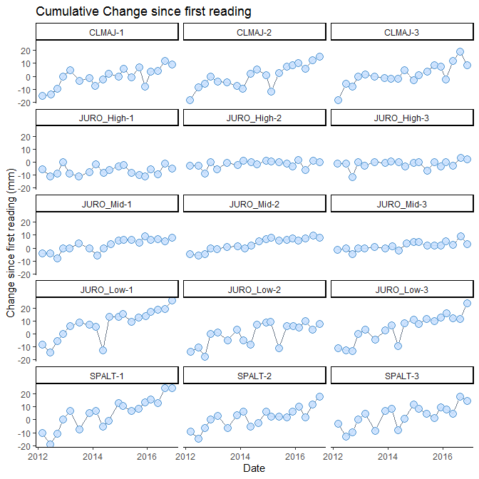

**The above graph is saved as:**  
*R_output/figures/cumu_change_plots/cumu_change_noLine.png*

Graphs for each SET individually are not shown here but have been saved in *R_output/figures/cumu_change_plots/individual_sets*

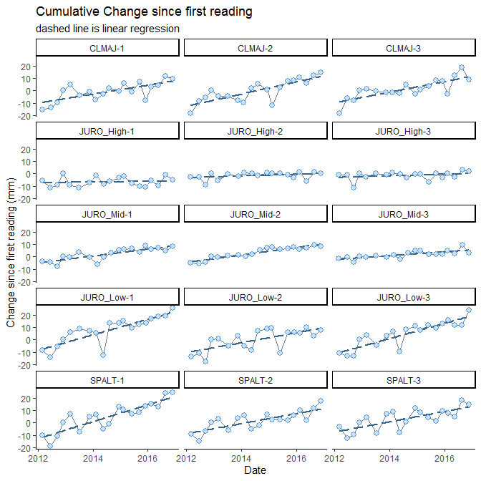

**The above graph is saved as:**  
*R_output/figures/cumu_change_plots/cumu_change_withLine.png*

Graphs for each SET individually are not shown here but have been saved in *R_output/figures/cumu_change_plots/individual_sets*

### Plus Sea Level Rise Line

**This is an oversimplification of sea level rise:** the slope is that of long-term, local SLR, calculated by NOAA COOPS at the NWLON station closest to the reserve. This line does not account for accelerating sea level rise or site-specific processes, and these graphs do not include actual water level data.

These graphs are meant to illustrate and provide context for SET elevation change relative to long-term SLR.

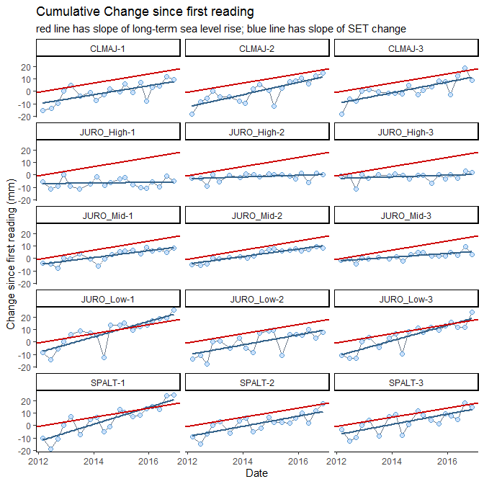

**The above graph is saved as:**  
R_output/figures/cumu_change_plots/cumu_change_withLineAndSLR.png

Graphs for each SET individually are not shown here but have been saved in *R_output/figures/cumu_change_plots/individual_sets*

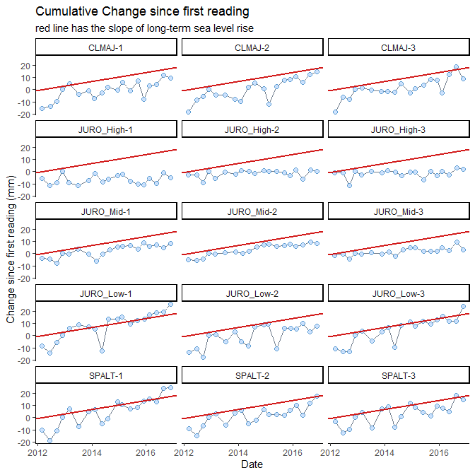

**The above graph is saved as:**  
R_output/figures/cumu_change_plots/cumu_change_withSLR.png

Graphs for each SET individually are not shown here but have been saved in *R_output/figures/cumu_change_plots/individual_sets*

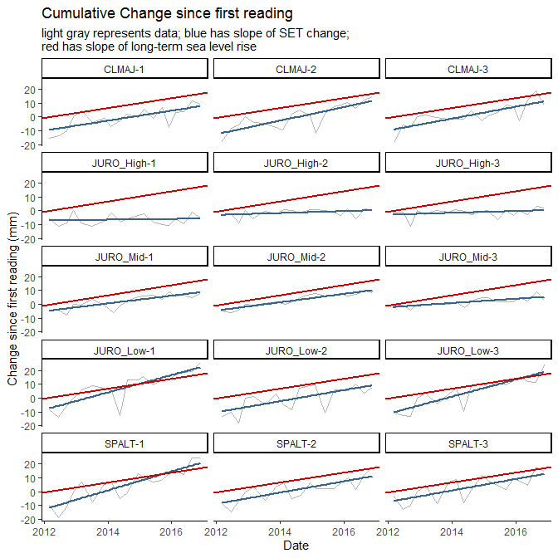

**The above graph is saved as:**  
R_output/figures/cumu_change_plots/cumu_change_linesOnly.png

Graphs for each SET individually are not shown here but have been saved in *R_output/figures/cumu_change_plots/individual_sets*

## Cumulative change along the elevation gradient

The following graph shows cumulative elevation change at all SETs in one graph panel. If NAVD88 information was present in metadata, the first reading at each SET was placed at that point on the y-axis. Otherwise, the SET cumulative change lines start at 0.

Available elevation information varied between reserves in this project; **this graph is meant to show changes along a relative elevation gradient only.** We have not overlaid water levels because we could not always be sure of the appropriate offset.

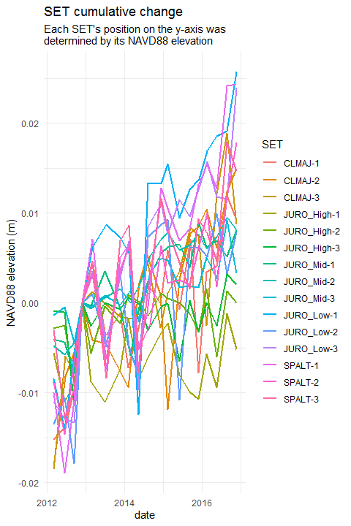

**The above graph is saved as:**  
*R_output/figures/cumu_change_plots/cumu_change_NAVD88.png*

# Rate Calculations

From this point on, **only SETs with 5 or more measurements over 4.5 or more years will be analyzed**. If you do not have any SETs that have been measured for this amount of time, you will NOT see analyses or graphs below.

### SETs that are included in the following analyses

## CLMAJ-1, CLMAJ-2, CLMAJ-3, JURO_High-1, JURO_High-2, JURO_High-3, JURO_Low-1, JURO_Low-2, JURO_Low-3, JURO_Mid-1, JURO_Mid-2, JURO_Mid-3, SPALT-1, SPALT-2, SPALT-3

### SETs that are not included in analyses

## All SETs were included in analyses.

# Statistical methodology

Rates of elevation change at each SET were generated using random-intercept linear mixed models. See Zuur et al. (2009) and Cahoon et al. (2019) for details.

Linear mixed models extend traditional linear regression models by allowing for the inclusion of both fixed and random effects. *These types of models are particularly useful when the data are structured hierarchically*, as with SET data. Data for each SET is analyzed separately using pin height as the response variable; arm and pin (nested in arm) are treated as random effects; and date is considered a numeric covariate. As both the intercept and slope include random effects, methods other than least squares must be employed.

For each SET, we initially considered two LMMs, as in Cahoon et al. (2019): a LMM that includes a random intercept (with a random effects for arm and for pin nested in arm) and a LMM that includes both a random slope and a random intercept (with random effects for arm and for pin nested in arm). For many SETs, we observed that the random intercept model fit better. At other SETs, the random slope and intercept model produced better fitting models (based on AIC). However, the resulting point estimates showed only small differences between the two approaches. As the random intercept models did not require the same degree of scrutiny when model fitting, and did not cause as many script-running errors, we exclusively employed random intercept models in these automated R scripts. For more detailed analyses at a smaller level, we recommend consideration of both models.

## General recommendations on analysis of SET data

* Before analysis, the analyst should carefully examine plots of the data to ensure that a linear model is appropriate. *If the points exhibit curvature or if there is some sort of a changepoint, this type of analysis may not be appropriate.* Graphs are provided in this report to help with this determination.
* The analyst should also look for highly influential observations. One way that this could occur is when there is a *large temporal gap* in the data.
* Be aware that, though we have done our best to appropriately describe uncertainty in the following rate calculations, the analyses below do not account for *temporal dependence* in the data. This could mean that confidence intervals are narrower than they should be and may be something the analyst wishes to address in future analyses.
* The analyst should employ a statistically valid model fitting strategy. When using Linear Mixed Models (LMMs), as we do below, this should also include addressing issues such as:
  + ensuring convergence of the numerical optimization
  + exploring sensitivity to starting values in the optimization procedure
  + determining whether a random slope model or a random slope/random intercept model is most appropriate, and
  + verifying model assumptions.

## Statistical details of this analysis

For this analysis, models were fit in R, using the lme() function in the nlme package (Pinheiro et al. 2019). Confidence intervals were generated using the intervals() function, also in the nlme package.

Variable names within each SET were:

* **response variable:** pin_height
* **fixed effect:** date
* **random effects:** arm_position, pin_number (with pin_number nested in arm_position)

All calculations generated output in *mm/day* and these rates were converted to *mm/yr* by multiplying by 365.25, to account for leap years.

## Calculated rates of elevation change

| reserve | set_id | rate | CI_low | CI_high |
| --- | --- | --- | --- | --- |
| GND | CLMAJ-1 | 3.627 | 2.820 | 4.434 |
| GND | CLMAJ-2 | 4.888 | 3.998 | 5.778 |
| GND | CLMAJ-3 | 4.303 | 3.521 | 5.085 |
| GND | JURO_High-1 | 0.270 | -0.119 | 0.659 |
| GND | JURO_High-2 | 0.699 | 0.391 | 1.007 |
| GND | JURO_High-3 | 0.663 | 0.371 | 0.955 |
| GND | JURO_Mid-1 | 2.808 | 2.432 | 3.183 |
| GND | JURO_Mid-2 | 3.030 | 2.765 | 3.295 |
| GND | JURO_Mid-3 | 1.547 | 1.094 | 2.001 |
| GND | JURO_Low-1 | 6.264 | 5.399 | 7.129 |
| GND | JURO_Low-2 | 3.998 | 3.152 | 4.844 |
| GND | JURO_Low-3 | 6.080 | 5.353 | 6.808 |
| GND | SPALT-1 | 6.786 | 6.060 | 7.513 |
| GND | SPALT-2 | 4.039 | 3.341 | 4.736 |
| GND | SPALT-3 | 4.159 | 3.445 | 4.874 |

### Additional model diagnostics

| reserve | set_id | sigma | AIC | BIC | logLik |
| --- | --- | --- | --- | --- | --- |
| GND | CLMAJ-1 | 15.555 | 5741.839 | 5764.457 | -2865.919 |
| GND | CLMAJ-2 | 17.174 | 5904.238 | 5926.864 | -2947.119 |
| GND | CLMAJ-3 | 15.091 | 5757.476 | 5780.102 | -2873.738 |
| GND | JURO_High-1 | 7.527 | 4778.305 | 4800.930 | -2384.152 |
| GND | JURO_High-2 | 5.953 | 4449.942 | 4472.560 | -2219.971 |
| GND | JURO_High-3 | 5.642 | 4367.162 | 4389.779 | -2178.581 |
| GND | JURO_Mid-1 | 7.252 | 4732.644 | 4755.269 | -2361.322 |
| GND | JURO_Mid-2 | 5.123 | 4271.926 | 4294.551 | -2130.963 |
| GND | JURO_Mid-3 | 8.762 | 4961.819 | 4984.444 | -2475.910 |
| GND | JURO_Low-1 | 16.653 | 5822.631 | 5845.234 | -2906.316 |
| GND | JURO_Low-2 | 16.312 | 5799.531 | 5822.149 | -2894.766 |
| GND | JURO_Low-3 | 13.999 | 5605.843 | 5628.454 | -2797.922 |
| GND | SPALT-1 | 13.986 | 5592.943 | 5615.546 | -2791.472 |
| GND | SPALT-2 | 13.390 | 5479.179 | 5501.730 | -2734.589 |
| GND | SPALT-3 | 13.784 | 5601.194 | 5623.819 | -2795.597 |

# Comparisons to 0 and SLR

In the following tables and graphics, rates of elevation change at each SET are compared to rates of water level change (SLR = long-term sea level rise; 19yr = water level change over a 19 year period) by investigating whether confidence intervals overlap. This method of comparison was chosen because different methods were used to calculate rates for sea level rise (ARIMA) and SET elevation change (LMMs), using data from different sources. We note that each individual interval has 95% confidence associated with it, and conclusions that are made based on pairwise comparison of these intervals will not necessarily be equivalent to conducting a formal hypothesis test for a difference at the 5% level (Schenker and Gentleman, 2001).

For comparisons to 0, if the SET’s 95% CI does not include 0, this *is* equivalent to a formal hypothesis test. For consistency, we are using the same terminology, involving overlapping CIs for all comparisons.

## Overall Summary Table

In this table, the SETs are ordered by their rate of change, from lowest at the top to highest at the bottom. The rate and 95% CI (all in mm/yr) for each SET are provided. The last 6 columns show comparisons to: zero (is elevation at the SET changing?), long-term SLR, and 19-year water level change. Each comparison takes up two columns: a comparison of point estimates (is the SET rate higher or lower than what it is compared to), and whether or not the confidence intervals overlap.

| **SET** | **Rate** | **95% CI** | | **Compared to 0** | | **Compared to SLR** | | **Compared to 19-yr change** | |
| --- | --- | --- | --- | --- | --- | --- | --- | --- | --- |
|  | **mm/yr** | **lower** | **upper** | **point** | **CI overlap?** | **point** | **CI overlap?** | **point** | **CI overlap?** |
| JURO_High-1 | 0.270 | -0.119 | 0.659 | higher | yes | lower | no | lower | no |
| JURO_High-3 | 0.663 | 0.371 | 0.955 | higher | no | lower | no | lower | no |
| JURO_High-2 | 0.699 | 0.391 | 1.007 | higher | no | lower | no | lower | no |
| JURO_Mid-3 | 1.547 | 1.094 | 2.001 | higher | no | lower | no | lower | no |
| JURO_Mid-1 | 2.808 | 2.432 | 3.183 | higher | no | lower | yes | lower | no |
| JURO_Mid-2 | 3.030 | 2.765 | 3.295 | higher | no | lower | yes | lower | no |
| CLMAJ-1 | 3.627 | 2.820 | 4.434 | higher | no | higher | yes | lower | yes |
| JURO_Low-2 | 3.998 | 3.152 | 4.844 | higher | no | higher | yes | lower | yes |
| SPALT-2 | 4.039 | 3.341 | 4.736 | higher | no | higher | yes | lower | yes |
| SPALT-3 | 4.159 | 3.445 | 4.874 | higher | no | higher | yes | lower | yes |
| CLMAJ-3 | 4.303 | 3.521 | 5.085 | higher | no | higher | yes | lower | yes |
| CLMAJ-2 | 4.888 | 3.998 | 5.778 | higher | no | higher | yes | lower | yes |
| JURO_Low-3 | 6.080 | 5.353 | 6.808 | higher | no | higher | no | lower | yes |
| JURO_Low-1 | 6.264 | 5.399 | 7.129 | higher | no | higher | no | lower | yes |
| SPALT-1 | 6.786 | 6.060 | 7.513 | higher | no | higher | no | lower | yes |

# Increasing/Decreasing (Comparison to 0)

The following tables break the SETs into groups where the rate of SET elevation change is *lower than* / *higher than* / *not different from* 0. *Lower than* and *higher than* tables imply that the 95% confidence intervals for the SET’s rate of elevation change do not include 0. *Not different from* means that 0 *is* included.

## SET Elevation Change < 0 mm/yr

| reserve | set_id | rate | CI_low | CI_high |
| --- | --- | --- | --- | --- |

## SET Elevation Change > 0 mm/yr

| reserve | set_id | rate | CI_low | CI_high |
| --- | --- | --- | --- | --- |
| GND | CLMAJ-1 | 3.627 | 2.820 | 4.434 |
| GND | CLMAJ-2 | 4.888 | 3.998 | 5.778 |
| GND | CLMAJ-3 | 4.303 | 3.521 | 5.085 |
| GND | JURO_High-2 | 0.699 | 0.391 | 1.007 |
| GND | JURO_High-3 | 0.663 | 0.371 | 0.955 |
| GND | JURO_Mid-1 | 2.808 | 2.432 | 3.183 |
| GND | JURO_Mid-2 | 3.030 | 2.765 | 3.295 |
| GND | JURO_Mid-3 | 1.547 | 1.094 | 2.001 |
| GND | JURO_Low-1 | 6.264 | 5.399 | 7.129 |
| GND | JURO_Low-2 | 3.998 | 3.152 | 4.844 |
| GND | JURO_Low-3 | 6.080 | 5.353 | 6.808 |
| GND | SPALT-1 | 6.786 | 6.060 | 7.513 |
| GND | SPALT-2 | 4.039 | 3.341 | 4.736 |
| GND | SPALT-3 | 4.159 | 3.445 | 4.874 |

## SET Elevation Change 95% CI Includes 0 mm/yr

| reserve | set_id | rate | CI_low | CI_high |
| --- | --- | --- | --- | --- |
| GND | JURO_High-1 | 0.270 | -0.119 | 0.659 |

# Sea Level Rise Comparisons

## Period of Record (long-term SLR)

The long-term local rate of sea level rise is **3.61 +/- 0.59 mm/yr** .

This rate is reported by Dauphin Island, Alabama, NWLON station number 8735180 based on data from *1966* to *2017*.

The following tables break the SETs into groups where the rate of SET elevation change is *lower than* / *higher than* / *not different from* this SLR rate. *Lower than* and *higher than* tables imply that 95% confidence intervals do not overlap between the SET and SLR. *Not different from* means that confidence intervals *do* overlap.

This method of comparison was chosen because different methods were used to calculate rates for sea level rise (ARIMA) and SET elevation change (LMMs) using data from different sources. We note that each individual interval has 95% confidence associated with it, and conclusions that are made based on pairwise comparison of these intervals will not necessarily be equivalent to conducting a formal hypothesis test for a difference at the 5% level (Schenker and Gentleman, 2001).

## SET Elevation Change < SLR; CIs don’t overlap

| reserve | set_id | rate | CI_low | CI_high |
| --- | --- | --- | --- | --- |
| GND | JURO_High-1 | 0.270 | -0.119 | 0.659 |
| GND | JURO_High-2 | 0.699 | 0.391 | 1.007 |
| GND | JURO_High-3 | 0.663 | 0.371 | 0.955 |
| GND | JURO_Mid-3 | 1.547 | 1.094 | 2.001 |

## SET Elevation Change > SLR; CIs don’t overlap

| reserve | set_id | rate | CI_low | CI_high |
| --- | --- | --- | --- | --- |
| GND | JURO_Low-1 | 6.264 | 5.399 | 7.129 |
| GND | JURO_Low-3 | 6.080 | 5.353 | 6.808 |
| GND | SPALT-1 | 6.786 | 6.060 | 7.513 |

## SET Elevation Change and SLR CIs overlap

| reserve | set_id | rate | CI_low | CI_high |
| --- | --- | --- | --- | --- |
| GND | CLMAJ-1 | 3.627 | 2.820 | 4.434 |
| GND | CLMAJ-2 | 4.888 | 3.998 | 5.778 |
| GND | CLMAJ-3 | 4.303 | 3.521 | 5.085 |
| GND | JURO_Mid-1 | 2.808 | 2.432 | 3.183 |
| GND | JURO_Mid-2 | 3.030 | 2.765 | 3.295 |
| GND | JURO_Low-2 | 3.998 | 3.152 | 4.844 |
| GND | SPALT-2 | 4.039 | 3.341 | 4.736 |
| GND | SPALT-3 | 4.159 | 3.445 | 4.874 |

## 19-year water level change

The local, 19-year rate of water level change is **7.37 +/- 3.18 mm/yr** .

This rate uses data reported by Dauphin Island, Alabama, NWLON station number 8735180 based on data from *1998* to *2017*.

The following tables break the SETs into groups where the rate of SET elevation change is *lower than* / *higher than* / *not different from* this 19-year rate. *Lower than* and *higher than* tables imply that 95% confidence intervals do not overlap between the SET and water level change. *Not different from* means that confidence intervals *do* overlap.

This method of comparison was chosen because different methods were used to calculate rates for sea level rise (ARIMA) and SET elevation change (LMMs) using data from different sources. We note that each individual interval has 95% confidence associated with it, and conclusions that are made based on pairwise comparison of these intervals will not necessarily be equivalent to conducting a formal hypothesis test for a difference at the 5% level (Schenker and Gentleman, 2001).

## SET Elevation Change < 19-year water level change; CIs don’t overlap

| reserve | set_id | rate | CI_low | CI_high |
| --- | --- | --- | --- | --- |
| GND | JURO_High-1 | 0.270 | -0.119 | 0.659 |
| GND | JURO_High-2 | 0.699 | 0.391 | 1.007 |
| GND | JURO_High-3 | 0.663 | 0.371 | 0.955 |
| GND | JURO_Mid-1 | 2.808 | 2.432 | 3.183 |
| GND | JURO_Mid-2 | 3.030 | 2.765 | 3.295 |
| GND | JURO_Mid-3 | 1.547 | 1.094 | 2.001 |

## SET Elevation Change > 19-year water level change; CIs don’t overlap

| reserve | set_id | rate | CI_low | CI_high |
| --- | --- | --- | --- | --- |

## SET Elevation Change and 19-year water level change CIs overlap

| reserve | set_id | rate | CI_low | CI_high |
| --- | --- | --- | --- | --- |
| GND | CLMAJ-1 | 3.627 | 2.820 | 4.434 |
| GND | CLMAJ-2 | 4.888 | 3.998 | 5.778 |
| GND | CLMAJ-3 | 4.303 | 3.521 | 5.085 |
| GND | JURO_Low-1 | 6.264 | 5.399 | 7.129 |
| GND | JURO_Low-2 | 3.998 | 3.152 | 4.844 |
| GND | JURO_Low-3 | 6.080 | 5.353 | 6.808 |
| GND | SPALT-1 | 6.786 | 6.060 | 7.513 |
| GND | SPALT-2 | 4.039 | 3.341 | 4.736 |
| GND | SPALT-3 | 4.159 | 3.445 | 4.874 |

# Graphical Comparisons to Sea Level Rise and 0

If dominant vegetation was provided in the metadata document, the following graphs will be provided both with and without points colored by vegetation type. If any vegetation entries were missing, the vegetation point-coloration will NOT be provided. You can generate them by adding vegetation to the “CoDominant Species 1” column of the ---set_metadata.xlsx document.

## Sites in alphabetical order, R’s default

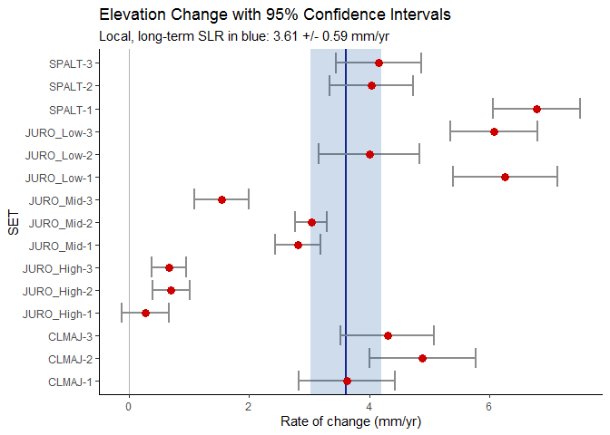

## The above graph is saved as: R_output/figures/summary_plots/summary_plot.png

## The above graph is saved as: R_output/figures/summary_plots/summary_plot_veg.png

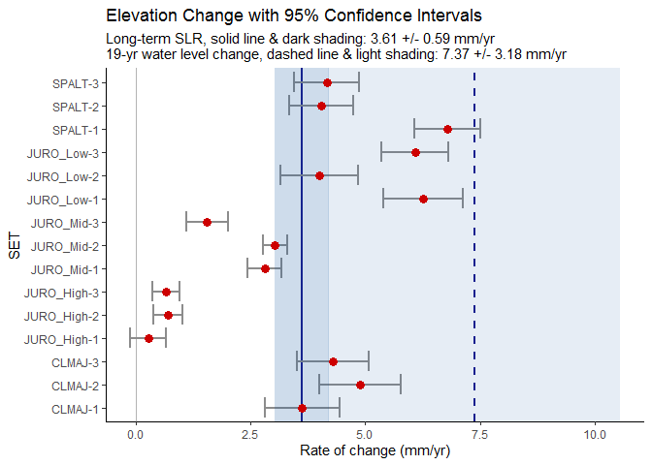

## The above graph is saved as: R_output/figures/summary_plots/summary_plot_bothSLRs.png

## The above graph is saved as: R_output/figures/summary_plots/summary_plot_veg_19yr.png

## Ordered (categorically) by NAVD88 elevation

If NAVD88 elevations were provided in the metadata, two more versions of the graph above are produced below. The SETs are ordered along the y-axis from highest to lowest elevation.

## Sites by a user-specified order

If the numerical_order column of the metadata was filled out, the order of SETs in the graphics below will be in that order, as well as labeled with user-friendly names. Note that no plot will be produced if there are any NAs (missing values) in the metadata fields numerical_order or user_friendly_set_name.

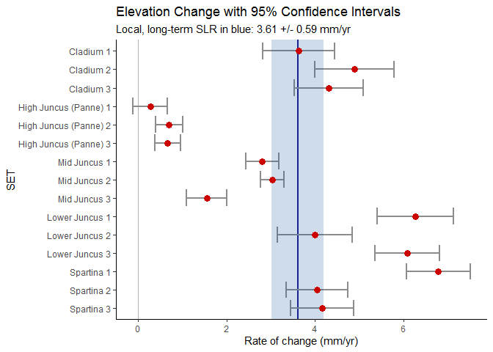

## The above graph is saved as: R_output/figures/summary_plots/summary_plot_ordered.png

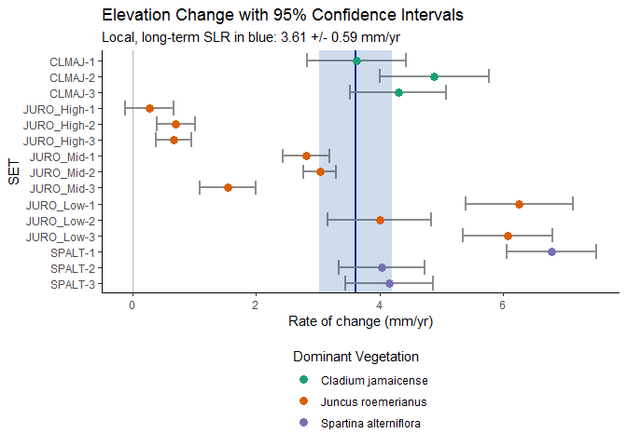

## The above graph is saved as: R_output/figures/summary_plots/summary_plot_ordered_veg.png



## The above graph is saved as: R_output/figures/summary_plots/summary_plot_ordered_friendly_names.png

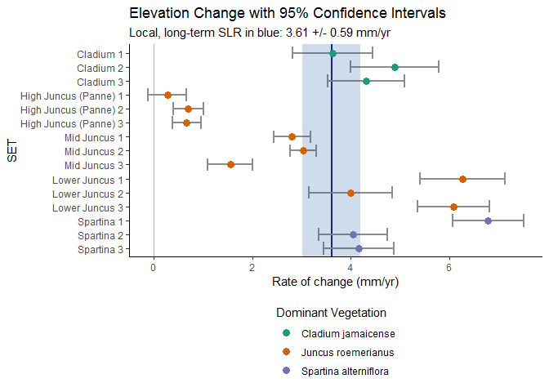

## The above graph is saved as: R_output/figures/summary_plots/summary_plot_ordered_friendly_names_veg.png

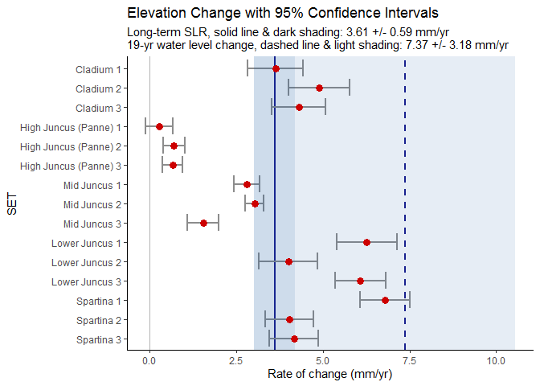

## The above graph is saved as: R_output/figures/summary_plots/summary_plot_ordered_with19yr.png

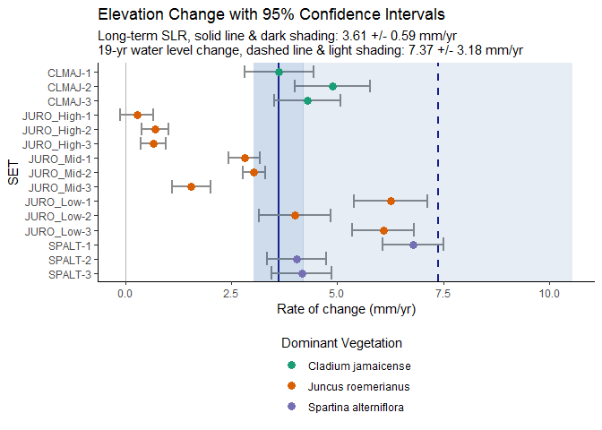

## The above graph is saved as: R_output/figures/summary_plots/summary_plot_ordered_with_19yr_veg.png



## The above graph is saved as: R_output/figures/summary_plots/summary_plot_ordered_friendly_names_with_19yr.png

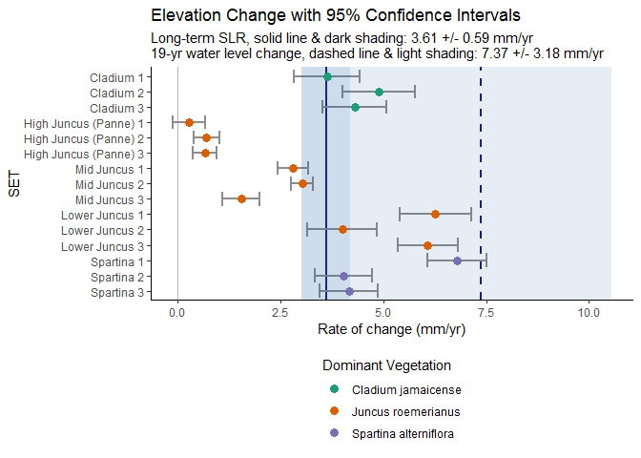

## The above graph is saved as: R_output/figures/summary_plots/summary_plot_ordered_friendly_names_with19yr_veg.png

# MAPS

The way the maps are rendered below (and even *if* they are rendered) depends on several things specific to your computer. The script R_scripts/04_interact_maps.R will let you interact with the maps, and you can either take a screenshot or use the Export command from RStudio’s Viewer pane to save a version that looks better. Even if no output was generated in this Word document, you should still be able to use the interactive script to generate maps.

### Comparisons to 0

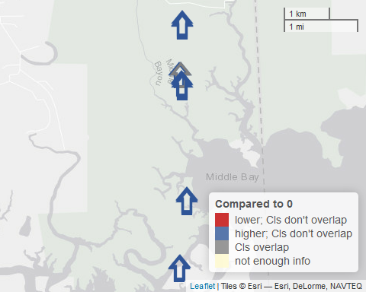

### Comparisons to long-term SLR

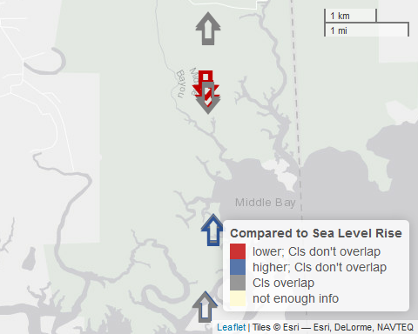

### Comparisons to 19-yr water level change

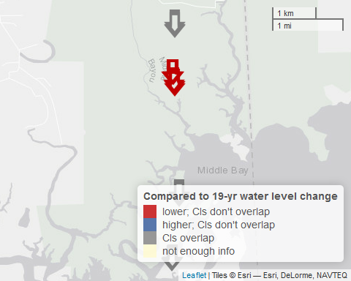

# References

Cahoon, D.R., J.C. Lynch, C.T. Roman, J.P. Schmit, and D.E. Skidds. 2019. Evaluating the Relationship Among Wetland Vertical Development, Elevation Capital, Sea-Level Rise, and Tidal Marsh Sustainability. Estuaries and Coasts 42:1-15. <https://doi.org/10.1007/s12237-018-0448-x>

Pinheiro J, Bates D, DebRoy S, Sarkar D, R Core Team. 2019. *nlme: Linear and Nonlinear Mixed Effects Models*. R package version 3.1-140, <https://CRAN.R-project.org/package=nlme>

Schenker, N. and J.F. Gentleman. 2001. On Judging the Significance of Differences by Examining the Overlap Between Confidence Intervals. The American Statistician 55(3):182-186. <https://doi.org/10.1198/000313001317097960>

Zuur, A.F., E.N. Ieno, N.J. Walker, A.A. Saveliev, and G.M. Smith. 2009. Mixed effects models and extensions in ecology with R. New York: Springer.