SET Outreach Tools

2020-01-24

# some questions and answers (will remove from final doc)

difference between deep and shallow SETs?

fig. 2 is a graph at *which* reserve? (answer = whichever one generates the document)

fig. 4 more explanation - this could be difficult based on these being auto-generated, so we can’t interpret every graph individually; that will have to happen between outreach and technical staff at the reserve using this. questions were: “I also thought these figures could have used a bit more explanation of what we are seeing. We see that sediment elevation has increased at what seems like the same rate as the increase in sea level. Wouldn’t we expect to see the opposite (more erosion as sea level rises)? Or is the sediment being built up at these locations from an increase in sea level?”

For figure 7, is the rate of change=the regression value? (answer: yes)

# Background - National level

This document is intended for use as an outreach tool to help National Estuarine Research Reserve (NERR) Education and Coastal Training Program staff present and describe information relating to Surface Elevation Table (SET) data. These products are output from a 2018-2019 NERRS Science Collaborative Catalyst Grant project nicknamed “SETr”.

The NERR Sentinel Site Program is an integrated set of System-Wide Monitoring Program (SWMP) data on water level and vegetation characteristics combined with elevation measurements used to assess the impacts of changes in sea level. Surface Elevation Table (SET) technology, a means of measuring height of the marsh substrate, is a key component of the NERRS Sentinel Site Program. In this project, the acquired NERRS Sentinel Site SET data is analyzed to answer the question – Are marsh vegetation communities keeping pace with sea level rise. Note that this is an analysis looking backwards in time; it is not a forecast.

A Surface Elevation Table (SET) is a specially machined apparatus designed to attach atop a rod driven into the ground as deeply as possible (point of refusal). A receiver is attached to the rod and permanently cast in a cement collar (referenced as #1 ‘SET mark’ in Figure 1). The SET apparatus consists of a vertical stand, which attaches to the receiver, and a horizontal arm that reaches out over the marsh surface. For measurements, the SET apparatus is temporarily deployed by affixed to the SET receiver and ensuring the arm is horizonatally level. Surface elevation measurements are taken at nine equidistant locations along the arm, and the arm has typically four (but as many as eight) possible orientations. This allows for a minimum of 36 measurements taken at any given SET.

A long narrow pin of a known length (see #4 in Figure 1) is inserted vertically through each of nine holes drilled through the arm. The observer then measures the height of each pin above the arm (#3 in Figure 1). The arm is then moved to another one of the directions around the SET mark and the process is repeated. Any descriptive information pertinent to the measurements at each pin is also recorded (e.g., mounds or divots on the substrate such as crab burrows, or the sediment surface being difficult to interpret due to the pin being located in water).

# This paragraph needs clarification

I’m thinking we can also simplify a bit?

The height of the sediment is then calculated by subtracting the measurement (M), #3 in Figure 1, from the Pin Length (PL) to get the distance from the top of arm to sediment surface. Real-world elevation (not just a measured height) on the top of the arm is obtained from a measure of the elevation of the top of the rod or SET mark (#1 in Figure 1) and the Vertical Offset of SET (#2 in Figure 1) using high accuracy survey equipment. The elevation of the SET mark (1) plus the Vertical Offset of SET (2) equals the real world elevation of the SET arm. Subtract the distance from top of the arm to sediment surface (M-PL) from the elevation of the arm to get the real-world elevation of the substrate surface.

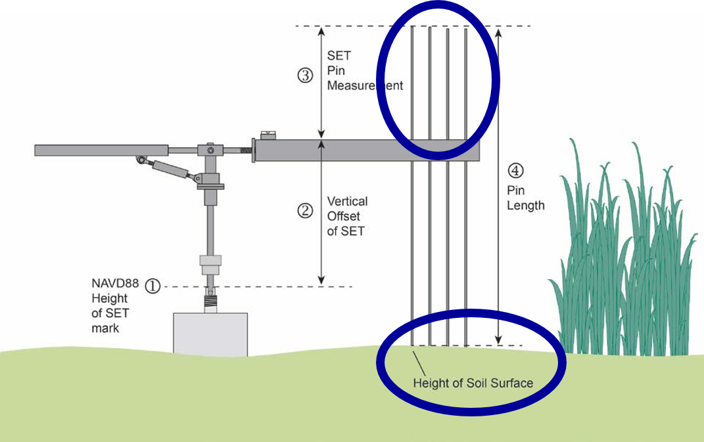

Figure 1. Example of a SET. Pin heights above the horizontal arm (A) are a proxy for the shape of the marsh surface (B) (adapted from Lynch et al. 2015).

## p.s. I know that image needs some revision

Just haven’t gotten to it yet

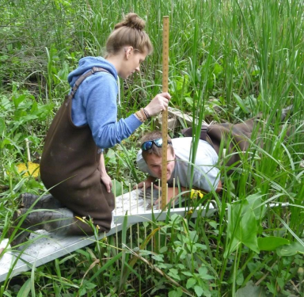

Figure 2. SET apparatus installed and observer taking measurement with meter stick atop the SET arm (photo credit Hudson River NERR).

# Background Information

Many factors such as elevation, dominant vegetation community, even the stability of the rod, have an influence on the substrate elevation observations that are obtained at a particular SET.

Pin measurements are stored in a spreadsheet that contains columns for the SET ID, date of measurement, measured height of the pin above the SET apparatus arm, and qa/qc codes (concise codes to mark common issues with a pin measurement).

A separate spreadsheet contains metadata: higher-level information about the SETs themselves, such as its exact location (latitude and longitude), the most common vegetation type around the SET, typical salinity in the nearby water body, and other general information.

Information from both spreadsheets can be pulled together to communicate about the SETs and how they are changing.

# this paragraph might get revised a bit and moved

The graphs and visualizations of the data are used to assess accuracy and quality of the entered data, compare SETs, calculate rates of change in surface elevations over time and ultimately compare to changes in local sea level. Local rate of sea level change is obtained from NOAA’s National Water Level Observation Network (NWLON) for each Reserve. This document is the output from the scripts and the following data sections will be auto populated for each Reserve’s SET and water level data.

## Reserve-level context

* Local rate of sea level change is **3.61** +/- **0.59** mm/yr.
* This rate is reported by Dauphin Island, Alabama, NWLON station number 8735180 based on data from *1966* to *2017*.

## SET-level characteristics

### Setting

# Clean up the language

The first table produced from the R scripts provides a descriptive list of SETS at this reserve. The columns from left to right provide the SET code = a unique ID for the SET, SET name = a descriptive name for the SET, Type of SET = Deep or Shallow, and the Main Veg = dominant species vegetation at the SET.

| SET_code | SET_name | Type | Main_Veg |
| --- | --- | --- | --- |
| CLMAJ-1 | Cladium 1 | Deep ROD SET | Cladium jamaicense |
| CLMAJ-2 | Cladium 2 | Deep ROD SET | Cladium jamaicense |
| CLMAJ-3 | Cladium 3 | Deep ROD SET | Cladium jamaicense |
| JURO_High-1 | High Juncus (Panne) 1 | Deep ROD SET | Juncus roemerianus |
| JURO_High-2 | High Juncus (Panne) 2 | Deep ROD SET | Juncus roemerianus |
| JURO_High-3 | High Juncus (Panne) 3 | Deep ROD SET | Juncus roemerianus |
| JURO_Mid-1 | Mid Juncus 1 | Deep ROD SET | Juncus roemerianus |
| JURO_Mid-2 | Mid Juncus 2 | Deep ROD SET | Juncus roemerianus |
| JURO_Mid-3 | Mid Juncus 3 | Deep ROD SET | Juncus roemerianus |
| JURO_Low-1 | Lower Juncus 1 | Deep ROD SET | Juncus roemerianus |
| JURO_Low-2 | Lower Juncus 2 | Deep ROD SET | Juncus roemerianus |
| JURO_Low-3 | Lower Juncus 3 | Deep ROD SET | Juncus roemerianus |
| SPALT-1 | Spartina 1 | Deep ROD SET | Spartina alterniflora |
| SPALT-2 | Spartina 2 | Deep ROD SET | Spartina alterniflora |
| SPALT-3 | Spartina 3 | Deep ROD SET | Spartina alterniflora |

### Sampling Information

The length of the observation period at a SET (how long it’s been installed) and the frequency of sampling can be useful for evaluating the data. We might be more confident in a trend from a SET that has been measured for many years than we are in one that has only been measured for a few. Table 2 below gives a summary of the SETs at this reserve: the date the SET was first sampled, the date it was most recently sampled, how many years it has been sampled, and number of sample events (SETs may be sampled more or less frequently than once per year).

| set_id | first_sampled | last_sampled | years_sampled | sample_events |
| --- | --- | --- | --- | --- |
| CLMAJ-1 | 2012-02-29 | 2016-11-21 | 4.728 | 19 |
| CLMAJ-2 | 2012-02-29 | 2016-11-21 | 4.728 | 19 |
| CLMAJ-3 | 2012-02-29 | 2016-11-21 | 4.728 | 19 |
| JURO_High-1 | 2012-02-28 | 2016-11-22 | 4.734 | 19 |
| JURO_High-2 | 2012-02-28 | 2016-11-22 | 4.734 | 19 |
| JURO_High-3 | 2012-02-28 | 2016-11-22 | 4.734 | 19 |
| JURO_Mid-1 | 2012-02-28 | 2016-11-22 | 4.734 | 19 |
| JURO_Mid-2 | 2012-02-28 | 2016-11-22 | 4.734 | 19 |
| JURO_Mid-3 | 2012-02-28 | 2016-11-22 | 4.734 | 19 |
| JURO_Low-1 | 2012-03-02 | 2016-11-23 | 4.728 | 19 |
| JURO_Low-2 | 2012-03-02 | 2016-11-23 | 4.728 | 19 |
| JURO_Low-3 | 2012-03-02 | 2016-11-23 | 4.728 | 19 |
| SPALT-1 | 2012-03-02 | 2016-11-23 | 4.728 | 19 |
| SPALT-2 | 2012-03-02 | 2016-11-23 | 4.728 | 19 |
| SPALT-3 | 2012-03-02 | 2016-11-23 | 4.728 | 19 |

# Graphs

## Change through time at each SET

### Single SET

Figure 3 is a graph of data from a single SET at this reserve. Remember how we said there are 36 measurements on each date? Those have been averaged together, so we’re looking at a single point for each date. The x-axis shows measurement date; as we move from left to right in the graph, we move through time. The y-axis shows change since the first reading (all 36 pin heights at a SET have been averaged together for each date to generate this number - otherwise there would be a lot of lines on the graphs!).

Is the marsh surface getting higher, lower, or staying the same at this SET?

# Try to automate an answer

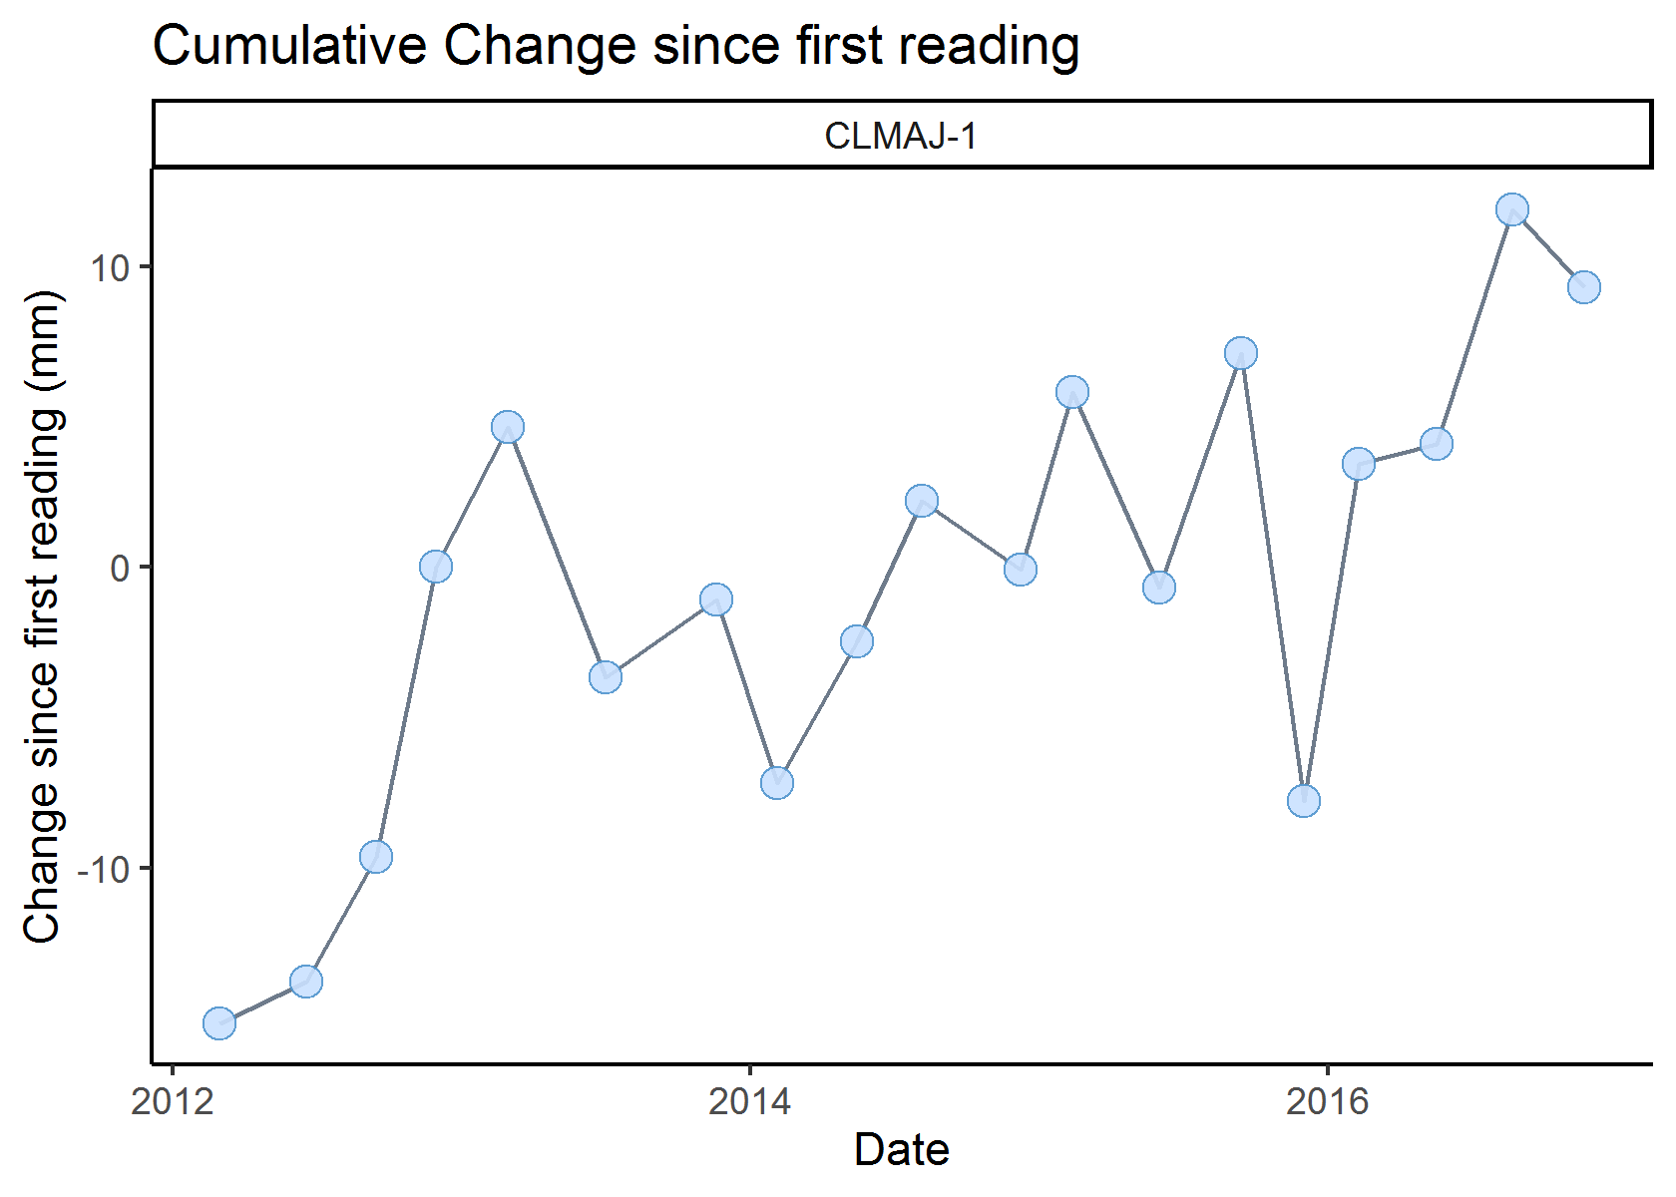

Figure 3. Average marsh height at one SET over time, as compared to the first reading.

Now, let’s add a line, from a statistical procedure called linear regression. For most SETs, a line is a useful simplification of the data. The data points bounce around a bit, but may still show that the marsh surface is changing over time. A linear regression takes all of this information and condenses it in ways that we can use to compare different sites numerically. The slope of the line, in mm/year, gives us a general idea of how quickly the surface at a SET is changing. We refer to this slope as the rate of elevation change at the SET.

# need to phrase this question better

Is a line a good way to describe change at this SET?

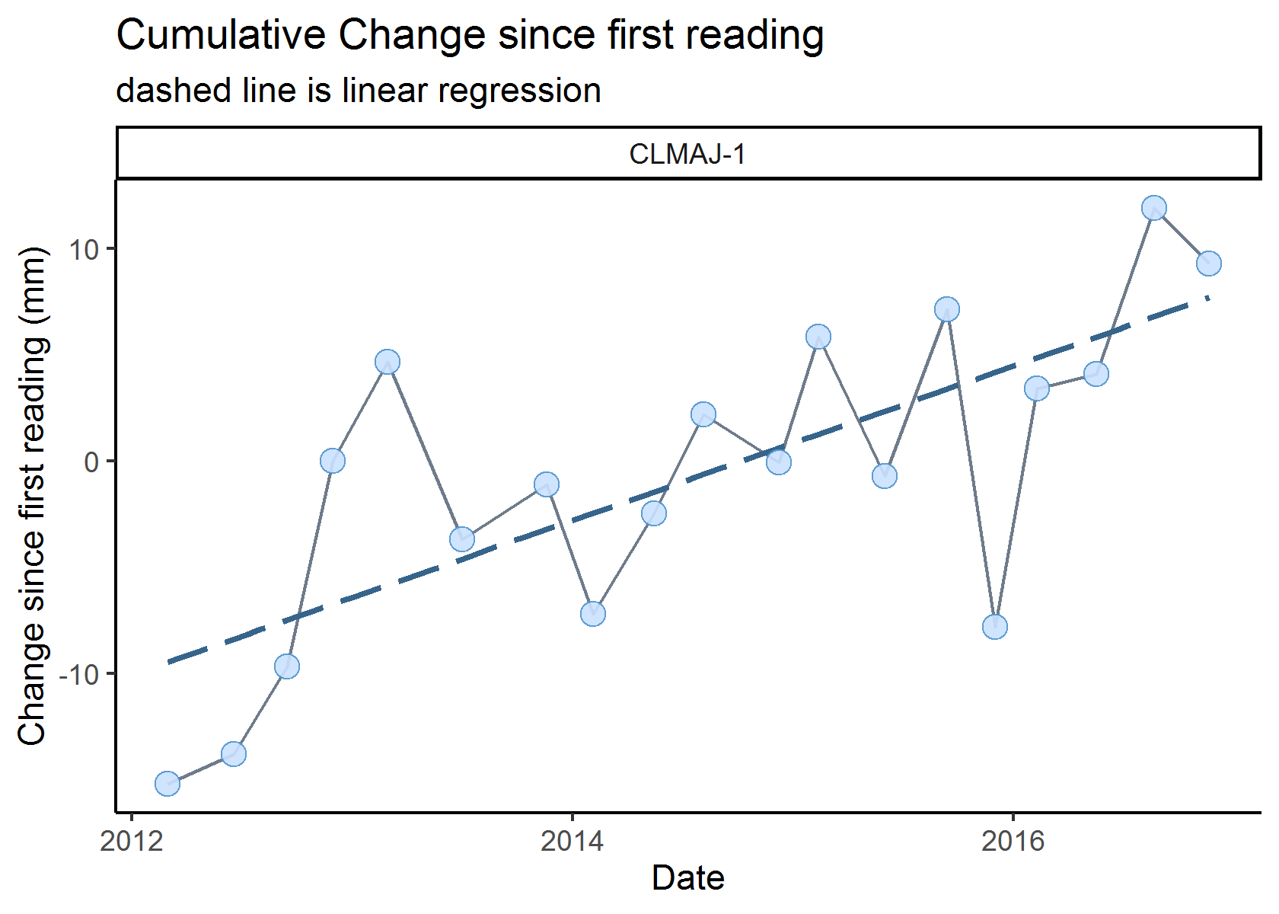

Figure 4. Average marsh height at one SET over time, as compared to the first reading, with a regression line (the dashed line) as an additional representation of that change. The slope of this line is what we refer to as the rate of change at this SET.

What we really want to know is, how does the slope of that line compare to the rate (slope) of sea level change? Is one steeper than the other? In the next graph (Figure 5), we add a red line to represent change in sea level, based on the long-term rate calculated from a nearby tide station, as described earlier.

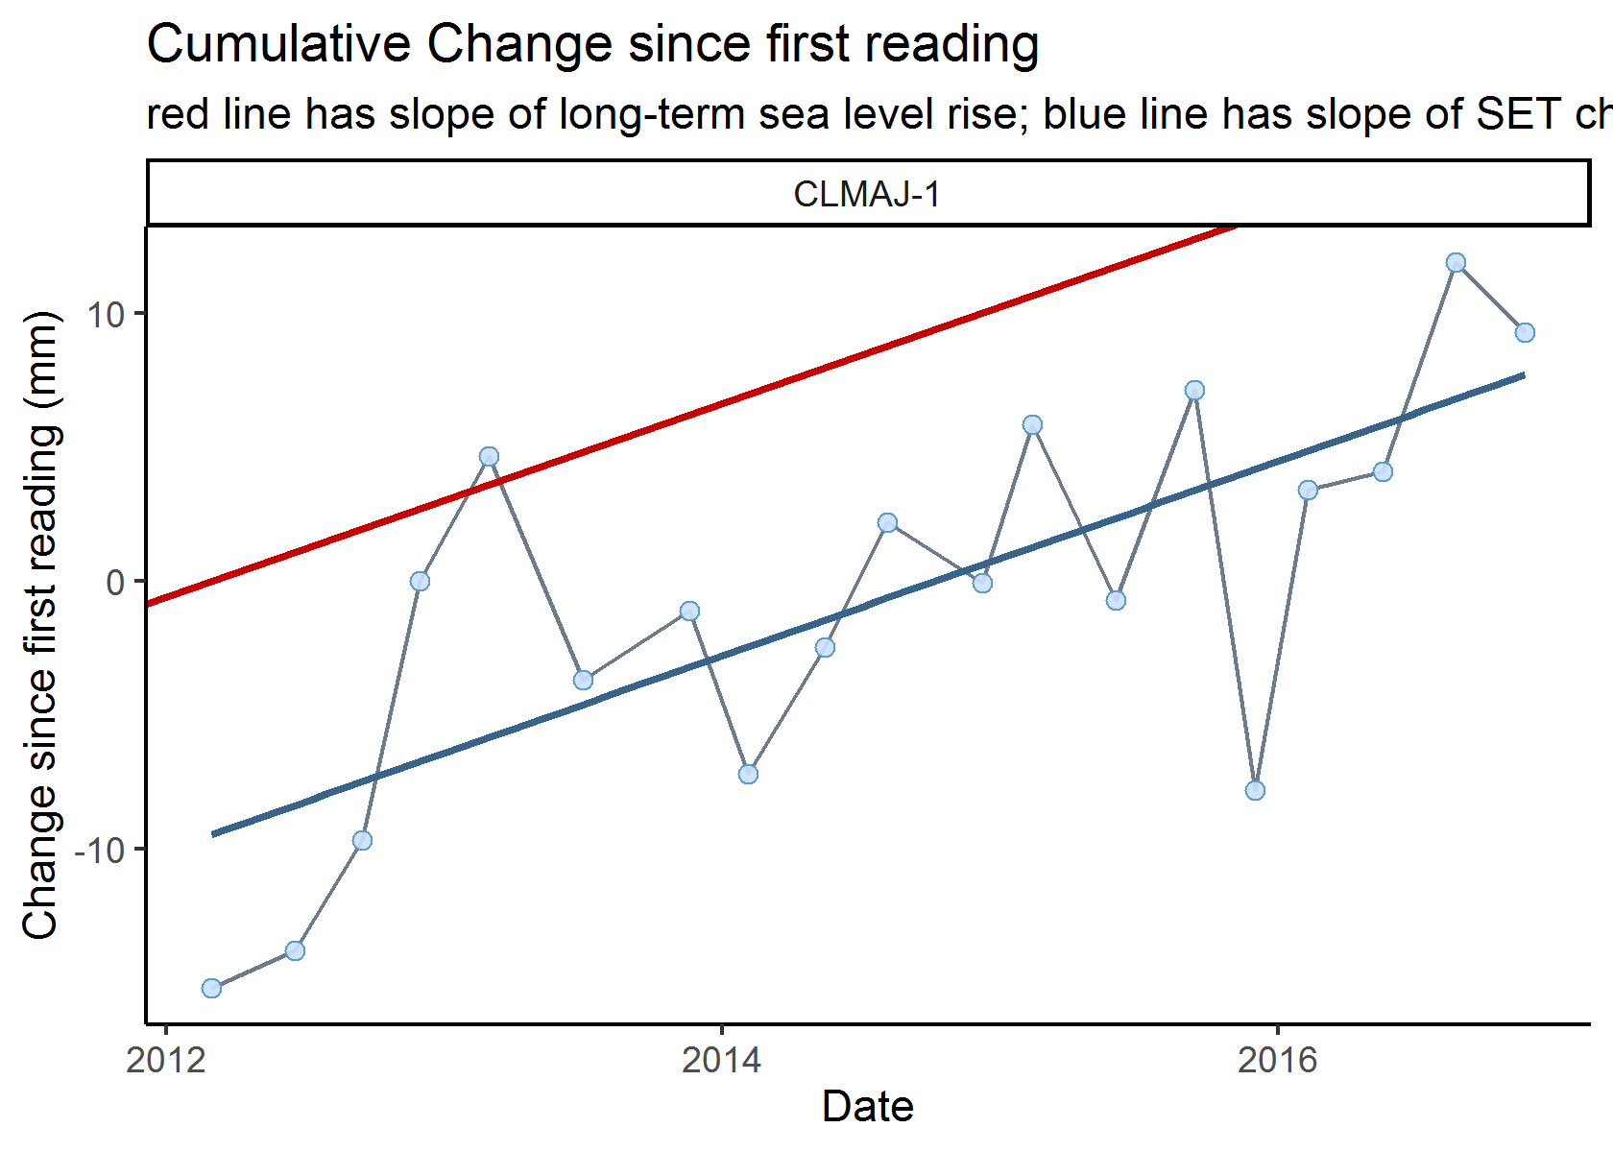

Figure 5. Average marsh surface height at one SET over time, as compared to the first reading. The solid blue line is a linear regression of the SET data, and the red line shows the rate of sea level change.

Finally, we simplify a bit by removing the points themselves, keeping only the lines (Figure 6). It will become clear why we needed to simplify when we put all the SETs from this reserve together in one graphic.

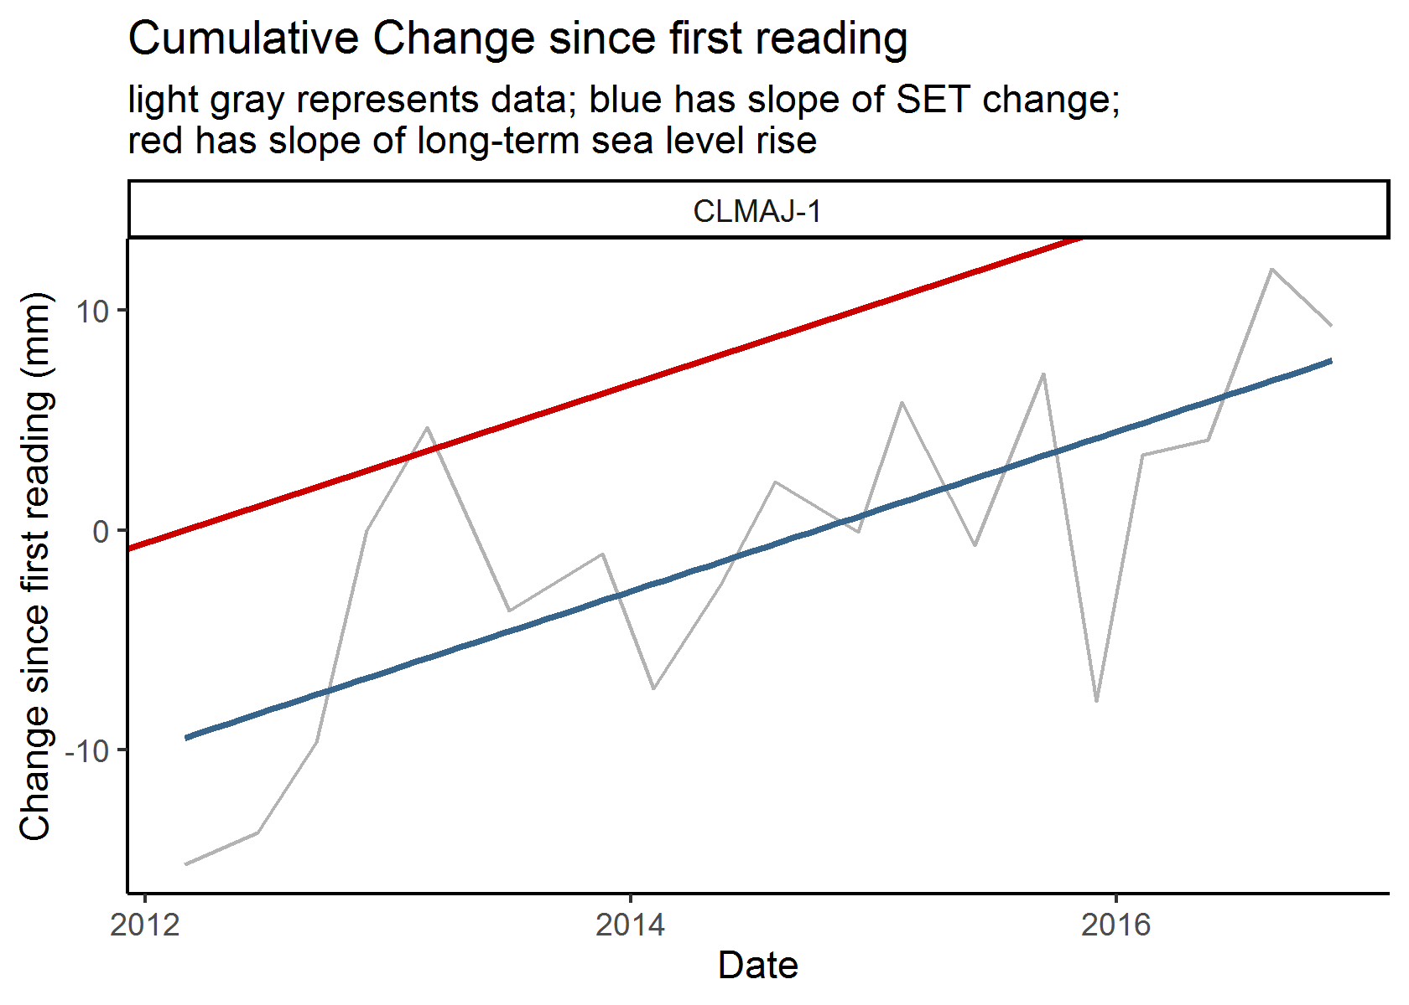

Figure 6. Average marsh surface height at one SET over time, as compared to the first reading. Gray line represents the data; the solid blue line is a linear regression of the data; the red line shows the rate of sea level change.

### All SETs at this reserve

Here is a birds-eye view of all SETs at this reserve! Does it look like SETs at this reserve are generally keeping up with sea level rise? (Are the blue lines steeper than the red lines?)

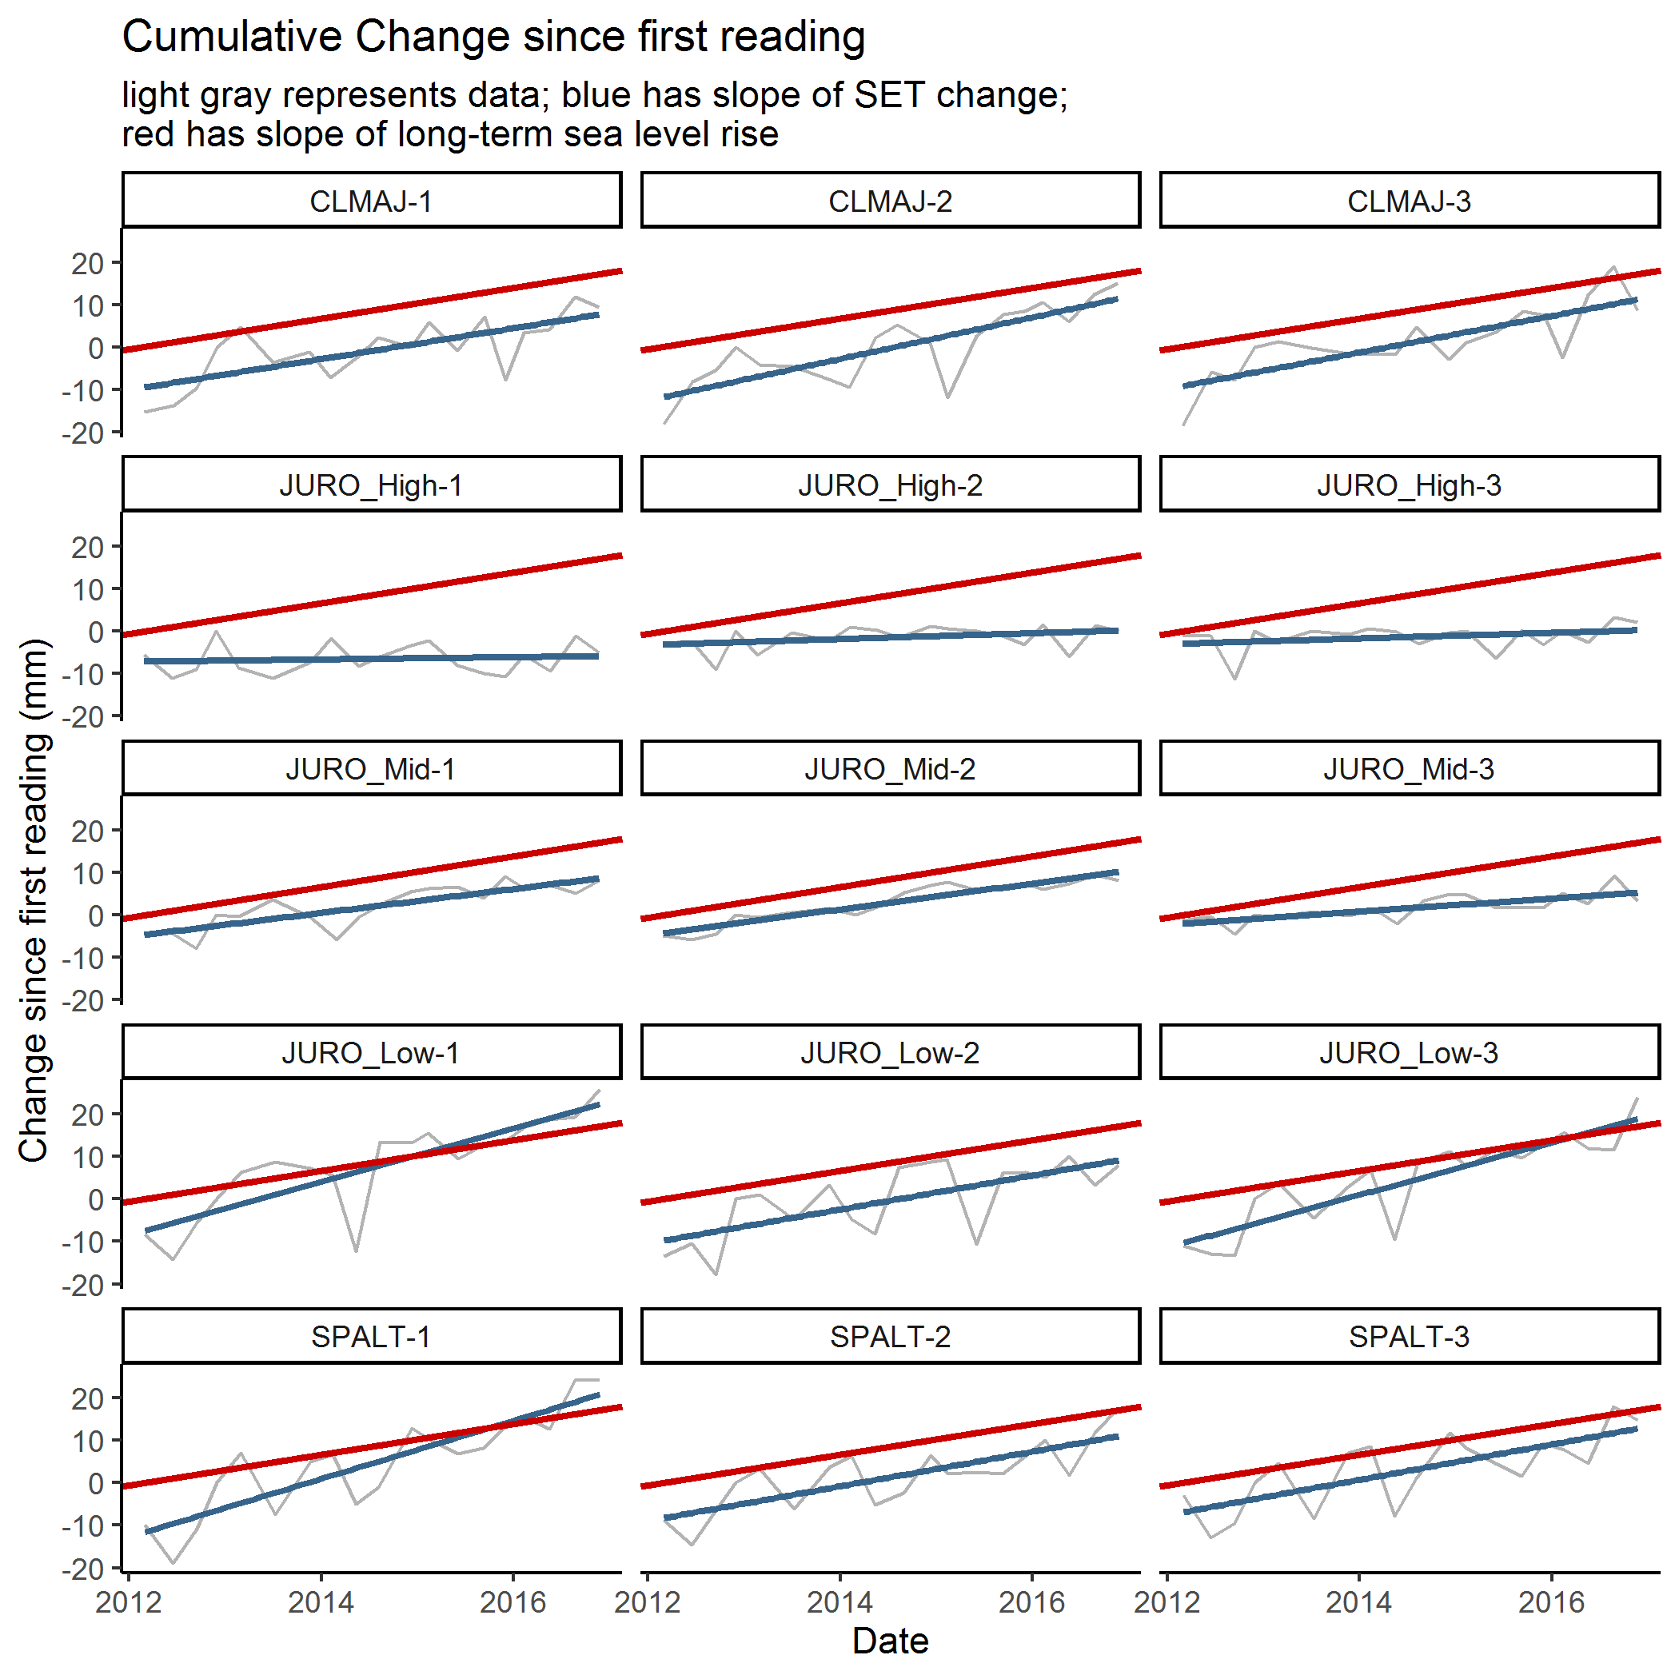

Figure 7. Average marsh surface height at each of this reserve’s SETs over time, as compared to each SET’s first reading. Each panel is one SET, with a gray line for the data, a solid blue line as a linear regression of the data, and a red line showing the rate of sea level change.

## Comparisons to 0 and SLR

In this section, we’ll look at how the rate of marsh surface change compares to 0 and to sea level change. We’ll start simple; with a gray vertical line at 0, a blue vertical line at the local rate of sea level rise (SLR), and a dot to represent the rate of change at each SET (rate of change increases from left to right on the x-axis):

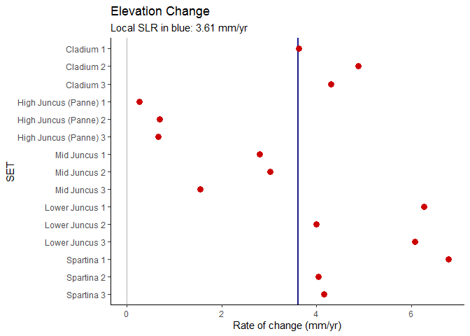

Figure 8. Summary graph of the rate of marsh surface elevation change at each SET.

# need some cleanup on confidence interval explanation

Of course, these calculated rates have some associated uncertainty. Here, we represent that with “whiskers” to show 95% confidence intervals. The wider the confidence interval is (whiskers are further apart), the less certain we are about the calculations:

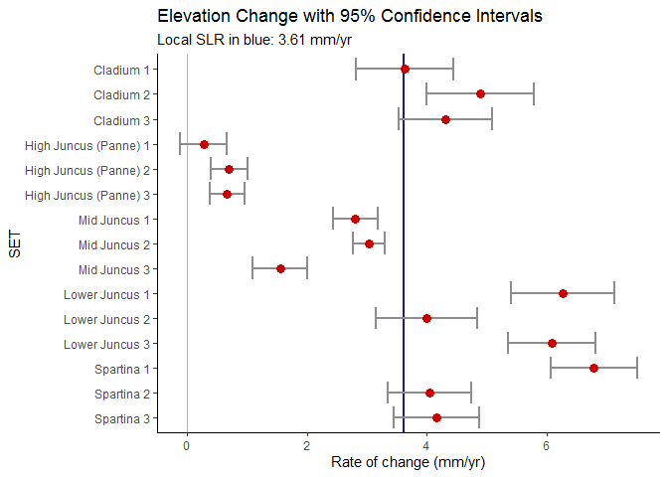

Figure 9. Summary graph of the rate of marsh surface elevation change at each SET, with whiskers to indicate 95% confidence intervals.

And: the calculated rate of sea level change ALSO has some associated uncertainty. Here, that is represented by light blue shading:

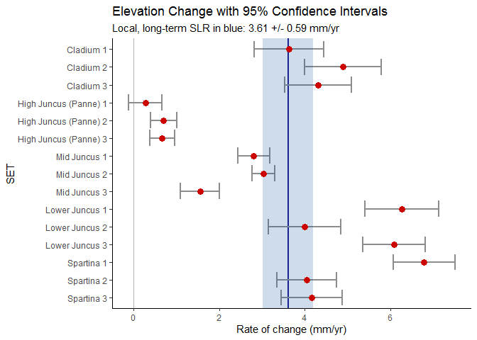

Figure 10. Summary graph of the rate of marsh surface elevation change at each SET, with whiskers to indicate 95% confidence intervals for the SETs and shading to represent a 95% confidence interval for sea level change.

Now we’ll do the same building up, with a twist. Different plant communities may show different patterns in change over time. We will represent this by coloring the points on the graph by the dominant vegetation around each SET:

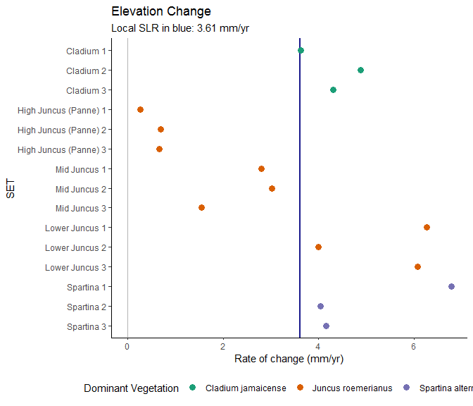

Figure 11. Summary graph of the rate of marsh surface elevation change at each SET, colored by dominant vegetation type.

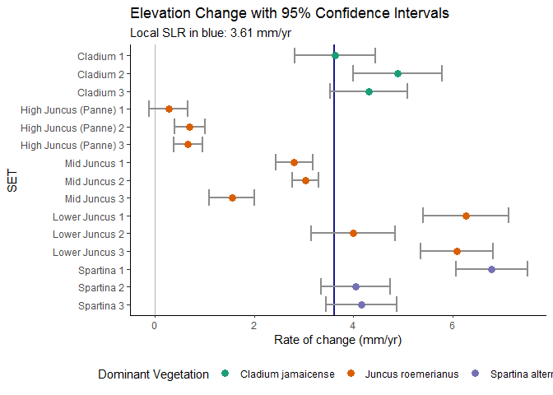

Figure 12. Summary graph of the rate of marsh surface elevation change at each SET, colored by dominant vegetation type, with whiskers to indicate 95% confidence intervals for the SETs.

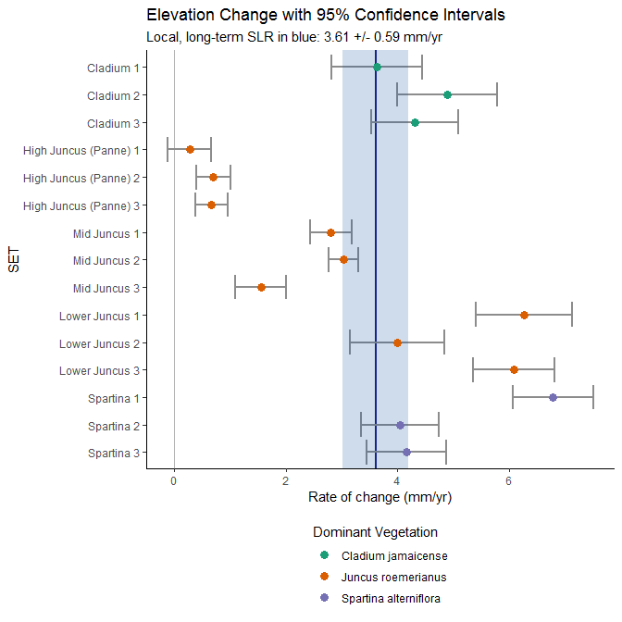

Figure 13. Summary graph of the rate of marsh surface elevation change at each SET, colored by vegetation type, with whiskers to indicate 95% confidence intervals for the SETs and shading to represent a 95% confidence interval for sea level change.

Some questions we can answer from this graph:

1. Are most of the SETs at your reserve showing trends that are greater than 0 but less than sea level change (e.g. to the left of the blue shading?)
2. Are the SETs within a similar dominant vegetation community showing similar trends to each other?
3. How do the trends between dominant vegetation communities compare to each other? Are some vegetation communities gaining or losing elevation more quickly than others?
4. What does it mean when the whiskers (confidence intervals) on the SET data overlap the variability in SLR data (blue band)?

## On a map

Here we display SET locations on a map, with color-coded arrows to represent the rate of elevation change at a SET compared to either 0 (Figure 14) or to long-term sea level change (Figure 15).

Where are the changes happening within the reserve? Do you see any spatial patterns? What could be the reasons for these, based on what you know about the landscape of your reserve?

### Compared to 0

# can an educator please make sure this explanation makes sense?

First, are the SETs generally gaining or losing elevation? We can determine this by comparing each SET’s rate of elevation change (the slope of the linear regression in the first set of graphs) to 0. Up arrows depict SETs with positive rates of change - meaning increasing elevation - and down arrows show negative rates of change - decreasing elevation. If the arrows are red or blue, this means that 0 was not inside the confidence interval for that SET, and we are confident the change at that SET is *not* 0. If the arrows are gray, we would not confidently claim a difference from 0.

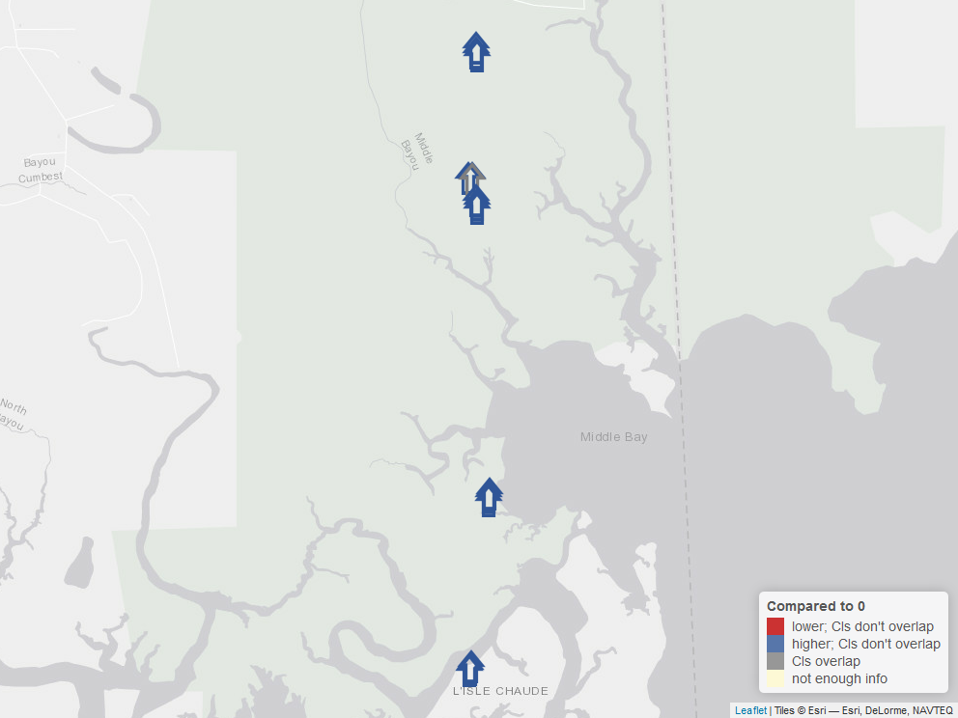

Figure 14. Map of this reserve, showing how the rate of elevation change at each SET compares to 0.

### Compared to SLR

The map below is similar to that above, but:

* An up arrow represents a SET where the rate of elevation change (represented as a point in the dot-and-whisker graphs above) is higher than the rate of sea level change (the vertical blue line from those graphs), and a down arrow represents a SET where the rate of elevation change is lower than the rate of sea level change.
* Instead of asking “is 0 inside the confidence interval for each SET”, we ask if the confidence interval for sea level change overlaps the confidence interval for a SET - do the whiskers overlap the blue shading?
  + If the confidence intervals do *not* overlap, the arrows are red or blue and we would be confident saying the SET is changing at a different rate than sea level is changing.
  + If the confidence intervals *do* overlap, the arrow is gray and we are not confident that there is a difference between the SET’s rate of elevation change and that of sea level.

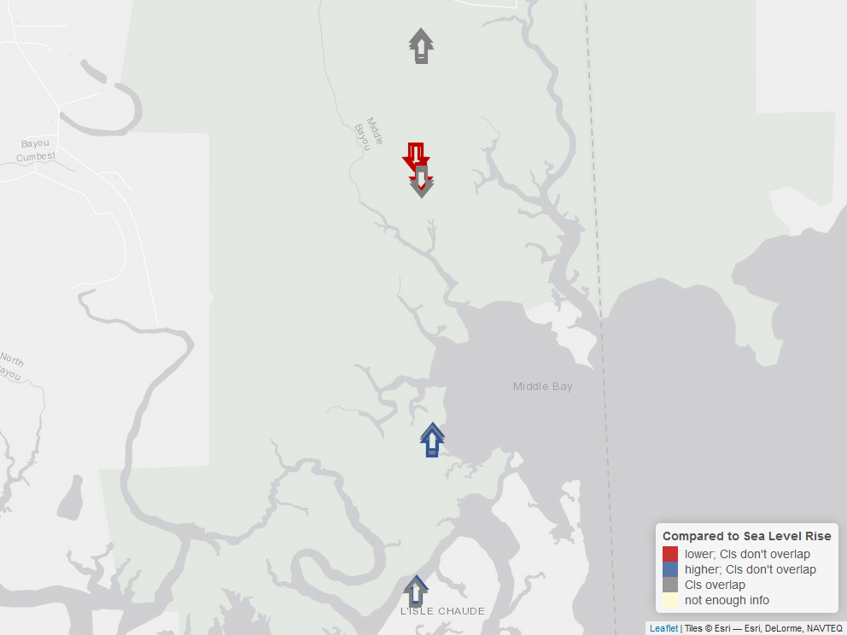

Figure 15. Map of this reserve, showing how the rate of elevation change at each SET compares to the rate of long-term sea level change.