**Activiti modeler流程设计器集成**

1、准备

下载Activiti；

2、复制相关文件到工程中

2.1首先复制类路径资源文件

复制以下文件到src或者classpath 根目录下：

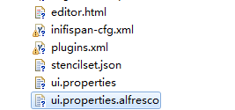

2.2复制ui文件到你的WebRoot文件夹中

在WebRoot下新建文件夹modeler，并把ui资源复制到其目录下：

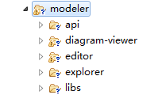

2.3 复制关键jar包到工程中

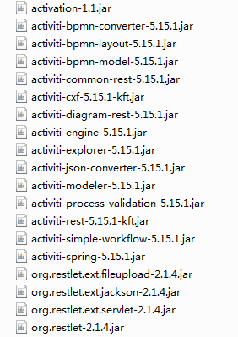

3、对工程进行配置

3.1 Activiti与Spring集成

配置如图所示

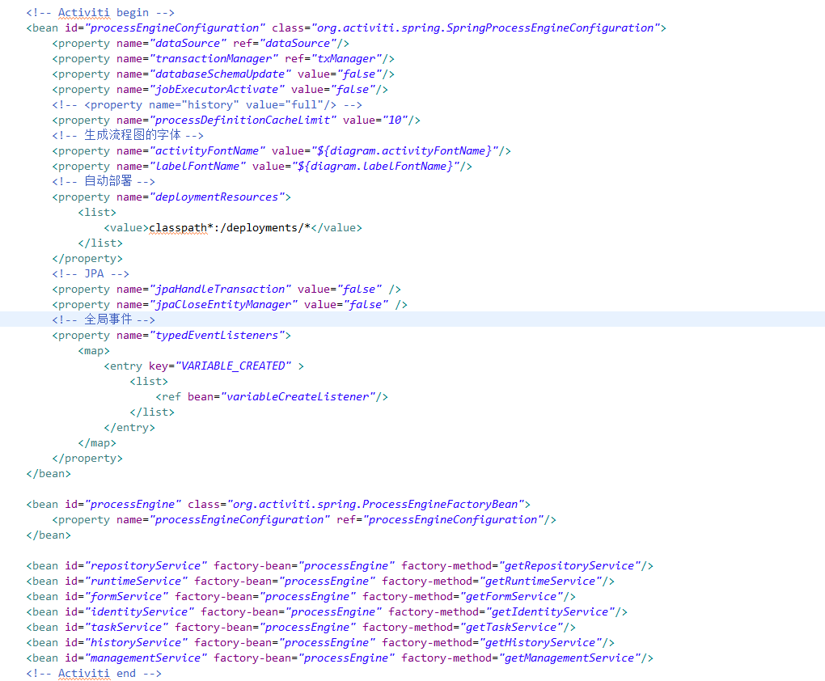

3.2 进行router配置

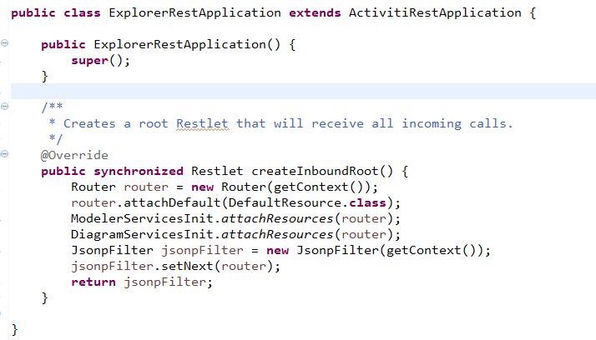

3.3进行web.xml配置

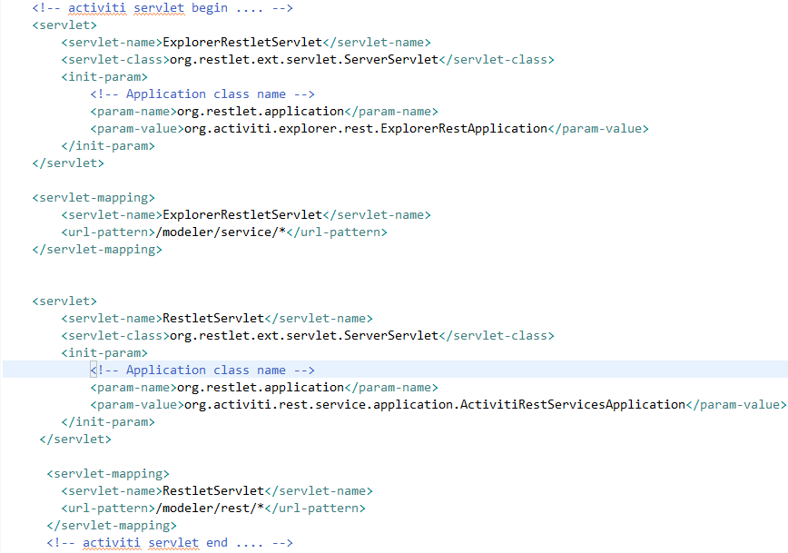

3.4 进行ui配置

修改WebRoot/modeler/diagram-viewer/index.html文件：

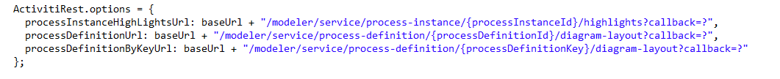

4、集成中错误处理

如下图黑框所标：



4.1 如果黑框中显示500错误，并且控制台打印：no router define，注意路由是否配置正确；

4.2 如果黑框中显示204错误，注意复制资源类文件是否放在classpath目录下；

5、查看是否配置正确

5.1 查看model

http://localhost:8080/platformncloud/modeler/service/editor?id=912

5.2 访问api

http://localhost:8080/platformncloud/workflow/demo/process-list.do

附1 Activiti与Spring集成代码

<!-- Activiti begin -->

<bean id=*"processEngineConfiguration"* class=*"org.activiti.spring.SpringProcessEngineConfiguration"*>

<property name=*"dataSource"* ref=*"dataSource"*/>

<property name=*"transactionManager"* ref=*"txManager"*/>

<property name=*"databaseSchemaUpdate"* value=*"false"*/>

<property name=*"jobExecutorActivate"* value=*"false"*/>

<!-- <property name="history" value="full"/> -->

<property name=*"processDefinitionCacheLimit"* value=*"10"*/>

<!-- 生成流程图的字体 -->

<property name=*"activityFontName"* value=*"${diagram.activityFontName}"*/>

<property name=*"labelFontName"* value=*"${diagram.labelFontName}"*/>

<!-- 自动部署 -->

<property name=*"deploymentResources"*>

<list>

<value>classpath*:/deployments/*</value>

</list>

</property>

<!-- JPA -->

<property name=*"jpaHandleTransaction"* value=*"false"* />

<property name=*"jpaCloseEntityManager"* value=*"false"* />

<!-- 全局事件 -->

<property name=*"typedEventListeners"*>

<map>

<entry key=*"VARIABLE_CREATED"* >

<list>

<ref bean=*"variableCreateListener"*/>

</list>

</entry>

</map>

</property>

</bean>

<bean id=*"processEngine"* class=*"org.activiti.spring.ProcessEngineFactoryBean"*>

<property name=*"processEngineConfiguration"* ref=*"processEngineConfiguration"*/>

</bean>

<bean id=*"repositoryService"* factory-bean=*"processEngine"* factory-method=*"getRepositoryService"*/>

<bean id=*"runtimeService"* factory-bean=*"processEngine"* factory-method=*"getRuntimeService"*/>

<bean id=*"formService"* factory-bean=*"processEngine"* factory-method=*"getFormService"*/>

<bean id=*"identityService"* factory-bean=*"processEngine"* factory-method=*"getIdentityService"*/>

<bean id=*"taskService"* factory-bean=*"processEngine"* factory-method=*"getTaskService"*/>

<bean id=*"historyService"* factory-bean=*"processEngine"* factory-method=*"getHistoryService"*/>

<bean id=*"managementService"* factory-bean=*"processEngine"* factory-method=*"getManagementService"*/>

<!-- Activiti end -->

附2 ExplorerRestApplication实现代码：

**import** org.activiti.rest.common.api.DefaultResource;

**import** org.activiti.rest.common.application.ActivitiRestApplication;

**import** org.activiti.rest.common.filter.JsonpFilter;

**import** org.activiti.rest.diagram.application.DiagramServicesInit;

**import** org.activiti.rest.editor.application.ModelerServicesInit;

**import** org.restlet.Restlet;

**import** org.restlet.routing.Router;

**public** **class** ExplorerRestApplication **extends** ActivitiRestApplication {

**public** ExplorerRestApplication() {

**super**();

}

/**

* Creates a root Restlet that will receive all incoming calls.

*/

@Override

**public** **synchronized** Restlet createInboundRoot() {

Router router = **new** Router(getContext());

router.attachDefault(DefaultResource.**class**);

ModelerServicesInit.*attachResources*(router);

DiagramServicesInit.*attachResources*(router);

JsonpFilter jsonpFilter = **new** JsonpFilter(getContext());

jsonpFilter.setNext(router);

**return** jsonpFilter;

}

}

附3 web.xml配置部分代码：

<!-- activiti servlet begin .... -->

<servlet>

<servlet-name>ExplorerRestletServlet</servlet-name>

<servlet-class>org.restlet.ext.servlet.ServerServlet</servlet-class>

<init-param>

<!-- Application class name -->

<param-name>org.restlet.application</param-name>

<param-value>org.activiti.explorer.rest.ExplorerRestApplication</param-value>

</init-param>

</servlet>

<servlet-mapping>

<servlet-name>ExplorerRestletServlet</servlet-name>

<url-pattern>/modeler/service/*</url-pattern>

</servlet-mapping>

<servlet>

<servlet-name>RestletServlet</servlet-name>

<servlet-class>org.restlet.ext.servlet.ServerServlet</servlet-class>

<init-param>

<!-- Application class name -->

<param-name>org.restlet.application</param-name>

<param-value>org.activiti.rest.service.application.ActivitiRestServicesApplication</param-value>

</init-param>

</servlet>

<servlet-mapping>

<servlet-name>RestletServlet</servlet-name>

<url-pattern>/modeler/rest/*</url-pattern>

</servlet-mapping>

<!-- activiti servlet end .... -->