Amazon Announces New Material Handling Equipment (MHE) Vertical
Amazon’s new division consolidates MHE value chain, empowers network evolution and enhances customer experience.
SEATTLE, WA - (INSIDE AMAZON) - July 5, 2026 - Amazon WW Operations will now benefit from internally developed and managed MHE solutions that scale and evolve with the needs of the network, enabling consistent performance and enhanced customer experience. The new division, One-MHE, establishes Amazon’s agency across the entire MHE value chain by bringing the high-value components in-house and disintermediating the rest through direct-sourcing and strategic partnerships. One-MHE delivers standardized MHE systems, diversifies Amazon’s MHE vendor base, compresses timelines, improves throughput, increases reliability, and reduces system lifetime costs.
MHE accounts for up to 50% ($200MM for ARS FC) of Amazon’s building startup expenditures and is critical to enabling optimized product flow in the network. In the 2020-2023 timeframe, Amazon spent $18B on MHE, including design, engineering, equipment, installation and integration, repairs and maintenance. During this time, Amazon grew increasingly dependent on the handful of qualified, vertically integrated Tier-1 vendors that struggled to reliably meet the needs of the network at scale. Their schedules and long lead times often required Amazon to lock-in building design up to two years in advance, hindering Amazon’s ability to move fast and innovate as the subsequent design iterations came at a cost of change-order related delays and markups. With little control over the equipment selection process, Amazon often ended up with suboptimal systems, high variability across the network as well as integration and maintenance challenges. Post deployment, Amazon saw ramp-up delays, quality and availability issues, with limited accountability from the vendors. Admittedly, Amazon’s internal mechanisms also contributed to these issues, including a lack of standardization that enabled the proliferation of bespoke and complex MHE systems, persistent design adjustments during execution, POR volatility, slow new vendor onboarding processes as well as suboptimal building management practices, impacting performance and maintenance.
One-MHE consolidates Amazon’s MHE strategy under a hybrid own/outsource model that establishes direct ownership across the high-value segments of the MHE value chain (design, firm engineering, controls) and forges strategic partnerships for the more commoditized components (parts and equipment sourcing, installation and integration labor, repair and maintenance). The MHE systems are now built upon a catalog of standardized sub-systems, designed and controlled by Amazon. With investment in specialized in-house capabilities for electrical, mechanical, and controls engineering, Amazon now has agency over the complete MHE system design. In a concerted effort, Amazon developed strategic partnerships with the equipment and component suppliers, thus, circumventing the vertically integrated vendors, and direct-sourcing, pre-ordering, co-developing and contract manufacturing products foundational for Amazon’s MHE sub-systems. Recognizing the importance of owning the ‘brains’ of the MHE systems, Amazon developed a common controls architecture that is vendor agnostic, enabling seamless access, integration and adjustment of PLC system logic. As the result of design standardization and controls ownership, Amazon is now delivering more generalizable systems across the network, alleviating integration and maintenance challenges. While continuing to outsource the bulk of the site integration and installation labor through strategic partnerships with integrators and OEMs, Amazon’s new in-house integration supervision team oversees the process end-to-end and enforces best practices. This configuration allows Amazon to seamlessly scale the MHE deployment labor capacity to match its POR fluctuations. These new capabilities, along with the decoupling of the equipment sourcing and design from integration services, expanded Amazon’s pool of qualified vendors, while supporting more competitive OEM and aftermarket pricing. With in-house MHE expertise and performance accountability, One-MHE accelerated the launch and ramp-up of Amazon’s buildings with more reliable equipment, while improving the maintenance practices.
“For years our MHE strategy was tethered to a handful of Tier-1 vendors that were not able to fully meet our needs at scale. The establishment of a dedicated MHE vertical in-house, One-MHE, increased our design velocity, spurred more generalizable MHE systems and enabled more seamless install and integration. We now have the flexibility we need to grow and iterate on our network while delighting our WW Operations customers with more reliable, performance-optimized systems.” Bill Bowes, VP of Amazon World Wide Design Engineering (WWDE).
Under One-MHE, the number of MHE sub-systems designed and owned by Amazon increased from zero in 2024 to 30+ with 90% of all MHE systems now built from the internally designed, standardized building blocks. The proportion of sub-systems accessible to be controlled by Amazon code is nearing 100%, up from 10% in 2024. The number of qualified integrators in Amazon’s approved vendor list is up from 5 to 10 and the overall qualified vendor pool has expanded from 20 and 50+ including component suppliers. At the same time, Amazon reduced the overall concept-to-full-ramp timelines for new buildings by up to one year. MHE concept-to-launch lead times are down by 25%, from 12-24 months to 9-18 months, and the full ramp-up period compressed by 50%, from 12 to 6 months, accelerating Amazon’s ability to meet the needs of the network. MHE related downtimes decreased by 50% during ramp-up and at full scale. Finally, Amazon’s MHE systems’ total cost of ownership is down 15%-30% across the network, driven by the reduction in total capex through standardization and direct sourcing, as well as lower maintenance and aftermarket costs.
“Six months post-launch with One-MHE, our MHE system is performing well, operating at a consistent 99%+ availability. Not only is it more intuitive to operate and maintain, but we also know who to call when we have questions or if something breaks down, so we can get it fixed quickly.” Jane Smith, General Manager, XYZ1.
To learn more about Amazon’s One-MHE initiative, its structure, mission, tenets and the MHE solution offering, as well as to engage directly with One-MHE team members for your existing or future MHE needs, go to [Wiki Link].
FAQs
FAQ1. What decisions and guidance do we need today?
- One-MHE Configuration: We are seeking to align on the parts of the value chain that are critical for us to own in-house vs. those that we can continue to outsource either directly or through strategic partnerships (FAQ2).
- Optimal Path to One-MHE: Based on our vision for the composition of One-MHE vertical, we need to align on our path to get there. For example, we may decide to build everything in-house or build some components, and acquire a Tier-2 integrator. Similarly, for our controls’ strategy, we might need to acquire a controls house and/or a development platform, where we would have significant dependencies if we bring the controls capabilities in-house (FAQ3).
FAQ2. What makes up this new MHE Vertical? What do we own, outsource and where do we develop strategic partnerships?
Within the MHE lifecycle (Table 1), it is critical for Amazon to consolidate and own Concept Design, Firm Engineering and Controls Engineering in order to enable system standardization and optimized design, giving us the capability to select our own equipment to best meet our needs, while supporting more seamless integration. When it comes to components and equipment procurement, we recommend going the 3P route with a mix of: 1) direct sourcing for commodity components, expanding the strategy already implemented by GPO; 2) contract manufacturing for standardized building blocks that connect our systems (e.g. conveyance, PLCs), a strategy being developed by NASC and 3) strategic partnerships /co-development of the more customized equipment. We believe that it would be impractical to in-house installation and integration labor, but we should establish an advanced integration supervisory team, consisting of electrical, mechanical and controls integration engineers and project managers, to oversee the process, develop Amazon specific commissioning requirements and standards, supervise 3P integration and institute best practices. In addition, we recommend bringing more RME capabilities in-house in NA, supported by the internalized MHE engineering expertise. For example, we could establish a dedicated RME supervisory team that is intimately familiar with our buildings, MHE system design, the catalog of sub-systems and components for the aftermarket needs and best practices for controls logic updates that will train and oversee the maintenance and repair work conducted by the 3P field RMEs. We already fully in-house RME in EU.
Table 1: Typical Large Building MHE Value Chain: Current State and Future State (See Appendix A for a more granular breakout)
FAQ3. How will we bring this One-MHE vision to life?
The most practical and efficient pathway that we considered involves a mix of internal development, strategic partnerships with external vendors and some outsourcing. Below, we discuss how Amazon’s Organizations would contribute to One-MHE vision, independent of how we decide to structure the new MHE vertical. We discuss One-MHE organizational structure options in FAQ5.
Concept Design (build in-house): For advanced Concept Design, we would lean on WWDE to develop a catalog of standardized sub-systems and products/components to be used in all of our MHE systems’ design. This would allow us to fully own equipment-specific Concept Design (1P) and subsequently diversify our sourcing options. While we will leverage the expanded internal design and firm engineering capabilities (below), depending on the program count, we may need to hire more talent to execute this vision.
Firm Engineering (build in-house): To support Firm Engineering and advanced design, we would need to hire MHE talent across the mechanical, electrical and controls engineering fields as well as build strategic partnerships with component providers in our catalog (developed by WWDE and GPO), that will include co-development opportunities for products to be used in our designs. We may leverage any available capacity at MSP Hamme that has significant design and firm engineering expertise to augment our efforts.
Parts/Equipment Sourcing (outsource/partner): We expect to continue sourcing equipment and parts externally. GPO will expand its direct-sourcing strategies that have shown the potential to reduce component costs by 10-15% or/and consider contract manufacturing for standardized conveyance. For more complex equipment, we may continue working with Tier-1 integrators, while developing strategic partnerships with Tier-2 integrators to support their advancement and expand our pool of suppliers.
Integration (outsource but supervise): For our integration needs, we will continue to outsource the bulk of the labor to allow us to flex our capacity with the POR. However, we will institute and enforce Amazon-specific commissioning standards by owning the integration supervision capability, built with externally hired integration talent and supported by our new in-house MHE expertise.
Controls (build in-house/partner): A cross-functional Controls team (GES, FTR and AWS) would need to be established to build a common controls architecture, standardizing the code building blocks and dictating the logic to be used across all of our MHE equipment (starting with advanced design at the Firm Engineering stage). To accelerate these efforts, we would need to establish strategic partnerships with controls houses and soft-PLC /development platform providers. This is also an area where we could consider making an acquisition. We could dictate the logic but outsource code development for more complex systems (e.g. to Alliant) or/and build a library of controls code to be used in all of the PLCs. (see Appendix B for more on our controls architecture).
Performance Management (outsource but supervise): While continuing to outsource the bulk NA RME labor, we will establish an advanced supervisory function for NA field RMEs in-house, to support and train our on-site 3P RMEs, to engage the mechanical, electrical or controls SMEs and to access our equipment suppliers for trouble-shooting (24/7). EU RMEs are already Blue Badge.
M&A: To supplement and accelerate our efforts above, we may consider one or several acquisitions in this space including a controls house (e.g. Alliant), a conveyance manufacturer (e.g. Hytrol) and/or a Tier-2 Integrator (e.g. TREW) with strong design, controls and firm engineering and some in-house equipment manufacturing capabilities. In a parallel effort with the Business and Corporate Development teams, we recently conducted due diligence on six Tier-2 integrators and six Controls companies with a separate WP to be presented specifically on MHE acquisition opportunities. The top companies that emerged in the process would contribute to all aspects of the MHE value chain but would need to be vetted carefully to gain further insights into the depth of their talent pool, product and service quality, the value of their offering vs. peers, capacity to scale to meet our needs over time as well as fit and path to successful integration, a significant challenge particularly if we decide to do more than one deal in this space.
Table 2: Scenarios for Implementing One-MHE Strategy

FAQ4. Where in our network should we deploy One-MHE first?
At inception, One-MHE will not provide a one-for-one replacement of the Tier-1 integrators’ capabilities and would not be ready to deploy at our ARS and IXD sites. We recommend that One-MHE develops and deploys its first MHE systems within the low-to-medium complexity sites (e.g. SSD, SC), working its way up to ARS and IXD over a two-to-three year period. To do this, we would consider incepting One-MHE within the fast-growing SSD network, where our preferred Tier-2 integrators and controls houses already have experience of working with Amazon (e.g. TREW and Alliant). This targeted approach would allow us to train, test and hone One-MHE capabilities, while gradually expanding its scope. Similarly, we could target medium-complexity SCs, where we are already advancing standardized design (e.g. High Intensity Process Path to Outbound sites) that aligns with our One-MHE strategy. When going down this path, we would also need to consider if we want to tackle Greenfield or Brownfield sites first, shaping One-MHE development roadmap to best meet the future needs of our entire network. The bottom line is that we need start small and establish our footing within a single vertical. This would allow us to uncover and fix One-MHE gaps and defects early, tactically augment its capabilities, all while de-risking the strategy without making big waves in the broader MHE space (see risks in FAQ7).
FAQ5. What organizational structure would be optimal to support the One-MHE vision?
We see two possible options. First, One-MHE would be a stand-alone organization, under one VP, overseeing dedicated teams for
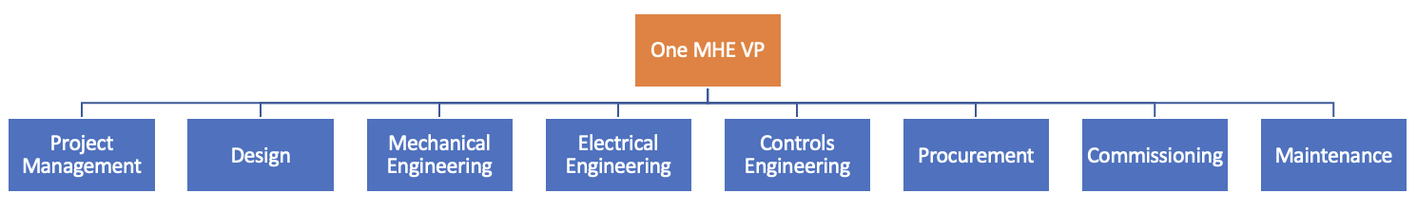
each MHE competency: Design (Sub-systems, Specifications and Advanced Design), Mechanical Engineering, Electrical Engineering, Controls, Procurement (in partnership with GPO), Commissioning (Integration Supervision) and Maintenance/Repairs (RME supervision for NA), with a strong Project Management team driving execution end-to-end (Figure 1). The main benefit of this structure is in the single-threaded ownership. The disadvantage is the parallelism between some of our existing capabilities and those being stood up under One-MHE.
Figure 1: One-MHE as a Stand-Alone Organization
Figure 2: One-MHE as a Cross-Functional Partnership
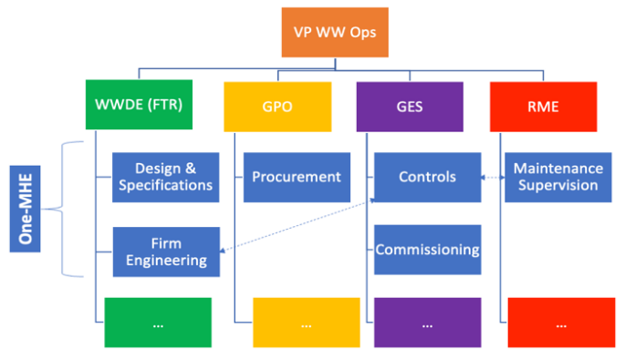
Alternatively, One-MHE could function as a cross-functional partnership across WWDE (FTR), GES, GPO and RME, where each organization owns a subset of deliverables, similar to what we do today but with the benefit of enhanced capabilities from One-MHE components as described in FAQ2 (Figure 2). The key advantage of this structure is that some of the required infrastructure is already in place within each organization and will readily absorb new components of the One-MHE strategy. The disadvantage is the lack of a single-threaded ownership and competing priorities within each organization as well as overlapping needs and capabilities (e.g. controls engineering needed within FTR, GES and RME).
FAQ6. How will we track performance / measure One-MHE success?
We will track One-MHE success across its five fundamental pillars: 1) standardization, 2) supply chain diversification, 3) speed and flexibility, 4) reliability and performance and 5) total cost of ownership/lifecycle costs.
Standardization: WWDE will develop a standard sub-system catalog, including packages for Inbound and Outbound Sortation, along with recommended components/products that will serve as building blocks for our in-house full system design. We will measure our success here by the number of complete sub-systems/packages developed and utilized, as well as the proportion of the MHE systems built upon our catalog (goal = 90%). Controls is another critical component of standardization and we will measure our ownership of the controls logic (and potentially code) by the proportion of the sub-systems accessible to be controlled by Amazon code (goal = 100%).
Diversification: Over the past four years nearly 2/3rd of our MHE capex was spent with just three Tier-1 integrators (Appendix C). In 2024, we are expanding our list of qualified integrators from two to 5-7 in our approved vendor list. We will measure the success of our strategy by the number of qualified integrators (goal =10) and the expansion of our overall qualified vendor pool including component suppliers (goal = 50+).
Speed & Flexibility: Currently, we lock in our MHE design 1-2 years ahead of installation (Appendix E). By in-housing full system design with increased standardization, firm engineering and controls, we anticipate to shrink our design-to-commissioning timelines by up to six months. After first receive, it typically takes our new ARS buildings up to 12 months to ramp up to sustainable full capacity/legacy rates. With standardized design and agency over controls, we anticipate to achieve reliable MHE equipment performance within the first six month post launch, cutting down the ramp up time in half. Combined, we anticipate reducing our concept-to-full-ramp timelines by up to 12 months.
Reliability & Performance: The MHE related (SEV1 and SEV2) downtimes account for up to 4% of total ARS labor hours as the building ramps from launch and up to 2% at steady state. We anticipate that our One-MHE strategy will produce MHE systems that are optimized to our needs and perform better. The ownership of the controls logic would allow us to more easily adjust and modify the systems when issues arise. Increased in-house MHE expertise and the new RME supervisory layer are expected to enhance our operating and maintenance practices as well as accelerate trouble-shooting and repairs, also aided by the inventory of spare parts on hand. Our goal is to reduce our MHE related downtimes by 50%, both during ramp-up and at full scale. Outside of SEV1/SEV2s, our buildings are reporting persistent MHE issues that are causing additional performance/throughput degradation. One-MHE will develop new mechanisms to better track MHE-related throughput detractors, with a stretch goal of cutting their impact in half.
Figure 4: MHE Cost Components
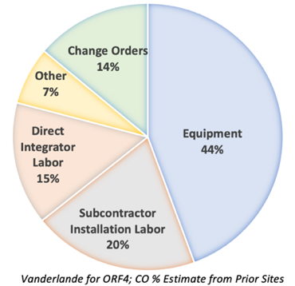
System Costs: The three largest components of our total MHE system cost for a large ARS building are Equipment (40-50%), Installation (15-20%) and Integration Labor (10-20%). Through direct sourcing and partnerships (e.g. contract manufacturing), we anticipate being able to drive down base equipment costs by 10-15% (validated by the recent GPO efforts in hybrid-sourcing). In addition, this strategy will help us remove the extra equipment markup applied by the Tier-1 integrators that will drive an additional 5-12% reduction, for a total equipment cost reduction of 15%-27% (6%-14% in total system cost impact). When it comes to installation labor, working with equipment vendors directly, we anticipate up to 30% savings by removing the hefty markup currently applied by our Tier-1 integrators (4%-6% in total system cost savings). Leaning on the Tier-2 integrators for integration labor, we anticipate more muted savings (<5%) as they would expect to be within a reasonable range of the established margins in the MHE space. In addition, with standardized system design and increased flexibility through controls ownership and short MHE design-to-install cycles, we anticipate to cut our Change Orders (14% of total) by 30%-50%, (4%-7% in total system cost). Our goal is to generate 20% in overall system cost savings with a stretch goal of 30% (if we end up acquiring a Tier 2 integrator or OEM). In addition to upfront system capex costs, there are also repair and maintenance costs that are added to the total cost of ownership over the life of the system. Our RME related MHE costs (aftermarket) are estimated at 2+% of upfront capex annually. We anticipate to be able to reduce these costs by up to 20% overtime by keeping standardized, spare parts on hand while working with a more diversified vendor base, where we have established strategic partnerships, and instituting maintenance best practices and oversight with more intuitive controls and system design.
FAQ7. What are the major risks associated with bringing MHE capabilities in-house?
Less than Sum-of-the-Parts: The fundamental risk for our One-MHE strategy is that we end up with a disconnected assortment of second tier capabilities, that combined yield a result that is worse than our current experience. Our Tier-1 vendors have decades of MHE experience, benefit from the convenience of in-house OEM, a wide network of tested products, relationships and strategic partnerships across the industry, a deep talent pool of mechanical, electric and controls engineers that will be very challenging to replicate at the same level and will certainly take a long time, even if we buy rather than build from scratch. Hence, we caution that no matter what approach we end up pursuing to get to One-MHE vision, we should start small, either by owning the MHE only for one, simpler building type (e.g. SSD) or one specific process path (e.g. Inbound) rather than trying to make a big splash before we have fully tested our new capabilities, identified and de-risked the shortfalls.
Talent: To do this successfully, we would need to attract top tier talent from internal organizations and external companies. Internally, we would need to dedicate resources just to One-MHE, rather than sharing with other organizations. Externally, we would be looking to hire top talent away from our vendors, a process that will strain our relationships, consume time and is not guaranteed to bring all the resources that we need in-house. Even if we acquire a Tier-2 integrator with strong design and engineering capabilities and/or a controls house, we are not guaranteed to retain their workforce and could see a competitive retaliation from the Tier-1 vendors that will offer more competitive compensation packages to hire away our talent.
Delayed Cost Benefits: We do not anticipate to see an immediate cost benefit from One-MHE strategy. We will have to pay to attract strong engineering talent and drive speed of development. Since we will start small, with less complex budlings, we will not see the economies of scale for several years until One-MHE expands to address more complex buildings and we hit a critical mass with our direct sourcing for the internally designed catalog.
In for a Penny, In for a Pound: One-MHE will now also own many challenges that were previously the responsibility of our vendors. For example, as project managers for our MHE systems, we will own the supply chain issues and manufacturing constraints. We will also be overseeing the blue collar labor required for installation / integration and will need to manage the associated risks. We will face a steep learning curve, as new issues arise, where we have no previous experience. Finally, by decoupling integration from equipment and parts sourcing, we will de-centralize our RME support resources, with individual suppliers now being the point of contact for parts/repairs. We would need to establish a new in-house mechanism for directing/managing RME needs efficiently.
Timeline: Since we are building several of the key capabilities from scratch with many unknowns (e.g. timeline for hiring, adoption of product standardization, development of vendor agnostic controls architecture etc.), One-MHE is unlikely to make a meaningful impact on our network for at least two-to-three years.
Tier-1 Relationships: Our desire to in-house an end-to-end MHE vertical, will become a source of friction with our Tier-1 vendors. We can anticipate hesitancy from the Tier-1 integrators to engage with Amazon, as we take away some of their highest value added work (integration and controls) as well as eliminate other profit pools for them (e.g. equipment procurement and installation). For example, Dematic might not want to integrate our direct sourced system without the mark-up opportunities that they are used to. That said, Amazon accounts for 25-50% of the MHE revenues for many of the Tier-1 integrators, making it difficult for them to walk away entirely. Since we do not anticipate being able to address the entire network with One-MHE alone, starting with a subset of buildings, we will remain reliant on our Tier-1 vendors for larger/more complex projects (e.g. Gen12 ARS) and would need them to prioritize us and reliably deliver our MHE systems. We will need to manage these relationships thoughtfully.
One Way Doors: If we go down the acquisition path, we risk making a one-way-door decision that may or may not provide the anticipated value. Some of the post deal risks include: 1) attrition/loss of talent that would significantly devalue the transaction, 2) discovery of previously unknown issues that prevent smooth integration and value unlocking (e.g. product quality, supply chain vulnerabilities, flawed infrastructure, higher than expected costs, surprise dependencies, cultural issues etc.) and 3) with an acquisition we will establish ourselves as a competitor to our current Tier-1 vendors that could retaliate with higher pricing/de-prioritization for the projects, where we would continue to depend on them until One-MHE ramps up over several years.

Appendix A: One-MHE Vision & Pathways (more granular)
Appendix B: MHE Controls Architecture
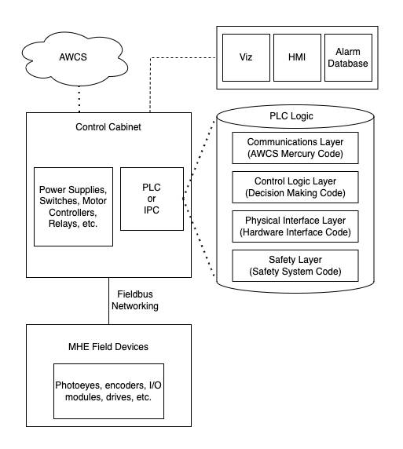
At the heart of an MHE system is the control cabinet, which houses the critical components of the controls system. This enclosure will house the PLC as well as other devices such as power supplies, motor controllers, relays, network equipment, and safety equipment. Field devices, such as photoeyes, safety devices, variable frequency drives, I/O modules, and encoders are wired back to the cabinet through industrial fieldbus or ethernet to provide inputs to the PLC where it will execute logic to control outputs such as starting/stopping a motor. Within the PLC there is code with various functions that can be simplified down to a physical interface layer, which will have direct interaction with the field devices, a control logic layer, which has predetermined decision making algorithms processing the inputs and executing decisions to equipment, a communications layer, which has two-way communication to a warehouse controls system (WCS) exchanging data and higher-level commands, and a separate safety layer, which is closely regulated.
In 2014, Amazon started to build our own warehouse controls system (AWCS) to interface directly with vendor programmed PLCs and Industrial PCs (IPC), which took approximately 2 years to become the global standard and 9 years to complete full conversion of the global network. Amazon owns and provides code libraries in the PLCs that communicate with AWCS, but vendors provide standard messaging interface to their black-box IPCs. In a practical example for a sorter, a PLC has item tracking and barcode detection logic that sends a request through AWCS for a destination. AWCS communicates with internal services and sends back to the PLC a preferred destination. The PLC itself will determine lane availability and then use speed and position data from the field devices to activate a divert mechanism at the precise moment to guide each package to its designated chute without collision.
The majority of Amazon’s equipment is setup in this similar architecture with the exception of some specialty equipment from some vendors such as Dematic and Intelligrated where their sorters are not using PLCs, but IPCs typically written in C on Linux OS. PLCs are capable of running that high-speed equipment, but the IPCs enable some scalability and increased functionality for the vendors, while creating a black-box systems with limited incremental value for Amazon.
Appendix C: Amazon Global MHE Spend

Appendix D: Project Seahorse Vision
Project Seahorse is an initiative that transforms how Amazon designs, supplies, and installs material handling systems within our North American Sortation Centers (NASC). By taking a more active role in this process, we will create solutions perfectly tailored to Amazon's unique needs and goals, driving efficiency and innovation in our operations. This transformation is being achieved through three key strategies: forming collaborative partnerships with suppliers to create Amazon-branded solutions that reflect our high standards; building strong relationships with experts in essential services like steel fabrication and controls design to optimize every component of our systems; and expanding our in-house engineering team to develop customized designs that integrate seamlessly with our existing infrastructure. Project Seahorse is about more than just improving material handling – it's about creating solutions that are truly Amazon, embodying our customer obsession and commitment to the highest standards. By combining strategic partnerships, in-house expertise, and a relentless focus on improvement, we are transforming the future of NASC and setting a new benchmark for our industry. Project Seahorse is about shaping the next generation of material handling systems, and the future of logistics at Amazon.
Appendix E: Greenfield ARS Timeline Compression Opportunity
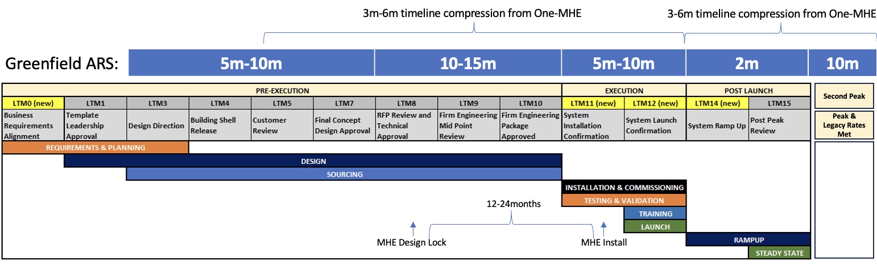

Appendix F: WWDE Product Development Process (PDP)

