Directory task:
- First I needed to upload my lab2 files via sftp to the SoC remote
- Next I rearranged the directories described using mv
- I renamed my lab2.c file to driver.c
- Because I am accessing the environment through ssh in my Mac’s zsh terminal I will need to add this task.docx (created on my desktop) to the directory after completion
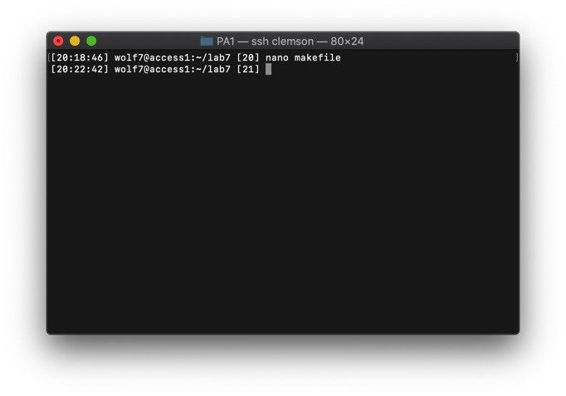
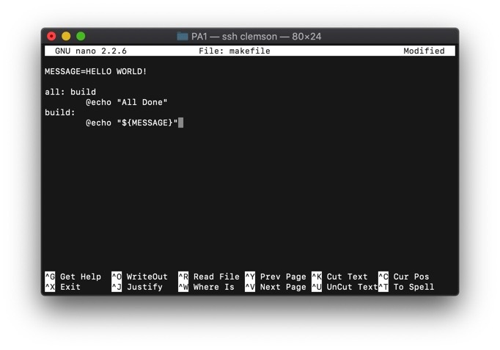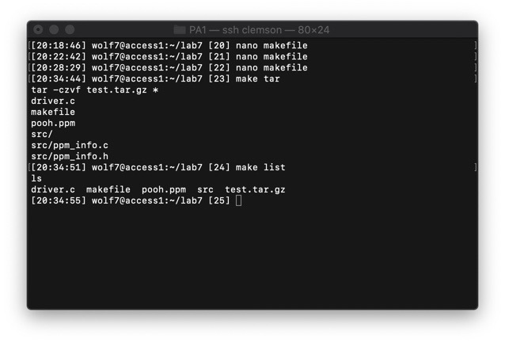
Regarding the addition of tar and list to the doc: When calling tar I used the wildcard * to get all files in the dir… but if test.tar.gz is present this creates an error. For now I just manually removed it
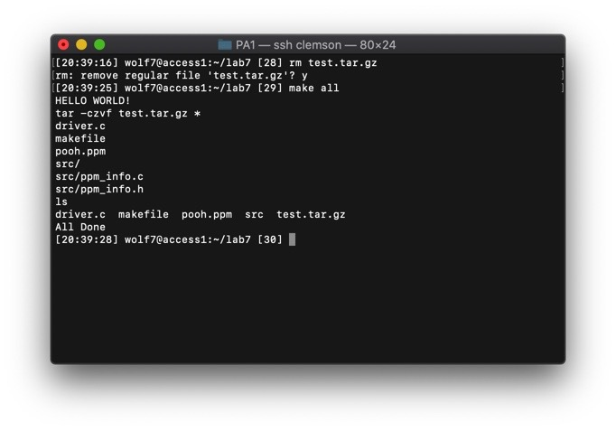
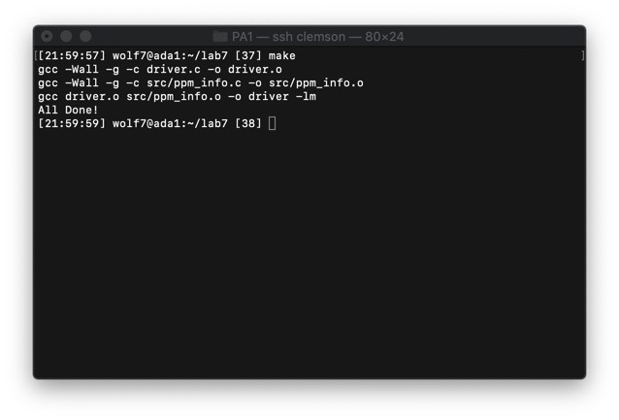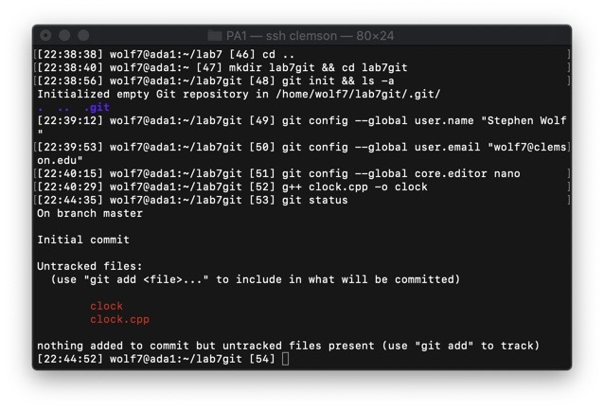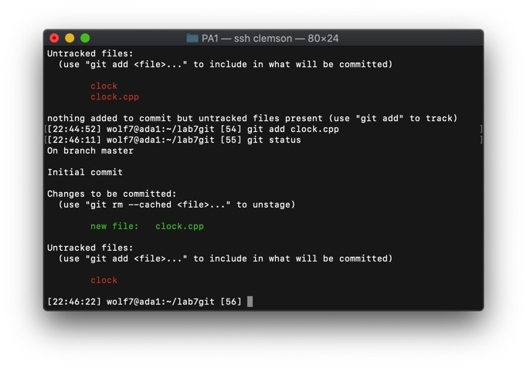
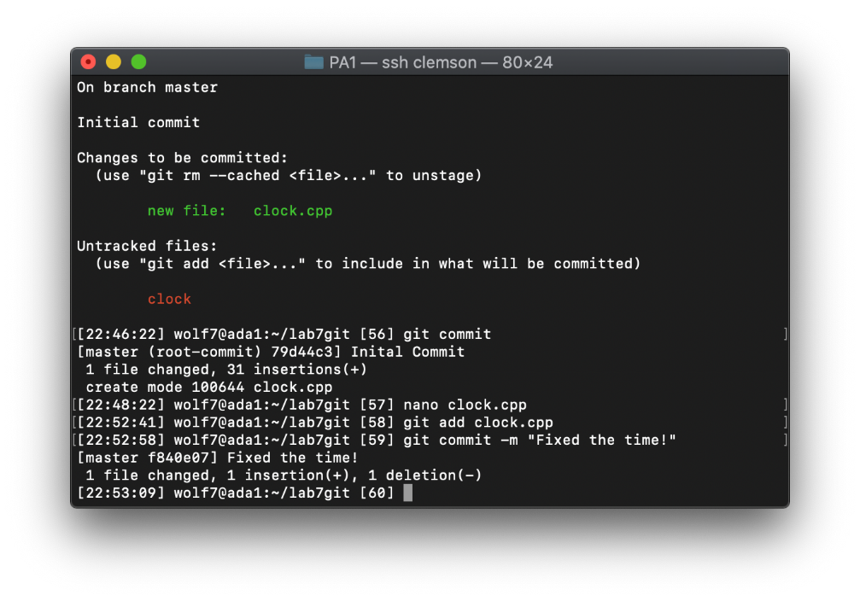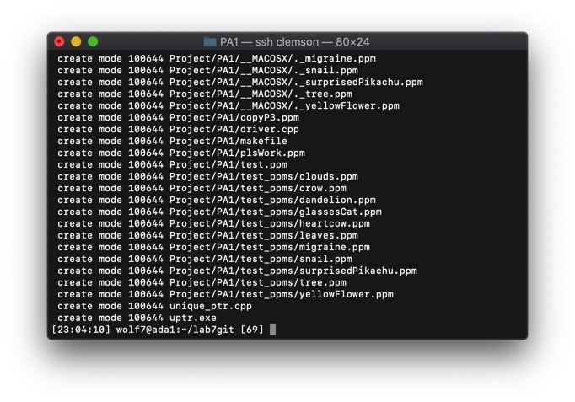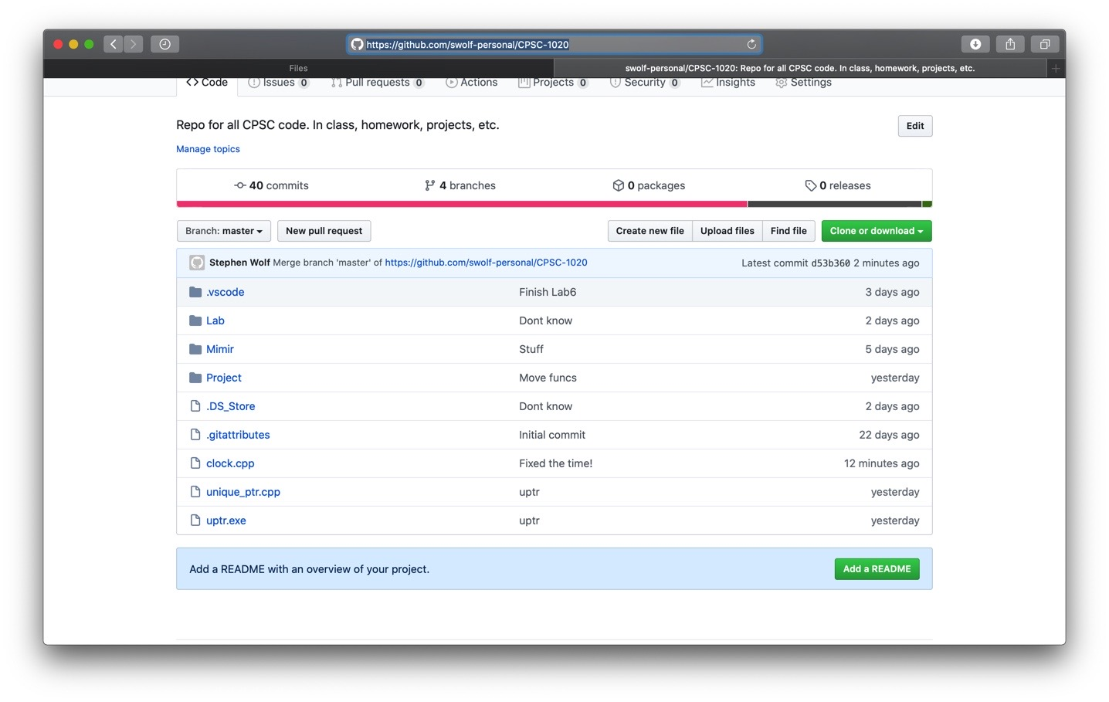Note: These last two points were a little complicated accessing my repo from the terminal (which I haven’t done before). But these are the results from pushing into my master branch (probably a mistake for tomorrow me to fix) and that is the “clock.cpp” online.

