Figures

Figure 1. Total abundance

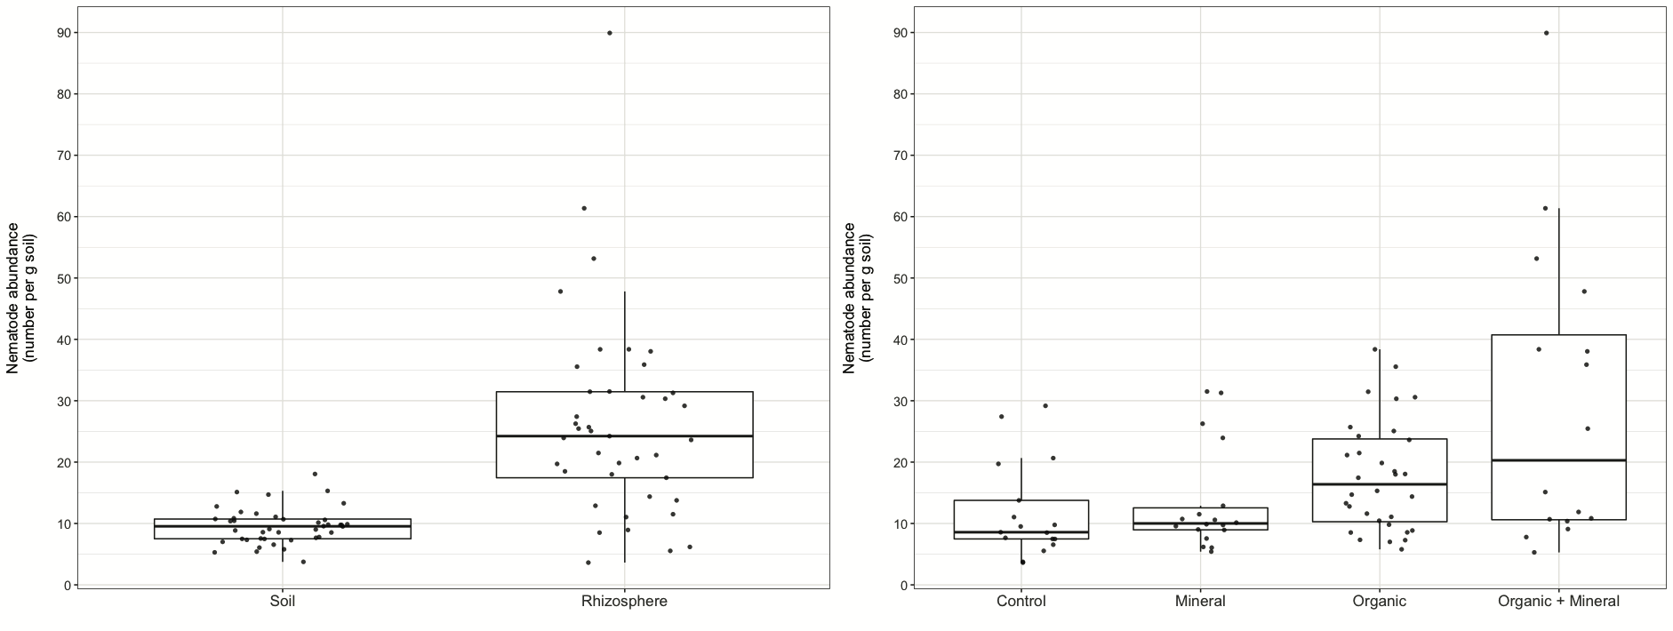

Figure 2. Taxonomy



Figure 3. Functional abundance—all and plant pathogens



Tables

Table 1: Average values of soil properties and microbial biomass in the six different treatments. Standard error is indicated in parentheses.

|  |  |  |  |  |  |  |
| --- | --- | --- | --- | --- | --- | --- |
|  | **Treatment** | | | | | |
|  | **C** | **NPK** | **Co** | **Co+NPK** | **HM** | **HM+NPK** |
| **Total N (g kg-1)** | 0.3 (se) | 0.2 (se) | 0.20 | 0.22 | 0.20 | 0.22 |
| **Total C (g kg-1)** | 6.3 (se) | 5.7 (se) | 5.03 | 5.17 | 5.55 | 5.34 |
| **Total P (mg kg-1)** | 1265.8 (se) | 1522.3 (se) | 1687.75 | 2135.75 | 1660.75 | 1978.00 |
| **C/N** | 30.1 (se) | 28.9 (se) | 29.15 | 27.90 | 31.83 | 28.68 |
| **Microbial biomass (µg C g-1)** | 127.8 (se) | 126.0 (se) | 97.50 | 125.25 | 146.25 | 158.00 |
| **N mineral (µg N g-1)** | 1722.0 (se) | 1890.3 (se) | 1861.00 | 2196.75 | 2011.00 | 2167.25 |
| **pH(H20)** | 8.4 (se) | 8.2 (se) | 8.38 | 8.19 | 8.18 | 8.01 |

Table 2: Regression model, Fig 1

Table 3: Regression model, Fig 2

Table 4: Regression model, Fig 3