ETHlogo

**Lecture with Computer Exercises:**

**Modelling and Simulating Social Systems with MATLAB**

Project Report

|  |
| --- |
| Modelling Fire Spread and Agent Mortality during a Forest Fire |

A. Agosti, M.R. Binelli, P. R. Kanduri, S. Park

Zürich

13th December, 2013

**Agreement for free-download**

We hereby agree to make our source code of this project freely available for download from the web pages of the SOMS chair. Furthermore, we assure that all source code is written by ourselves and is not violating any copyright restrictions.

|  |  |
| --- | --- |
| A. Agosti | M.R. Binelli |

|  |  |
| --- | --- |
| P. R. Kanduri | S. Park |

# Abstract

The behaviour of forest fires has already been thoroughly studied and implemented, and many papers regarding trail formation are easily found in literature [1][2]

The aim of this study is to show how the two models, when applied together, can provide a fairly good simulation of the forest fire development, and of the behavior of the animals involved.

Several parameters leading to the creation of paths in a forest are examined, their action on forest environment explained. In addition, the influence of such trails on animals’ mobility for escaping the incoming flame fronts and on fire propagation itself is analysed.

The results obtained could provide a starting point for further study on the topic of safeguarding animals in national parks and also fire safety problems might be tackled with the insights generated with the help of our model.

# Individual contributions

Amedeo Agosti

Model (Trail Formation and Path Finding)

Report (Introduction and Motivations)

Marco Binelli

Model (Trail Formation and Forest Fire)

Report (Forest Fire, Simulation Results)

Prashanth Kanduri

Model (Trail Formation and Forest Fire)

Report (Trail Formation, Summary and Outlook)

Seonwook Park

Model (Trail Formation and Path Finding)

Report (Path Finding, Simulation Results), Visualizations

Table of Contents

1. Introduction and Motivations 6

2. Description and Implementation of the Model 7

2.1. Trail formation 7

2.1.1. Input Parameters 7

2.1.2. Algorithm Flow 8

2.2. Forest Fire Model 9

2.3. Path Finding 11

2.3.1. FV, the fire potential 11

2.3.2. Destination of agents 11

2.3.3. Fire awareness 12

2.3.4. Variation in agent speed depending on vegetation 12

3. Simulation Results and Discussion 12

3.1. The case under consideration 12

3.2. Fire spreading in open border forest 13

3.3. Fire spreading in closed border forest 13

3.4. Quantifying the variation in survival rate 15

3.4.1. Variation in number of iterations taken in trail formation, $N$ 15

3.4.2. Variation in visibility of agents, $σ$ 16

4. Summary and Outlook 17

4.1 Possible applications 18

4.2 Future improvements 18

5. References 18

# 1. Introduction and Motivations

Social collective behavior has been attracting the attention of researchers for decades and computational simulation has offered very powerful tools to predict aspects of such multi-variable problems. Here we propose a model that is aiming to shed light on the influences of trail formation in a forest that is subjected to an unforeseeable natural phenomenon, namely a fire.

Trail formation models have already been implemented in case studies involving human beings [1]. In the reference paper, authors show the development of walking-clusters, stressing the crucial importance of the orientation parameter that guides humans toward a specific destination. However, this piece of literature also offers some insights to animal trail formation [2], yielding a complementary overview of different factors affecting non-human behavior.

Our model digs its roots into this field and extends its branches with the evaluation of behavior of deer, following previous descriptions that involved active agents. The inspiration came after a powerful childhood memory: Walt Disney movie “Bambi”, starring a white-tailed deer fleeing from a forest fire.

In addition to this, we incorporated in our model the simulation of a forest fire, in order to give a possible and direct application of the usefulness of trail formation in a forest. As a result we structured our work in three main steps:

* trail formation;
* forest fire;
* path finding.

Apart from the desire of reproducing the movie plot, the idea of combining two models in a single project was to realistically assess the dynamic process involving animals. We modeled our simulation according to previous literature, i.e. including an orientation potential that guides our agents towards fixed destinations; furthermore our attention focused on how variables such as the extent of trail formation and the visibility affect the survival rate of deers escaping from fire. The evaluation of subtle parameters counterbalance the simplified approach dedicated to the chosen environment for the simulation. A flat surface enclosed in a rectangular space represents nonetheless the starting point for many simulations found in literature, waiting for future potential improvements.

The accurate weighting of the simulation’s parameters ended up with a relevant relationship between path finding during forest fire and survival rate, with and without the presence of trails.

# 2. Description and Implementation of the Model

## 2.1. Trail formation

Trail formation is a natural process in any vegetated area having a certain animal movement. The process depends on several real world conditions, such as vegetation type, animal type, magnitude of movement, among many more. Individual animals, referred to as agents here, may have a smaller impact over the vegetation, thereby increasing the time it takes to create a mature trail. Phenomena such as herd migration can lead to a faster formation of a prominent trail. Vegetation also regrows, but that again depends on the activity on the terrain.

We adapted a trail formation model by Dirk Helbing, et al.[1], which modeled the evolution of human trail systems. Large scale pedestrian movement can actually be approximated by movement of simple creatures, making intuitive decisions in every step. Trail formation is a social phenomenon. It is more likely that an agent takes a path that has been taken before. Similar phenomena are also observed in forests. Large animals/herds such as elephants trample large tracts of vegetation as they walk. These trails are then frequently used by other animals for movement.

It must be understood that trail formation is a slow process and formation of mature trails can take several months to years. Hence, it is implied that the timescales of the simulations in this model are much greater than the ones in fire propagation and path finding.

This highly simplified model assumes the existence of a single species, in this case an *American White Tailed Deer* in a forest that has limited entry and exit points. This is a plausible assumption because most sanctuaries or reserve forests are often fenced with few corridors opening up to regions outside. We start off with a forest with fairly uniformly distributed vegetation with our deer population beginning to explore their new home.

### 2.1.1. Input Parameters

The model takes into consideration several factors in addition to the agent’s desire to take the shortest distance to its destination. These factors can be explained in terms of the following parameters that play a role in the whole system:

* Terrain Attractiveness (G)

The more the vegetation, the less attractive the terrain is to take a step. A trail would be more comfortable to walk on than a terrain with wild bush growing.

* Step Impact (I)

This is the amount of visible vegetation damage that taking a step does. With each agent stepping over a certain vegetated region, the attractiveness of the region goes up.

* Trail Durability (T)

This parameter is high when it takes a long time for a trampled region to regrow again. Essentially, it is how long a formed trail stays. For lower values, the trail weathers away faster.

* Animal Visibility (σ)

This depends on the animal, as well as on vegetation intensity; can also be adjusted for different animals. This parameter has a huge impact on the foresight an agent uses when making a decision regarding the next step. Visibility dictates the region of the map taken into consideration for making the next move.

### 2.1.2. Algorithm Flow

#### Agent Destination

In this patch of wilderness, there are particular areas where our agents frequent to. This activity might represent natural movements to locations such as water bodies, grazing areas, territory movements, local herd migrations, high vantage points (think Disney), etc. A new destination is assigned to the agents whenever they reach their current destination. The destination selection process is randomized.

#### Attractiveness Potential of the Position

This is a parameter calculated by taking into account the agent’s awareness with the highest contribution from the more visible regions of the map. In essence, the attractiveness of a region decreases exponentially with distance while depending on visibility. An integral is performed over the whole domain to assign a potential to the positions neighbouring those to that of our agents.

$V_{tr}(r_{α},t)=\iint{{(e}^{-\left|r-r_{α}\right|/σ\left(r_{α}\right)}G\left(r,t\right).dr).dr}$ (1)

#### In the equation below, *α* refers to the particular agent, and *r* refers to the radial distance.

#### Direction Calculation

At every step, the agent makes a decision choosing between the directions of movement available based on a linear combination of the direction of the destination, and the direction of the steepest increase in potential. The contributions of these two factors can be tuned in the algorithm. The position is incremented in the direction of the unit vector generated in the operation.

$e_{α}(r_{α},t) = \frac{d-r+ ∇_{r}V_{tr}(r,t)}{|d-r+ ∇_{r}V_{tr}(r,t)|}$ (2)

A more detailed mathematical explanation of this model can be found in the paper by Helbing et al [1].

## 2.2. Forest Fire Model

Many different forest fire models have been developed throughout the years, as this kind of self-organized criticality is very easily tunable and can provide satisfactory results in various applications.

In order to begin with a very general and therefore customizable model, we started implementing the one proposed by Bak et al. [3], which relies on a grid (simulating a forest) which follows three simple rules, after fire is started:

* After one step, each tree (cell) on fire burns down.
* At every step, every neighboring cell to the one on fire takes fire itself.
* Trees regrow on every burnt out spot with probability *p.*

As we found this model too simplistic for representing the situation we wanted to describe, mostly because of the time scale of it being too long, we came up with a heavily modified version of it.

Firstly, we didn’t want trees to regrow at the burnt spot, as this process would be way too long in comparison with the duration of animals’ escape.

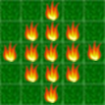Secondly, we switched the propagation of the fire from being purely deterministic to being a probabilistic event: this was required in order to relate propagation speed to the modifications in forest vegetation due to the creation of trails.

|  |  |  |  |  |
| --- | --- | --- | --- | --- |
| 0 | 0 | 1 | 0 | 0 |
| 0 | 1 | 1 | 1 | 0 |
| 1 | 1 | 1 | 1 | 1 |
| 0 | 1 | 1 | 1 | 0 |
| 0 | 0 | 1 | 0 | 0 |

*Fig.1. Binary matrix (F) and its visualization during simulation*

rand < K*(1 - g)

The event of a fire spread occurs only for randomly generated number being minor than (1-g), g being the value of G (comfort of walking) for each cell. Threshold constant K enables tuning of the frequency.

This probabilistic approach also enables control over the brutality of fire - which of course isn’t the same in every kind of fire i.e. it lets us control the frequency of the fire-spreading event by fine-tuning a threshold constant (K, see eq. [X]), which increases/decreases the probability of one cell catching fire at every time step.

We then introduced a ‘timer’, for controlling the number of time steps the fire would burn inside each cell: this is surely necessary because of the probabilistic behavior of the model, and can be adjusted in order to also simulate different environmental conditions. Moreover, areas with more abundant vegetation burn longer.

timer = n (n ∈ N)

if timer == 1;

F(i,j) = -1;

timer = 0

else

timer(i,j) = timer(i,j)-1

end

*Timer behaviour: notice how, for fire having ended its lifespan (timer = 0), a new value of F (matrix describing fire spreading) in given: this represents the ashen area, which will become relevant in the path finding part.*

|  |  |  |  |  |
| --- | --- | --- | --- | --- |
| 0 | 0 | 1 | 0 | 0 |
| 0 | 1 | -1 | 1 | 0 |
| 1 | -1 | -1 | -1 | 1 |
| 0 | 1 | -1 | 1 | 0 |
| 0 | 0 | 1 | 0 | 0 |



*Fig.2. Modified values in F matrix due to flame getting dwindled. The burnt down areas take on a different value.*

In the end we needed a way for relating the spreading of the fire to the movement of the animals. We then attributed different values of G to cells touched by fire: this yielded a time-varying situation which enabled to model the escape of animals during fire spreading. The cells on fire were given negative values of G, whereas the ashen areas were given an average attractiveness. Of course every value was chosen accordingly to the maximum value of G (Gmax), defined in the beginning for the trail formation part.

if F == -1 (ashen cells)

G = Gmax/2

if F == 1 (cells on fire)

G= -Gmax

*Construction of G matrix at every time step: G assumes -Gmax value when cells are on fire; burnt down cells are given average attractiveness*.

## 

## 2.3. Path Finding

The path finding model is heavily based on the trail formation model. Tweaks are made to adjust the values which affect the attractiveness of areas on the grid.

### 2.3.1. FV, the fire potential

During trail formation, the direction of an agent is determined by considering the gradient of the trail potential $V$ as well as the direction of the agent’s destination. We add in the effect of the fire on an agent’s movement by calculating a fire potential.

This is done by modifying equation (1) to yield:

$FV=\iint{e^{-\left|r-r_{α}\right|/σ\left(r_{α}\right)}F\left(r,t\right){dr}^{2}}$ (3)

where $F\left(r,t\right)$ is a grid of values representing fire spread (1: on fire, 0: not on fire).

This yields fire potential values where areas with higher fire spread have higher $FV$ values. Calculating $-∇FV$ yields a vector which points away from areas with high fire spread.

By adding the contribution of $-∇FV$ to the existing contributions of $∇V$ and $d-r$, we can allow for the fire potential to affect the direction of an agent, and thus the path it follows towards its demise or destination.

### 2.3.2. Destination of agents

The trail formation model - from which the path-finding model is derived - requires the existence of a final destination for agents. During a forest fire, however, agents cannot select destinations which could lead directly to their demise. It is much more likely that an agent would seek the nearest exit on noticing mortal danger.

Thus our model was adjusted to set the nearest entry/exit point as an agent’s destination on every time step. Assumptions made include the fact that agents are aware of nearby entry/exit points, and that the proximity of the points does not depend on trails formed.

### 2.3.3. Fire awareness

In a forest fire situation, it is improbable that agents will notice the existence of a fire from far away. A way to determine the proximity of fire is to evaluate the value of the fire potential $FV$.

In our simulations, an agent is prompted to start moving when $FV>0.8$ at its position. The burnt down areas of the forests can also be used by agents to navigate.

### 2.3.4. Variation in agent speed depending on vegetation

Thus far, the only dependence of the path finding model on trails was the navigation of the agents. This allows for cases where the path taken by an agent is not the shortest path. With constant agent velocity, this would indicate that using existing paths can reduce the chance of survival for agents as more time is taken to reach their destinations.

To alleviate this problem, we varied the speed of agents depending on the comfort of walking of their current location. This is done by referring to $G\left(r_{α}\right)$ and $G_{max}$ in the following way:

$v=\frac{G}{G_{max}}\left(v_{max}-v_{min}\right)+v_{min}$ (4)

where $v_{max}=2v$ and $v_{min}=0.4v$. In our simulation, the parameter values $v=1$ and $G_{max}=100$ were used.

# 3. Simulation Results and Discussion

The code was run several times in order to test its response and the survival rates it yielded by modifying some of the parameters used.

## 3.1. The case under consideration

We considered a simplified set of initial conditions for the evaluation of our model.

The dimensions of the forest are selected to be 50 by 50. Agent destination or entry/exit points are defined to be at the corners, specifically the coordinates (1, 1), (1 50), (50, 1), and (50, 50). The forest is flat, with no variation in type of vegetation and altitude.

This results in trail patterns which converge towards the corners of the forest. Adding complexity to our selected environment would not be a complicated task. Our focus however, is not on specific forest cases but on investigating effects of two basic parameters, trail intensity and agent visibility.

## 3.2. Fire spreading in open border forest

The first runs of the simulation were carried out assuming that the agents managed to reach safety upon arrival at the border of the grid. In most cases, this hypothesis is a good one, as it actually reproduces the finiteness of a forest.

During these simulations agents manage perceptibly well the escape from the fire, remarkably following the paths formed by them in advance, in order to increase their mobility on rough forest ground.

This fact, even if hardly surprising, is well reflected in real world cases: during a forest fire, average and large sized animals manage to escape successfully because of their high mobility and speed, which enable them to keep ahead of the fire front [4].

## 3.3. Fire spreading in closed border forest

Afterwards, the simulation was carried out in different terrain conditions: in order to reproduce the presence of cliffs, fences and other obstacles often found in forests and parks, a grid with boundaries which stop the agents has been established. Zones out of which the agents could escape the fire have been only kept at the corners of the grid, but their position can easily be set according to real forest data with simple parameter variation in the code.

With this setup the simulation provided interesting results in agent behavior and survival rate: whereas in the previous setup every agent managed to escape, now a noticeably large part of them die.

This mostly happens because the agents tend to cluster along the insurmountable border, unable to move towards the exits for the fire repels them in different directions.

Other intriguing occurrences have been observed during some of the runs, which actually reproduce some natural animal behavior: some animals manage to find holes in the fire front, and therefore to cross it towards safety. On the contrary, there are other agents seem to freeze on their spots whenever fire is approaching from different directions at the same time, resembling a panic-driven decision process. In a way, the model also accounts for irrationality on the part of the agent. Some examples of the above-described behaviors are shown in figures followed:

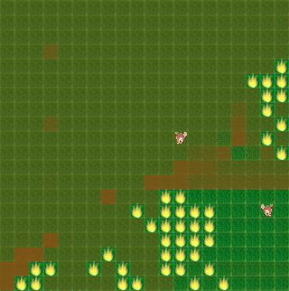

*Fig.3. Agents awaiting the clearing of fire to use trails*

|  |  |
| --- | --- |
| *Fig.4. Agents clustering at borders* | *Fig.5. Agent about to die at border* |
| *Fig.6. Agents slowing down then dying in vegetation* | *Fig.7. Escaping of agents by following trails* |
| *Fig.8. Path-finding through burnt out areas* | *Fig.9. Running between fires* |

## 3.4. Quantifying the variation in survival rate

For evaluating the effect of the trails on the effectiveness of fire escape quantitatively, an analysis of agents’ survival rate was conducted.

The survival rate of agents is calculated with the following equation:

$S=\frac{\left(No. of Agents\right) - \left(No. of Dead Agents\right)}{\left(No. of Agents\right)}×100$ (5)

## 

### 3.4.1. Variation in number of iterations taken in trail formation, $N$

The first parameter we varied was the number of iterations taken for trail formation ($N$). An increase in $N$ results in a strengthening of trails formed by agents. This in turn means that agent velocities on trails are higher, allowing for quicker escape. We therefore expect an increase in survival rate with an increase in $N$.

Figure 10 confirm our predictions, with the increase in trail intensity clearly improving the survival rate of agents. Though the probabilistic nature of the forest fire spread results in high variance in outcomes, the correlation between $N$ and agent survival rate is quite clear.

We also note that as mentioned in section 3.2, the survival rate of agents in an open border forest is substantially higher than those of a closed forest. The survival rate is greater than 80% for most cases, with a slight increase notable with increasing $N$.

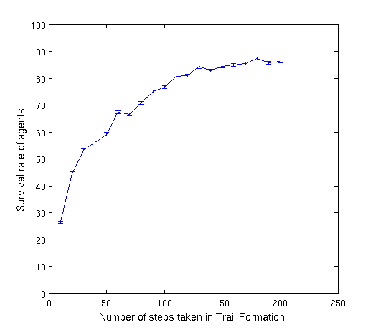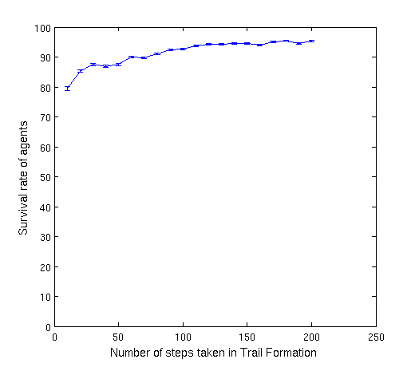

*(a) Closed border (b) Open border*

*Fig.10. Survival rate of agents against number of steps taken in trail formation. Error bars represent standard deviation of survival rates for a sample of 8 runs per parameter configuration.*

### 3.4.2. Variation in visibility of agents, $σ$

Another variable examined was the visibility of agents. This parameter is strongly dependent on forest type, and accounts for density of vegetation. With increased vision, it is expected that agents find trails more easily and thus form more efficient paths to escape fire. Thus with increasing $σ$, an increase in survival rate is expected.

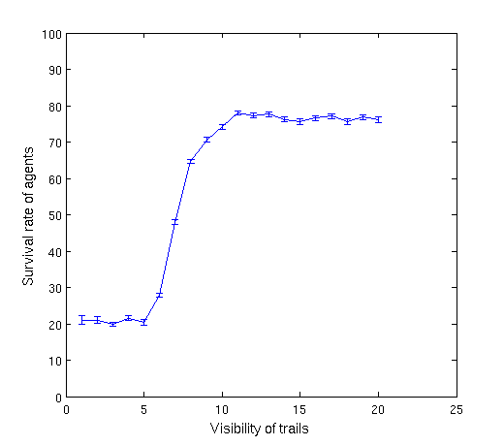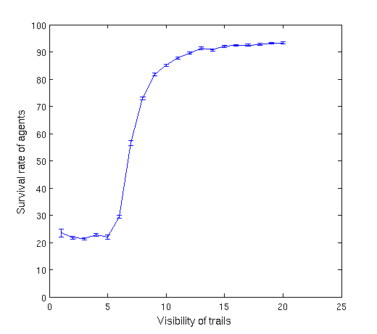

*(a) Closed border (b) Open border*

*Fig.11. Survival rate of agents against visibility of agents. Error bars represent standard deviation of survival rates for a sample of 8 runs per parameter configuration.*

Once again our expectations are confirmed in figure 11. The increase in visibility causes an increased survival rate as the agents became more rapidly aware of the fire. There is a large change in survival rate as $σ$ exceeds 5. Before this threshold value of visibility, the agents are not able to respond to the incoming flame front fast enough to escape mortal danger. Beyond it however, the agents are aware of the presence of fire early enough to make path-finding decisions.

For the case of an open border forest, the survival rate again increases substantially. Contrary to the case of increasing $N$, the borders do not contribute greatly towards decreasing agents’ survival rate. The limits due to forest dimension as well as proportionality between $σ$ and survival rate is still very clearly observable.

# 4. Summary and Outlook

A model combining features of trail formation, fire propagation and path finding was implemented to examine the effects of trails on agent mortality in the event of a forest fire. This was achieved by generating a trail system in a vegetated area using a population of agents.

The process was an adaptation of a deterministic model of pedestrian movement and its role in the evolution of trail systems: the timescales in this model allow for long term effects such as vegetation regrowth. The second part of the study involves capturing the behavior of the agents in a forest on fire. This process involves models on fire propagation as well as path finding: these two processes are coupled, in the sense that agents make decisions in each time step depending on their awareness regarding the fire propagation. Analysis involves simulating this process on uniform and trailed landscapes.

The fire propagation model is a probabilistic model where a vegetated segment ignites depending on the amount of vegetation and the state of the neighboring trees. This implies that trailed regions of the landscape are less likely to catch, thereby propagate fire and that the amount of vegetation influences duration of the fire in that region. Difference between the fire spreading in even and trailed landscapes is therefore very relevant. The stochastic model allows possibilities for cases where large tracts of the forests may actually be untouched by the fire, and trails have a significant effect over this.

The path finding heuristic is an adaptation of the trail formation code where an agent attempts escaping fire within its sphere of visibility. Agents prefer trailed paths as they offer greater mobility. They can also traverse through burnt down regions of the forest which cannot catch fire again or can dynamically switch exit destinations if heading in a certain direction puts them closer to mortal danger.

These simple rules exhibit a myriad of interesting behaviors: visualizations show instances where agents are seen navigating through gaps in the fire front. Among others, they also take a relatively longer path to escape successfully. The comparative study produced a strong correlation suggesting a positive effect of trails on the survival rate of the agents. Another study swept different levels of the visibility parameter, accounting for greater awareness of the fire spread. This study also demonstrated a similarly positive correlation.

## 4.1 Possible applications

The model we developed could provide better insight in several fire-protection strategies: firstly, it could be used for studying shape and dimension of fences around forests, in order to minimize the damage caused to animal population.

Moreover, for the safeguard of national parks, backfire torch strategies are very frequently employed: these consist of using portable gasoline- or kerosene-fuelled torches for spreading small controlled fires, in order to limit greater fire risk and controlling the growth of the vegetation. Our model could provide a useful tool for planning such operations, taking into account fauna survival as well as minimization of forest damage.

## 4.2 Future improvements

A deeper study of the influence of trails, and in particular of their shape inside the forest, has to be conducted in order to provide better data and further justify the use of the model.

Ulterior development could then include studies on more complex forest landscapes, in order to apply it to specific cases.

After that, real data comparison with fire events could be conducted for better tuning of the model.

Furthermore, different kind of agents could be inserted in the simulation, so as to evaluate different degrees of risk for different animal populations.

# 5. References

[1] *Helbing, Dirk, Joachim Keltsch, and Peter Molnar.* **"Modelling the evolution of human trail systems"** Nature 388.6637 (1997): 47-50.

[2] *Helbing, Dirk, et al.* **"Active walker model for the formation of human and animal trail systems"** Physical review E 56.3 (1997): 2527.

[3] *Bak, Per, Kan Chen, and Chao Tang.* **"A forest-fire model and some thoughts on turbulence"** Physics letters A 147.5 (1990): 297-300.

[4] *Lyon, L. Jack, et al.* **"Wildland fire in ecosystems: effects of fire on fauna"** (2000).