



Final Year Project

Literature Review

Pet Pal

Student name: Arjun Gyawali
University ID: 2333960
Reader: Subash Khatiwada
Supervisor: Sanjog Sigdel
Date: 2024/01/02

Table of Contents
A. Literature Review 2
1. Research Paper 1: Design and Implementation of Pet care system 2
2. Research Paper 2: Pet care technology and its advancement 3
3. Research Paper 3: Android application based Pet care system 4
4. Research Paper 4: Family, Pets, and the life course 5
5. Research Paper 5: Pet care and Adoption 5
B. Similar systems Analysis 7
1. Rover 7
2. Wag! 8
3. Urban Leash 9

Literature Review

Research Paper 1: Design and execution of Pet support system
The following report explores the combination of IoT and web development to develop an automated for pet care by making the use of raspberry pi and servo motors to control the food dispense, which is the complimented the web application which is developed using VueJS and NodeJS. The project mentioned aims in providing the solution which allows the pet owners to remotely control the feeding schedule with the use of web interface. This system is very beneficial for the pet owners who are far away from their pets and are busy with their works as it ensures that pets are fed constantly on time. The use of raspberry pi and servo mechanism ensures the precise control while dispensing the food for the pets which also help to manage diet specific requirement and also prevent the overfeeding that can lead to health issues in pet. Along with the hardware, integration of software will allow the user to control the hardware systems while feeding their pet. Systems like this can potentially reduce instances where the pets are fed late or not fed at all due to unavailability of their owner. This kind of technology encourages pet owners to maintain close relation with their pet’s daily routine for caring them, which ultimately leads to higher satisfaction among the pet owners and also helps in improving the health of the pets. (Nguyen, 2020)

Research Paper 2: Pet care technology and its advancement
The following research paper gives an in-depth analysis of technological step in pet care system which mainly focuses on improving the health of pets and overall well-being with the use of varieties of technologies and devices. The study is important in understanding how the modern technology developed in the field of pet care reshapes the ownership of the pets by offering solutions that bridge the gap between pet owners’ busy life schedule and the need to care their pets constantly. The integration of devices such as GPS-enabled collars, automatic feeding machine and health monitoring systems has revolutionized how the pet owners interact with their pets and care them ultimately providing the pet owners with peace of mind. The paper also discusses the rapid growth in the population of pet which causes the rising demand for advanced pet care solutions. The paper not only highlights current developed technologies but also discusses the future technological advancements in the field of pet care which could lead to even more personalized pet care strategies. This survey acts as a significant resource for the one interested in adapting the technology for the caring of their pets suggesting towards more advanced, automated, and intuitive pet care environments. (Tauseef, 2024)

Research Paper 3: Android application based Pet care system
The following paper explores the mobile solution aimed for easing the various burdens while owning the pet. The system provides a comprehensive list of services which are easily accessible via android app, catering to the need of pet owners who find it very challenging to constantly take care of their pets due to busy lifestyles and frequent travel out of the house. The android application contains various functionalities, including advice on pet care, dietary management, temporary adoption services and training guides to the pets.

The mobile system leverages location-based services to connect pet owners with their potential caretakers, offering a platform for those who are looking temporary pet care. It mentions common problem such as where to leave the pets during the holiday or vacation. It also ensures that the pets are well cared by the caretakers in the absence of their owners. By integrating expert advice from veterinarians and allowing the users for accessing and sharing the pet care information, the app not only supports the health of the pet but also nurtures the community of engaged pet owners. Through the apps built in options, users can easily buy accessories of pet. The software also creates a list of facilities that are available for boarding of pet, training. With the addition of institution filtration system, the app also makes the services like grooming, bathing, nail chipping very accessible. This in-depth analysis digs into the complex design procedure illuminating the methodical execution pet care system. In India, a significant rise in the adoption has been seen from 2006-2011. Every year, on average 600,000 pets are adopted. Having pets these days has become a part of luxury lifestyle of the humans. In maintain the lifestyle and adopting the pets, many pet owners suffer and struggle to take well care of their pets as they require special care and attention from humans. (Saswadkar, 2018)

Research Paper 4: Family, Pets, and the life course
In the following study, the deep psychological and emotional roles that the pets play in different families is inspected. The researcher interviewed pet owners, total of 320 and non-pet owners in total of 116 in the Island of Rhode. The finding resulted that pet ownership differs significantly over different family structures and life stages, meanwhile being most common with in the remarried individuals, families, and children, whereas so less among widows, and low-income families. The study also found that the pets are often considered as the important and integral part of the family and even counted as family members.

This research keeps the pet’s as important component of modern family who offer companionship and emotional support. After integrating the family development theory, from responsibility fostering in families that have children to providing strong purpose for empty-nesters and single individuals. The survey also underscores the growing human and animal bond, where pets not only complement social structures but also improve the mental well-being by removing the stress and nurturing emotional connections. Furthermore, the study also highlights the shifting perception of pets as a family member rather than only just animals. Further analysis also demonstrates that the pet’s type is also crucial in determining the characteristics of human character. The people who live with their dog’s state that they have a strong feeling of connection with their dog. These discoveries are examined with the help of family development theory which provides the inner information on how families are changing over the time. The changing and a bit complex relationship between humans and animal in developed cities is clearly highlighted by the complex interplay of family dynamics, and the emotional attachment the human establish with their pets. (Bulcroft, 1998)

Research Paper 5: Pet care and Adoption
The study of “Pet Care and adoption” highlights the enlarged importance of pets as essential components and the increasing components for sustainable resources to make sure about the well-being. The research also highlights that pets demand a comprehensive health care that includes proper nutrition, exercise, mental stimulation, and healthcare to balance a healthy life. The study emphasizes the importance of a species particular diet mainly focused to a pet age and health conditions while featuring a key element of liveliness. Regular physical activity, whether it can be walking, playtime or interacting with toys can be very essential for weight management and behavioral health as well as cognitive health. Providing the pets with regular exercise and different activities helps to make the pets healthy, energetic, and playful with their owners. As like, the study discovered that the often-missed aspect of mental stimulation, remarking that toys, puzzles, and social interactions are vital for lowering stress and anxiety while encouraging cognitive growth. These components generally power the bond between pets and their owners, creating an energetic and powerful relationship.

The study investigates the progressing dynamics of pet care in modern society, where internet websites play a vital role in labelling pet owners’ needs. It also discusses the development of pet care websites that provide advice on educational materials and devices like trackers and indication to enhance dedicated care. By integrating features such as growth charts, action and manner journals, and primping, these objectives simplify complex veterinary information, popular and affordable to pet owners. The easy availability of the supplies that pets demand will make the pet owners tension free and also gives them assuarance. The study also indicates that the pet care sectors, such as the competitive market and the need for regular updates and exact content. It recommends collaborating with animal specialists and behavioristic to ensure the dependability of resources. In addition to that the article emphasizes the importance of elevate through alliance with local shelters and community engagement. This diverse advance not only enhances the standard of the quality of pet care but also promotes a sense of community among pet owners coming up with better care trials and pace of adoption. At last, the research presents a guideline for moving forward to pet care systems and forwarding the assorted necessities of pets and their owners in an expanding computerized world. (Sunil Kumar R, 2024)

Similar systems Analysis
After doing some research about different websites and services that are similar to my project where pets are given for day care, boarding and different features I have listed some of them below in this report and have done some critical analysis on them. The analysis of those websites is listed below:

Rover
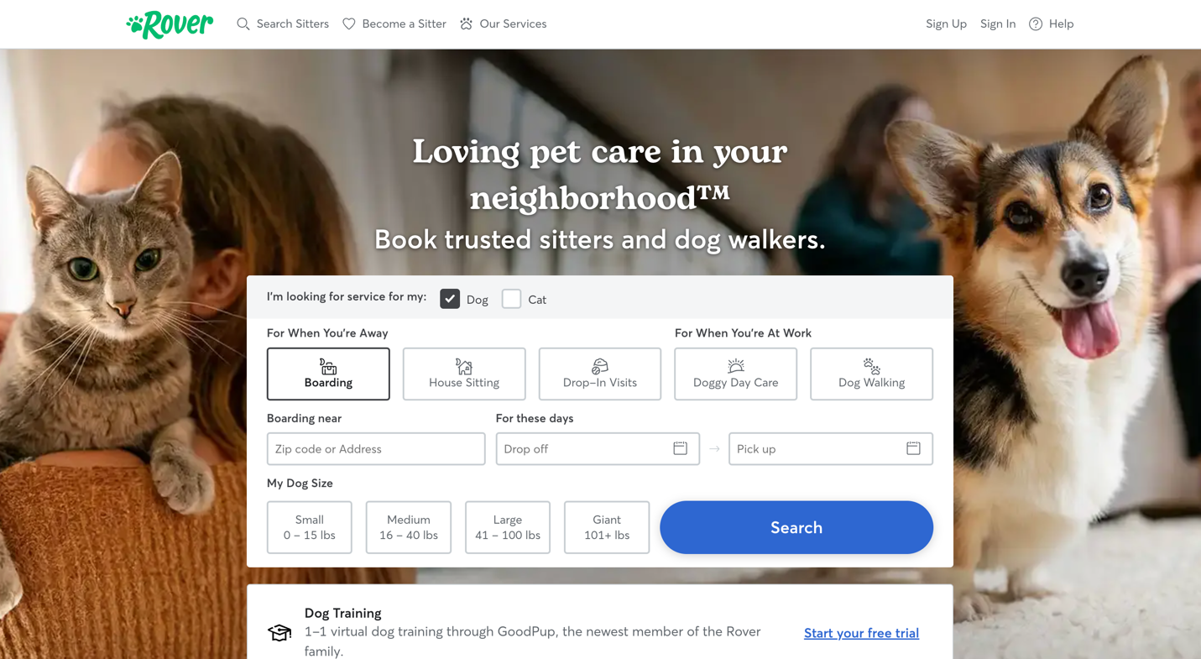

Rover is a well-established platform that helps to connect owners with professional caretakers for different types of services like dog walking, pet boarding, house sitting. The websites user friends interface allows the user to browse profiles, read reviews and do other different type of things on the website. The one main feature of this service is the 24/7 support to the users, which ultimately enhances the user confidence. Rover also provides the insurance coverage for the pet care services which ensures safety of the pets and give the owner a peace of mind. However, the platform charges a heavy fee for their services which can change the mind of budget conscious user not to user their platform for the care of their pets. The platform also mainly focuses on dog care, limiting the services for other pet animals. The platform’s services excel in connecting pet owners with the professional care takers, but their high fees can change the mindset of some pet owners. (Rover, 2024)

Wag!
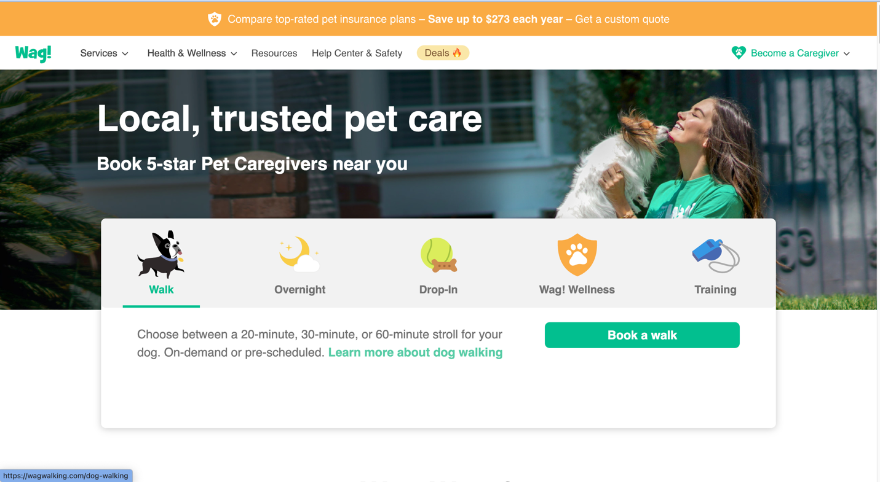

Wag! Is a web app-based platform which is developed for providing different pet care services like dog walking, pet sitting, and training. The main strength of this website lies in convenience, which allows the pet owner to book the services instantly. Wag! has GPS tracking, which enables pet owners to track their pets and monitor them in real time which helps to gain the trust of the pet owners and become tension. It also includes option for recurring booking mainly focusing on the busy pet owners. However, Wag! ‘s quality of service can vary due to inconsistent in the standard of training given to the care takers which can result in customer dissatisfaction. This platform also heavily focuses dogs, limiting the services for other pet animals. Wag! ’s focus of convenience and technology driven features is a great benchmark for other similar projects. (Wag!, 2024)

Urban Leash
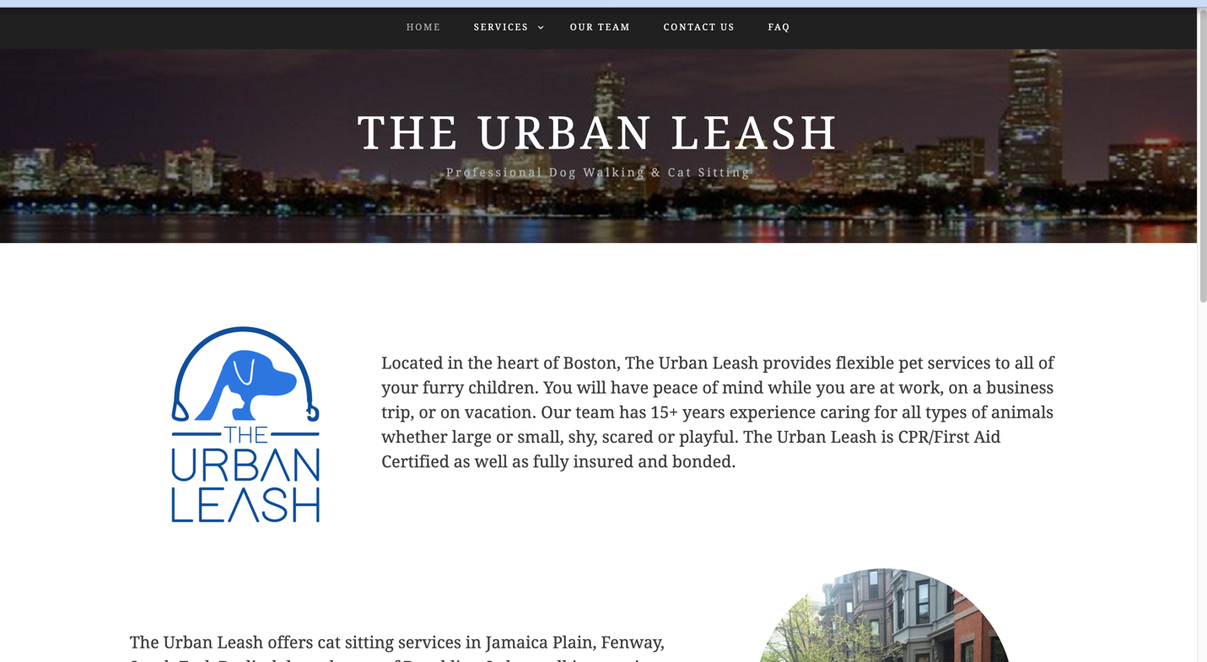

Urban leash is an online platform especially dedicated to urban pet owners by providing the last-minute pet care services like dog walking and cat sitting. The platform is best known for its approach for connecting the pet owners with the professional pet caretakers. It ensures safety for pets giving a peace of mind to the pet owners and become carefree about their pets. However, its availability is limited to selective cities only which ultimately restricts its reach to other pet owners. The platform also has fewer service option in compared to other similar platforms that provides this kind of services. They mainly focus of walking and sitting. Urban Leash thrives for its customer -centric approach such as detailed progress updates which having the pet care session which helps to build the trust of the pet owners. The fees of the service of this platform are competitive, but lack of pet care options might limit its user base. (The Urban Leash, 2024)

