Adapted by

Helen Steiner Rice

From an old German

Legend and Poem



When soft in the silence a voice he heard…

“Lift Up Your Head For I Kept My Word…

Three Times My Shadow Crossed Your Floor…

Three Times I Came To Your Lonely Door…

And Conrad was sitting with face a-shine…

When he suddenly stopped as he stitched a twine…

And said “Old friends, at dawn today…

When the rooster was crowing the night away…

The Story of the Christmas Guest



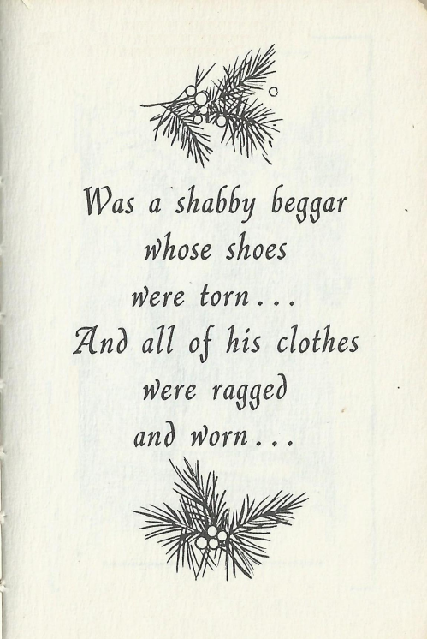

Was a shabby beggar whose shoes were torn…

And all of his clothes were ragged and worn…



So Conrad brewed her a steaming cup…

And told her to sit at the table and sup.

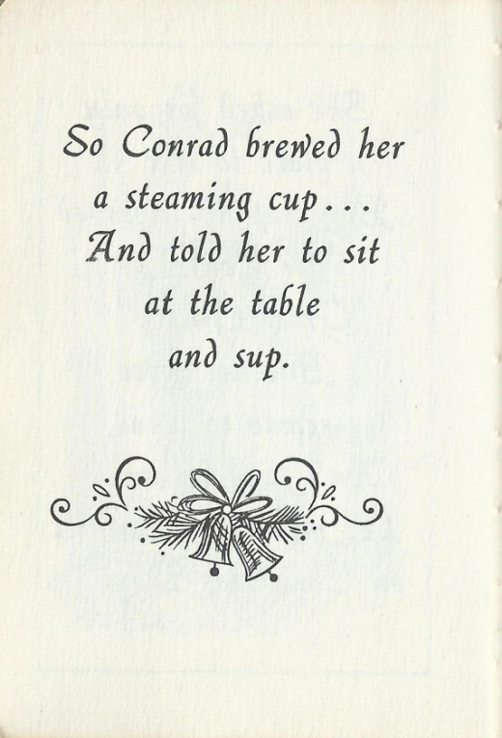

When he heard a knock and ran to the door…

But it was only a stranger once more…

A bent old woman with a shawl of black…

A bundle of branches piled in her back…

So with grateful heart the man went away…

But as Conrad noticed the time of day…

He wondered what made the dear Lord so late…

And how much longer he’d have to wait…

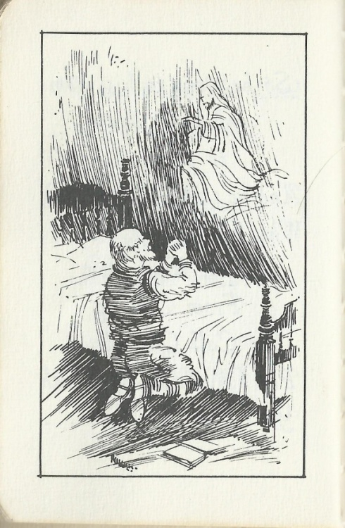

The Lord appeared in a dream to me…

And said, ‘I am coming your guest to be’…

So I’ve been busy with feet astir…

Strewing my shop with branches of fir…

And look for the Lord to be standing there…

In answer to his earnest prayer.

So he ran to the window after hearing a sound…

But all that he saw on the snow-covered ground…

So he called her in and wiped her tears…

And quieted all her childish fears…

The he led her back to her home once more…

But as he entered his own darkened door…

His step as He nears my humble place…

And I open the door and look in His face…

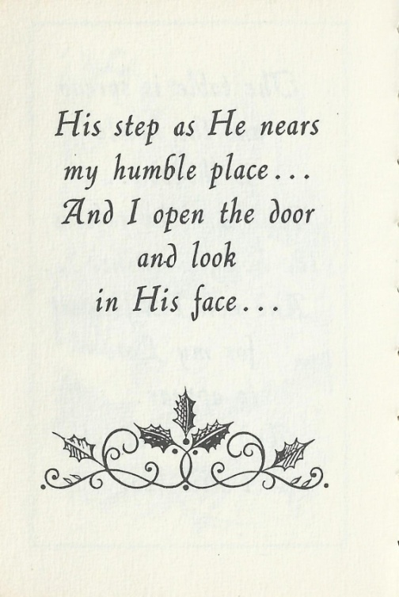

So his friends went home and left Conrad alone…

For this was the happiest day he had known…

For, long since, his family had passed away…

And Conrad had spent a sad Christmas Day…

But after she left he was filled with dismay…

For he saw that the hours were passing away…

And the Lord had not come as He said He would…

And Conrad felt sure he had misunderstood…

