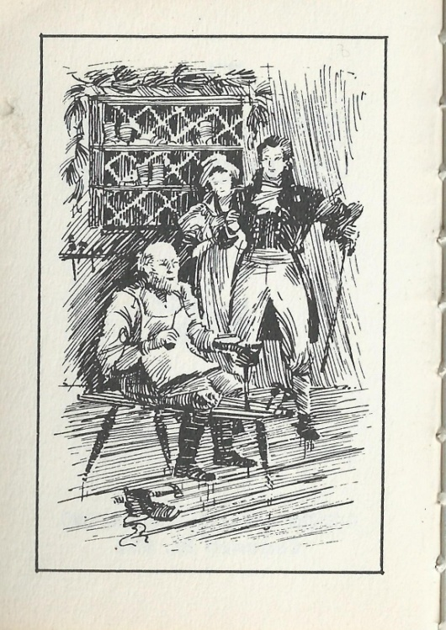

It happened one day at the year’s white end…

Two neighbors called on an old-time friend…

And they found his shop so meager and mean…

Made bright with a thousand boughs of green…

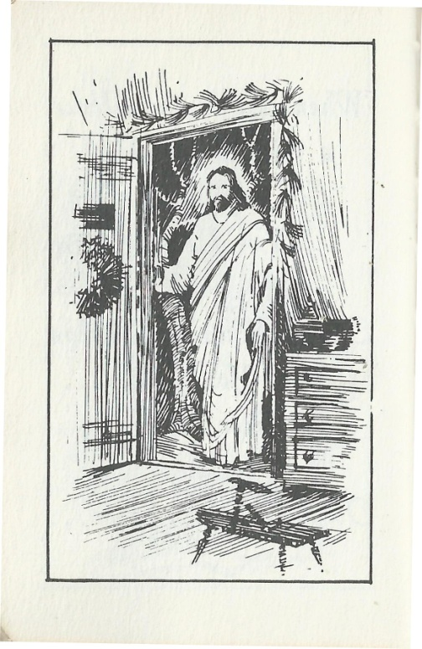

For I was the Beggar with bruised, cold feet…

I was the Woman you gave to eat…

And I was the Child on the homeless street.”

She asked for only a place to rest…

But that was reserved for Conrad’s Great Guest…

But her voice seemed to plead, “Don’t send me away…

Let me rest for a while on Christmas Day”…

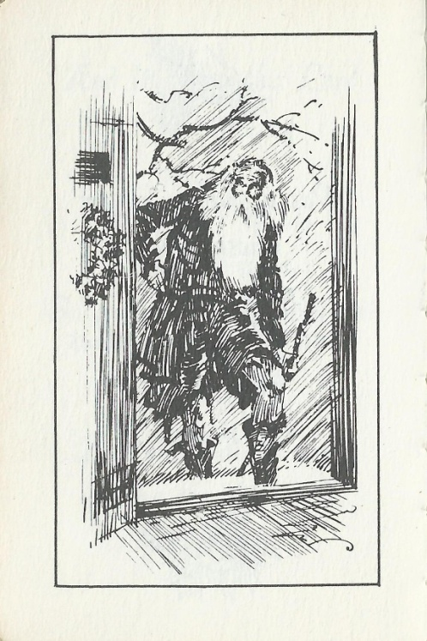

So Conrad was touched and went to the door…

And he said, “Your feet must be frozen and sore…

And I have some shoes in my shop for you…

And a coat that will keep you warmer, too…”

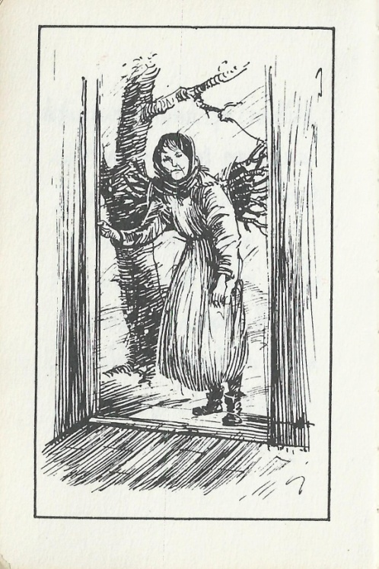

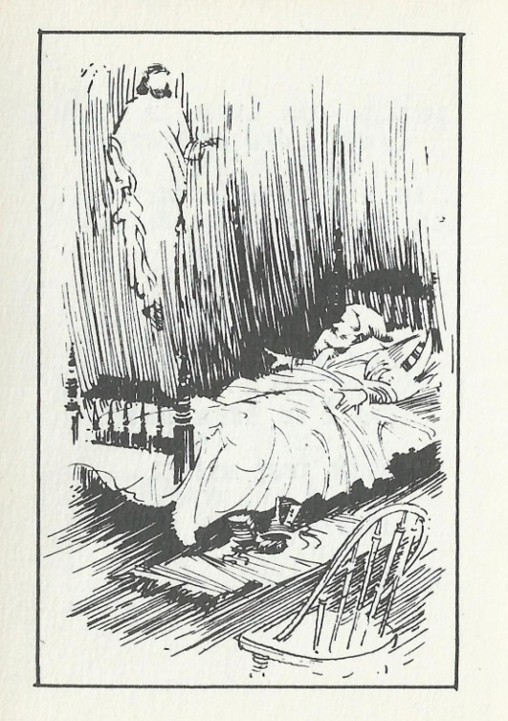

So he went to his room and knelt down to pray…

And he said, “Dear Lord, Why Did You Delay…

What Kept You From Coming To Call On Me…

For I Wanted So Much Your Face To See”…

When out of the stillness he heard a cry…

“Please help me and tell me where am I”…

So again he opened his friendly door…

And stood disappointed as twice before…

The table is spread and the kettle is shined…

And over the rafters the holly is twined…

And now I will wait for my Lord to appear…

And listen closely so I will hear…

He knew the Lord was not coming today…

For the hours of Christmas had passed away…

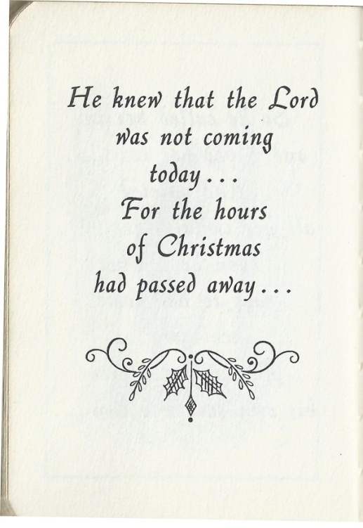

It was only a child who had wandered away…

And was lost from her family on Christmas Day…

Again Conrad’s heart was heavy and sad…

But he knew he should make this little girl glad…

But he knew with the Lord as his Christmas guest…

This Christmas would be the dearest and best…

And he listened with only joy in his heart…

And with every sound he would rise with a start…

